Solutions of Assignment4
1. Basic angular application

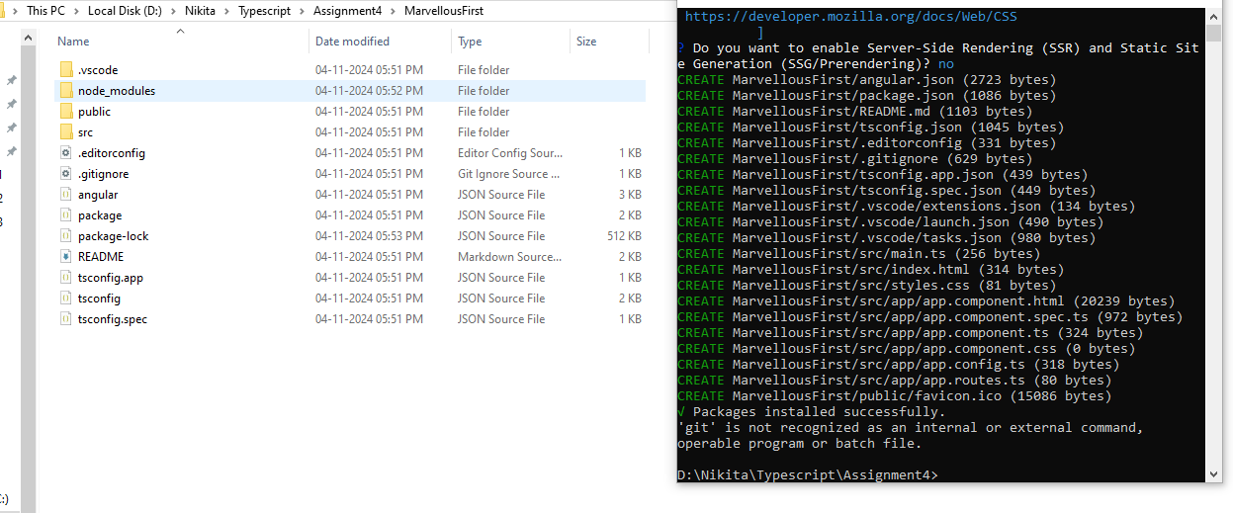
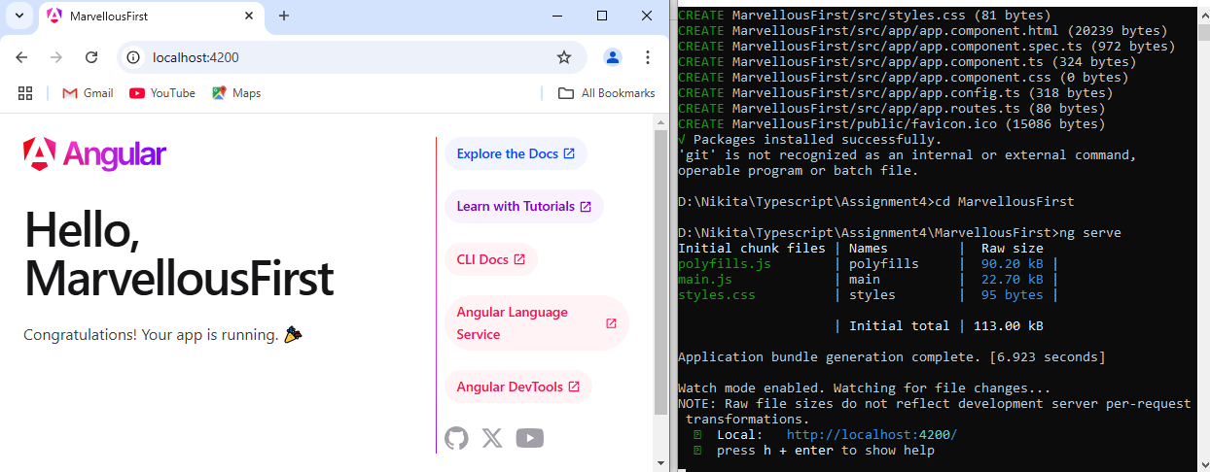
2. Display string on webpage.
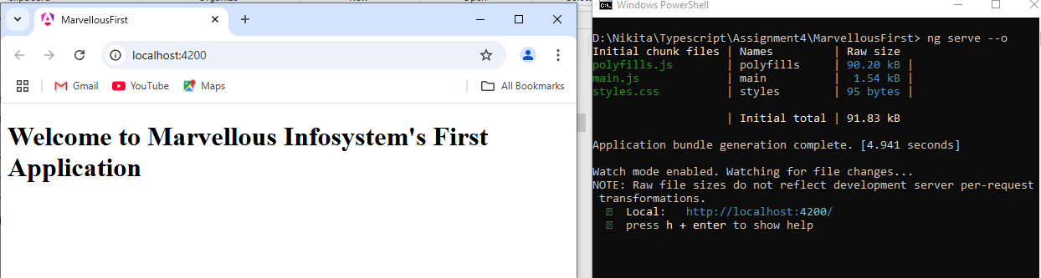
3. Display one textfield and static text.
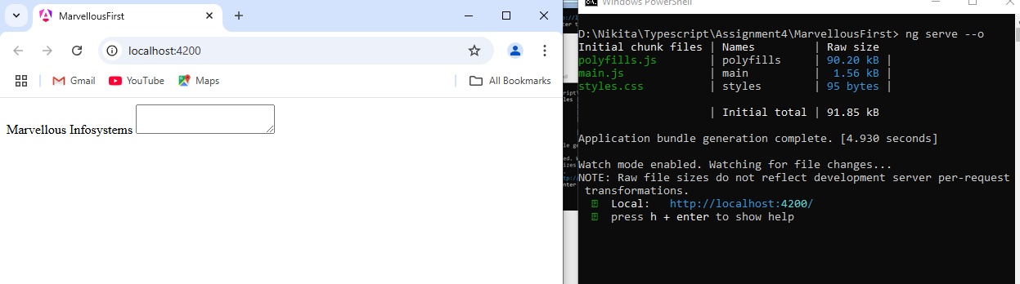
4. Render Demo component from app component
