**C0766552_W2020_MAD3125_MidTerm**

**Documentation of Mid Term**

**Tax Filing System**

**Submitted by:**

**Nikita Sandhu**

**C0766552**

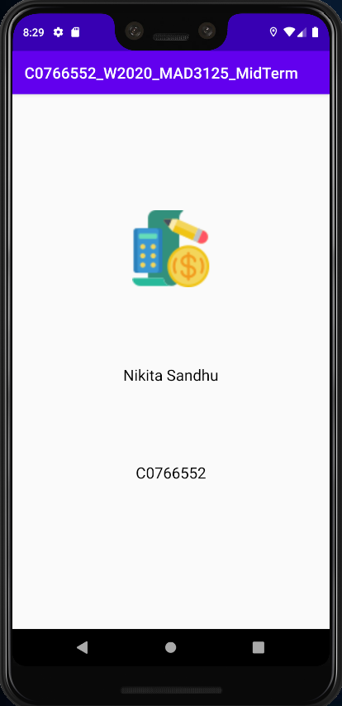

* Splash Screen that will appear for 5 seconds on the screen.

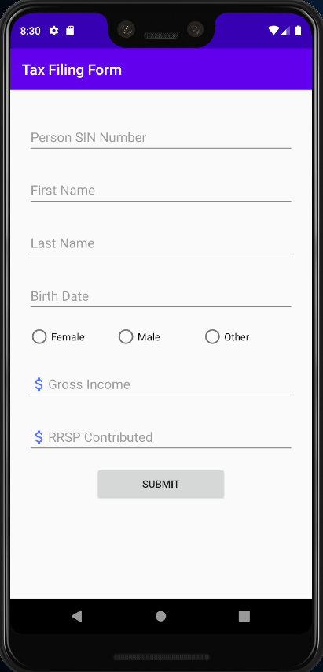

* Tax Filing Form scree.
* Here all the required details need to be entered to file tax.

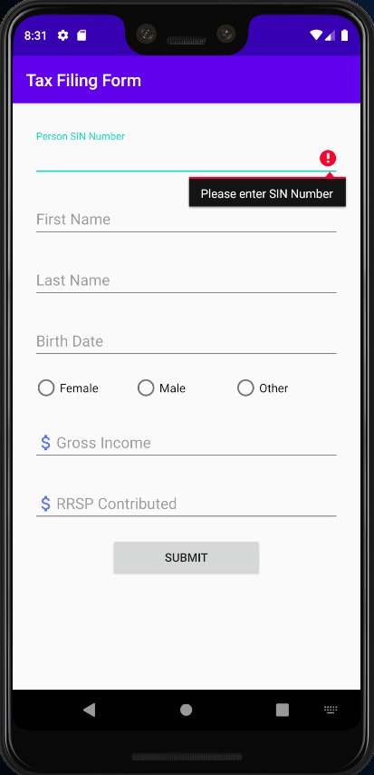

* Error will appear when SIN number is not entered.

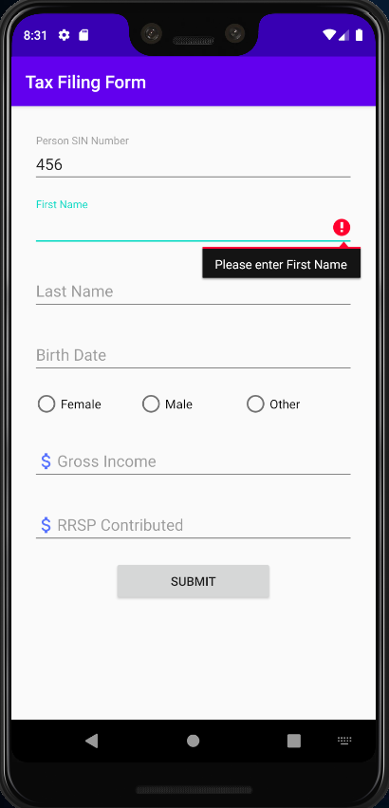

* Error will appear when First Name is not entered.

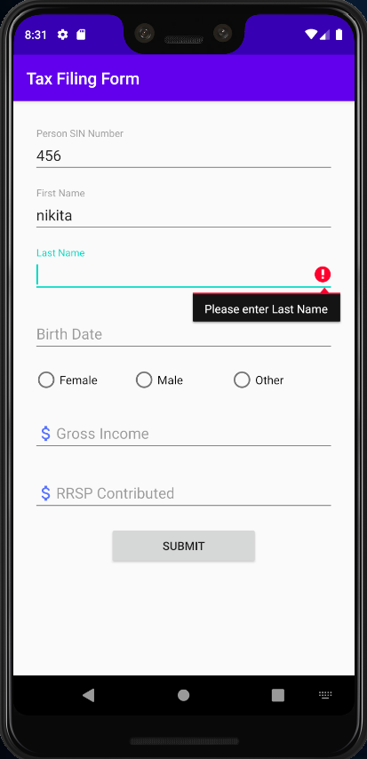

* Error will appear when Last Name is not entered.

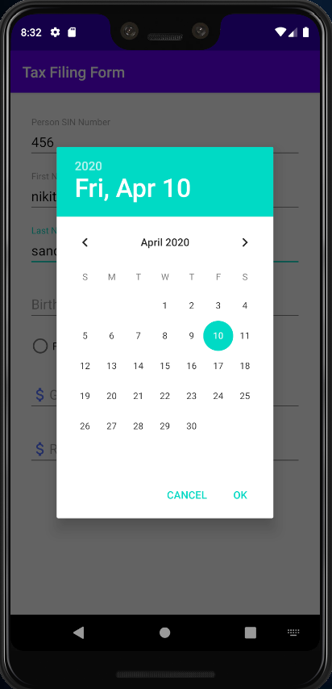

* Date Picker will appear when Birth Date field is clicked to enter the birthdate.

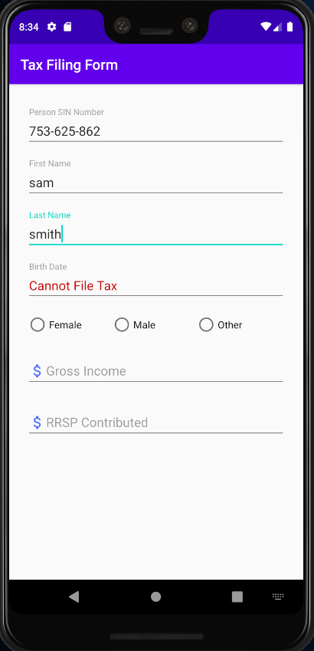

* When the age is less than 18 years, then the customer “Cannot File Tax” message will appear in the Birth Date field in red color.
* And the submit button will disappear.

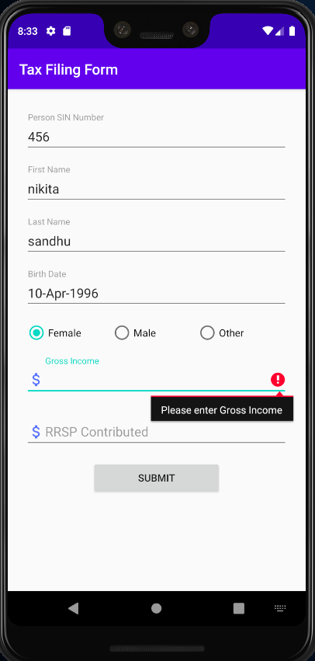

* Error will appear when Gross Income is not entered.

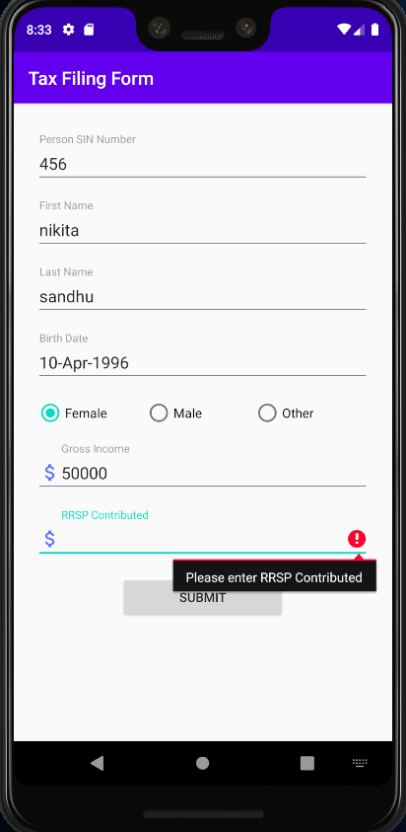

* Error will appear when RRSP Contributed is not entered.

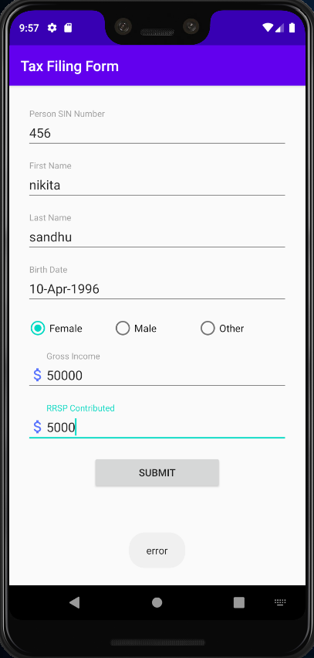

* The SIN Number needs to be entered in the valid Canadian SIN Number format, otherwise a toast will appear with error.

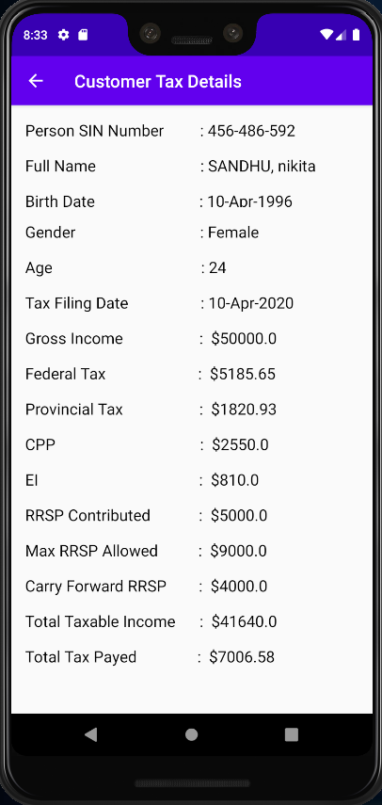

* Customer Tax details will get displayed after the tax calculation on the next screen when submit button is pressed.

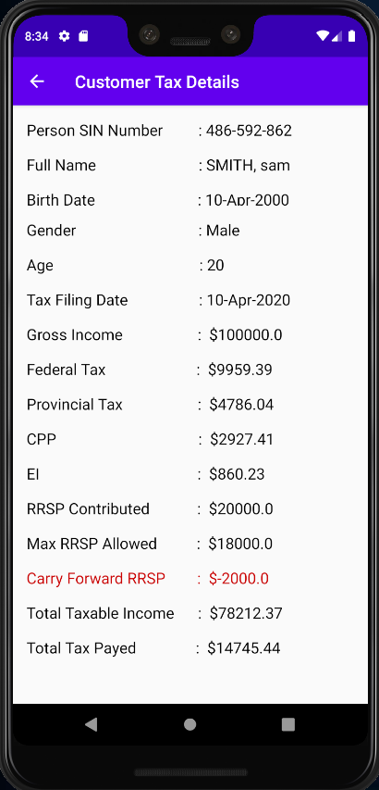

* If Carry Forward RRSP, that is calculated is negative, then it will appear in red color.