Shell scripting

What is a kernel🡪 interface between hardware and software.

User🡪appln🡪shell🡪kernel🡪hardware

Hardware is like cpu memory hard disk and any hardware peripheral devices.

Kernel is the program that keep running its take command from shell e.g gui, bash, csh and communicated toward hardware.

Shell and kernel is called operating system like any OS linux mic windows.

Shell + applin(brower, sendmail) 🡪 software

What is a shell

Its like a container

Interface between users and kernel/OS. Its provide u a environment to execute the command.

Find your shell🡪 echo $0

Available shells “cat/etc/shells”

Your shell? /etc/passwd

Types of linux shells

Gnome is GUI environment in linux

KDE, Sh, bash, csh and tcsh ksh

What is shell script : is an executable file containing multiple shell commands that are executed sequentially.

File contain :

Shell (#!/bin/bash)

Commands (#command)

Commands (echo, grep, cp)

Statement (if, while, for etc)

Shell scripting should have executable permission (rwx-rx-x)

Basic of shell scripting

Example for small script :

#!/bin/bash

echo Hello world

runcommand :

#!/bin/bash

Pwd

Echo

Hotname

Echo

Ls -ltr

Echo

Whoami

Defining variables :

#!/bin/bash

#example for variables

a=Nikita

b=Wankhade

c=linux_class

echo “my name is $a”

echo “My surname is $b”

echo “My class is $c”

input/output

read : for user to enter wait for user to enter

echo is output

#!/bin/bash

#Author

#Date

#Desc

#

echo Hello, my name is nikita

echo

what is your name?

read namecont

echo

echo Hello $namecont

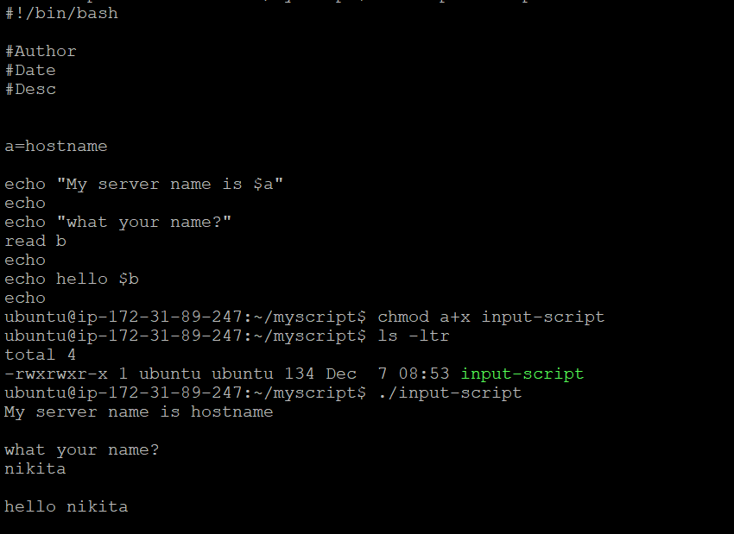

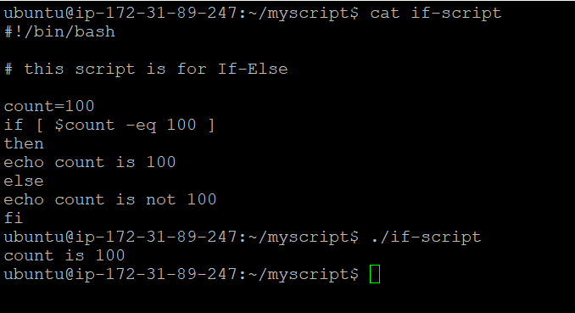

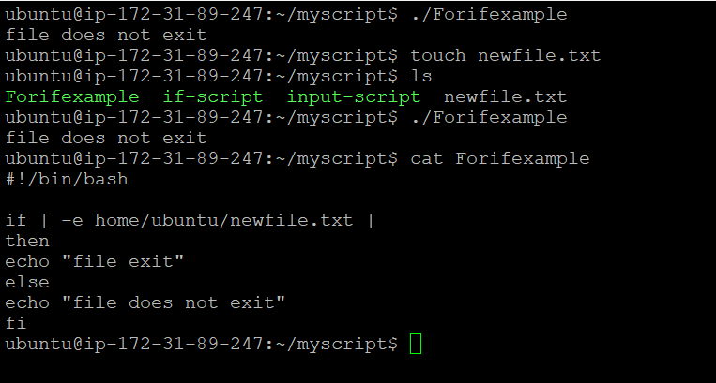

Do while : continuously run the a block of statement until the condition is true or met

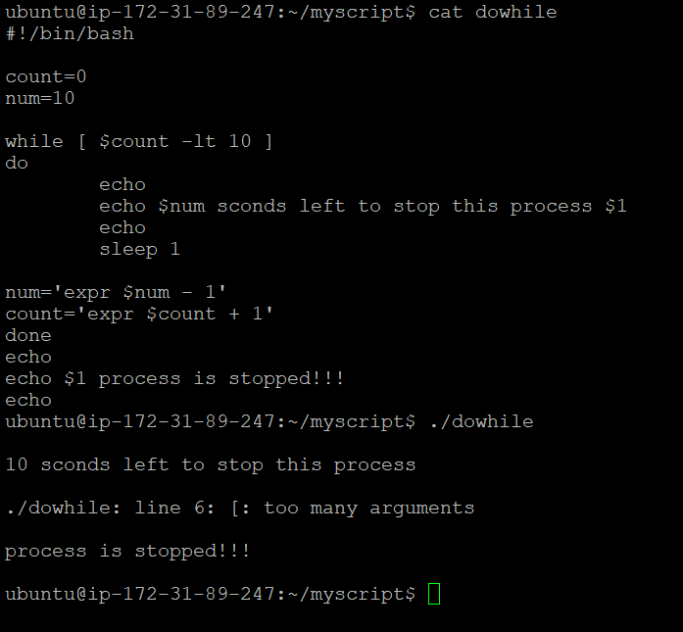

Case statement

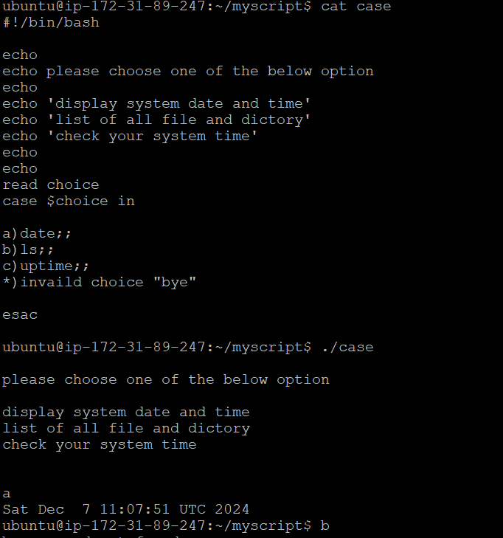

alias l='ls -la'

alias l='ls -la'

alias la='ls -A'

alias ll='ls -alF'

alias ls='ls --color=auto'

alias pl='pwd; ls'

alias tell='whoami; hostname; pwd'