ZOMATO RESTAURANT DATA ANALYSIS
Executive Summary, Methodology, Visualizations & GitHub Guide

1. Executive Summary
This project analyzes restaurant data from a Zomato-style dataset. It performs data cleaning, exploratory data analysis, feature engineering, supervised classification, regression diagnostics, and unsupervised clustering. The cost-for-two field is converted into a binary label called 'expensive' using the median cost as the threshold. Four classifiers are compared using accuracy, precision, recall, and F1 score. Regression models are also compared by RMSE, while K-Means and t-SNE are used to explore patterns among restaurants.
Actual metric values and result charts must be generated by running the notebook with the real zomato.csv file. They are not invented in this report.

2. Objectives
- Clean and prepare restaurant information for analysis.
- Visualize numeric distributions and common restaurant categories.
- Create a binary price-level label using median cost.
- Compare classification algorithms using multiple metrics.
- Inspect regression diagnostics, K-Means clusters, and t-SNE patterns.
- Publish reproducible code and documentation on GitHub.

3. Workflow
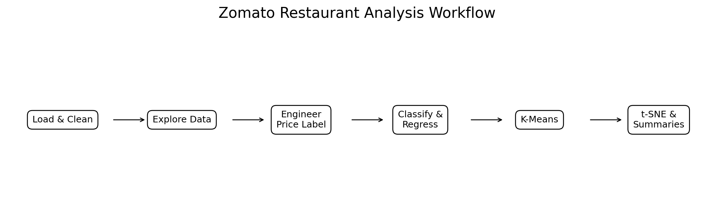
Figure 1. Analysis workflow.

4. Methods and Models
Stage | Methods | Output
Cleaning | Numeric conversion, imputation, category grouping | Prepared dataframe
EDA | Histograms, count plots, pairplot, boxplots | Exploratory charts
Classification | Logistic Regression, Decision Tree, Random Forest, Gradient Boosting | Accuracy, precision, recall, F1
Regression diagnostics | Linear, Ridge, Lasso, ElasticNet, Random Forest, Gradient Boosting | RMSE
Clustering | K-Means with elbow plot | Cluster assignments and summary
Visualization | t-SNE on sampled training rows | 2D cluster visualization

5. Results and Charts
The notebook saves classification accuracy, regression RMSE, cluster summaries, the K-Means elbow plot, distributions, count plots, pairplot, boxplots, and t-SNE visualization. Run the notebook to generate these outputs; this report does not include fabricated scores.

6. Notebook Link
Local notebook: zomato_restaurant_analysis.ipynb
GitHub URL template: https://github.com/YOUR_USERNAME/zomato-restaurant-analysis/blob/main/zomato_restaurant_analysis.ipynb
Replace YOUR_USERNAME after publishing the repository.

7. Screenshot Preview
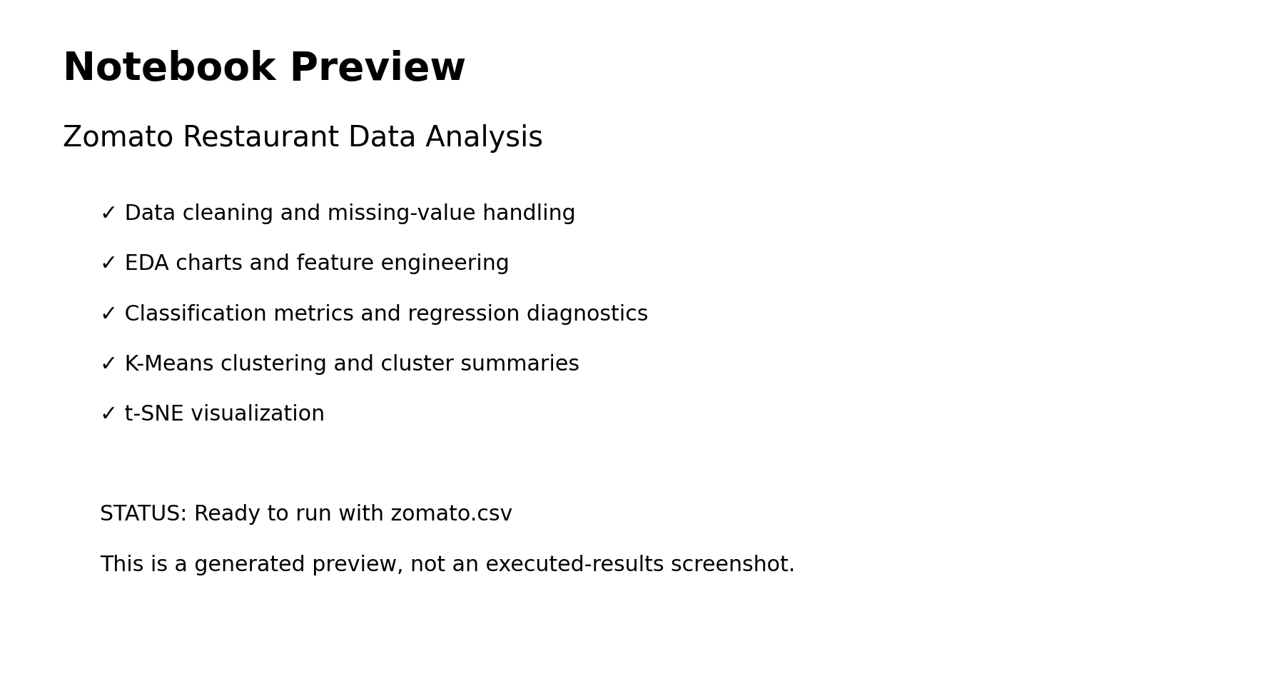
Figure 2. Generated preview only; replace with a screenshot of the executed notebook.

8. Important Methodology Notes
- The regression section predicts the binary expensive label, not restaurant ratings.
- To avoid data leakage, fit the encoder inside a scikit-learn Pipeline after splitting the data.
- t-SNE is a visualization tool, not a standalone measure of cluster quality.
- The original data source and license should be checked before sharing zomato.csv publicly.

9. GitHub Publishing
- Create a repository named zomato-restaurant-analysis.
- Add the notebook, Python script, README, requirements, report, and charts.
- Add zomato.csv only if its license permits redistribution.
- Run the notebook and confirm all generated outputs.
- Commit and push the project to the main branch.
Commands:
git init
git add .
git commit -m "Add Zomato restaurant analysis project"
git branch -M main
git remote add origin https://github.com/YOUR_USERNAME/zomato-restaurant-analysis.git
git push -u origin main

10. Conclusion
This package provides a reproducible starting point for exploring restaurant pricing and patterns. The final interpretation should be based on executed metrics and plots from the actual dataset, with preprocessing leakage addressed before presenting the model results as a rigorous evaluation.

