INSTAGRAM DATA PIPELINE
COMPLETE PROJECT REPORT
CSV ingestion • data cleaning • interaction modeling • SQLite analytics • GitHub publishing

1. Executive summary
This project builds a repeatable Python ETL workflow for Instagram-related CSV exports. It loads source files, standardizes column names, converts selected yes/no values to Boolean values, parses recognized date fields, combines likes, comments, and follows into a unified interactions fact table, stores the resulting tables in SQLite, and prints summary counts.
The main benefit is a single local database for querying account, photo, tag, comment, like, follow, and interaction records. The project also includes a notebook walkthrough and this report to help explain, validate, and publish the work. No original CSV data was supplied when this document was created, so the screenshots and static chart examples are explicitly illustrative; no real counts or analytical findings are claimed.

2. Project objectives
- Load Instagram data exports from a predictable folder structure.
- Clean column names and standardize selected Boolean/date fields.
- Create a unified fact table for like, comment, and follow events.
- Persist prepared datasets in a local SQLite database.
- Summarize the number of users, photos, distinct tags, likes, comments, and follows.
- Provide a notebook, visual documentation, and GitHub publishing instructions.

3. Workflow and architecture chart
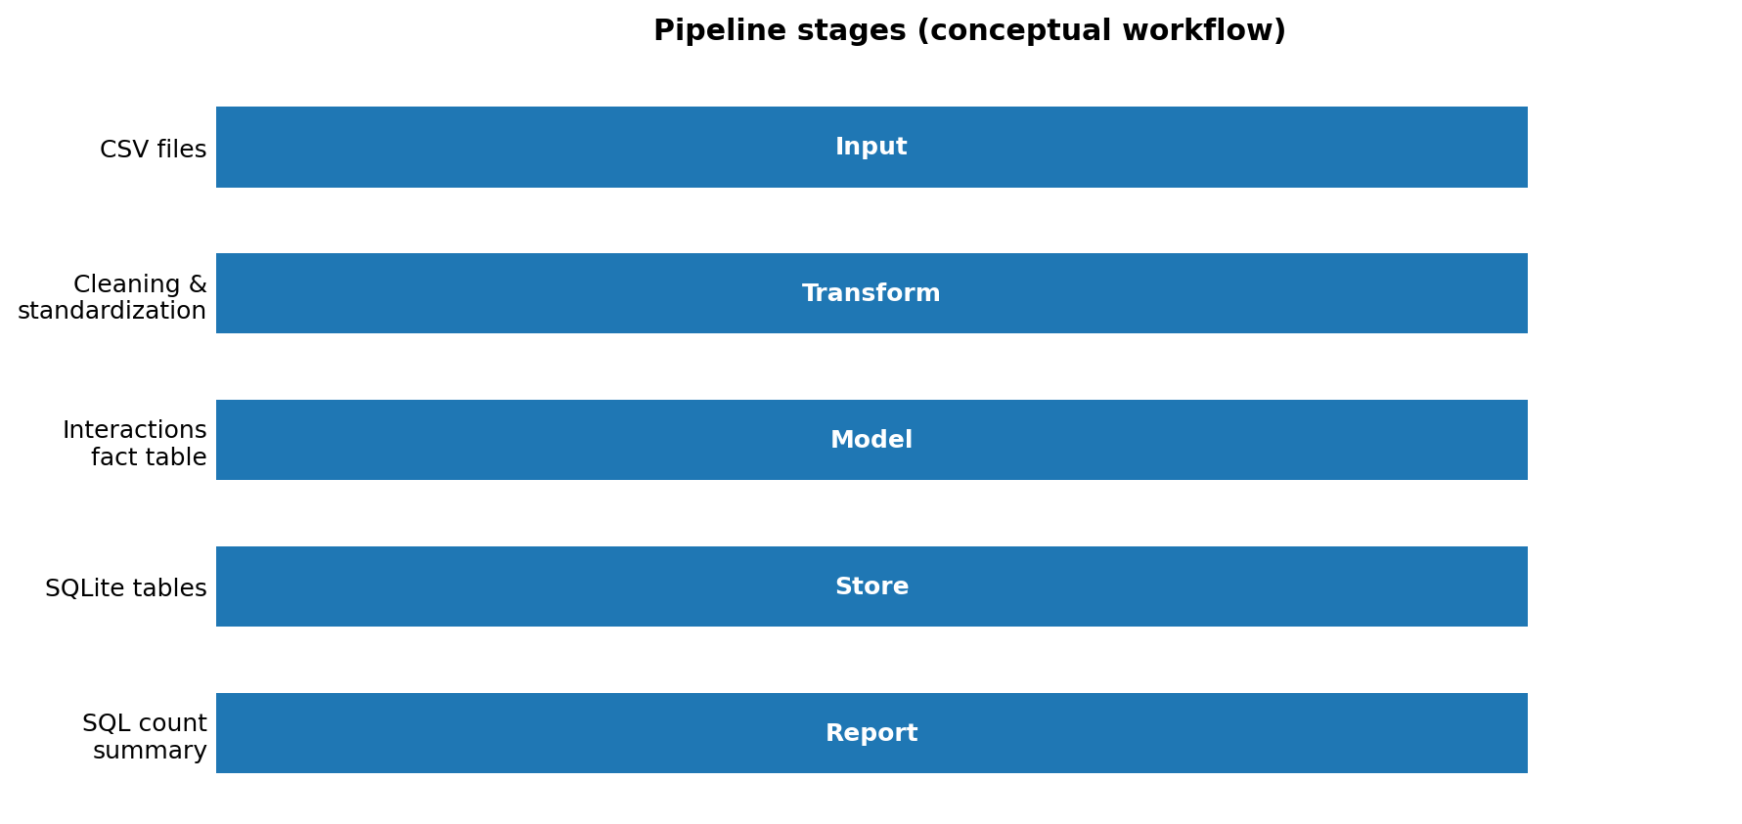
Figure 1. Conceptual pipeline workflow. This diagram explains the processing stages and is not a measurement from the dataset.

4. Database tables
Table | Purpose
users | User/account attributes and profile metadata
photos | Photo/post records and creation metadata
tags | Tag text, timestamp, and location metadata
comments | Comment events and related user/photo fields
likes | Like events and related user/photo fields
follows | Follower/followee relationships
interactions | Unified event table for likes, comments, and follows

5. Interaction categories chart
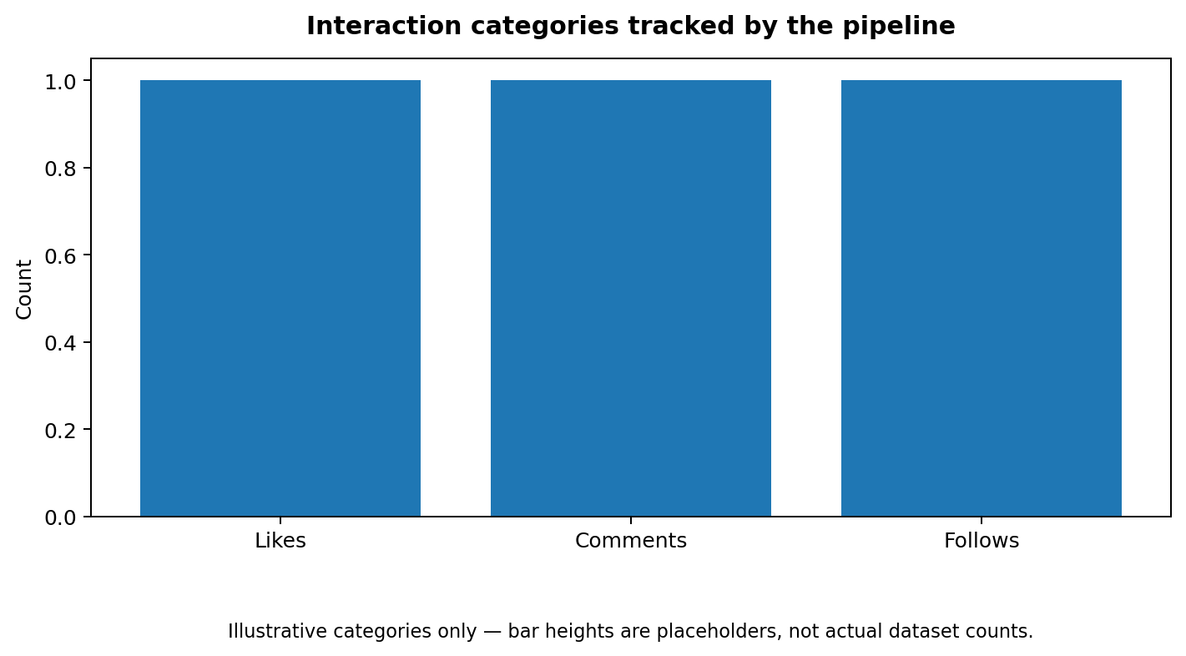
Figure 2. Interaction categories tracked by the pipeline. Bar heights are placeholders, not actual counts. The notebook can generate a data-driven version after the real CSV files are added and the pipeline is run.

6. Screenshot / expected terminal output
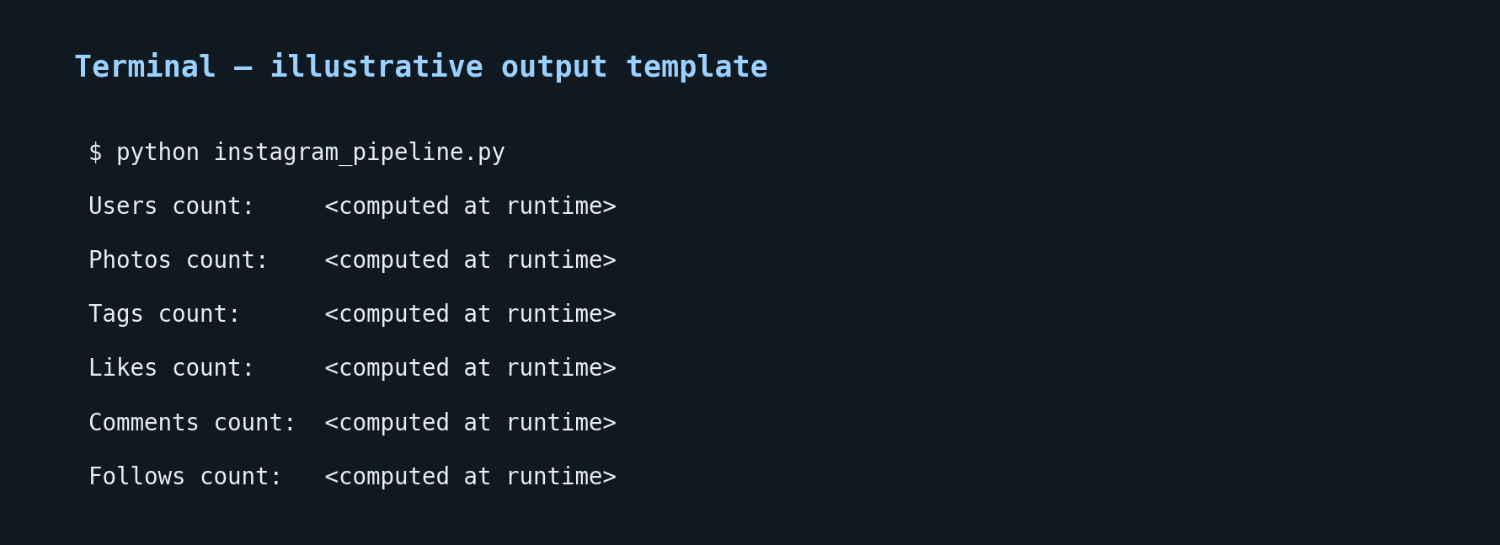
Figure 3. Illustrative terminal-output template. Replace this with a screenshot from a successful run using your own data before presenting final results.

7. Notebook links
The Jupyter notebook is included in the project bundle at:
notebooks/instagram_pipeline_walkthrough.ipynb
After you push the repository to GitHub, replace YOUR_USERNAME and YOUR_REPOSITORY in these URL templates:
GitHub notebook URL:
https://github.com/YOUR_USERNAME/YOUR_REPOSITORY/blob/main/notebooks/instagram_pipeline_walkthrough.ipynb
Google Colab notebook URL:
https://colab.research.google.com/github/YOUR_USERNAME/YOUR_REPOSITORY/blob/main/notebooks/instagram_pipeline_walkthrough.ipynb
These are templates until your repository is public at the chosen URL. The notebook covers input inspection, pipeline execution, SQLite table validation, and plotting interaction totals.

8. How to run the project
- Install Python 3.10 or later.
- Install dependencies with: pip install -r requirements.txt
- Place users.csv, photos.csv, tags.csv, comments.csv, likes.csv, and follows.csv inside the instagram details/ directory.
- Run: python instagram_pipeline.py
- Inspect the generated insta_lite.db database and terminal summary.
- Open notebooks/instagram_pipeline_walkthrough.ipynb in Jupyter or Google Colab.

9. GitHub publishing commands
git init
git add .
git commit -m "Add Instagram SQLite analytics project"
git branch -M main
git remote add origin https://github.com/YOUR_USERNAME/YOUR_REPOSITORY.git
git push -u origin main
Replace the remote URL with your repository URL. If a remote already exists, check it with `git remote -v` before adding another one. Review the staged files before pushing and do not publish private CSV exports or the generated database.

10. Quality notes and limitations
- The pipeline expects six CSV files with known filename stems and broadly compatible column names.
- Unparseable dates become missing values when errors='coerce' is used; inspect parse failures before time-based analysis.
- Generated row-based identifiers can change if input row ordering changes. Prefer stable source identifiers when available.
- Pandas to_sql with if_exists='replace' does not preserve primary-key and foreign-key constraints declared separately. Use explicit table creation and inserts if database-enforced integrity is required.
- The original broad exception handling can hide file loading problems; the packaged script instead reports missing inputs.
- The supplied chart and screenshot templates are illustrative until actual source data is run.

11. Deliverables checklist
☐ Python ETL script: instagram_pipeline.py
☐ Notebook walkthrough: notebooks/instagram_pipeline_walkthrough.ipynb
☐ Project README and requirements file
☐ Pipeline architecture chart and interaction-category chart
☐ Illustrative terminal screenshot
☐ This consolidated report containing executive summary, charts, screenshot, notebook URL templates, and GitHub instructions

Appendix A — All graphs and pictures
This appendix attaches the visual assets used in this project report. The workflow graphic, interaction-category chart, and terminal screenshot are illustrative templates because the source CSV files were not provided.

A1. Pipeline workflow graph
Conceptual workflow from CSV input through cleaning, interaction modeling, SQLite storage, and summary reporting.

A2. Interaction categories graph
Illustrative categories for likes, comments, and follows. Values are placeholders, not actual dataset counts.

A3. Terminal output screenshot
Illustrative terminal output layout. Replace with a screenshot captured after a successful run on the real dataset.

