Instagram Data Pipeline
Project Report
CSV ingestion • data cleaning • interaction modeling • SQLite analytics

1. Executive summary
This project turns a collection of Instagram-related CSV exports into a local SQLite database for structured analysis. It standardizes column names, converts selected yes/no fields to Boolean values, parses recognized date columns, aligns likes/comments/follows into a unified interactions fact table, and reports basic counts for core entities and interaction types.
The primary value is a repeatable local ETL workflow: raw CSV files become queryable tables, while the interactions table gives analysts one place to compare likes, comments, and follows. No dataset was supplied with this documentation request, so actual row counts, trend findings, and performance metrics are intentionally not asserted.

2. Goals and workflow
The pipeline is organized into five stages:
- Ingest CSV files from the `instagram details/` folder.
- Normalize headers, yes/no fields, and recognized date columns.
- Prepare entity tables and create a unified interactions fact table.
- Persist the resulting DataFrames to `insta_lite.db` using SQLite.
- Run SQL count queries for users, photos, tags, likes, comments, and follows.
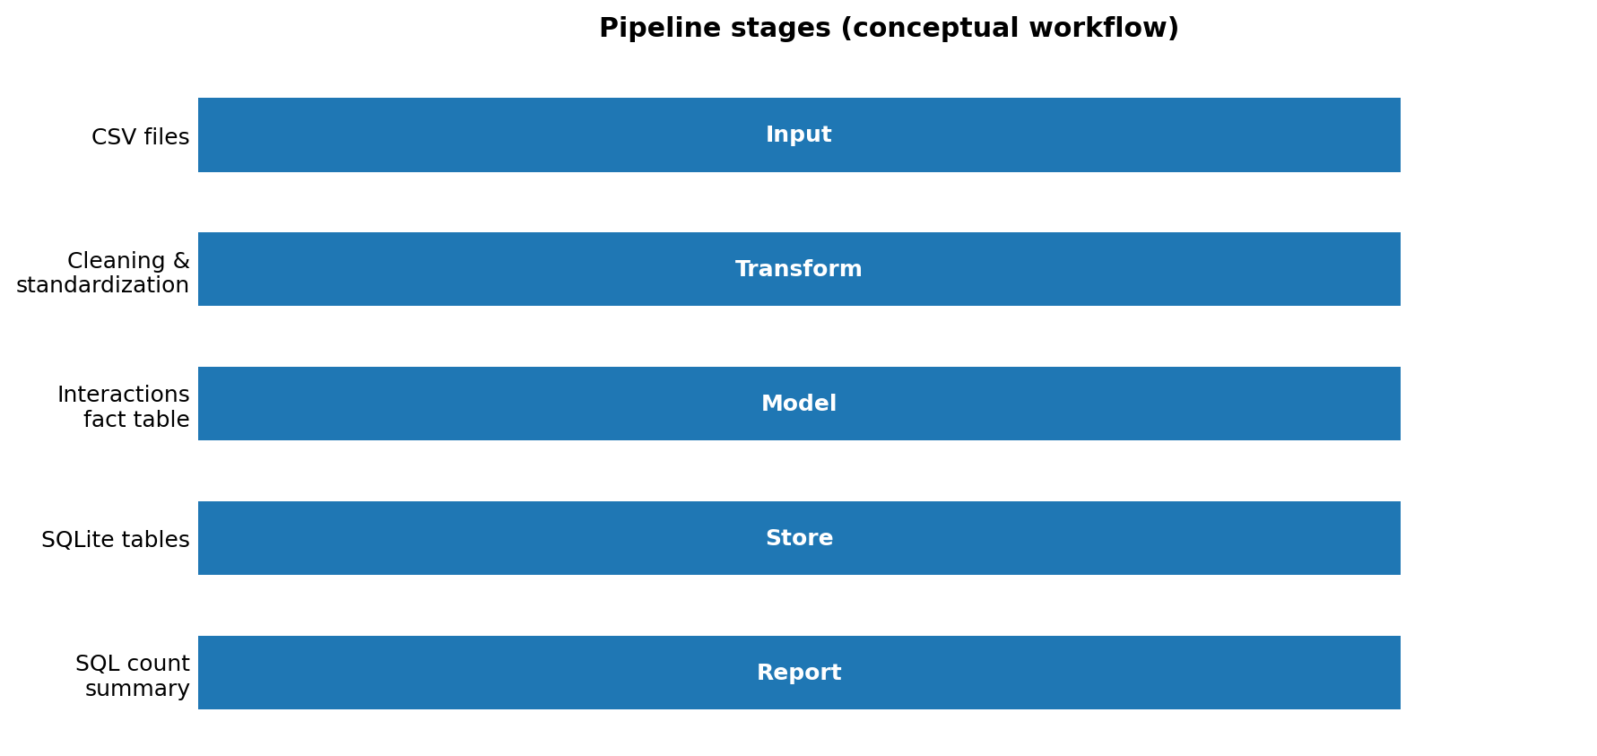
Figure 1. Conceptual pipeline stages; this is a workflow diagram, not a data-derived chart.

3. Data model
Table | Purpose
users | Account attributes and profile metadata
photos | Photo/post records and creation metadata
tags | Tag text, timestamp, and location metadata
comments | Comment events and comment content/attributes
likes | Like events and related user/photo fields
follows | Follower/followee relationships
interactions | Unified fact table for like, comment, and follow events

4. Notebook and repository links
Local notebook file included in the project bundle: notebooks/instagram_pipeline_walkthrough.ipynb
After pushing to GitHub, replace YOUR_USERNAME and YOUR_REPOSITORY in these URL patterns:
GitHub notebook: https://github.com/YOUR_USERNAME/YOUR_REPOSITORY/blob/main/notebooks/instagram_pipeline_walkthrough.ipynb
Google Colab notebook: https://colab.research.google.com/github/YOUR_USERNAME/YOUR_REPOSITORY/blob/main/notebooks/instagram_pipeline_walkthrough.ipynb
These are URL templates, not live links yet; they become valid when the repository exists and the notebook is pushed.

5. Charts and screenshot
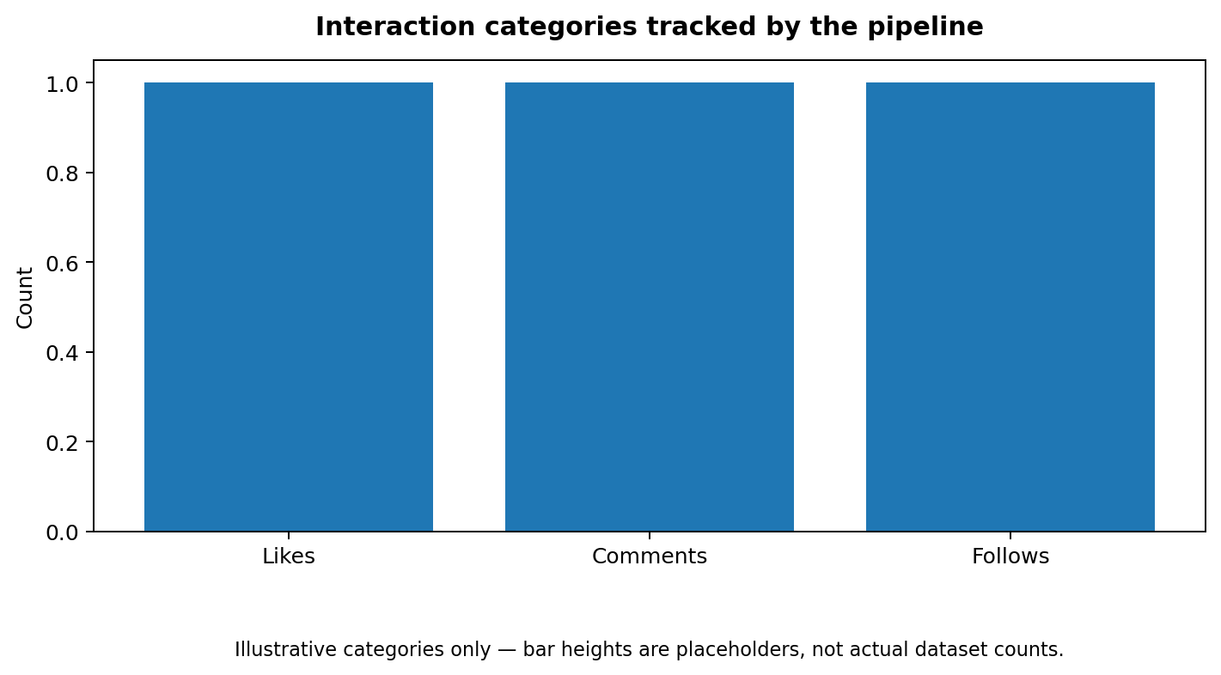
Figure 2. Interaction categories tracked. Bar heights are placeholders because the source CSV data was not provided.
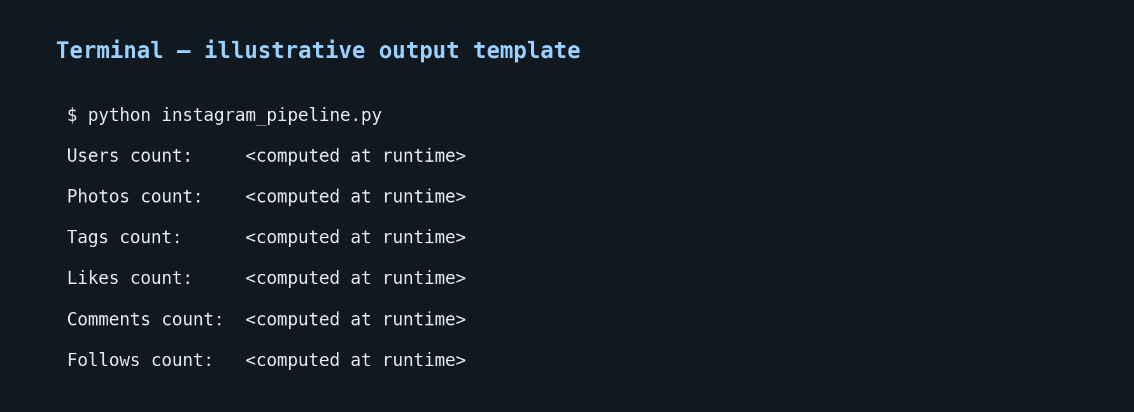
Figure 3. Illustrative terminal-output screenshot template. Replace it with a screenshot from a real successful run after adding your CSV files.

6. Expected outputs
- `insta_lite.db` SQLite database in the project root.
- Tables for users, photos, tags, comments, likes, follows, and interactions.
- Terminal summary with counts for users, photos, distinct tags, likes, comments, and follows.
- A notebook for inspecting input files, running the pipeline, validating table counts, and plotting actual interaction totals.

7. Quality checks and limitations
- Input schema assumptions: the pipeline expects six CSV files with filename stems users, photos, tags, comments, likes, and follows.
- Date parsing: errors='coerce' turns unparseable values into missing timestamps; quantify failures before interpreting time trends.
- Identifier creation: row-based IDs depend on stable row ordering. Prefer stable source IDs when available.
- SQLite constraints: pandas to_sql with if_exists='replace' recreates tables and does not retain primary-key/foreign-key constraints declared separately. Use explicit schema creation plus inserts if enforcement is needed.
- Data privacy: exclude personal exports, credentials, and identifying data from public repositories.

8. GitHub publishing checklist
☐ Create an empty GitHub repository.
☐ Review and remove sensitive or licensed data from the project folder.
☐ Keep CSV exports and the generated database out of Git using .gitignore.
☐ Run the script locally with the real CSV files and capture the actual terminal output.
☐ Replace the illustrative screenshot and placeholder chart with real outputs.
☐ Commit and push README, script, notebook, report, charts, and screenshot.

9. Push commands
git init
git add README.md instagram_pipeline.py notebooks charts screenshots docs requirements.txt .gitignore
git commit -m "Add Instagram CSV to SQLite analytics pipeline"
git branch -M main
git remote add origin https://github.com/YOUR_USERNAME/YOUR_REPOSITORY.git
git push -u origin main
Note: I cannot push to your GitHub account from this chat. The bundle is prepared for you to review and push. If you share your repository URL, the documentation can be updated with the exact GitHub and Colab notebook links.

