## **1. Importing Data into Power BI**

**Steps:**

1. Open **Power BI Desktop**.
2. Click **Home → Get Data → Excel** (or CSV).
3. Browse and select your file.
4. In the **Navigator window**, select the sheet/table you want to load.
5. Click **Load** to bring the data into Power BI or **Transform Data** to open Power Query.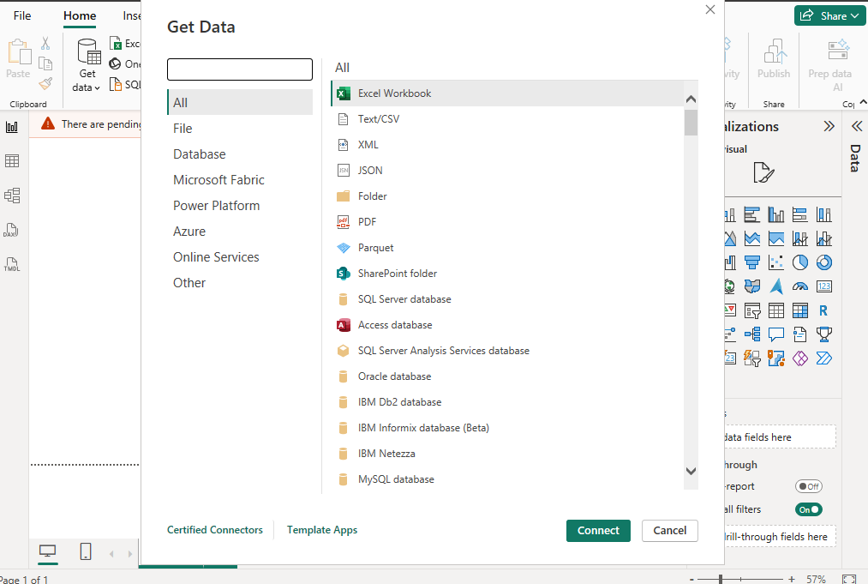

**Why:** Getting data into Power BI is the first step before you can clean, transform, or visualize it. Without importing correctly, your entire report could be based on incomplete or wrong data.

## **2. Remove Top Rows**

**Steps:**

1. In **Power Query**, go to **Home → Remove Rows → Remove Top Rows**.
2. Enter the number of rows to remove (e.g., 1–3 rows if they contain titles or notes).

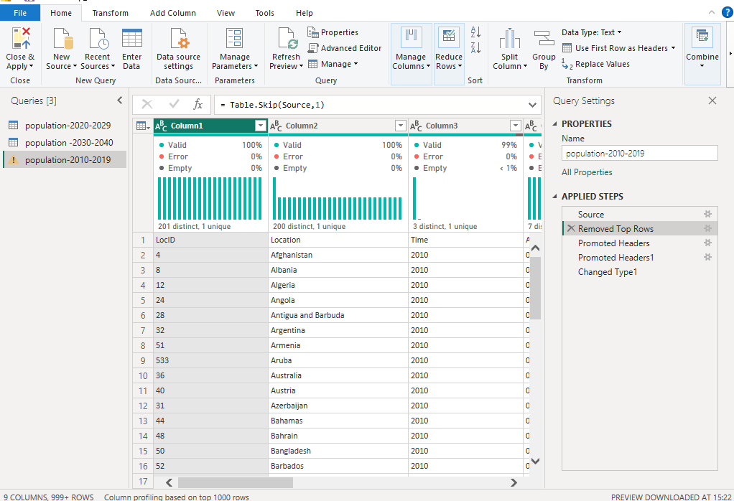

**Why:** Some files contain unwanted information at the top (titles, instructions, blank lines) that are **not part of the dataset**. Removing them ensures cleaner data and correct column headers.

## 

## **3. Promote Headers**

**Steps:**

1. In **Power Query**, go to **Home → Use First Row as Headers**.

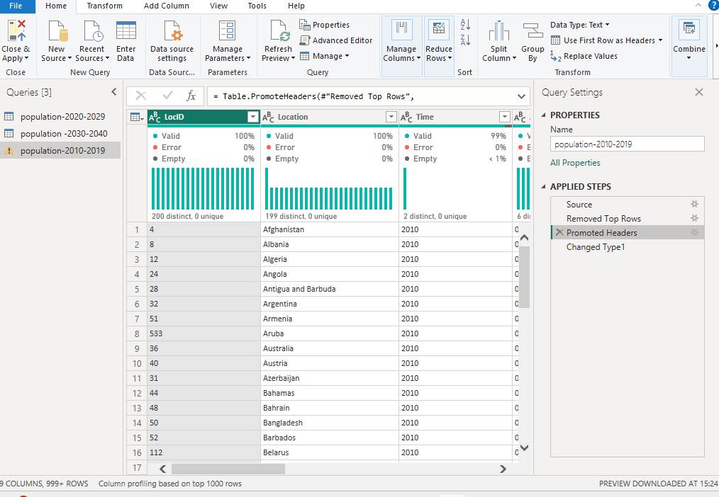

**Why:** Often, the first row of data contains **column names**. Promoting them makes your dataset more readable and ensures column names match their actual content.

## 

## 

## 

## **4. Sort Data**

**Steps:**

1. Select a column.
2. Go to **Home → Sort Ascending** or **Sort Descending**.

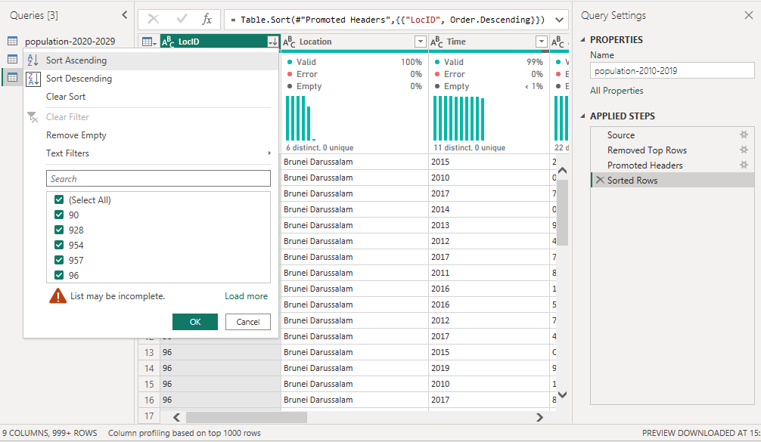

**Why:** Sorting helps you quickly find trends, check for errors, and arrange data logically before analysis.

## 

## 

## 

## **5. Change Data Types**

**Steps:**

1. Select a column.
2. Go to **Home → Data Type** and choose the correct one (Text, Whole Number, Decimal Number, Date, etc.).

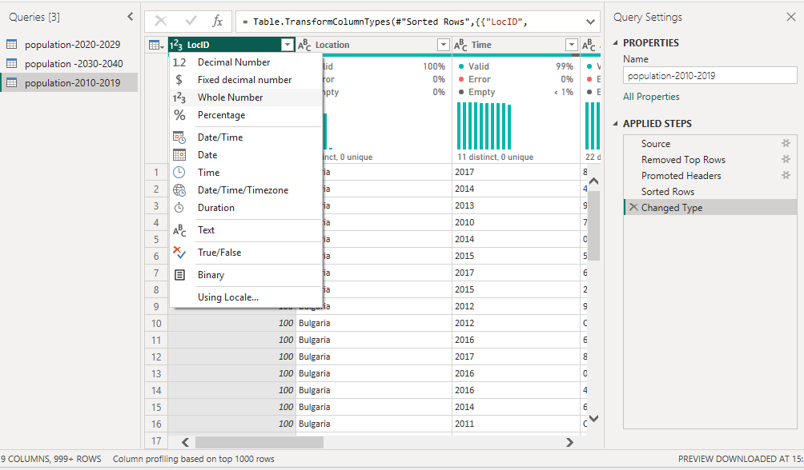

**Why:** Power BI applies calculations and visuals based on data type. Wrong data types (e.g., dates stored as text) can cause incorrect results or errors in visuals.