INTERACTIVE EDA DASHBOARD

A Project Report Submitted in
the partial fulfillment of the requirements for the award of the degree of

BACHELOR OF TECHNOLOGY
In

DEPARTMENT OF COMPUTER SCIENCE AND ENGINEERING
By
Y. Revanth | :2420030605
G. Rithwik | :2420030415
A. Nikitha | :2420030505

Under the Esteemed Guidance of

Dr. N. Sunanda
Associate Professor

Department of COMPUTER SCIENCE AND ENGINEERING

AY- 2026-27

Semester: ODD




K L (Deemed to be) University
DEPARTMENT OF COMPUTER SCIENCE AND ENGINEERING

Declaration

The Project Report entitled “Interactive EDA Dashboard” is a record of Bonafide work of Y. Revanth – 2420030605, G. Rithwik – 2420030415, A. Nikitha – 2420030505 submitted in partial fulfillment for the award of B. Tech in CSE to the K L University. The results embodied in this report have not been copied from any other departments/University/Institute.

Y. Revanth – 2420030605
G. Rithwik – 2420030415
A. Nikitha – 2420030505



ACKNOWLEDGEMENT
The success in this project would not have been possible but for the timely help and guidance rendered by many people. Our wish to express my sincere thanks to all those who has assisted us in one way or the other for the completion of my project.

Our greatest appreciation to my Course Coordinator and my guide Dr. N. Sunanda, Department of CSE which cannot be expressed in words for his/her tremendous support, encouragement and guidance for this project.

We express our gratitude to Dr. P. Venkateswara Rao, Head of the Department for COMPUTER SCIENCE AND ENGINEERING for providing us with adequate facilities, ways and means by which we are able to complete this project-based Lab.

We thank all the members of teaching and non-teaching staff members, and also who have assisted me directly or indirectly for successful completion of this project. Finally, I sincerely thank my parents, friends and classmates for their kind help and cooperation during my work.

Y. Revanth - 2420030605
G. Rithwik – 2420030415
A. Nikitha – 2420030505

Abstract
Exploratory Data Analysis (EDA) is an important first step in understanding a dataset. However, examining an unfamiliar dataset often requires users to perform several separate tasks, such as checking its dimensions, reviewing column types, identifying missing values and duplicate records, calculating summary statistics, and writing code to create visualizations. These repeated steps can be time-consuming, particularly for students and users who are still learning data analysis.
The Interactive EDA Dashboard provides a single, user-friendly environment for carrying out these initial exploration tasks. Users can upload tabular datasets in supported formats and view the dataset structure, column information, data preview, missing-value details, and duplicate-record count. The dashboard also provides statistical summaries and interactive visualizations, including bar charts, histograms, box plots, scatter plots, and correlation heatmaps. The system is developed using Python, Pandas, NumPy, Dash, and Plotly.
The project was demonstrated using a synthetic Retail Sales sample dataset containing 1,508 records and 12 columns. The dashboard reported 216 missing cells, 8 duplicate rows, and 0 text consistency issues, with an overall data completeness of 98.8%. These outputs show how the dashboard organizes dataset profiling, quality inspection, and visualization in one workflow. The system presents evidence for the user to interpret; it does not automatically clean the source data or make predictive conclusions.
The main aim of the project is to make the initial stages of data exploration easier, clearer, and more repeatable for students, beginners, and early-stage data analysts.
Keywords: Exploratory Data Analysis, Interactive Dashboard, Data Profiling, Data Quality, Pandas, Dash, Plotly, Data Visualization

Index
S. No. | Chapters | Topics | Page No.
 |  | Acknowledgement | 3
 |  | Abstract | 4
1 | Introduction | 1.1 Motivation  1.2 Objective  1.3 What is Data Science?  1.4 What is Exploratory Data Analysis?  1.5 What is a Dashboard?  1.6 What is Data Quality Analysis? | 6  6  6  7  7  7
2 | Software Requirement | 2.1 Problem Statement  2.2 Technologies Used  2.2.1 Python  2.2.2 Pandas  2.2.3 NumPy  2.2.4 Matplotlib  2.2.5 ARIMA  2.2.6 Prophet  2.2.7 Streamlit | 8  8  8  9  9  9  9  10  10
3 | Software Design | 3.1 System Overview  3.2 Data Flow Diagram – Level 0  3.3 Data Flow Diagram – Level 1  3.4 System Architecture | 11  11  11  11
4 | Implementation and User Interface | 4.1 Main Modules  4.2 Dataset Overview Module  4.3 Data Quality Analysis Module  4.4 Visualization Module  4.5 Statistics and Insights Module  4.6 Sample Dataset Description  4.7 Implementation Workflow | 13  13  14  15  16  16  16
5 | Conclusion and Future Aspects | 5.1 Conclusion  5.2 Future Aspects | 17  17
6 | Bibliography | References and Documentation | 18
7 | Appendices | 7.1 Python – Required Libraries  7.2 Loading Dataset  7.3 Dataset Profiling and Quality Checks  7.4 Statistical Summary  7.5 Creating a Visualization  7.6 Dash Application Layout  7.7 Application Setup  7.8 Sample Output Summary | 19  19  19  19  19  19  20  20

CHAPTER 1
Introduction

1.1 Motivation
Datasets are often received in raw tabular form and may contain many records, different variable types, incomplete values, repeated rows, and relationships that are not immediately visible. Before performing advanced analysis or building a model, users need to understand the structure and quality of the data. This initial investigation is known as Exploratory Data Analysis (EDA).
In a manual workflow, users may need to write separate commands to inspect the dataset, calculate summary values, check missing information, and generate charts. The Interactive EDA Dashboard was developed to bring these common tasks together in one interface. It reduces repetitive setup work and allows users to focus more on examining and interpreting the data.
1.2 Objective
• Develop an interactive dashboard that accepts tabular datasets in supported file formats.
• Display dataset dimensions, column names, data types, and a preview of records.
• Identify missing values, duplicate records, and text consistency issues.
• Calculate descriptive statistical measures for numerical variables.
• Generate bar charts, histograms, box plots, scatter plots, and correlation heatmaps.
• Provide a simple interface that helps users explore datasets without writing separate plotting code.
1.3 What is Data Science?
Data Science is an interdisciplinary field that involves collecting, processing, analyzing, and interpreting data to extract meaningful information. It combines statistics, programming, and machine learning techniques to identify patterns, discover trends, and make predictions. Data Science plays an important role in business decision-making by converting raw data into useful insights.
Data Science involves various activities such as data collection, data preprocessing, data analysis, data visualization, and predictive modeling. It uses programming languages, statistical methods, and machine learning algorithms to extract valuable information from large datasets. Data Science can be applied in different fields, including business, healthcare, finance, education, and retail. In Sales Pulse, these techniques are used to process sales datasets, identify patterns, analyze demand variations, and generate future sales predictions.
1.4 What is is Exploratory Data Analysis?
Exploratory Data Analysis is the process of examining a dataset using numerical summaries and graphical techniques to understand its main characteristics. It helps identify distributions, patterns, unusual observations, possible relationships, and data-quality concerns before further analysis. EDA does not replace domain knowledge or formal statistical testing; it helps the analyst decide what should be investigated next.
1.5 What is a Dashboard?
A Dashboard is a visual interface that presents important information and data through charts, graphs, tables, and other visual elements. It helps users understand complex information quickly and monitor performance. Dashboards allow users to compare data, identify trends, and gain useful insights.
A dashboard provides a simple and organized way to access important information without manually analyzing large amounts of data. In Sales Pulse, the dashboard displays historical sales data, forecasted sales values, graphical visualizations, and important business insights. It helps users understand sales performance, monitor demand variations, and make informed decisions based on the available data.
1.6 What is Data Quality Analysis?
Data quality analysis helps users identify incomplete or repeated information that may affect interpretation. Missing values indicate fields for which information is not available, while duplicate rows indicate repeated records. The dashboard reports these issues so that the analyst can decide whether cleaning is appropriate. The original data is not silently modified by these indicators.

CHAPTER 2
Software Requirement

2.1 Problem Statement
Performing basic EDA on an unfamiliar dataset can involve several disconnected steps. Users must identify the number of records and variables, inspect data types, detect missing values and duplicate records, calculate statistical summaries, select suitable chart types, and interpret the resulting views. When these activities are performed manually, the process requires repeated coding and movement between datasets and separate analysis scripts. The project addresses this problem by providing a single interactive dashboard for dataset profiling, data-quality inspection, statistical summaries, and visual exploration.
2.2 Technologies used
1. Python:
Python is a high-level, interpreted programming language used for data analysis, machine learning, and data visualization. It provides a wide range of libraries that simplify data processing and forecasting. In the Sales Pulse project, Python is used to clean sales datasets, perform exploratory data analysis, build forecasting models, and generate sales predictions.

2. Pandas:
Pandas is a Python library used for data manipulation and analysis. It provides data structures such as Series and DataFrames to organize and process structured data. In Sales Pulse, Pandas is used to load sales datasets, handle missing values, remove duplicate records, and prepare data for forecasting.
3. NumPy:
NumPy is a Python library used for numerical computations and mathematical operations. It supports arrays, statistical calculations, and efficient processing of numerical data. In Sales Pulse, NumPy helps perform numerical operations on sales values during data analysis and forecasting.
4. Matplotlib:
Matplotlib is a Python library used for creating graphs and visualizations. It helps represent numerical data through line charts, bar charts, and other graphical formats. In Sales Pulse, Matplotlib is used to visualize historical sales trends and forecasted sales values.
5. ARIMA:
ARIMA (AutoRegressive Integrated Moving Average) is a statistical time-series forecasting model used to predict future values based on historical data. It uses past observations, differencing, and moving averages to identify patterns. In Sales Pulse, ARIMA is considered for forecasting future sales based on historical sales records.

6. Prophet:
Prophet is a time-series forecasting tool developed by Meta. It is designed to handle trends, seasonality, and changes in time-series data. In Sales Pulse, Prophet is considered as another forecasting approach to predict future sales and identify demand patterns.
7. Streamlit:
Streamlit is an open-source Python framework used to create interactive web applications for data science and machine learning projects. In Sales Pulse, Streamlit is used to develop the dashboard where users can upload sales datasets, select forecasting periods, view charts, and understand sales predictions and business insights.

CHAPTER 3
Software Design

3.1 System Overview
The system follows a modular workflow. A user supplies a dataset through the dashboard. The data-processing layer loads the file using Pandas and identifies its structure. The analysis layer calculates summary information and checks data quality. The visualization layer creates interactive charts using Plotly, and the Dash interface presents the results to the user.

3.2 Data Flow Diagram – Level 0
At Level 0, the Interactive EDA Dashboard is represented as one main process. The user provides a dataset as input. The dashboard processes the dataset and returns a dataset overview, quality indicators, statistical summaries, and visualizations as output.
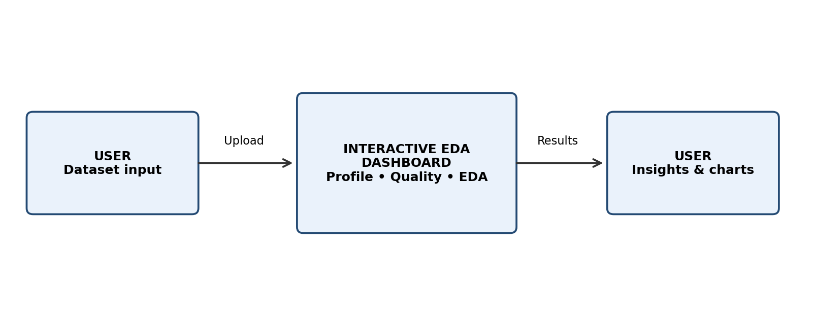
Fig. 3.1. Level-0 data flow diagram of the Interactive EDA Dashboard.

3.3 Data Flow Diagram – Level 1
At Level 1, the main process is divided into smaller activities: (1) dataset upload and validation, (2) data loading and profiling, (3) data-quality inspection, (4) statistical analysis, (5) chart generation, and (6) display of results. User selections determine which variables and visualization types are used in the chart-generation stage.

3.4 System Architecture
The architecture separates the application into logical layers. The upload interface receives the file; Pandas loads and inspects the data; the EDA and quality modules calculate descriptive information; Plotly generates the selected visual representation; and Dash displays the results. The architecture is designed so that profiling, quality checks, and chart generation can be improved independently.
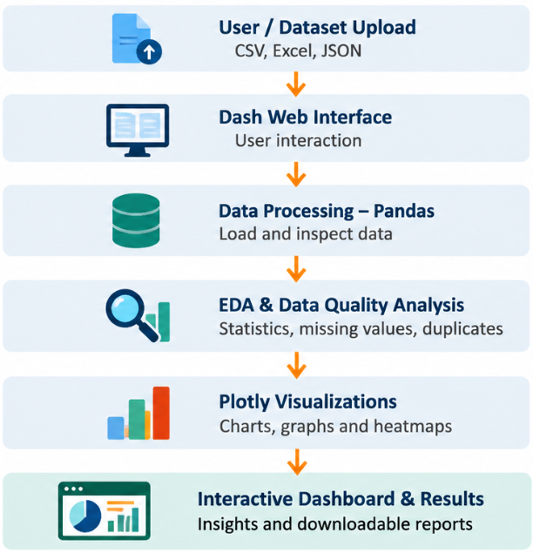
Fig. 3.2. Logical system architecture of the proposed dashboard (as presented in the project review).

3.5 Data Flow Description
Input: user uploads a supported tabular dataset or selects the provided sample dataset.
Processing: Pandas loads the data and identifies rows, columns, data types, and available fields.
Quality inspection: missing values, duplicate rows, and text consistency issues are counted.
Analysis: descriptive statistics are calculated for suitable numerical columns.
Visualization: the user selects a chart type and relevant columns; Plotly generates the chart.
Output: the dashboard presents the overview, quality indicators, statistics, charts, and insights.
CHAPTER 4
Implementation and User Interface

4.1 Main Modules
Module | Description
Dataset Overview | Displays dataset dimensions, column types, column profile, and a preview of records.
Data Quality Analysis | Reports missing cells, duplicate rows, and text consistency issues.
Visualization | Allows the user to select chart types and variables to explore patterns.
Statistics | Displays descriptive statistical measures such as mean, median, standard deviation, quartiles, and skewness.
Insights | Presents important observations from the selected dataset and visual analysis.

4.2 Dataset Overview Module
The overview module is the first stage after the dataset is loaded. It displays the number of records and columns, the distribution of column types, column-level information, and a preview of the uploaded data. This helps users understand the structure of the dataset before selecting an analysis.
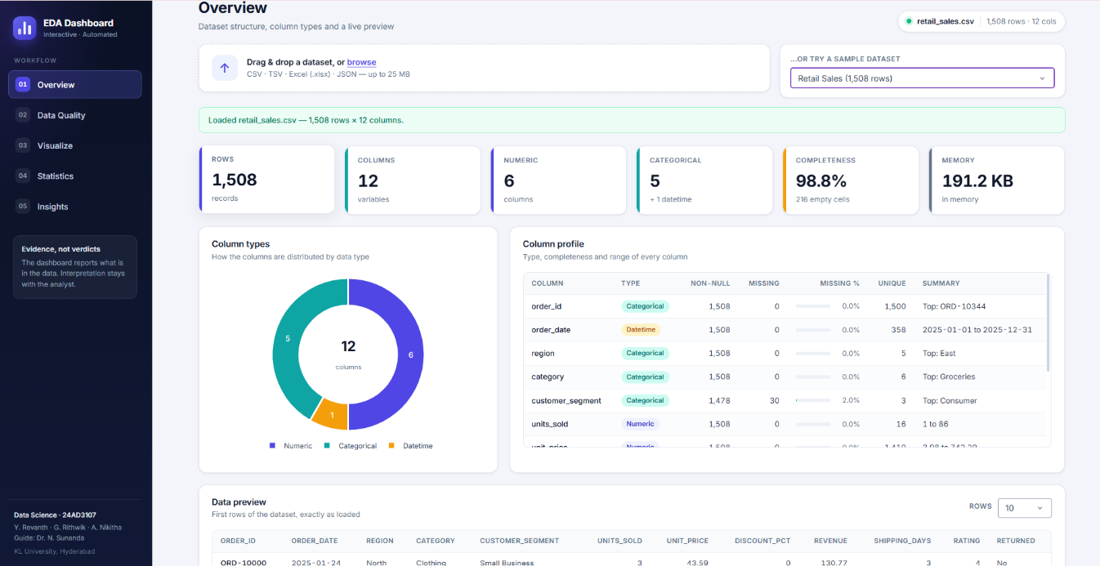
Fig. 4.1. Dataset overview showing rows, columns, data types, completeness, column profile, and preview.
4.3 Data Quality Analysis Module
The data-quality module checks the uploaded dataset for missing cells, duplicate rows, and text consistency issues. These indicators help the user identify areas that may need further investigation. The dashboard reports the counts and leaves decisions about deletion, replacement, or correction to the analyst. 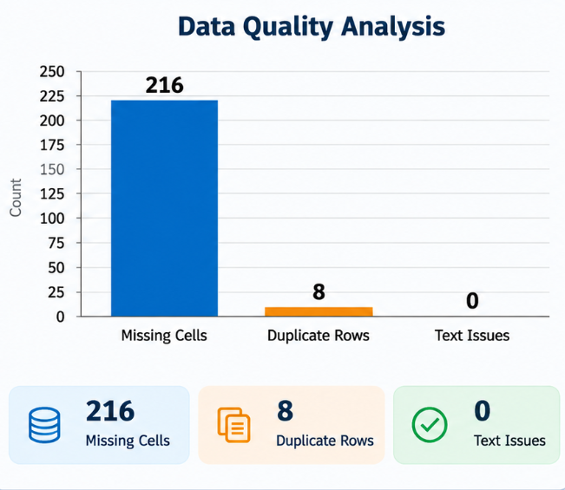
Fig. 4.2. Data-quality summary for the Retail Sales sample dataset.
4.4 Visualization Module
The visualization module provides five chart types. A bar chart compares values across categories. A histogram shows the distribution of a numerical variable. A box plot summarizes spread and highlights possible outliers. A scatter plot helps examine the relationship between two numerical variables. A correlation heatmap provides a matrix view of pairwise numerical associations. Users can select relevant columns and update the chart view interactively.
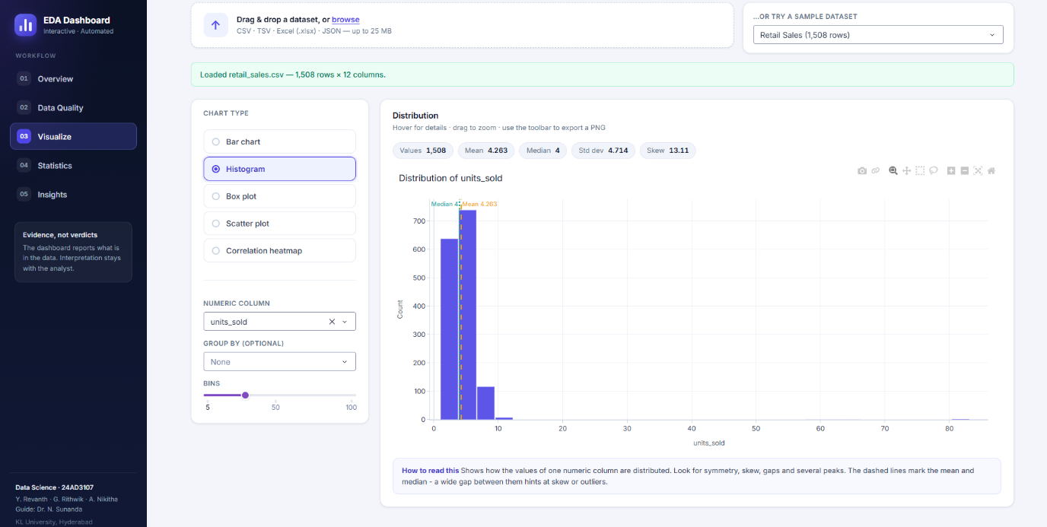
Fig. 4.3. Interactive histogram view with variable selection and distribution summary.
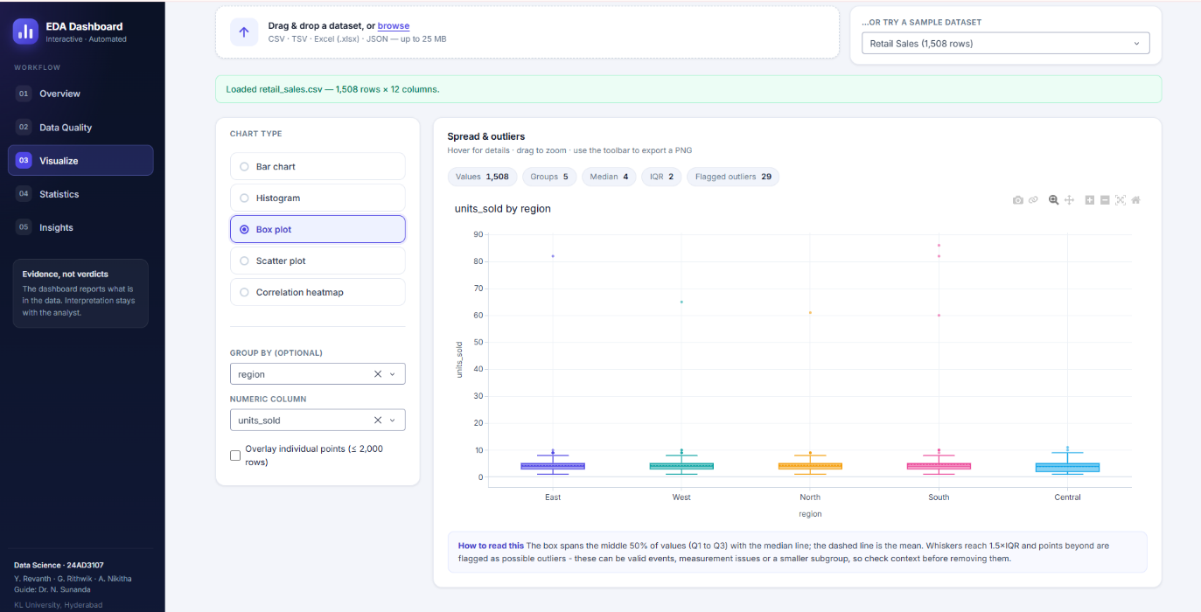
Fig. 4.4. Box-plot view used to compare the distribution of units sold across regions.
4.5 Statistics and Insights Module
The statistics module calculates descriptive measures for numerical variables. These include count, mean, median, standard deviation, quartiles, and skewness where applicable. The insights module presents the key information available from the dataset and visualizations. The dashboard is intended to support interpretation rather than automatically establish causal relationships or final analytical conclusions.
4.6 Sample Dataset Description
The project review presentation demonstrates the dashboard using a synthetically generated Retail Sales sample dataset. The dataset contains 1,508 records and 12 columns. The fields include order identifier, order date, region, category, customer segment, units sold, unit price, discount percentage, revenue, shipping days, rating, and returned status. The dashboard classifies the columns into 6 numerical, 5 categorical, and 1 datetime field.
Dataset indicator | Reported value
Number of records | 1,508
Number of columns | 12
Numerical columns | 6
Categorical columns | 5
Datetime columns | 1
Missing cells | 216
Duplicate rows | 8
Text consistency issues | 0
Data completeness | 98.8%

4.7 Implementation Workflow
Open the dashboard in a web browser through the local application address.
Upload a supported dataset or select the Retail Sales sample dataset.
Review the dataset dimensions, data types, column profile, and data preview.
Open the data-quality view to inspect missing values, duplicate records, and text issues.
Select a chart type and the relevant variables in the visualization section.
CHAPTER 5

Conclusion and Future Aspects

5.1 Conclusion
The Interactive EDA Dashboard brings dataset profiling, data-quality inspection, descriptive statistics, and interactive visualizations into one application. It provides users with a structured workflow for understanding an unfamiliar dataset before proceeding to more advanced analysis. The dashboard uses Python, Pandas, NumPy, Dash, and Plotly to load data, calculate summaries, identify quality indicators, and display charts.
During the project demonstration, the synthetic Retail Sales dataset contained 1,508 records and 12 columns. The dashboard reported 216 missing cells, 8 duplicate rows, 0 text consistency issues, and 98.8% completeness. These results illustrate how the application makes important dataset characteristics visible in a single interface. The project meets its stated aim of making initial data exploration more accessible; interpretation and data-cleaning decisions remain with the user.

5.2 Future Aspects
• Add linked filtering so that selections in one chart can update other visualizations.
• Provide export options for charts, tables, and summary reports.
• Add more data-quality checks and configurable cleaning suggestions while preserving the original dataset.
• Include additional statistical summaries and visualization types where useful.
• Optimize loading and chart generation for larger datasets through measured performance testing.
• Deploy the dashboard on a secure hosting platform so that it can be accessed beyond the local machine.
• Improve privacy, access control, and file-handling safeguards for sensitive datasets.
CHAPTER 6
Bibliography
[1] J. W. Tukey, Exploratory Data Analysis. Reading, MA, USA: Addison-Wesley, 1977.
[2] H. Wickham, “Tidy data,” Journal of Statistical Software, vol. 59, no. 10, pp. 1–23, 2014.
[3] W. McKinney, “Data structures for statistical computing in Python,” in Proc. 9th Python in Science Conf. (SciPy 2010), pp. 51–56, 2010.
[4] J. D. Hunter, “Matplotlib: A 2D graphics environment,” Computing in Science & Engineering, vol. 9, no. 3, pp. 90–95, 2007.
[5] M. L. Waskom, “seaborn: statistical data visualization,” Journal of Open Source Software, vol. 6, no. 60, p. 3021, 2021.
[6] Plotly Technologies Inc., “Dash Documentation.” Available: https://plotly.com/dash/
[7] pandas development team, “pandas documentation.” Available: https://pandas.pydata.org/docs/
[8] T. Munzner, Visualization Analysis and Design. Boca Raton, FL, USA: CRC Press, 2014.
[9] S. Few, Information Dashboard Design: Displaying Data for At-a-Glance Monitoring, 2nd ed. Burlingame, CA, USA: Analytics Press, 2013.
[10] Plotly Technologies Inc., “Histograms in Python.” Available: https://plotly.com/python/histograms/
[11] Plotly Technologies Inc., “Box Plots in Python.” Available: https://plotly.com/python/box-plots/
[12] Plotly Technologies Inc., “Heatmaps in Python.” Available: https://plotly.com/python/heatmaps/
[13] NumPy Developers, “NumPy documentation.” Available: https://numpy.org/doc/
[14] Python Software Foundation, “Python documentation.” Available: https://docs.python.org/3/
CHAPTER 7

Appendices

The following representative code snippets summarize the main operations described in the project presentation and research paper. They are illustrative excerpts of the workflow, not a complete copy of the application source code.

7.1 Required Libraries
import pandas as pd
import numpy as np
import plotly.express as px
from dash import Dash, dcc, html

7.2 Loading a Dataset
Pandas is used to load a tabular dataset. The file reader is selected according to the uploaded file format supported by the application.
df = pd.read_csv(file_path)
# For an Excel dataset: df = pd.read_excel(file_path)
# For JSON data: df = pd.read_json(file_path)

7.3 Dataset Profiling and Quality Checks
summary = df.describe(include="all")
rows, columns = df.shape
missing = df.isnull().sum()
duplicates = df.duplicated().sum()
column_types = df.dtypes

7.4 Statistical Summary
numeric_summary = df.describe()
means = df.select_dtypes(include=np.number).mean()
medians = df.select_dtypes(include=np.number).median()
standard_deviation = df.select_dtypes(include=np.number).std()

7.5 Creating a Visualization
fig = px.histogram(df, x="units_sold", title="Distribution of Units Sold")
# Other chart choices in the dashboard include bar, box, scatter, and heatmap.

7.6 Dash Application Layout
app = Dash(__name__)
app.layout = html.Div([
html.H1("Interactive EDA Dashboard"),
dcc.Graph(figure=fig)
])
if __name__ == "__main__":
app.run(debug=True)

7.7 Application Setup (General)
Install Python 3.x and Visual Studio Code.
Create and activate a Python virtual environment for the project.
Install the project dependencies used by the application, including pandas, numpy, dash, and plotly.
Open the project folder in Visual Studio Code and run the application entry-point file.
Open the localhost address shown in the terminal using a web browser.
Upload a dataset and use the dashboard navigation to explore the overview, quality, statistics, and visualization modules.

7.8 Sample Output Summary
For the synthetic Retail Sales sample dataset used in the project review, the dashboard displayed 1,508 records, 12 columns, 216 missing cells, 8 duplicate rows, 0 text consistency issues, and 98.8% completeness. These values are included as the demonstrated sample output and should not be interpreted as results for every uploaded dataset.

