**CHAPTER 1**

**INTRODUCTION**

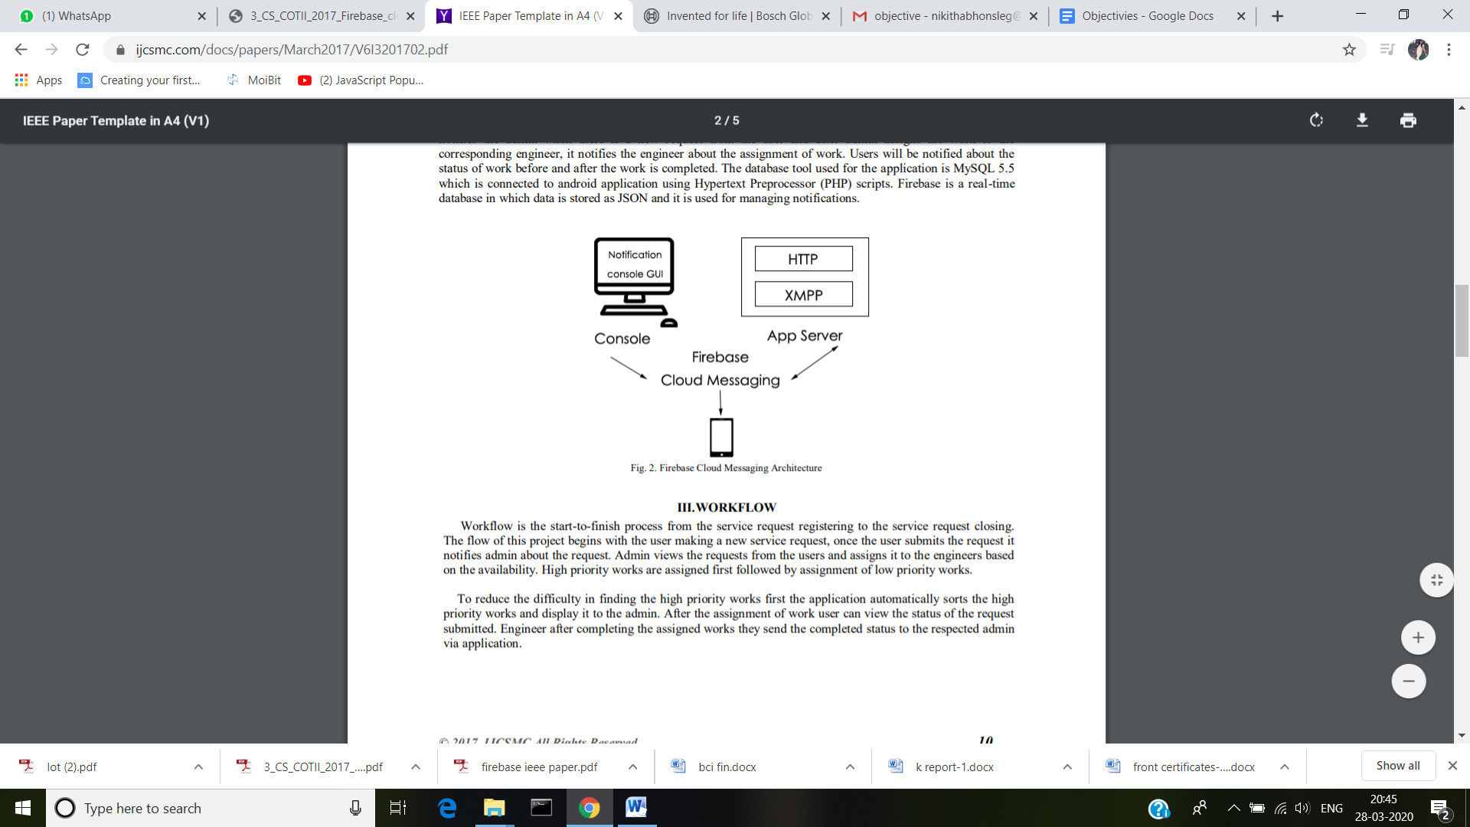Firebase is a cloud services supplier and backend as a service company. A special platform is provided by firebase for building mobile and web application. It can build application and update it in realtime. Firebase is very easy and it stores data in JSON format. We do not need to configure our server when we use firebase. Every thing will be handled by firebase automatically. So server side coding is not  required. It will save time and will make us more productive. We use firebase for android application. Firebase utilizes web sockets for pushing state to our application. It updates the data in real time and therefore we need not to refresh the browser to get update thereby making it more interactive.

**Figure 1.1:** Firebase Cloud Messaging Architecture**.**

**1.1 Objective**

When an organisation is small, it’s simple for someone to just walk over to your desk with a requirement and you can set about fulfilling it. But the larger your organisation gets, the service request process gets complicated, thus opting for service request management application to automatically route the requests through an appropriate process for approval and reliable service delivery. This application manages submission and handling of all requests for service. The main objective of the service request application is to provide a stable process for the users to submit requests for services.

**1.2 Problem Statement:**

FCM (Firebase Cloud Messaging) is a improved version of the Google Cloud Messaging API & it have all features of GCM with some additional features also. Firebase is known for being cross platform, so FCM now makes a natural fit in the Firebase suite of features designed for Android, iOS, and mobile web. It is simpler client development. You no longer have to write your own registration or subscriptions retry logic. An out-of-the-box notification solution. You can use Firebase Notifications, a server less notifications solution with a web console that lets anyone send notifications to target.

**1.3 Scope of the Project**

[Firebase Notifications](https://firebase.google.com/docs/notifications/?utm_campaign=Firebase_featureoverview_education_notification_en_06-14-16&utm_source=Firebase&utm_medium=blog) is a free service that enables user notifications for Android and iOS devices. Through the Firebase console, you can send notifications quickly and easily across platforms with no server coding required. These notifications can be directed at your individual users.  It supports a graphical console for sending messages, removing the need for you to create a server. With this console you can send notification to the users from anywhere. Notification feature is done with the help of Firebase Cloud Messaging technology that sends push notifications whenever necessary. It notifies the engineer about the assignment of work. Users will be notified about the status of work. Firebase is a real-time database in which data is stored as JSON and it is used for managing notifications.

Firebase utilizes web sockets for pushing state to our application. It updates the data in real time and therefore we need not to refresh the browser to get update thereby making it more interactive.

**CHAPTER 2**

**LITERATURE SURVEY**

**2.1 Brain Computer Interface:**

BCI refers to “A system for controlling a device e.g. computer, wheelchair or a neuroprothesis by human intention which does not depend on the brain’s normal output pathways of peripheral nerves and muscles”.

Brain computer interface consists of multiple components in which brain signals unwrap the intention of the subject. BCI has three components namely signal acquisition, signal processing, and effectors device. Recording of the signals created by human brain is done by signal composition. This component can be either invasive or non-invasive. The next component signal processing helps in analyzing the signals from the brain. The goal of this component is to identify the features and markers which can be translated into desired actions that have to be performed. The last component is the external device which can be a computer, a prosthetic arm, a spell checker, or even a wheel chair which means it is the hardware device through which actions are performed.

There are different types of BCI

* Firstly we have Invasive BCI
* Secondly we have the Partially Invasive BCI
* Third we can make use of Non-Invasive BCI

They are differentiated based on the methods used for the interface. Each of these methods has some pros and cons.

**Invasive BCI:**

During neurosurgery electrodes are directly attached to the grey matter of the brain in invasive BCI. Best quality of signals of BCI devices are produced by them. One of the applications of this is that it provides functionality to paralyzed people [11]. Invasive BCI repairs the damaged sight and provides new functionalities to the people who are suffering from paralysis. Invasive BCI are very much influences in building up of unwanted tissue layer which is the main cause for the signals to become weak due to this the body start reacting to the foreign agents in the brain as a result there is a chance of losing the signals. BCI's focuses on motor Neuroprosthetics which aims at either to restore movements in paralyzed persons or to provide instruments such as robotic arm to help them.

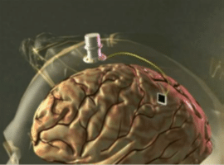

**Figure 2.1: Invasive BCI.**

**Partially Invasive BCI:**

In partial or semi invasive BCI devices, electrodes are attached to the skull this will remain outside the brain and is not attached to the grey matter. Partially invasive BCI produce signals of better quality than non-invasive BCI. The risk of formation of scar tissue is also low when compared to fully invasive brain computer interface.

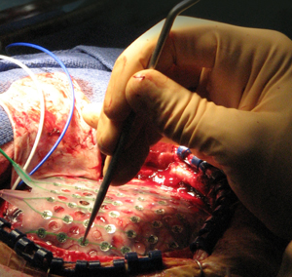

**Figure 2.2: Partially Invasive BCI.**

**Non-Invasive BCI:**

With the help of non-invasive neuroimaging techniques as interfaces many experiments were conducted on human beings. The recorded signals from this technology were used to strengthen muscle implants. Later on the partial movement in the experimental volunteer was restored. It is easy to wear but still the non-invasive produce signals of very poor resolution due to the humidity by the skull which covers the brain, neurons create blur and dispersion of electromagnetic waves that arise in the brain. The signal capacity is of least quality in the non-invasive BCI but when it comes to communication, it is considered to be the safest.

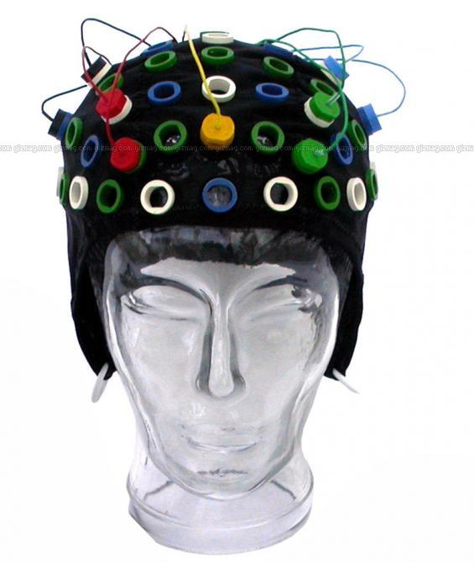

**Figure 2.3: Non Invasive BCI.**

**APPLICATIONS OF BCI:**

* This technology supports physically disabled and mentally challenged people for communication.
* Provides enhanced control of instruments like wheel chairs, robotic arms, spell checkers for the people with severe disabilities.
* Helps in sending out warning for aircraft pilots, monitors out attending the long distance drivers.
* Development of intelligent relaxation devices.
* Controlling of robots in dangerous and hazardous circumstances.
* Used in applications in the field of multimedia, providing security by making it use in biometrics to have an eye on unauthorized access.

**ELECTROENCEPHALOGRAPHY:**

Electroencephalography (EEG) is the electrophysiological monitoring process which records electrical features of human brain. Electrodes that are non invasive in nature are implanted along the scalp usually but sometimes we even use invasive electrodes for some specific applications. EEG computes the fluctuations in voltage which is the result of the ionic current generated within the neurons of the brain. Diagnostic applications focus typically on the spectral content of EEG.

It is a neural oscillation which is generally also known as "brain waves". EEG is mainly used to treat patients who are suffering from epilepsy which causes abnormality while taking EEG readings and also in the treatment of sleep disorders, coma, encephalitis and brain death. EEG signals have been originated from biomedical origin. Lot of information can be obtained from these waves. The activities that are electrical in nature are obtained by placing electrodes on the scalp of the brain.

EEG is a firm most tool for the diagnosis of disorders like stroke, detection of tumours, other focal brain diseases. Since technologies advancement have taken place and new high-resolution imaging methods like magnetic resonance imaging (MRI) and computed tomography (CT) have been developed the use of EEG has been decreased. When millisecond-range temporal resolution is required during research, diagnosis and development EEG is the most common tool that is used. The figure 6 shows how the electrodes of an EEG are places on the scalp of the human brain. To collect the accurate signals all the electrodes should touch the scalp

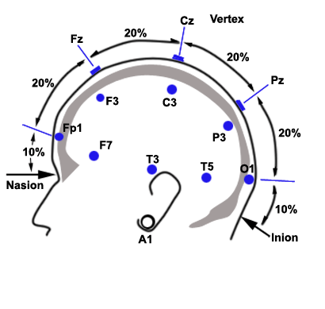

**Figure 2.4: EEG Electrode Placement.**

**WORKING OF EEG**

Brain’s activities are maintained by millions of neurons in human brain. These neurons communicate among each other they are charged electrically or polarized by a transparent protein which pumps calcium, sodium, potassium ions across their membranes. Charges repulse each other and at the same time when many of the ions are pushed out. During this process many neurons can push their neighbours in the form of a wave which results in a process called as volume collection.

When a person is thinks, writes, reads, hears, watches television or listens to radio, different parts of the brain will be activated which initiates different signals which can be recorded and monitored by EEG. A conductive gel or paste is used while placing electrodes on the scalp of human brain to record the conventional scalp EEG signals. Most of the system uses electrodes, where electrodes are connected through a single wire. Electrodes are attached either to a cap like structure or to a net like structure.

The electrode is connected to one end of input of differential amplifier and system reference electrode is connected to the other end of input of each differential amplifier. Amplifier performs amplification of the voltage value of the active electrodes and reference electrode should be 60-100 DB. Later the signal is filtered using analog EEG. The amplified signal should be converted into digital signal since all EEG systems are now a day digital. Then we apply anti-aliasing filter to the signal.

EEG signals are processed using EEG Lab or Neuro-physiological biomarker toolbox. The amplitude of EEG signal for a normal adult is about 10μV to 100 μV. This value is valid when it is taken from the scalp. From subdural electrodes it is about 10-20Mv.Difference between the voltages of the two electrodes is represented by the EEG signal.

Waveforms obtained are classified into bandwidths. The various bands are as follow:

* **DELTA:** Its frequency range is less than 4hz.it is used to measure the depth of sleep. Stronger the delta rhythm, deeper is the sleep.
* **THETA:** Its frequency range is between 4-7hz.It is associated with the cognitive processing such as memory encoding and retrieval. Waves become prominent when difficult task is presented.
* **ALPHA:** Its frequency range is between 8-15hz.When human mind is in relaxed state or when human is awake alpha waves are considered. Alpha waves co-ordinates multi-sensor processing, attention and concentration.
* **BETA:** Its frequency range is between 16-31hz.It becomes stronger when body movements are executed.
* **GAMMA:** Its frequency is greater than 32 Hz. These reflect attentive focusing and serve as carrier frequency to facilitate exchange of data between brain regions.

The below figure 2.5 shows the waves obtained by different EEG bands such as alpha, beta, delta, and theta.

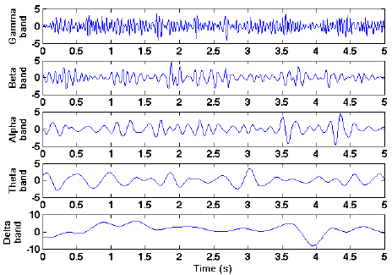

**Figure 2.5: EEG Bands**

**ADVANTAGES AND DISADVANTAGES OF EEG**

**Advantages of EEG**

* The Hardware costs of EEG is much more than other techniques
* It provides better study of the responses to sense stimuli which is modality in nature since the EEG process is silent
* It is safe way to check the functioning of brain.

**Disadvantages of EEG**

* It provides reduced space resolution on the scalp.
* Neural activity of the brain which is under the upper layers are usually poorly measured.
* It is not very accurate.
* Measures activity in general areas.

**10-20 SYSTEM**

The fig 2.6 represents international recognized electrode position system. The earlobe electrodes are connected to left and right earlobe which can be used as reference electrodes and are denoted by A1 and A2. The letters F stands for frontal, T stands for temporal C stands for central, P stands for parietal, O stands for occipital. Central lobe is not present. For identification purposes we use letter “C” and letter “Z” is used for representing electrode which is on midline. The numbers on right hemisphere are denoted by even numbers 2,4,6,8. The numbers on left hemisphere are denoted by odd numbers 1, 3, 5, 7.

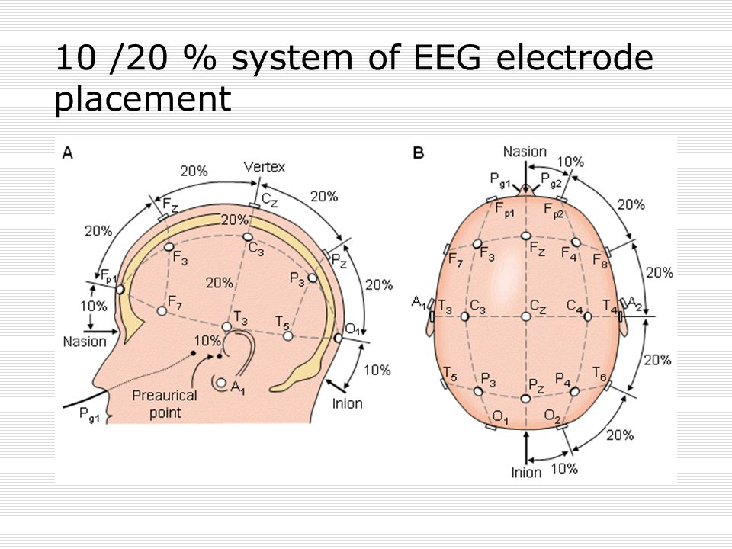

**Figure 2.6:10-20 System of EEG electrode Placement.**

There are four anatomical landmarks:

* First: The first nasion point is represented by the fore head and nose.
* Second: The second nion point represents the skull point which is lowest in the skull present behind the head
* Third: The third nasion point is present in the anterior of ear and it is the pre-auricular point to the ear.

Variable measure is considered for the head size. The percentage of distance from a couple of fixed points on the head is used by the system. It consists if an imaginary vertical line which is present from nasion to the nion, and a horizontal line from left ear lobe to the right. From 10% above the nasion and nion, along the vertical line, a theoretical circle is drawn around the head.

By maintaining a 20% inter-electrode distance the other electrodes are positioned, as is indicated by the 20Pz is positioned on the vertical line and similarly we position C3, T3, C4 and T4 along the horizontal mark. The other electrodes are positioned with equal distance between the vertical line and the circle and filling the horizontal lines of the frontal and parietal electrodes as shown in the right side of the figure.

**2.2 Related Work**

**2.2.1Classification of four eye directions from EEG signals for eye movement based communication system:**

**Problem Statement:**

Many classification algorithms have been developed to distinguish brain activity states during different mental tasks. Although these algorithms achieve good results, they require many training loops to make a decision. As the complexity of an algorithm grows, it becomes more and more difficult to execute commands in real time. The detection of eye movement from brain activity data provides a new means of communication and device control for disabled and healthy people.

**Methodology:**

Many research groups have proposed algorithms for interpreting and classifying EEG data for use in BCIs. These groups have monitored different aspects of brain activity such as motor imagery and steady-state visually evoked potential (SSVEP) via EEG and achieved good classification accuracy via these algorithms. However, most of these algorithms are computationally complex and the classification accuracy of a four-class BCI, measured using EEG is only between 40% and 70%. Thus, while EEG-based BCIs are a reality, this classification problem prevents viable practical application of this technology [1]. Some patients still have voluntary control of the muscles controlling eye movement. Thus, the monitoring of eye movement can help these patients communicate with their environment and control devices.

These artifacts are actually a valuable source of data and are useful for communication and control. Our research has shown that the same data can be obtained from EEG and EOG signals using the same number of electrodes with almost the same classification accuracy. The results of other studies also support this use of EEG data.

This present study focuses on the following four points:

1. The development of an algorithm for BCI classification. This algorithm is suitable for real-time applications using EOG artifacts to control the movement in four directions.

2. Verification that EEG and EOG signals result in almost the same classification accuracy.

3. Examination of the effect of the visual angle on classification accuracy.

4. Examination of variability and non-stationary of EEG signals by testing several participants on different days.

**Result:**

This paper presented a novel approach for eye-movement-based communication systems. A simple algorithm was developed for offline classification of eye movement from EEG signals without any training phase. The major difficulty with such an algorithm is the variability of data. Although we still need to investigate whether common threshold scan be applied to newly recorded data of new subjects, the results show that the proposed algorithm is promising for real-time applications.

**2.2.2: Open Access database of EEG signals recorded during imagined speech:**

**Problem Statement:**

Brain-Computer Interfaces (BCI) that could decode thoughts into commands would improve the quality of life of patients who have lost control over voluntary muscles.

**Methodology:**

Imagined speech consists in imagining the pronunciation of words, without moving or emitting sounds. In this study, we introduce a new open access database of electroencephalogram (EEG) signals recorded while 15 subjects imagined the pronunciation of two groups of Spanish words. The first one contained the vowels /a/, /e/, /i /, /o/, /u/; and the second one corresponds to the commands up, down, left, right, backward and forward. Each subject repeated each word 50 times in a random order, meanwhile EEG signals were recorded using a six channel acquisition system and sampled at1024 Hz.

The aim of this work is to create an openly accessible database of EEG signals acquired during imagined and pronounced speech from healthy subjects. This would provide a starting point for future research about imagined speech and facilitate the development of new classification algorithms by avoiding the time-consuming stages of acquisition and artifact removal. Furthermore, we present the results achieved using a similar classification method as the one proposed by Torres-Garcfia et al.

Also, given the relationship between hearing impairment and distorted speech development, an audiometry was performed on each subject to discard hearing pathologies that could introduce changes in speech, and thus possibly modify EEG patterns [2]. The software used to perform the audiometries was designed by the University of New South Wales and is available online on its website. The program measures the hearing sensitivity to different frequencies, described by a curve of equal loudness. None of the subjects presented moderate or severe hearing deficiencies so, for the purpose of this study, they can be considered normal listeners.

The acquisition process of EEG signals requires specific equipment and time, and this coupled with the fact that there are not public databases of EEG recordings during imagined speech; hamper the number of investigations regarding the classification of imagined words. In this work, a public database of EEG signals recorded while the subjects imagined or pronounced two groups of words or vowels was presented. It is believed that this will facilitate and encourage studies tending to improve the recognition rates for imagined words, and ultimately lead to the development of BCI systems that could decode thoughts.

**Result:**

The results of an exploratory experiment were described in this work, using as features the Relative Wavelet Energy of each channel and five levels of decomposition. In addition, two classifiers were tested, being Random Forest the best. The accuracy achieved is above chance level suggesting that there is information of the imagined word within the EEG signal, although further research must be done to find the features that provide better discriminative information and the optimal classifier.

**2.2.3 Brain Computer Interface using Silent Speech for Speech Assistive Device**

**Problem Statement:**

The classification of silent speech is a simple method that requires no special training. In addition, spatial filtering enables silent speech to be detected by single trial. Many silent speech interface studies have used electromyography (EMG) signals [3], electromagnetic field measurements with implanted magnets, and ECoG signals detected using invasive electrodes.

**Methodology:**

The method using EMG signals requires electrodes mounted on the user’s face or neck. The system is uncomfortable and fragile. The method using magnet implantation around a patient’s mouth is effective, but it requires surgical operations. Severely paralyzed patients might accept surgical operations, but healthy individuals would not accept them. Moreover, any method using invasive electrodes necessitates surgical operations. The detection of silent speech by EEG is a good method in terms of portability and user-friendliness. It doesn’t need surgical operation.

**Result:**

Silent speech is that a subject imagines vocalization while he/she remains silent and immobilized. The benefit is that critically ill patients, who can’t vocalize by themselves, can make silent speech and it doesn’t need special training and single trial detection is possible. My research started from vowels because Japanese syllables are based on five vowels, /a/, /i/, /u/, /e/, and /o/. Most Japanese syllables consist of one of five vowels and a consonant.

**2.2.4. Simulation Experiment of BCI Based on Imagined Speech EEG Decoding:**

**Problem Statement:**

To deal with the problem of limited ability of BCI, this paper verified the feasibility of constructing BCI based on decoding imagined speech electroencephalography (EEG). As sentences decoded from EEG can have rich meanings, BCIs based on EEG decoding can achieve numerous control instructions.

**Methodology:**

By combining a modified EEG feature extraction method with connectionist temporal classification (CTC), this paper simulated decoding imagined speech EEG using synthetic EEG data without help of speech signal. The performance of decoding model over synthetic data to a certain extent demonstrated the feasibility of constructing BCI based on imagined speech brain signal.

Current BCIs mostly rely on recording several classes of brain activities like motor imagery(MI) and steady state visual evoked potential (SSVEP), then map them to specific instructions . For example, BCI based on motor imagery may work through mapping left hand motor imagery to car moving forward and mapping right hand motor imagery to car moving backward. The number of brain activities is countable. Though applications of BCI like controlling car or controlling UAV can be diverse, ability of each application is limited.

Variable-length sentences can have rich meanings. If we can decode the sentence from imagined speech EEG signal, incorporating natural language processing will result in BCIs with flexible functions. Focused on classifying imagined syllables with different rhythms. Researched on word pair classification during imagined speech [4]. The above studies didn’t consider the sentence-level imagined speech decoding.

Decoded sentences from electrocorticography (ECoG) during speaking, but needed the recorded sound signal to help split ECoG signal and label each ECoG segment what phones they correspond to. The above researches are all about imagined speech decoding task, but constructing BCIs needs decoding sentences from brain signal without sound information.

**Result:**

In this paper we modified an EEG feature extraction method and based on it we introduced recurrent neural network (RNN) to capture the temporal features of EEG signal. Then we combined the feature extraction structure with CTC to avoid reliance on sound signals. The decoding performance on synthetic data demonstrated ability of the model decoding imagined speech EEG signal without sound information and the feasibility of constructing BCIs based on imagined speech directly.

**2.2.5 Converting Your Thoughts to Texts: Enabling Brain Typing via Deep Feature Learning of EEG Signals:**

**Problem Statement:**

More specifically, motor imagery EEG (MI-EEG), which reflects a subject’s active intent, is attracting increasing attention for a variety of BCI applications. Accurate classification of MI-EEG signals while essential for effective operation of BCI systems, is challenging due to the significant noise inherent in the signals and the lack of informative correlation between the signals and brain activities.

**Methodology:**

In this paper, we propose a novel deep neural network based learning framework that affords perceptive insights into the relationship between the MI-EEG data and brain activities. We design a joint convolution recurrent neural network that simultaneously learns robust high-level feature presentations through low-dimensional dense embeddings from raw MI-EEG signals. We also employ an Auto encoder layer to eliminate various artifacts such as background activities.

The proposed approach has been evaluated extensively on a large scale public MI-EEG dataset and a limited but easy-to-deploy dataset collected in our lab. The results show that our approach outperforms a series of baselines and the competitive state-of-threat methods, yielding a classification accuracy of 95.53%. The applicability of our proposed approach is further demonstrated with a practical BCI system for typing.

In this paper, we aim at enabling a brain typing system by enhancing the decoding accuracy of EEG signals for wider range of brain activities (e.g., multi-class scenario). We vision a real-world implementation of such a system which can interpret the user’s thoughts to infer typing commands in real-time. Motor disabled people would benefit greatly from such a system to express their thoughts and communicate with the outer world. To tackle the mentioned challenges.

we propose a novel hybrid deep neural network that combines the benefits of both Convolutional Neural Networks (CNNs) and recurrent neural networks (RNNs) for effective EEG signal decoding. Our model is capable of modelling high-level, robust and salient feature representations hidden in the raw EEG signal streams and capturing complex relationships within data via stacking multiple layers of information processing modules in a hierarchical architecture [5]. Specifically, RNN is designed to model sequential information while CNN is well suited to extract higher-level spatial variations. In particular, a specific RNN architecture, named Long Short-Term Memory (LSTM),is designed to model temporal sequences and their long-range dependencies more accurately than conventional RNNs.

In comparison, CNN is typical feed-forward architecture and is able to extract higher-level features that are invariant to local spectral and temporal variations.

The main contributions of this paper are highlighted as follows:

We design a unified deep learning framework that leverages recurrent Convolutional neural network to capture spatial dependencies of raw EEG signals based on features extracted by Convolutional operations and temporal correlations through RNN architecture, respectively.

Moreover, an Auto encoder layer is fused to cope with the possible incomplete and corrupted EEG signals to enhance the robustness of EEG classification. We extensively evaluate our model using a public dataset and also a limited but easy-to-deploy dataset that we collected using an off-the-shelf EEG device.

**Result:**

The experiment results illustrate that the proposed model achieves high level of accuracy over both the public dataset (95.53%) and the local dataset (94.27%). This demonstrates the consistent applicability of our proposed model. We have made our local dataset and the source code used in our evaluations available to the research community to encourage further research in this area and foster reproducibility of results.

**2.2.6 A High Performance Spelling System based on EEG-EOG Signals with Visual Feedback**

**Problem statement**:

Over the last 20 years, various types of speller systems have been developed in brain-computer interface and EOG/eye tracking research; however, these conventional systems have a trade-off between the spelling accuracy (or decoding) and typing speed. Healthy users and physically challenged participants, in particular, may become exhausted quickly; thus, there is a need for a speller system with fast typing speed while retaining a high level of spelling accuracy.

**Methodology**:

In this paper, we propose a highly accurate and fast spelling system that employs multi-model electroencephalography-elecctrooculograpy (EEG-EOG) signals and visual feedback technology.

In this paper, we propose the first hybrid speller system that combines EEG and EOG signals with visual feedback technology so that the user and the speller system can act cooperatively for optimal decision-making. First, the online ERP speller calculates classification probabilities for all candidate characters from the EEG epochs. Second, characters are sorted by their probability, and the characters with the highest probabilities are highlighted as visual feedback within the row-column spelling layout.

Finally, the user can actively select the character as the target by generating an EOG command. The proposed system shows 97.6% spelling accuracy and an information transfer rate of 39.6 (±13.2) [bits/min] across 20 participants. Most importantly, a new weighted strategy resulted in 100% accuracy and a 57.8 (±23.6) [bits/min] information transfer rate across six participants. This paper demonstrates that the proposed system can provide a reliable communication.

**Result:**

In this study, the outstanding online performance with an accuracy of 97.6% and an ITR of 39.6 [bits/min] indicates that the proposed RC-VF paradigm is a very promising system as a real-world application [6]. Our extended experiment further showed real world applicability by reducing the number of channels, changing the input EOG signal for easier use(eye-up versus blinking), and modifying the stimulus presentation for better ERP signal generation and comfort for the user. The extended experiment also introduced the weighted classifier paradigm that eliminates the need for two-step error correction and enables 100% spelling accuracy.

**2.2.7 EEG-Based Speech Recognition:**

**Problem Statement:**

In this paper, we investigate the use of electroencephalograhic signals for the purpose of recognizing unspoken speech. The term unspoken speech refers to the process in which a subject imagines speaking a given word without moving any articulatory muscle or producing any audible sound.

**Methodology:**

By Wester (Wester) presented results which were initially interpreted to be related to brain activity patterns due to the imagination of pronouncing words. However, subsequent investigations lead to the hypothesis that the good recognition performance might instead have resulted from temporal correlated artifacts in the brain waves since the words were presented in blocks. In order to further investigate this hypothesis, we run a study with 21 subjects, recording 16 EEG channels using a 128 cap montage [7]. The vocabulary consists of 5 words, each of which is repeated 20 times during a recording session in order to train our HMM-based classifier.

The words are presented in block wise, sequential, and random order. We show that the block mode yields an average recognition rate of 45.50%, but it drops to chance level for all other modes. Our experiments suggest that temporal correlated artifacts were recognized instead of words in block recordings and back the above-mentioned hypothesis.

The main goal of the work presented here was to investigate whether it is possible to reliably recognize unspokend speech based on EEG signals using the method proposed (Wester). While data presented (Wester) was given a promising interpretation,(Calliess) suggested that temporal correlated artifacts in the EEG signals may have been recognized instead of words.

These two hypotheses were refined during the course of our work:

Hypothesis A. Unspoken speech can be recognized based on EEG signals employing the method proposed (Wester). The fact that other word orders yield worse recognition rates may be explained by the following assumptions:

• A1: Block recordings facilitate thinking the words in a consistent way.

• A2: Block recordings lead to more reliable data containing less noise and showing less variance in the length of the utterances.

Hypothesis B. Unspoken speech cannot be recognized based on EEG signals employing the method proposed (Wester). The recognition results reported (Wester) were overestimated due to temporal correlated artifacts in the brainwave signals that were recognized instead of words. It could be shown that except for the block mode which yielded an average recognition rate of 45.50%, all other modes had recognition rates at chance level. This may be partially explained by the assumptions stated in A1 and A2. However, our experiments suggest that temporal correlated artifacts indeed superimpose the signal of interest in block recordings.

**Result:**

Promising initial results presented (Wester) seem most likely to have been caused by an artifact in the experimental design that is temporal correlated patterns were recognized rather than words. Thus, we conclude that hypothesis B is probably correct.

It has been shown in (Birbaumer) that subjects can indeed be trained to modify their brainwaves for using an EEG-based BCI. Thus, we would expect that the subject could adapt his/her brain waves such that they are recognized more easily.

**2.2.8 Optimal spatial filtering of single trail EEG during imagined hand movement:**

**Problem Statement:**

The development of an EEG-based Brain Computer Interface (BCI) requires rapid and reliable discrimination of EEG patterns, e.g., associated with motor imagery. One sided hand movement imagination results in EEG changes. Located at contra and lateral central areas. We demonstrate spatial filters for multi-channel EEG effectively extract discriminatory information from two populations of single trial EEG, recorded during left and right movement imagery.

**Methodology:**

The best classification results for three subjects are 90.8%, 92.7% and 99.7%. The spatial filters are estimated from a set of data by the method of Common Spatial Patterns and reflect the specific activation of cortical areas. The method performs a weighting of the electrodes according to the importance for the classification task. The high recognition rates and computational simplicity make it a promising method for an EEG-based Brain Computer Interface.

In this paper, the results obtained online where by in each subject the band power of two optimized narrow frequency bands are classified [8]. The use of common spatial patterns method increases the classification accuracy between 1%(subject S1) and 10%(S3) even though in the multichannel experiment no feedback was given. From the inspection of the EDR time course calculated for electrodes C3 & C4 during left and right motor imagery in experiments with and without feedback, it can be expected that in the latter case the classification accuracy is lower.

**Result:**

The results further indicate that, for example, 18 channels covering the hand area of the motor cortex are sufficient for good classification. A further increase in the number of channels doesn’t significantly improve accuracy. A large Laplacian reference with two channels also gives good results; however, this referencing method requires a total of 10 EEG electrodes.

**2.2.9 Brain to text: decoding spoken phrases from phone representations in the brain:**

**Problem Statement:**

Communication with computers or humans by thought alone is a fascinating concept and has long been a goal of the brain-computer interface (BCI) community (Wolpaw et al.). Traditional BCIs use motor imagery (McFarland et al.) to control a cursor or to choose between a selected numbers of options. Others use event-related potentials (ERPs) (Farwell and Donchin) or steady-state evoked potentials (Sutter, 1992) to spell out texts. These interfaces have made remarkable progress in the last years, but are still relatively slow and unintuitive.

**Methodology:**

The possibility of using covert speech, i.e., imagined continuous speech processes recorded from the brain for human-computer communication may improve BCI communication speed and also increase their usability. Numerous members of the scientific community, including linguists, speech processing technologists, and computational neuroscientists have studied the basic principles of speech and analyzed its fundamental building blocks. However, the high complexity and agile dynamics in the brain make it challenging to investigate speech production with traditional neuroimaging techniques [9]. Thus, previous work has mostly focused on isolated aspects of speech in the brain.

Gaussian models as a generative statistical representation for log- transformed broadband gamma power have been found well- suited for the observed cortical activity. These models facilitate the analysis of the spatial and temporal characteristics of each phone model within its 450ms context.

Note that only one context-independent model is trained for each phone, i.e., without consideration of preceding or succeeding phones due to the limited amount of data, even though effects of context have been shown in neural data (Mugler et al., 2014a).While context dependent modelling is very common in acoustic speech recognition and known to significantly improve recognition performance, it requires substantially more training data than available in our ECoG setting. Decoding over speech production is a necessary first step toward human computer interaction through imagined speech processes.

**Results:**

Our results show that with a limited set of words in the dictionary. Brain-to-Text reconstructs spoken phrases from neural data. The computational phone models in combination with language information make it possible to reconstruct words in unseen spoken utterances solely based on neural signals (see Supplementary Video).Despite the fact that the evaluations in this article have been performed offline, all processing steps of Brain-to-Text and the decoding approach are well suited for eventual real-time online application on desktop computers.

**CHAPTER 3**

**SYSTEM ANALYSIS**

**3.1 EXISTING SYSTEM:**

Unspoken speech cannot be recognized based on EEG signals employing the method proposed in wester. The recognition results reported in that were overestimated due to temporal correlated artifacts in the brain wave signals that were recognized instead of words.

It could be shown that the average recognition rate of 45.50%.

The signals are weak and the accuracy is low, there is no better sensor modify.

The error rate is high and follows inaccurate signal classification.

The process speed is low.

**3.2 PROPOSED SYSTEM:**

We are developing a cost effective BCI thoughts to speech conversion using EEG that will help the paralyzed patients to express their feelings with help of their brain signals using Non-invasive techniques.

Here we are using NIC software for collecting and storing EEG samples. The collected signals were pre-processed and the artifacts were removed by filters. We used multi wavelet transform method for extracting the features and statistical parameters like standard deviation, variance, mean.

Here we are using KNN classifier to classify and aimed to achieve higher accuracy. We get the speech as output which gets converted from thoughts of human brain.

**CHAPTER 4**

**SYSTEM SPECIFICATION**

**4.1 HARDWARE REQUIREMENTS:**

**4.1.1 ENOBIO**

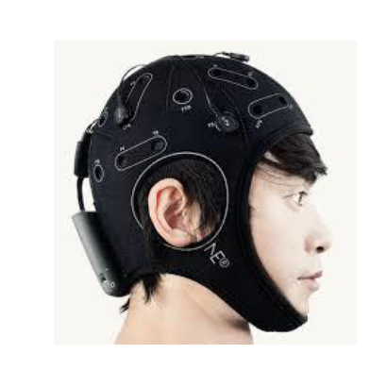

**Figure 4.1:ENOBIO EEG Headset.**

Enobio is a easy carrying, wireless EEG/ECoG/ECG controlling device. This instrument operates with the help of battery. To control its application and guarantee the correct reading specialized medical personnel is required. Enobio should be used in normal temperature (10-45oC) and pressure (700-1000 hPa) conditions Enobio has designed with some limitations and it provides a platform to design and develop many BCI applications away from the laboratory.

Enobio 8 is ideally used for out-of-lab applications. It is a combination of powerful user interface which is ease in configuration, recording, visualization of 24-bit EEG data at 500 samples per second which includes spectrogram and 3D visualization in real time of spectral features. Enobio-20 is best for medium-density recording research applications which make use of 10-20 system. It is used in research purpose or clinical uses and also it is used for telemedicine using NUBE cloud system for collecting and organizing of experimental data.

Enobio 32 is suitable for high-density recording research applications. Tri axial accelerometer data is also collected in addition to EEG data. Data can be stored in offline mode using micro SDcard.

**4.1.2Technical Specifications:**

* EEG consists of different number of channels for different applications, the number of channels can be 8,20 or 32
* EEG consists of bandwidth from 0 to 125 Hz
* The Sampling rate in EEG is 500 SPS
* The Resolution used in the EEG is 24 bits to 0.05 microvolt.
* EEG has an measurement Noise less than 1 micro V RMS
* The impedance of input EEG is of 1G ohm

**4.1.3 Other Technical Specifications:**

* For the Communication purpose we require a Bluetooth whose versions are 3.0 or 2.1
* The Battery time of this hardware is 16hrs
* Output is of the form EDF+ or ASCII data files or TCP/IP raw data streaming
* The value of Accelerometer is 3 axes
* For the storage of data in offline mode we use Micro SD card
* This device has an operating time of 8 hours which is only for EEG
* This device have the Dimensions of 60 x 85 x 20 mm
* It is about 65 g in weight.
* This device is highly compatible with Windows 7, Windows Vista, Windows XP, and MAC OS X.

**4.1.4 Other Hardware requirements**

* This device requires a Intel® Pentium 4 CPU processor and higher versions
* Its Speed must be 1.1 GHz
* It should have a RAM of 256 MB (min)
* 30 GB of hard disk is required
* Key Board must be a Standard Windows QWERTY Keyboard
* Monitor should be a Standard VGA Monitor

**4.2 SOFTWARE REQUIREMENTS:**

**4.2.1 NIC SOFTWARE**

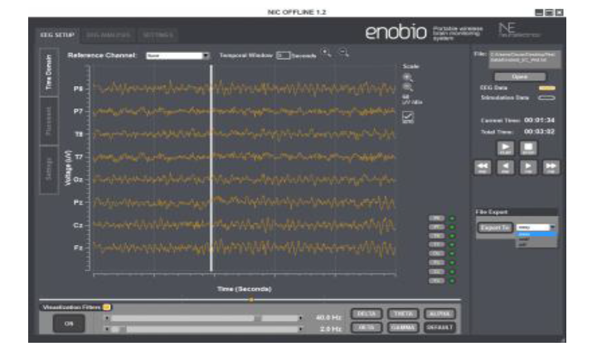

**Figure 4.2: NIC Software.**

NIC (Neuroelectrics Instrument Controller) is software which provides a graphical user interface for controlling neuro-electric devices like Enobio or starstim. This software helps user to collect the signals from devices. At first to begin with the software it has to be connected with the Bluetooth device on successful connection a message box will be displayed, if connection fails then user will be redirected to settings pane to select the Bluetooth device to be paired with.

This software consists of few tabs and panes. Tabs refer to top navigation bar and panes refer to left navigation bar in each tab. When NIC is paired with specific device some of the tabs get activated. For example when Starstim device is connected stimulation tabs gets activated. NIC software it compatible with many platforms like windows vista/7/8 and Mac OS X.

**CHAPTER 5**

**SYSTEM DESIGN**

EEG brain waves

Classification

**Figure 5.1: Overall System Architecture.**

The methodology starts by collecting the EEG samples from normal persons with different thinking (visualizing) called as Data Collection, then the process followed by pre-processing of the collected data, features extraction from the data and classification of the data and then we get speech.

1. Data Collection

2. Data Pre-Processing

3. Feature Extraction

4. Classification

5. Speech

Data collection

Processing to remove noise

Feature Extraction

Classification

Speech

**Figure 5.2: Flowchart for visual movement classification using EEG signal.**

Here we are considering samples:

Scenario: food-water predictions.

Feature Extraction

Pre-processing

Data collection

Classification

**Figure 5.3: Flow chart for food-water predictions.**

**5.1 Use case diagram:**

Collect EEG sample from users

Apply filter and Extract band

Extract statistical parameters

Apply Classification

**Figure 5.4: Use case diagram.**

Use case diagram for proposed system is as shown in fig 5.5. Initially EEG sample is being collected from the user then for the collected sample we apply filtering and after filtering is applied we extract bands. Then we extract statistical parameters and finally apply the classification. This is repeated for every trail.

**5.2 Sequence Diagram**

Sequence diagram for proposed system is as shown in fig 5.6. Initially EEG sample is being collected from the user then for the collected sample we apply filtering and after filtering is applied we extract bands. Then we extract statistical parameters and finally apply the classification. This process is repeated for every trial.

Collect EEG sample

Apply filtering process

Band Extraction

Extract statistical features

Apply classifier

Classification

Feature Extraction

Signal pre-processing

Data Acquisition

User

**Figure 5.5: Sequence diagram.**

**5.3 Dataflow diagram:**

Dataflow diagram for proposed system is as shown in fig 5.7. Initially EEG sample is being collected from the user then for the collected sample we apply filtering and after filtering is applied we extract bands. Then we extract statistical parameters and finally apply the classification. This process is repeated for every trial.

**Figure 5.6: Dataflow diagram.**

**CHAPTER 6**

**IMPLEMENTATION**

**6.1 EEG Signal Acquisitions:**

The Data Collection starts with using the EEG headset to collect the EEG signals from around 6 healthy participants or subjects between the ages of 20 to 23 years with the duration of 15-20 seconds for 10 trials. In that 4 datasets or samples are taken for training the system called as training phase and other samples are taken for testing phase. An 8-channel EEG module ENOBIO 8 was used for recording the EEG signals. Firstly, we give the instructions to the participants to sit without any body movements. Secondly, we place the headset using international 10-20 system so that the electrodes are placed properly to collect the brain signals. The EEG headset is connected to the system via Bluetooth. In that system, we use NIC software to extract the brain signals. Data collection in NIC software is shown in fig.

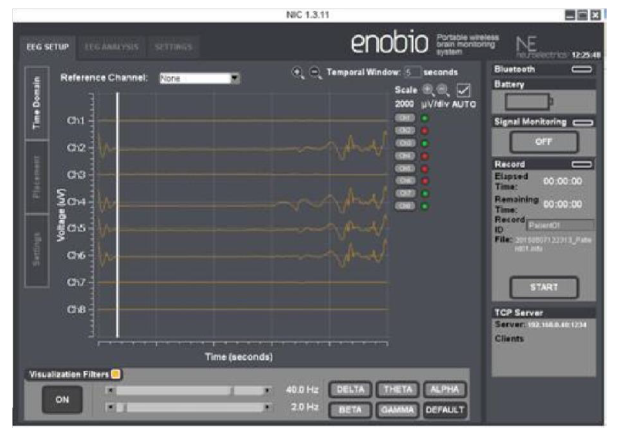

**Figure: 6.1 Collecting Data using NIC software.**

The each extracted signals are saved in the form of “easy” or “.ascii”. The data is recorded at frequency up to 250 Hz with sampling rate of 500 samples per second with a resolution of 24 bit allows us to record EEG in delta, theta, alpha, beta and gamma bands. In recorded dataset the signals or data is stored in the form of instantaneous values for each signal in arrays. Each data array contains 8 columns correspond to 8 channels or electrodes they are “F3”, “F4”, “T7”, “C3”, “F8”, “T8”and “Pz” and rows corresponds to number of samples. With the increase of time duration the number of samples or number of rows are increases.

**6.2 Signal Pre-Processing:**

After signal acquisition stage, signals are to be pre-processed because the acquired brain signals are most affected by noise and artifacts (unwanted signals). Signal pre- processing is also called as Signal Enhancement it is the process of removing noise from original signals and reconstructs those signals. The artifacts that contaminated the EEG signals are divided into physiological artifacts obtained from muscle activity, pulse, eye blinking, eye movements (EOG), heart beat (ECG), and non-physiological artifacts obtained from power line interference noise, sweat and neuronal activity obtained from background are also mixed with brain signals.

To extract the feature matrix from the EEG signal the artifacts have to be removed. Hence the goal of this pre-processing step is to reconstruct the original brain activity by removing contained artifacts. To remove this we apply filtering process by designing a Parks-McClellan optimal FIR filter.

**6.3 Filtering**

To remove unwanted signal from the recorded EEG each samples has to be passed through a FIR filter. The linear phase FIR filter is designed by using Parks-McClellan algorithm. Parks-McClellan algorithm design filters with an optimal fit between the desired and actual frequency responses by using the Remez exchange algorithm and Chebyshev approximation theory. The filters are optimal hence the maximum error between the desired frequency response and the actual frequency response is minimized. Filters designed in this way exhibits equiripple behaviour in their frequency responses therefore sometimes they are called as equiripple filters.

The Parks-McClellan FIR filter is designed by using function “firpm” in the MATLAB code it exhibits discontinuities at the head and tail of its impulse response due to the equiripple nature. The EEG wave contains delta (0-3Hz), theta (3-7Hz), alpha (8- 13Hz), beta (13-30Hz) and gamma (above 30Hz). Therefore, a band pass FIR filter of 1- 40 Hz is applied to signal. This designed FIR filter removes the DC offset of each electrode, drifts due to electrode impedance over time and power lines 50HZ noise and some artifacts are removed manually. The filter order, vector of pairs of normalized frequency points specified in the range between 0 and Nyquist frequency and vector containing the desired amplitudes are the arguments used in the designing of a filter.

**6.4 Feature Extraction**

After pre-processing the EEG signals the features are have to extract from EEG signals for emotion classification. Feature extraction is the process of extracting useful information from the signal. Features are characteristics of a signal that are able to distinguish between different emotions. The filtered signal is then wavelet decomposed to a level of 6 using Daubechies 14 wavelet. Six level is sufficient to extract all five EEG bands namely delta, theta, alpha, beta and gamma for each emotions. For wavelet decomposition of a signal “wavedec” function is used, wavedec is an inbuilt function in MATLAB. Here multiwavelet transform is used for wavelet decomposition.

**6.4.1 Extracted Statistical Parameters**

**Standard deviation:**

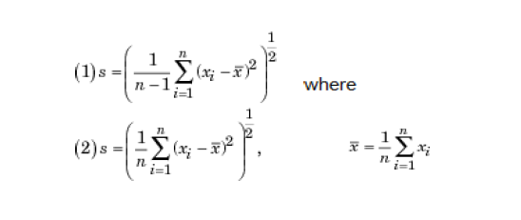

s = std(X), where X is a vector, returns the standard deviation using (1) above. The result s is the square root of an unbiased estimator of the variance of the population from which X is drawn, as long as X consists of independent, identically distributed samples.

If X is a matrix, std (X) returns a row vector containing the standard deviation of the elements of each column of X. If X is a multidimensional array, std (X) is the standard deviation of the elements along the first non singleton dimension of X.

s = std (X, flag) for flag = 0, is the same as std(X). For flag = 1, std (X,1) returns the standard deviation using (2) above, producing the second moment of the set of values about their mean.

s = std (X, flag, dim) computes the standard deviations along the dimension of X specified by scalar dim. Set flag to 0 to normalize Y by n-1; set flag to 1 to normalize by n.

**Variance:**

The variance is a determinant of measure of how far a set of numbers is spread out. It is specially a raw material of statistics and it helps and allows us to compute the dispersion of a set of variables around their mean. To calculate variance value for each channel in EEG samples the “var” function is used in the MATLAB command line. If a random variable is X, its expected value is E(X), then the variance of X(1) is the covariance of X with itself, it is given as,

Var (X) = Cov (X , X) = [(μ)]

**Mean:**

Average or mean value of array

M = mean(A) returns the mean values of the elements along different dimensions of an array. If A is a vector, mean(A) returns the mean value of A. If A is a matrix, mean(A) treats the columns of A as vectors, returning a row vector of mean values.

If A is a multidimensional array, mean(A) treats the values along the first non-singleton dimension as vectors, returning an array of mean values.

M = mean(A,dim) returns the mean values for elements along the dimension of A specified by scalar dim. For matrices, mean(A,2) is a column vector containing the mean value of each row.

**6.5 Classification:**

In this we used the KNN classifier for the classification. KNN can be used for both classification and regression predictive problems. However, it is more widely used in classification problems in the industry.

We can implement a KNN model by following the below steps:

1. Load the data
2. Initialize the value of k
3. For getting the predicted class, iterate from 1 to total number of training data points

**Algorithm:**

* 1. Calculate the distance between test data and each row of training data. Here we will use Euclidean distance as our distance metric since it’s the most popular method. The other metrics that can be used are Chebyshev, cosine, etc.
  2. Sort the calculated distances in ascending order based on distance values
  3. Get top k rows from the sorted array
  4. Get the most frequent class of these rows
  5. Return the predicted class

**How does the KNN algorithm work?**

Let’s take a simple case to understand this algorithm. Following is a spread of red circles (RC) and green squares (GS):

[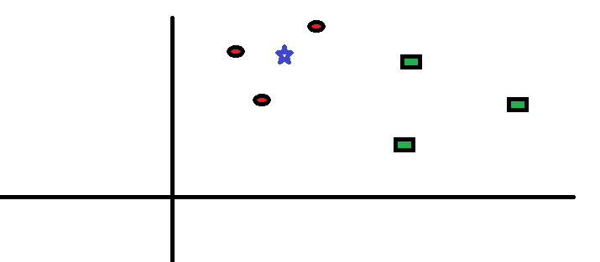](https://www.analyticsvidhya.com/blog/wp-content/uploads/2014/10/scenario1.png)

You intend to find out the class of the blue star (BS). BS can either be RC or GS and nothing else. The “K” is KNN algorithm is the nearest neighbours we wish to take vote from. Let’s say K = 3. Hence, we will now make a circle with BS as centre just as big as to enclose only three data points on the plane. Refer to following diagram for more details:

[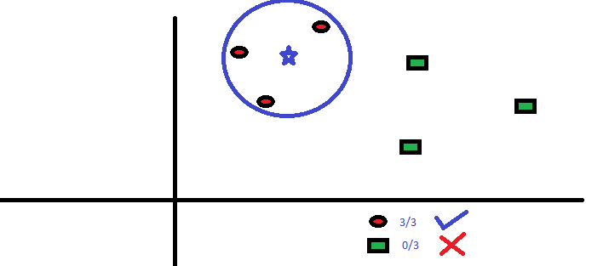](https://www.analyticsvidhya.com/blog/wp-content/uploads/2014/10/scenario2.png)

The three closest points to BS is all RC. Hence, with good confidence level we can say that the BS should belong to the class RC. Here, the choice became very obvious as all three votes from the closest neighbour went to RC. The choice of the parameter K is very crucial in this algorithm. Next we will understand what are the factors to be considered to conclude the best K.

**How do we choose the factor K?**

First let us try to understand what exactly K influences in the algorithm. If we see the last example, given that all the 6 training observation remain constant, with a given K value we can make boundaries of each class. These boundaries will segregate RC from GS. The same way, let’s try to see the effect of value “K” on the class boundaries. Following are the different boundaries separating the two classes with different values of K.

[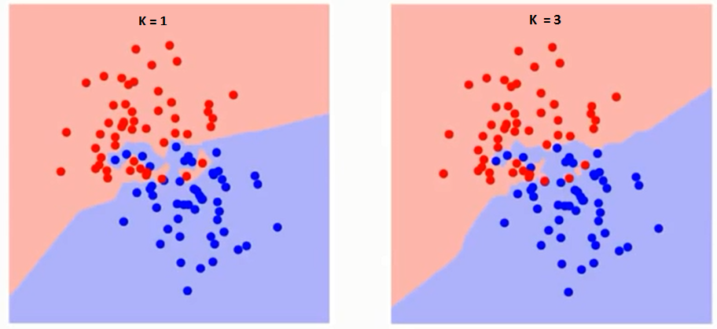](https://www.analyticsvidhya.com/blog/wp-content/uploads/2014/10/K-judgement.png)

If you watch carefully, you can see that the boundary becomes smoother with increasing value of K. With K increasing to infinity it finally becomes all blue or all red depending on the total majority.  The training error rate and the validation error rate are two parameters we need to access on different K-value. Following is the curve for the training error rate with varying value of K.

The error rate at K=1 is always zero for the training sample. This is because the closest point to any training data point is itself. Hence the prediction is always accurate with K=1. If validation error curve would have been similar, our choice of K would have been 1. Following is the validation error curve with varying value of K. This makes the story clearer. At K=1, we were over fitting the boundaries. Hence, error rate initially decreases and reaches a minima. After the minima point, it then increases with increasing K. To get the optimal value of K, you can segregate the training and validation from the initial dataset. Now plot the validation error curve to get the optimal value of K. This value of K should be used for all predictions.

**6.7 Training phase:**

In training phase we have loaded EEG samples, they are

1. Loading EEG samples of food.

2. Loading EEG samples of water.

**6.8 Testing Phase:**

In the testing phase, a popup button is used to select samples for testing which can be need food and need water.

If we select need food then the output should be need food and if we select need water as sample, output should be need water. In the testing phase we have to test for all cases of the samples.

**CHAPTER 7**

**SYSTEM TESTING**

**Test case 1: Visuals of food and water:**

|  |  |  |
| --- | --- | --- |
| Samples | Expected output | Obtained output for  KNN classifier |
| 1 | Food | Food |
| 2 | Food | Food |
| 3 | Food | Food |
| 4 | Food | Food |
| 5 | Food | water |
| 6 | Food | Food |
| 7 | Water | Water |
| 8 | Water | Water |
| 9 | Water | Water |
| 10 | Water | Food |
| 11 | Water | Water |
| 12 | Water | Water |

**Figure 7.1: Results of visual need food and water.**

We calculate the total accuracy based on the following formula,

a = (no of correct output/ total no of testing samples) * 100

In the table we have taken 12 samples, out of which 6 are food and 6 are water for testing for all three classifiers.

Accuracy for food and water in KNN Classifier: 83.33

**CHAPTER 8**

**RESULT AND DISCUSSION**

In computing, a graphical user interface (GUI) or something is a type of interface that allows users to interact with electronic devices through graphical icons and visual indicators such as secondary notations, as opposed to text-based interfaces, typed command labels or text navigations, GUIs were introduced in reaction to the perceived steep learning curve of command-line interfaces (CLIs), which require commands to be typed on the keyboard.

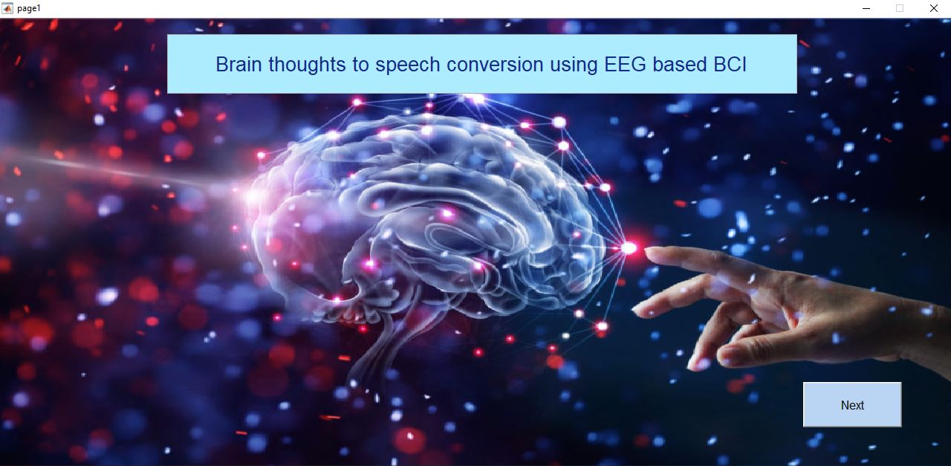

**Figure 8.1: Front page of GUI.**

The fig shows the front page, it consists of pushbutton on clicking that a new page will be displayed which is a Graphical display which consists of raw EEG signal, filtered EEG signal and bands.

The EEG signal classifications for different samples are analyzed by following results. The original EEG signal which is taken for analysis is filtered for classification is as shown below.

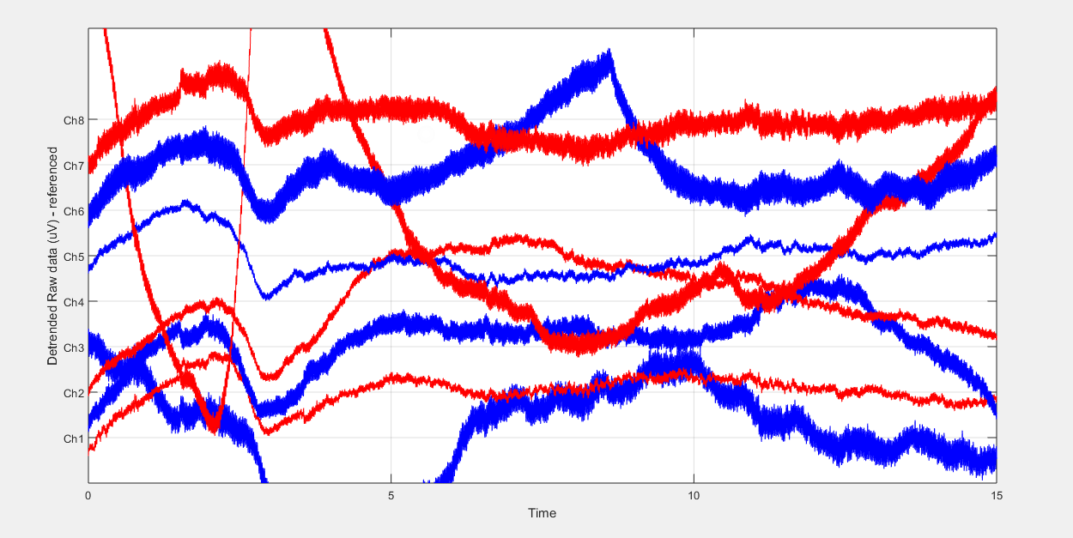

**Figure 8.2: EEG raw data and detrend data for samples.**

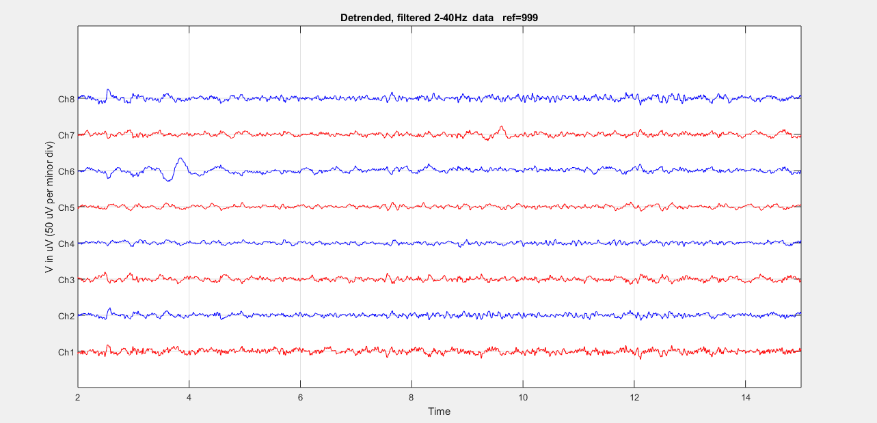

**Figure 8.3: EEG filtered data.**

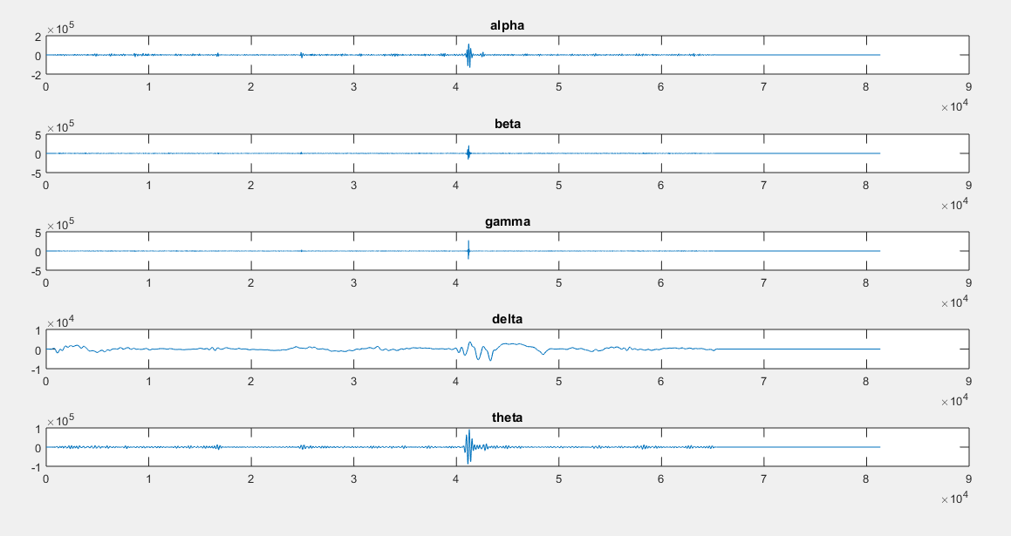

**Figure 8.4: EEG extracted bands.**

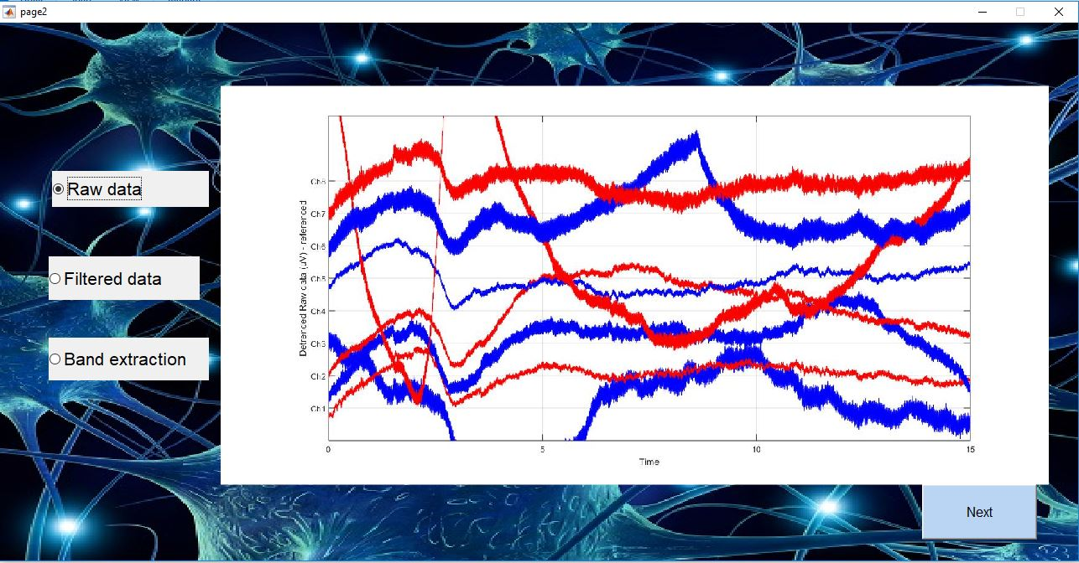

**Figure 8.5: GUI showing the raw data.**

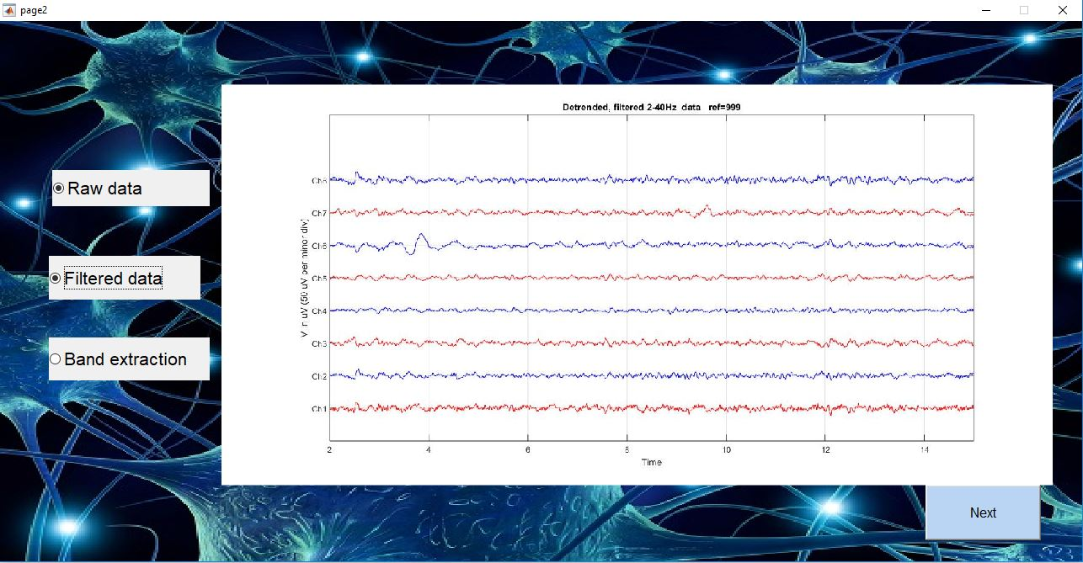

**Figure 8.6: GUI showing the filtered data.**

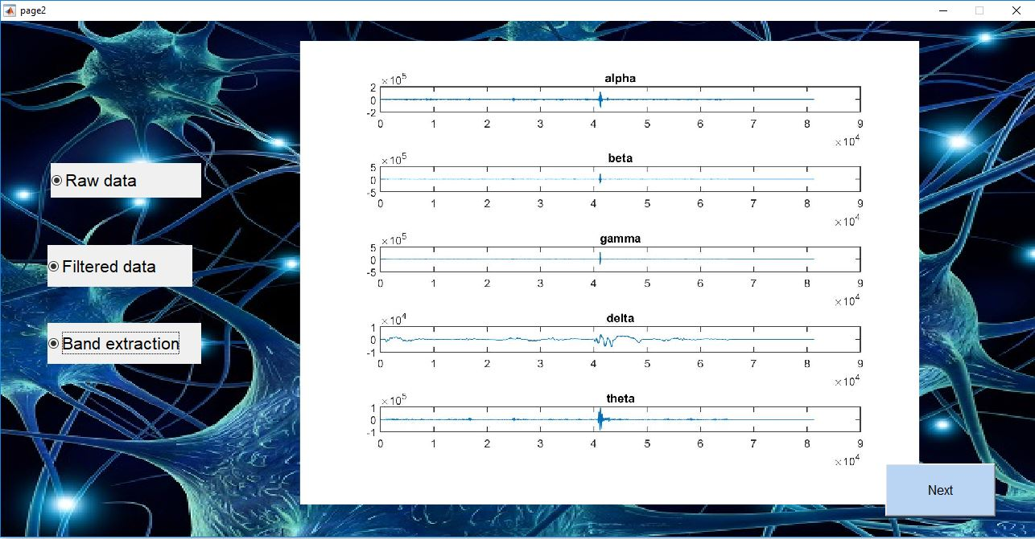

**Figure 8.7: GUI shows band extraction.**

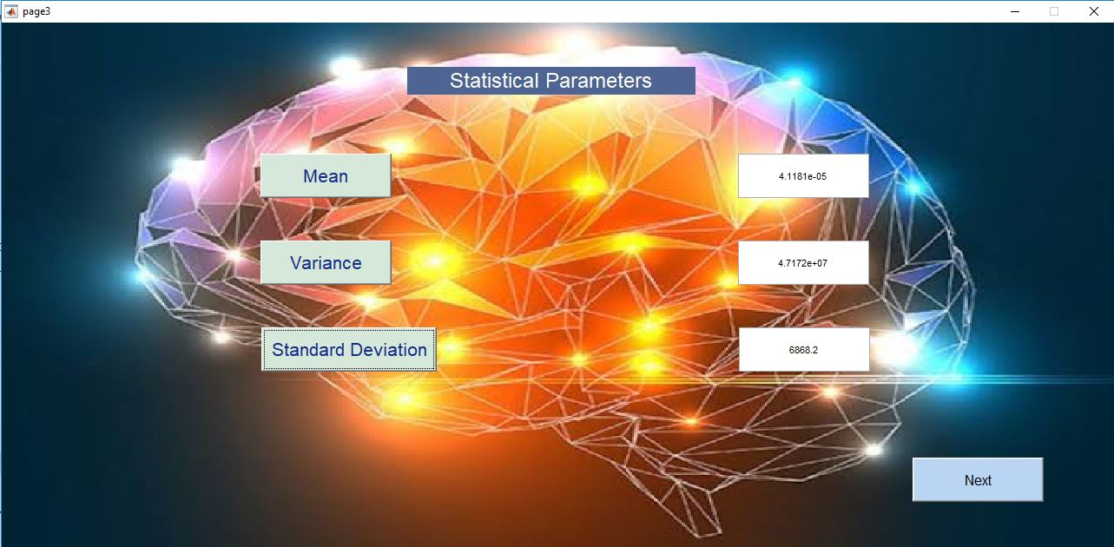

**Figure 8.8: GUI shows the values of the parameters.**

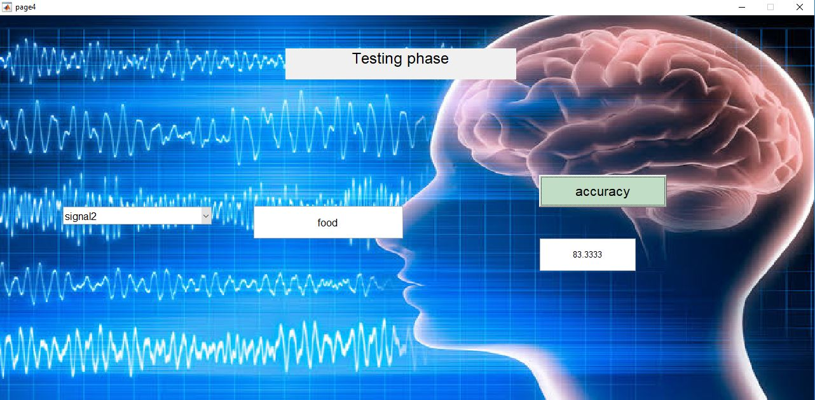

**Figure 8.9: GUI shows the values of the testing phase.**

**CHAPTER 9**

**CONCLUSION**

The acquisition process of EEG signals requires specific equipment and time. It is believed that this will facilitate and encourage studies tending to improve the recognition rates for imagined words, and ultimately lead to the development of BCI systems that could decode thoughts.

The results of an exploratory experiment were described in this work, using as features the Relative Wavelet Energy of each channel and five levels of decomposition. In addition, classifier KNN is tested, for the best. The accuracy achieved is above chance level suggesting that there is information of the imagined word within the EEG signal, although further research must be done to find the features that provide better discriminative information.

Here we achived the accuracy about to 83.3% for the imagined words by applying the KNN classifier. Decoding overt speech production is a necessary first step toward human-computer interaction through imagined speech processes. Brain-to-speech reconstructs spoken words from neural data. The computational phone models in combination with language information make it possible to reconstruct words in unseen spoken utterances solely based on neural signals (see Supplementary Video). All processing steps of Brain-to-speech and the decoding approach are well suited for eventual real-time online application on desktop computers. The approach introduced here may have important implications for the design of novel brain-computer interfaces, because it may eventually allow people to communicate solely based on brain signals associated with natural language function and with scalable vocabularies.

**FUTURE ENHANCEMENT**

In our future work, we will focus on testing (and possibly adapting) this system with the help of a clinical subject population. We hope that it will be possible soon to bring this technology from the test bench to the clinical subjects for whom the design was intended.

**REFERENCES**

[1] Classification of Four Eye Directions from EEG Signals for Eye-Movement-Based Communication Systems. Abdelkader Nasreddine Belkacem1, Hideaki Hirose Natsue Yoshimura Duk Shin Yasuharu Koike Received 10 Jun 2013; Accepted 2 Oct 2013; doi: 10.5405/jmbe.1596

[2] Open Access database of EEG signals recorded during imagined speech German Pressel Corettoa, Ivian E, Gareis, and H. Leonardo Rufiner

[3] Brain Computer Interface using Silent Speech for Speech Assistive Device. Mariko Matsumoto.DoctoralProgramin InformationScienceandEngineering.GraduateSchool of Science and Technology.M Matsumoto

[4] Simulation Experiment of BCI Based on Imagined Speech EEG Decoding Kang Wang, Xueqian Wang, and Gang Li; 22 May 2017.

[5] Converting Your Thoughts to Texts: Enabling Brain Typing via Deep Feature Learning of EEG Signals Xiang Zhang, Lina Yao, Dalin Zhang; 26 september 2017.

[6] A High Performance Spelling System based on EEG-EOG Signals With Visual Feedback Min-Ho Lee , John Williamson, Dong-Ok Won , SiamacFazli, and Seong-Whan Lee, Fellow IEEE TRANSACTIONS ON NEURAL SYSTEMS AND REHABILITATION ENGINEERING, VOL. 26, NO. 7, JULY 2018

[7] EEG-BASED SPEECH RECOGNITION Impact of Temporal Effects Anne Porbadnigk, MarekWester, Jan-P.

[8]Optimal spatial filtering of single trail EEG during imagined hand movement

H. Ramoser, J.M ulerGerking, G. Pfurtscheler; IEEE Transactions on Rehabilitation Engineering · January 2001.

[9] Brain-to-text: decoding spoken phrases from phone representations in the brain

Christian Herff, Dominic Heger; 12 June 2015.

[10] A Practical Guide to Support Vector Classification Chih-Wei Hsu, Chih-Chung Chang, and Chih-Jen Lin; May 19, 2016.