*“***VEHICLE NUMBER PLATE DETECTION”**

**For the Academic Year 2019-2020**

**Submitted by**

**Student Name:**

**Nikitha B A**

**Supriya Narayan Hegde**

**Sanjana N R**

**Under the Guidance of,**

**Guide Name:**

**Aditya S K**

**Co-founder of Tequed Labs,Bangalore**

**2019-2020**

**Department of Information Science and Engineering**

**JSS Academy of Technical Education**

**JSS Campus, Dr. Vishnuvardhan Road, Bengaluru-560060**

**ACKNOWLEDGEMENT**

The satisfaction and euphoria that accompany the successful completion of any task would be incomplete without the mention of the people who made it possible. So, with gratitude, we acknowledge all those whose guidance and encouragement crowned my effort with success.

First and foremost we would like to thank **Tequed Labs** Bangalore for providing an opportunity to carry out the Presentation as a part of our curriculum in the partial fulfilment of the degree.

We express our sincere gratitude for our beloved CEO **Supreeth Y S** and cofounder **Aditya S K** , for his co-operation and encouragement at all the moments of our approach.

It is our pleasant duty to place on record our deepest sense of gratitude to our respected guide, **Aditya S K** for the constant encouragement, valuable help and assistance in every possible way for continuous co-operation and support.

We would like to thank all **Tequed Labs** for providing us with their valuable guidance and for being there at all stages of our work.

**Student Name :**

**Nikitha B A**

**Supriya Narayan Hegde**

**Sanjana N R**

**INDEX**

|  |  |
| --- | --- |
| SlNo. | Content |
| 1. | Problem Statement and it’s Description |
| 2. | Propose Solution |
| 3. | Literature Survey |
| 4. | Requirement Specification |
| 5. | Methodology |
| 6. | Testing |
| 7. | Future Enhancement |
| 8. | Reference |
| 9. | Appendix |

**PROBLEM STATEMENT**

**Company Vehicle Analytics** -Detect number plates of every vehicle entering the building and verify with standard database of employee vehicles and create another database of visitor vehicle every day and predict vehicle flow.

**Description:** The problem is to detect the number plate of every vehicle entering into the building of a company.

To check whether a vehicle belongs to the employee of a company or not.If not a notification need to displayed so that it is a visitor’s vehicle.

**PROPOSED SOLUTION**

* To detect whether the vehicle entering inside the campus of a company belongs to the employee or not.
* To check the attendance of the employees in a company.
* To check the time and date at which the employee enters and leaves the campus.

**LITERATURE SURVEY**

Priyanka Prabhakar, P Anupama, S R Resmi (2014) worked on Automatic Vehicle Number Plate Detection. This paper presents a strong technique for localisation, segmentation and recognition of the characters within the located plate. Images from still cameras or videos are obtained and regenerated in to grayscale images. Hough lines are determined using Hough transform and therefore the segmentation of grey scale image generated by finding edges for smoothing image is employed to cut back the quantity of connected part and then connected part is calculated. Finally, single character within the registration code is detected. The aim is to indicate that the planned technique achieved high accuracy by optimizing numerous parameters that has higher recognition rate than the standard ways.

Muhammad Tahir Quadri et.all (2009) worked on Automatic Number Plate Recognition System for Vehicle Identification Using Optical Character Recognition. Automatic number plate recognition (ANPR) is an image processing technology which uses number (license) plate to identify the vehicle.

The objective of this paper is to design an efficient automatic authorized vehicle identification system by using the vehicle number plate. The system is implemented on the entrance for security control of a highly restricted area like military zones or area around top government offices e.g. Parliament, Supreme Court etc. The developed system first detects the vehicle and then captures the vehicle image. Vehicle number plate region is extracted using the image segmentation in an image. Optical character recognition technique is used for the character recognition. The resulting data is then used to compare with the records on a database so as to come up with the specific information like the vehicle owner, place of registration, address, etc.

# K.B. Satya (2017) worked on Vehicle license plate recognition. In general, human can easily read the character but the computer cannot read the character easily unless the computer is pre-trained to do so. VLPR deals with License Plate localization and vehicle number recognition. VLPR has three modules namely License Plate Extraction, Segmentation and Recognition. Extraction of plate is mostly carried out using edge detection. In Segmentation various tasks such as Filtering, Thinning, Vertical and Horizontal projections are performed. Recognition is the final stage to recognize character and numbers.

**METHODOLOGY**

In huge multinational companies the number of vehicles entering into the campus are more. There will be a confusion between the vehicles of the employees and the vehicles of the stakeholders. In order to differentiate between the vehicles of the employees who works in the company to those of visitor’s vehicle number plate is detected. Based on the previous data set which contains all the employee vehicle number plate details, matching is done. Hence, they can easily differentiate between the vehicles. This helps in allowing only those vehicles which belongs to the company employees inside the campus. Over the last few years, the ANPR has become a useful approach for vehicle surveillance. Typically, an ANPR system consists of three main stages:

1) Number Plate Localization (NPL)

2) Character Segmentation (CS) and

3) Optical Character Recognition (OCR).

The NPL stage is where the Number Plate is being detected based on Image Processing. The Character Segmentation stage is an important pre-processing step before applying OCR, where each character from the detected Number Plate is segmented before recognition. In the last stage, characters are segmented from the Number Plate so that only useful information is retained for recognition of the image.

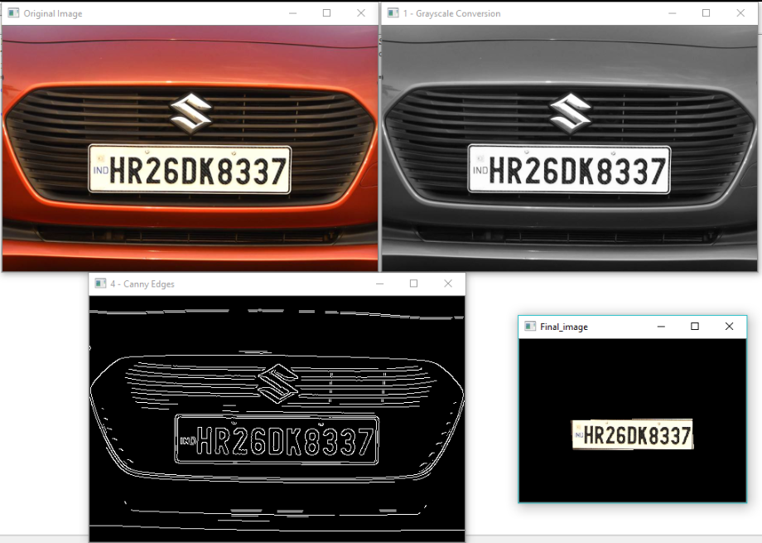

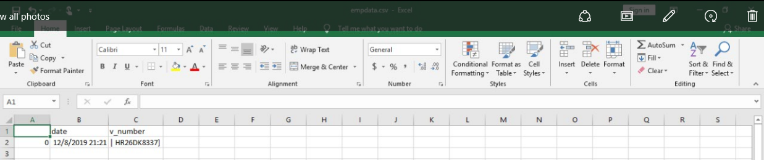

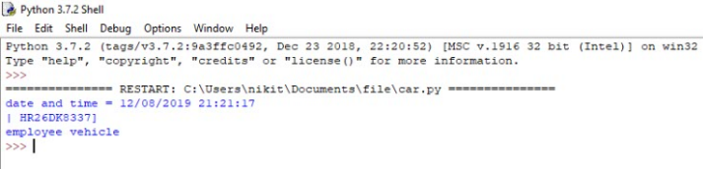

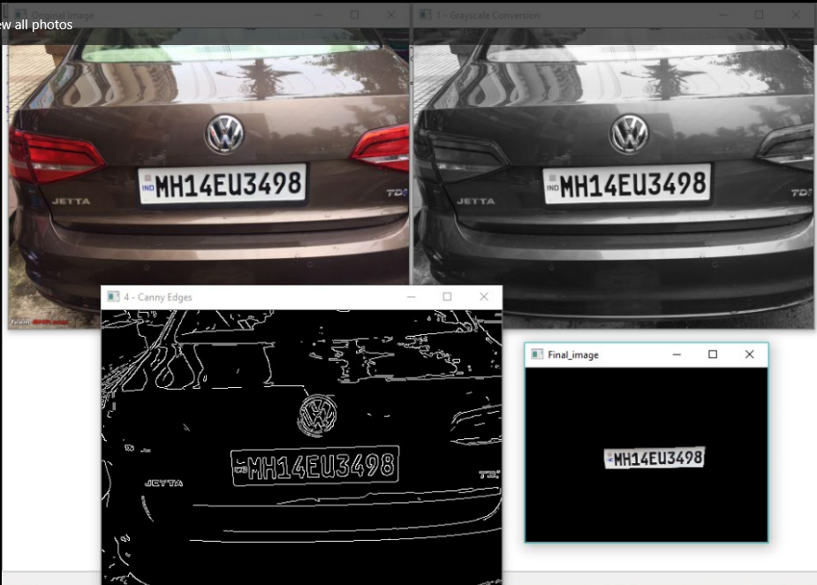

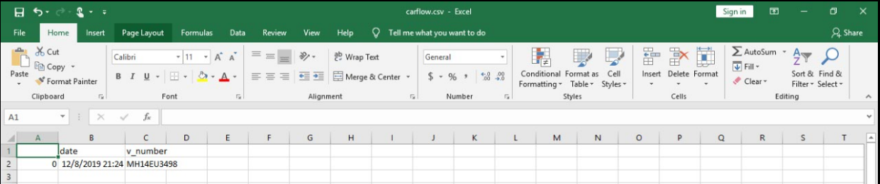

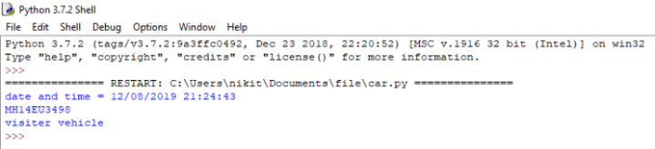

**REQUIREMENT SPECIFICATION**

* Libraries and Packages used:
* NumPy
* Cv2
* Imutils
* Sys
* Pandas
* Time
* Datetime
* Tesseract
* Image
* PIL
* Image_to_string

**TESTING**

| **TEST CASE SPECIFICATION** | **DESCRIPTION** |
| --- | --- |
| Test Case Objective | Detection of vehicle number plate and displaying the message whether it is employee vehicle or not. |
| Pre-requisite | Python environment, software’s like tesseract, and some libraries like NumPy, CV2 etc.. |
| Steps | Image of a vehicle is given as an input.  The number plate of the vehicle id detected by applying Machine Learning algorithm.  Number Plate Localization (NPL)  Character Segmentation (CS) and  Optical Character Recognition (OCR). |
| Input Data | Image of a vehicle is given as an input. |
| Expected Result | The vehicle number plate.  And to print the message whether it is employee vehicle or not. |
| Actual Result | The vehicle number plate.  And prints the message whether it is employee vehicle or not. |
| Status | PASS |

**FUTURE ENHANCEMENT**

* In this algorithm, we are detecting only a single number plate at a time as an image.
* In future, videos can be given as an input to detect the number plate.
* In a video, multiple number plate of vehicles can be detected.
* Number of vehicles entered in and their exit can be counted.

**REFERENCE**

* [**https://youtu.be/Rb93uLXiTwA**](https://youtu.be/Rb93uLXiTwA)
* [**https://www.youtube.com/watch?v=isC8xyOLJds**](https://www.youtube.com/watch?v=isC8xyOLJds)
* [**https://github.com/vjgpt/Vehicle-Number-Plate-Reading**](https://github.com/vjgpt/Vehicle-Number-Plate-Reading)

**Appendix**

import numpy as np

import cv2

import imutils

import sys

import pytesseract

import pandas as pd

import time

image = cv2.imread('v2.jpg')

image = imutils.resize(image, width=500)

cv2.imshow("Original Image", image)

gray = cv2.cvtColor(image, cv2.COLOR_BGR2GRAY)

cv2.imshow("1 - Grayscale Conversion", gray)

gray = cv2.bilateralFilter(gray, 11, 17, 17)

edged = cv2.Canny(gray, 170, 200)

cv2.imshow("4 - Canny Edges", edged)

contours, hierarchy = cv2.findContours(edged, cv2.RETR_TREE, cv2.CHAIN_APPROX_SIMPLE)

contours=sorted(contours, key = cv2.contourArea, reverse = True)[:30]

NumberPlateCnt = None

count = 0

for c in contours:

peri = cv2.arcLength(c, True)

approx = cv2.approxPolyDP(c,0.02 * peri, True)

if len(approx) == 4:

NumberPlateCnt = approx

break

mask = np.zeros(gray.shape,np.uint8)

new_image = cv2.drawContours(mask,[NumberPlateCnt],0,255,-1)

new_image = cv2.bitwise_and(image,image,mask=mask)

cv2.namedWindow("Final_image",cv2.WINDOW_NORMAL)

cv2.imshow("Final_image",new_image)

from datetime import datetime

now = datetime.now()

dt_string = now.strftime("%d/%m/%Y %H:%M:%S")

print("date and time =", dt_string)

from PIL import Image

from pytesseract import image_to_string

config = ('-l eng --oem 1 --psm 3')

tesseract_cmd = 'C:\\Program Files (x86)\\Tesseract-ORC\\tesserect'

text = pytesseract.image_to_string(new_image, config=config)

raw_data = {'date': dt_string,

'v_number': [text]}

df = pd.DataFrame(raw_data, columns = ['date', 'v_number'])

print(text)

str_y=text;

emp_list = ['MH12DE1433','| HR26DK8337]','KL 65K 7111','MH 14BR 6899']

emp_list.sort()

if str_y in emp_list:

print ("employee vehicle")

df.to_csv('empdata.csv')

else :

print ("visiter vehicle")

df.to_csv('carflow.csv')

cv2.waitKey(0)