A
Real-Time Research Project On
A Novel Approach for Disaster Victim Detection Under Debris Environments Using Decision Tree Algorithms With Deep Learning Features

(Submitted in partial fulfillment of the requirements for the award of Degree)

BACHELOR OF TECHNOLOGY
In

COMPUTER SCIENCE AND ENGINEERING
By

M.Nikitha (247R1A05BN) P.Sathwika (247R1A05CB )
P.Anjali (247R1A05BY)

Under the Guidance of

M. Madhusudhan
(Assistant Professor)


DEPARTMENT OF COMPUTER SCIENCE AND ENGINEERING
CMR TECHNICAL CAMPUS
UGC AUTONOMOUS
(Accredited by NAAC, NBA, Permanently Affiliated to JNTUH, Approved by AICTE, New Delhi)
Recognized Under Section 2(f) & 12(B) of the UGCAct.1956, Kandlakoya (V), Medchal Road, Hyderabad-501401.
April, 2026.

DEPARTMENT OF COMPUTER SCIENCE AND ENGINEERING


CERTIFICATE

This is to certify that the project entitled “ A Novel Approach for Disaster Victim Detection Under Debris Environments Using Decision Tree Algorithms With Deep Learning Features”
being submitted by M.Nikitha (247R1A05BN), P.Sathwika (247R1A05CB) & P.Anjali (247R1A05BY) in partial fulfillment of the requirements for the award of the degree of B.Tech in Computer Science and Engineering to the Jawaharlal Nehru Technological University Hyderabad, during the year 2025-26.

The results embodied in this thesis have not been submitted to any other University or Institute for the award of any degree or diploma.

M.Madhusudhan Dr. Nuthanakanti Bhaskar Assistant Professor HoD
INTERNAL GUIDE

ACKNOWLEDGEMENT
We take this opportunity to express our gratitude to the people who have been instrumental in the successful completion of this project, we take this opportunity to express our profound gratitude and deep regard to our guide M.Madhusudhan, Assistant Professor for his exemplary guidance, monitoring and constant encouragement throughout the project work. The blessing, help and guidance given by him shall carry us a long way in the journey of life on which we are about to embark.

We take this opportunity to extend our heartfelt appreciation to the Project Review Committee (PRC) Coordinators—Dr. J. Narasimharao, Mrs. M. Srilekha, Dr. G. Venkateshwarlu Nayak, and Mrs. A. Divya Bharathi—for their unwavering support, insightful guidance, and valuable inputs, which played a crucial role in steering this project through its various stages.

Our sincere appreciation also goes to Dr. Nuthanakanti Bhaskar, Head, for his encouragement and continuous support in ensuring the successful completion of our project.

We are deeply grateful to Dr. A. Raji Reddy, Director, for his cooperation throughout the course of this project. Additionally, we extend our profound gratitude to Sri. Ch. Gopal Reddy, Chairman, Smt. C. Vasantha Latha, Secretary and Sri. C. Abhinav Reddy, Vice-Chairman, for fostering an excellent infrastructure and a conducive learning environment that greatly contributed to our progress.

We also acknowledge and appreciate the guidance and assistance provided by the faculty and staff of CMR Technical Campus, whose contributions have been invaluable in bringing this project to fruition.
Lastly, we sincerely thank our families for their unwavering support and encouragement. We also extend our gratitude to the teaching and non-teaching staff of CMR Technical Campus for their guidance and assistance. Their contributions, along with the support of everyone who helped directly or indirectly, have been invaluable in the successful completion of this project.

M.Nikitha (247R1A05BN)
P.Sathwika (247R1A05CB) P.Anjali (247R1A05BY)

VISION AND MISSION

INSTITUTE VISION:
To Impart quality education in serene atmosphere thus strive for excellence in Technology and Research.

INSTITUTE MISSION:
- To create state of art facilities for effective Teaching- Learning Process.

- Pursue and Disseminate Knowledge based research to meet the needs of Industry & Society.

- Infuse Professional, Ethical and Societal values among Learning Community.

DEPARTMENT VISION:
To provide quality education and a conducive learning environment in computer engineering that foster critical thinking, creativity, and practical problem-solving skills.

DEPARTMENT MISSION:
- To educate the students in fundamental principles of computing and induce the skills needed to solve practical problems.

- To provide State-of-the-art computing laboratory facilities to promote industry institute interaction to enhance student’s practical knowledge.

- To inculcate self-learning abilities, team spirit, and professional ethics among the students to serve society.

ABSTRACT

Search and Rescue operations for victim identification in an unstructured collapsed building are high-risk and time-consuming. The possibility of saving a victim is high only during the first 48 hours, and then the prospect tends to zero. The faster the response and identification, the sooner the victim can be taken to medical assistance. Combining mobile robots with practical Artificial Intelligence (AI) driven Human Victim Detection (HVD) systems managed by professional teams can considerably reduce this problem. In this paper, we have developed a Transfer Learning-based Deep Learning approach to identify human victims under collapsed building environments by integrating machine learning classification algorithms. A custom-made human victim dataset was created with five class labels: head, hand, leg, upper body, and without the body. First, we extracted the class-wise features of the dataset using fine-tuning-based transfer learning on ResNet-50 deep learning model. The learned features of the model were then extracted, and then a feature selection was performed using J48 to study the impact of feature reduction in classification.
Several decision tree algorithms, including decision stump, hoeffiding tree, J48, Linear Model Tree (LMT), Random Forest, Random Tree, Representative (REP) Tree, J48 graft, and other famous algorithms like LibSVM, Logistic regression, Multilayer perceptron, BayesNet, Naive Bayes are then used to perform the classification. The classification accuracy of the abovementioned algorithms is compared to recommend the optimal approach for real-time use. The random tree approach outperformed all other tree-based algorithms with a maximum classification accuracy of 99.53% and a computation time of 0.02 seconds.

LIST OF FIGURES

FIGURE NO FIGURE NAME PAGE NO

Figure 3.1
Project Architecture of 14
A Novel Approach for Disaster
Victim Detection Under Debris
Environments Using Decision Tree
Algorithms With Deep Learning Features.

Figure 3.2

Dataflow Diagram of A Novel 28
Approach for Disaster
Victim Detection Under Debris
Environments Using Decision Tree
Algorithms With Deep Learning Features.

Figure 4.1

Dataset directory structure with 34
folders body,hand and leg having
all the training examples

Figure 4.2

Screenshot of the "Inappropriate 34
Content" Folder Showing
Sample Image Files

Figure 5.1
In above screen click on upload victim 48
Detection dataset button to upload
Dataset and get below output.
Figure 5.2

In above screen selecting and uploading 49
Dataset and then click on ‘Select Folder’
button to load dataset and get below page.

Figure 5.3

In above screen selecting and uploading 50
Dataset and then click on ‘Select Folder’
button to load dataset and get below page

Figure 5.4

In above screen application read 3072 51
features from each image and then input
this features to ResNet50 algorithm to
extract features and get below page

Figure 5.5

In above screen Resnet50 extracted 52
relevant 256 features from given 3072
original features and now click on
‘Features Selection Decision Tree’
button to select relevant features out of 256.

Figure 5.6

In above screen from 256 J48 Decision 53
Tree selected 14 features and then can see Train
and test size and now click on ‘Run SVM
Algorithm’ button to get below page

Figure 5.7
In above screen SVM training completed and it got 95% accuracy on test images and can see other metrics like precision, recall and FSCORE.
Figure 5.8
In above screen SVM training completed 55 and it got 95% accuracy on test images and can see other metrics like precision, recall and FSCORE.

Figure 5.9

In above screen MLP got 22% accuracy 56
and now click on ‘Run Extension Algorithm’
button to get below output.

Figure.5.10

Figure.5.11

Figure.5.12

Figure 5.13

In above screen MLP got 22% accuracy and now click on ‘Run Extension Algorithm’ button to get below output.

In above screen x-axis represents algorithm 57
names and y-axis represents accuracy and
other metrics in different colour and in all
algorithms XGBOOST got high accuracy.

In above screen selecting and uploading 0.jpg 58
file and then click on ‘Open’ button to get below
output.

In above screen in red colour text can see victim 59
part detected as HAND and similarly you can
upload and test other images.

 | LIST OF TABLES
TABLE NO | TABLE NAME | PAGE NO
Table 6.2.1 | Uploading Dataset &  classification | 61

TABLE OF CONTENTS

ABSTRACT i
LIST OF FIGURES ii
LIST OF TABLES v
- INTRODUCTION 1
  - PROJECT PURPOSE 3
  - PROJECT FEATURES 3
- LITERATURE SURVEY 5
  - REVIEW OF RELATED WORK 7
  - DEFINITION OF PROBLEM STATEMENT 9
  - EXISTING SYSTEM 10
  - PROPOSED SYSTEM 11
  - OBJECTIVES 12
  - HARDWARE & SOFTWARE REQUIREMENTS 13
    - HARDWARE REQUIREMENTS 13
    - SOFTWARE REQUIREMENTS 13
- SYSTEM ARCHITECTURE & DESIGN 14
  - PROJECT ARCHITECTURE 14
  - DESCRIPTION 29
  - DATA FLOW DIAGRAM 30
- IMPLEMENTATION 18
  - ALGORITHMS USED 32
  - SAMPLE CODE 36
- RESULTS & DISCUSSION 48
- VALIDATION 60
  - INTRODUCTION 60
  - TEST CASES 61
    - UPLOADING DATASET 61
    - CLASSIFICATION 62
- CONCLUSION & FUTURE ASPECTS 65
  - PROJECT CONCLUSION 65
  - FUTURE ASPECTS 66
- BIBLIOGRAPHY 67
  - REFERENCES 67
  - GITHUB LINK 69

INTRODUCTION

INTRODUCTION

T Massive earthquakes, floods, plane crashes, tsunamis, and building collapses are only a few examples of the many catastrophic natural and human-caused disasters that plague the world. Disaster management is essential for reducing and avoiding the losses these catastrophes cause. Depicts the mortality statistics in building collapses caused by earthquakes and other factors worldwide over the last few years. According to the emergency relief cycle the four stages of disaster management include prevention, preparedness, reaction, and recovery. This work comes under the preparedness and reaction phases of the disaster management cycle to aid fast rescue assistance for identifying victims. This work is a continuation of our previous work as part of our motto to develop a snake-like robot for rescue assistance for human victim detection in earthquake environments. According to Urban Search And Rescue (USAR), the chances of saving a victim are only good for the first 48 hours of the rescue operation, after which the probability is almost zero. Hence, the faster the rescue mission higher the probability of saving a life. Victim identification in the collapsed building environment is one of the chief challenges for responders. One of the main concerns is the accuracy of identification. Accurately identifying victims in this situation is often difficult because of the uncertainties in the victims’ bodies and the surrounding environment. Despite these potential limitations, this work tries to identify victims using the information available to responders based on human physical anatomy. A detailed study of human identification methods is discussed in the next section. RGB and thermal image-based datasets are more useful in search and rescue scenarios involving the detection of human victims. An RGB image-based custom dataset is employed in this work for HVI in collapsed, unstructured building scenarios. Once we have a dataset, its features must be learned to identify the victim accurately. Deep learning (DL) has emerged as a powerful tool for computer vision applications, including image classification and object detection. The most common deep learning models are convolutional neural networks (CNNs), which can be applied to many data types. CNNs have become increasingly popular due to their ability to learn and extract relevant features from raw image data and classify them into different categories based on those features without manual feature engineering. CNN architecture is constituted of different layers: the input layer, convolutional layer, pooling layer, and fully connected layers are the main types of layers used in CNN. The input layer takes in a set of images and runs them through a series of convolutional layers to extract features. Each layer of a CNN typically takes as input a 4D array. The convolutional layer, the first layer in a CNN, uses filters to scan over the input data to detect features or patterns such as edges, corners, and other relevant information. The pooling layer, which follows the convolutional layer, down-samples the output from the convolutional layers by taking the maximum or average value within a specific window size, reducing the spatial dimensions of the data while preserving important information. Finally, the output of the convolutional and pooling layers is flattened into a 1D array that serves as the input to the fully connected layers. The fully connected layers are the last set of layers in a CNN and are typically used for classification or regression tasks. They take in the flattened output from the previous layers and use weights to perform matrix operations that transform the input data into predictions or outputs. Other layers, such as activation, batch normalization, and dropout, can be used to improve the performance and stability of CNN. Furthermore, the arrangement and number of each type of layer can be customized to suit specific tasks and datasets, allowing for a high degree of flexibility and adaptability in designing CNN architectures. Combining these layers allows CNNs to extract features and learn patterns from large sets of images, making them powerful tools for object detection, image recognition, and more. The success of CNN in image-related tasks has led to their application in other fields, such as natural language processing, speech recognition, and even drug discovery. This highlights the versatility and potential of CNNs as a powerful tool for various applications beyond image-related tasks. However, CNN requires a large amount of labelled data to perform well. Such a large amount of data is lacking in victim identification which is necessary for a CNN training assignment. This issue can be resolved by employing Transfer Learning (TL) techniques. TL is another technique to help deep learning systems improve their accuracy. They use pre-trained models from other tasks to help improve the learning speed and the accuracy of the new model being trained. Transfer learning helps to use the knowledge gained from a model trained on a larger dataset in a task-oriented small dataset with minimal fine-tuning, as shown in Fig. 2. That is, first, the network parameters are pre-trained using the source data, followed by their application in the target domain, and finally, the network parameters are tuned for improved performance. The main benefits of TL are increased classification accuracy and accelerated training. More literature on CNN and TL is discussed in detail in the next section. When DL models learn features from complex problems at the cost of massive data and high computation time, ML models, such as decision trees, logistic regression, and support vector machines, are easier to interpret and require fewer data and computational resources to train. Therefore this paper has tried to improve the results using ML’s benefits. ML algorithms deliver extremely accurate classification results quickly and with few hardware requirements. Features extracted from the pre-trained model are used for classification with ML-based classifiers after feature selection (i.e., discarding insignificant features). Detailed literature on ML-based classifiers is provided in the next section. Therefore, this paper proposed a deep learning-based human victim identification model combined with machine learning-based classifiers, as shown in for HVI tasks in unstructured collapsed building environments. The significant features of the work are listed below.
(i) RGB-based multiclass custom human victim dataset creation.
(ii) Data augmentation and pre-processing for enlarging the size and quality of the dataset. (iii) Transfer Learning-based feature learning.
(iv) Integration of DL-based feature extraction with ML-based feature selection and classification for victim detection. Human detection using ML classifiers is a less explored area. Our proposed integration approach for human victim detection is not found anywhere in the literature. The paper is organized as follows. Section II discusses the literature related to human detection, deep learning, and ML concepts. The materials and methods used, like data acquisition, dataset creation, and work methodology, are detailed in section III, followed by the results and discussions in section IV.

PROJECT PURPOSE
The purpose of this project is to develop an intelligent and efficient system for identifying human victims trapped under debris in disaster-affected environments such as collapsed buildings. During search and rescue operations, the likelihood of saving lives is highest within the first 48 hours, making rapid and accurate victim detection extremely critical. Traditional victim detection methods based on physical signals like sound, heat, or motion often fail due to dust, debris, poor visibility, and unpredictable victim postures. To address these challenges, this project proposes an AI-based human victim detection approach using RGB image data, deep learning, and machine learning techniques. By employing transfer learning with a pre-trained ResNet-50 model for feature extraction and integrating decision tree-based machine learning classifiers for classification, the system aims to achieve high detection accuracy with low computational cost. The proposed approach supports faster decision-making, improves reliability in unstructured rescue environments, and assists rescue teams and robotic platforms in locating victims quickly, thereby increasing the chances of saving human lives.

PROJECT FEATURES
The proposed project incorporates several advanced features to ensure accurate and efficient disaster victim detection in unstructured debris environments. A custom RGB-based multiclass human victim dataset is created to represent real-world rescue scenarios, including different human body parts and non-human regions. Data augmentation and preprocessing techniques are applied to improve dataset quality and robustness against variations in lighting, orientation, and occlusion. Transfer learning using a pre-trained ResNet-50 deep learning model is employed to extract meaningful and high-level visual features with minimal training data and reduced computational cost. To enhance classification performance and reduce complexity, decision tree-based feature selection is applied to retain only the most relevant features. The extracted features are then classified using multiple machine learning algorithms such as decision trees, random forest, support vector machine, multilayer perceptron, and XGBoost to identify the most accurate and efficient model. The system is designed for fast execution with high accuracy, making it suitable for real-time search and rescue operations. Additionally, a graphical user interface is implemented to allow easy dataset handling, model training, performance comparison, and victim detection from test images, enabling practical deployment in rescue assistance systems and robotic platforms.

LITERATURE SURVEY

LITERATURE SURVEY

‘‘A survey on snake robot locomotion,’’
Snake robots have been a topic of discussion among researchers for decades. They are potentially strong enough to bring substantial contributions to the fields which are unsafe/ narrow/ dirty/ hard reachable to human operators, such as inspections, rescue missions, fire fighting, etc. Though the inventions of the wheel and legged mechanisms are amazing, they often fail when coming to these scenarios. Terrain adaptability is the vital essence of locomotion over constrained surfaces in biological snakes. But how this natural adaptability is accomplished in snake-like robots? Therefore, this paper focuses a study on factors behind the recreation of a physical snake, like the kinematics and dynamics modelling, mechanical design, and locomotion control approaches from existing literature. With their feature comparison, the simulators available for verifying the mathematical model and the feasibility of the mechanical design are also made for researchers new to the field.
‘‘Using deep learning to find victims in unknown cluttered urban search and rescue environments,’’
Purpose of Review We investigate the first use of deep networks for victim identification in Urban Search and Rescue (USAR). Moreover, we provide the first experimental comparison of single-stage and two-stage networks for body part detection, for cases of partial occlusions and varying illumination, on a RGB-D dataset obtained by a mobile robot navigating cluttered USAR-like environments. Recent Findings We considered the single-stage detectors Single Shot Multi-box Detector, You Only Look Once, and RetinaNet and the two-stage Feature Pyramid Network detector. Experimental results show that RetinaNet has the highest mean average precision (77.66%) and recall (86.98%) for detecting victims with body part occlusions in different lighting conditions. Summary End-to-end deep networks can be used for finding victims in USAR by autonomously extracting RGB-D image features from sensory data. We show that RetinaNet using RGB-D is robust to body part occlusions and low-lighting conditions and outperforms other detectors regardless of the image input type.
‘‘Analysis and prediction of land use in Beijing–Tianjin–Hebei region: A study based on the improved convolutional neural network model,’’
During the rapid economic development of China, there are certain blind decisions made in the use of land resources, which poses a significant threat to sustainable development. With the help of the improved convolutional neural network model, this paper analyzes the land use of the Beijing-Tianjin-Hebei region of China from 1995 to 2018, and provides a prediction for 2023. The research results show that: (1) There is still much room for improvement in the land use of the Beijing-Tianjin-Hebei region, with dry land taking up the largest proportion of land in these three locations; (2) Beijing’s development has been well protected in terms of land use. It is predicted that by 2023, the proportions of its woodland, grassland, and rivers, lakes, reservoirs and ponds would increase by 0.26%, 0.30%, and 0.61%, respectively, compared with their proportion in 2018; (3) the land use type in Tianjin during the research period was generally stable. In 2018, the proportion of its woodland and grassland had increased by 1.04% and 0.61%, respectively, compared with that of 1995; and (4) many ecological and environmental problems were exposed during the construction of highways in Hebei province. The area of sand land, saline-alkali land, marshland, bare land, and bare rock areas have all increased, and their total proportion is predicted to reach 1.48% by 2023.
‘‘Feature fusion based on convolutional neural network for SAR ATR,’
In this paper, we propose a novel multi-manifold feature fusion (MMFF) based deep learning framework for automatic target recognition (ATR) in complex-valued synthetic aperture radar (SAR) images. The conventional real-valued convolutional neural networks (CNN) usually ignore the intrinsic geometry structure of complex numbers, and the existing complex- and manifold-valued CNNs are not in accordance with the multimodality of SAR images. Founded on parallel manifold convolution branches for magnitude and phase data, the proposed MMFF model takes both the underlying geometry and the multimodal information of complex-valued SAR data into consideration, to learn manifold features of military and civilian targets for recognition tasks. Besides, we investigate manifold-valued layers such as activation function and batch normalization to leverage the MMFF architecture as well as the multimodal data. We validate our methods on two public SAR datasets in single- and dual-polarization, and achieve obviously better classification performance with less model parameters, compared with previously proposed real-, complex- and manifold-valued baselines.
‘‘Multi-channel spectrograms for speech processing applications using deep learning methods,’’
Time–frequency representations of the speech signals provide dynamic information about how the frequency component changes with time. In order to process this information, deep learning models with convolution layers can be used to obtain feature maps. In many speech processing applications, the time–frequency representations are obtained by applying the short-time Fourier transform and using single-channel input tensors to feed the models. However, this may limit the potential of convolutional networks to learn different representations of the audio signal. In this paper, we propose a methodology to combine three different time–frequency representations of the signals by computing continuous wavelet transform, Mel-spectrograms, and Gammatone spectrograms and combining then into 3D-channel spectrograms to analyze speech in two different applications: (1) automatic detection of speech deficits in cochlear implant users and (2) phoneme class recognition to extract phone-attribute features. For this, two different deep learning-based models are considered: convolutional neural networks and recurrent neural networks with convolution layers.
‘‘Detection of non-stationary GW signals in high noise from Cohen’s class of time frequency representations using deep learning,’’
Analysis of non-stationary signals in a noisy environment is a challenging research topic in many fields often requiring simultaneous signal decomposition in the time and frequency domain. This paper proposes a method for the classification of noisy non-stationary time-series signals based on Cohen’s class of their time-frequency representations (TFRs) and deep learning algorithms. We demonstrated the proposed approach on the example of detecting gravitational-wave (GW) signals in intensive real-life, non-stationary, non-white, and non-Gaussian noise. For this purpose, we prepared a dataset based on the actual data from the Laser Interferometer Gravitational-Wave Observatory (LIGO) detector and the synthetic GW signals obtained by realistic simulations. Next, 12 different TFRs from Cohen’s class were calculated from the original noisy time-series data and used to train three state-of-the-art convolutional neural network (CNN) architectures: ResNet-101, Xception, and Efficient Net. The obtained classification results are compared to those achieved by the base model trained on the original time series. Analysis of the results suggests that the proposed approach combining deep CNN architectures with Cohen’s class TFRs yields high values of performance metrics and significantly improves the classification performance compared to the base model. The TFR-CNN models achieve the values of the classification accuracy of up to 97.10%, the area under the receiver operating characteristic curve (ROC AUC) of up to 0.9885, the recall of up to 95.87%, the precision of up to 99.51%, the F1 score of up to 97.03%, and the area under the precision-recall curve (PR AUC) of up to 0.9920. This classification performance is obtained on the dataset in which the signal-to-noise ratio (SNR) values of the raw, noisy time-series signals range from −123.46 to −2.27 dB. Therefore, this study suggests that using alternative TFRs of Cohen’s class can improve the deep learning-based detection of non.

REVIEW OF RELATED WORK

T Human victim detection in disaster-hit environments has been an active area of research in the fields of disaster management, robotics, computer vision, and artificial intelligence. Identifying trapped victims quickly and accurately in unstructured and debris-filled environments remains a major challenge for search and rescue teams. Several techniques have been proposed in the literature, ranging from traditional sensor-based methods to advanced deep learning approaches. This section reviews existing methodologies, their advantages, and their limitations.
1. Traditional Sensor-Based Victim Detection Approaches
Early victim detection methods primarily relied on physical and sensor-based techniques such as sound detection using microphones, heat sensing through thermal cameras, carbon dioxide sensors for breathing detection, motion sensors, and skin color analysis. These methods were useful in controlled environments but proved unreliable in real disaster scenarios due to dust, debris, humidity, temperature variations, and unpredictable victim postures. Prolonged response time, atmospheric interference, and limited accuracy significantly reduced their effectiveness in collapsed building environments.
2. Robotics-Based Search and Rescue Approaches
Several studies have explored the use of mobile and snake-like robots for urban search and rescue operations. Snake robots gained attention due to their ability to navigate narrow, constrained, and unstable environments where wheeled or legged robots fail. Research in this domain has focused on locomotion control, terrain adaptability, kinematics, and mechanical design inspired by biological snakes. While these robotic platforms improved accessibility to trapped victims, accurate human victim identification using onboard vision systems remained a major challenge.
3. Machine Learning-Based Victim Detection Methods
With advancements in machine learning, researchers began using handcrafted visual features extracted from RGB images combined with classifiers such as Support Vector Machines, Decision Trees, Logistic Regression, and Random Forests. These methods offered faster computation and lower hardware requirements compared to deep learning models. However, their performance depended heavily on manual feature design and they struggled to generalize well in complex disaster environments involving occlusions and lighting variations.
4. Deep Learning-Based Approaches for Human Detection
Recent studies have demonstrated the effectiveness of deep learning, particularly Convolutional Neural Networks, for human detection and image classification tasks. CNN-based models automatically learn hierarchical features from raw image data, improving detection accuracy. Many works employed RGB and RGB-D datasets along with bounding-box-based object detection models for detecting human body parts under partial occlusion and low-light conditions. Despite high accuracy, these models require large labeled datasets and high computational resources, limiting their real-time deployment in rescue operations.
5. Transfer Learning and Hybrid Deep Learning–Machine Learning Approaches
To address data scarcity and computational challenges, transfer learning techniques using pre-trained deep learning models have been introduced. These models extract meaningful features from small task-specific datasets with minimal training. Some studies combined deep learning-based feature extraction with traditional machine learning classifiers to improve efficiency and interpretability. However, the use of decision tree-based feature selection integrated with deep learning features for disaster victim detection remains limited in existing research.
6. Comparison with the Proposed Approach
While existing approaches have achieved notable progress, challenges remain in terms of real-time performance, accuracy, and robustness in unstructured debris environments. The proposed approach overcomes these limitations by integrating transfer learning-based deep feature extraction with decision tree-based feature selection and machine learning classifiers. By focusing on fast classification rather than complex bounding-box detection, the system achieves high accuracy with low computational cost, making it suitable for real-time search and rescue applications.

DEFINITION OF PROBLEM STATEMENT
Disaster situations such as earthquakes, building collapses, floods, and explosions often result in victims being trapped under debris in unstructured and hazardous environments. During search and rescue operations, identifying the presence and location of human victims quickly and accurately is a critical challenge, as the probability of survival decreases significantly after the first 48 hours. Existing victim detection methods that rely on physical cues such as sound, heat, motion, or gas sensors are often unreliable due to dust, debris, poor visibility, environmental noise, and unpredictable victim postures. Although deep learning-based vision systems have shown promising results, they require large labeled datasets and high computational resources, making real-time deployment difficult. Additionally, traditional machine learning approaches depend heavily on handcrafted features and struggle to generalize in complex disaster scenarios. Therefore, there is a need for an efficient, accurate, and computationally feasible human victim detection system that can operate effectively in collapsed and unstructured environments by combining deep learning-based feature extraction with machine learning-based classification to assist rescue teams in timely and reliable victim identification.

EXISTING SYSTEM

The previous section discussed that victim identification in unknown and unstructured environments is highly uncertain. Using a machine to distinguish a human body or portion from a debris environment is challenging. To detect human presence, physical characteristics such as voice, aroma, body warmth, motion, facial form, skin colour, and body shape are used . Several research teams have developed algorithms for human victim detection based on detecting these physical features in recent years. Table lists the most widely used human identification parameters with their features. Quick human body identification can be made with RGBimage datasets and standard person detection algorithms.
A cross-power spectrum technique is used by to identify voice using a microphone. CO2 sensors sense the gas emission, so the breathing pattern is identified to detect humans. However, the prolonged response time and atmospheric air quality in terms of dust, humidity, and temperature bring this option to a downside. 3D colour histogram-based skin identification is another way, but there can be drastic pixel reduction when mobile robots use them in outdoor environments as they have a relatively wide field of view.
Nevertheless, actual life victim positions are usually unpredictable and may not tend to stand up or look straight into the camera. RGB-D is more robust against illumination and texture variations.RGB and thermal image-based datasets are more useful in search and rescue scenarios involving the detection of human victims. An RGB image-based custom dataset is employed in this work to identify human victims in collapsed, unstructured building scenarios. Once we have a dataset, its features must be learned to identify the victim accurately. Deep Learning algorithms primarily used for image and video analysis can automatically detect patterns in images and classify them into different categories based on those patterns. Different deep-learning techniques for different applications are listed in Table 2, in which learning models are classified into three categories, namely Basic deep learning models (standard pre-trained networks), deep learning models (application-based models trained from scratch), and Transfer learning-based models (task-based models derived from pre-trained models). It was found that most of the deep learning-based human detection studies used bounding box-based detection methods like YOLO. However, for rescue assistance, fast determination of the presence of a victim is more important when the location of the acquisition device is obvious. Therefore, the usual classification (without the bounding box) is enough for victim detection applications.

Limitations of Existing System

- Feature selection is finding and selecting the most important characteristics that could help achieve the intended class forecast. The classifier’s efficiency may suffer as a result of the existence of irrelevant information that can significantly raise the estimation complexity.

- Consequently, the feature selection procedure discards characteristics that are less important to increase the classification accuracy of the classifier. Decision tree methods are frequently employed in feature selection because they reflect information effectively.

PROPOSED SYSTEM
- The system proposed a deep learning-base human victim identification model combined with machine learning-based classifiers, as mentioned in this system, for HVI tasks in unstructured collapsed building environments.

- Creating a CNN network from scratch and training requires a sizable amount of properly labeled dataset and Such a procedure takes time and necessitates more in-depth data examination. Numerous research has shown and advised using a pre-trained network model as they have been trained on a large amount of image data and typically have better feature extraction properties.

Advantages of the Proposed System:

- The system proposed a deep learning-base human victim identification model combined with machine learning-based classifiers, as mentioned in this system, for HVI tasks in unstructured collapsed building environments.

- Creating a CNN network from scratch and training requires a sizable amount of properly labeled dataset and Such a procedure takes time and necessitates more in-depth data examination. Numerous research has shown and advised using a pre-trained network model as they have been trained on a large amount of image data and typically have better feature extraction properties.

OBJECTIVES
- Develop a Human Victim Detection System – Design an AI-based system to identify human victims in collapsed and unstructured building environments during disaster scenarios.
- Support Rapid Search and Rescue Operations – Enable fast victim identification within the critical first 48 hours to increase the probability of saving human lives.
- Improve Detection Accuracy – Utilize transfer learning with a pre-trained ResNet-50 deep learning model to extract meaningful visual features for accurate human victim identification.
- Reduce Computational Complexity – Integrate decision tree-based feature selection and machine learning classifiers to achieve efficient and fast classification suitable for real-time use.
- Classify Human Body Parts Under Debris – Identify different human body parts such as head, hand, leg, upper body, and non-human regions using an RGB-based multiclass dataset.
- Assist Rescue Teams with Practical Implementation – Provide a usable system that can be integrated into rescue assistance platforms to support responders in disaster environments.

HARDWARE & SOFTWARE REQUIREMENTS

HARDWARE REQUIREMENTS:
Hardware interfaces specifies the logical characteristics of each interface between the software product and the hardware components of the system. The following are some hardware requirements,

- Processor - Pentium –IV
- RAM - 4 GB (min)
- Hard Disk - 20 GB
- Key Board - Standard Windows Keyboard
- Mouse - Two or Three Button Mouse
- Monitor - SVGA

SOFTWARE REQUIREMENTS:
Software Requirements specifies the logical characteristics of each interface and software components of the system. The following are some software requirements,

- Operating system : Windows 7 Ultimate.
- Coding Language : Python(3.7.0)

SYSTEM ARCHITECTURE &
DESIGN

SYSTEM ARCHITECTURE & DESIGN

SDLC (Umbrella Model):
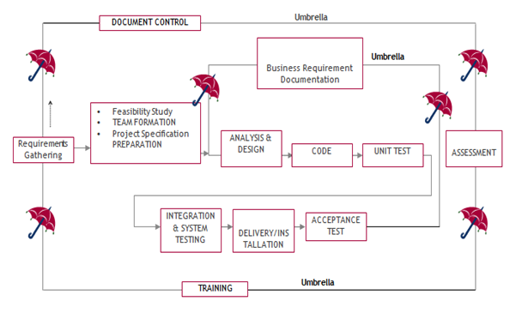
SDLC is nothing but Software Development Life Cycle. It is a standard which is used by software industry to develop good software.
Stages in SDLC:
- Requirement Gathering
- Analysis
- Designing
- Coding
- Testing
- Maintenance
Requirements Gathering stage:
The requirements gathering process takes as its input the goals identified in the high-level requirements section of the project plan. Each goal will be refined into a set of one or more requirements. These requirements define the major functions of the intended application, define operational data areas and reference data areas, and define the initial data entities. Major functions include critical processes to be managed, as well as mission critical inputs, outputs and reports. A user class hierarchy is developed and associated with these major functions, data areas, and data entities. Each of these definitions is termed a Requirement. Requirements are identified by unique requirement identifiers and, at minimum, contain a requirement title and textual description. 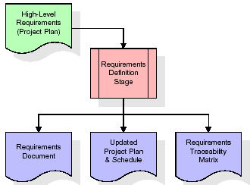
These requirements are fully described in the primary deliverables for this stage: the Requirements Document and the Requirements Traceability Matrix (RTM). The requirements document contains complete descriptions of each requirement, including diagrams and references to external documents as necessary. Note that detailed listings of database tables and fields are not included in the requirements document.
The title of each requirement is also placed into the first version of the RTM, along with the title of each goal from the project plan. The purpose of the RTM is to show that the product components developed during each stage of the software development lifecycle are formally connected to the components developed in prior stages.
In the requirements stage, the RTM consists of a list of high-level requirements, or goals, by title, with a listing of associated requirements for each goal, listed by requirement title. In this hierarchical listing, the RTM shows that each requirement developed during this stage is formally linked to a specific product goal. In this format, each requirement can be traced to a specific product goal, hence the term requirements traceability.
The outputs of the requirements definition stage include the requirements document, the RTM, and an updated project plan.
- Feasibility study is all about identification of problems in a project.
- No. of staff required to handle a project is represented as Team Formation, in this case only modules are individual tasks will be assigned to employees who are working for that project.
- Project Specifications are all about representing of various possible inputs submitting to the server and corresponding outputs along with reports maintained by administrator.
Analysis Stage:
The planning stage establishes a bird's eye view of the intended software product, and uses this to establish the basic project structure, evaluate feasibility and risks associated with the project, and describe appropriate management and technical approach
hes.
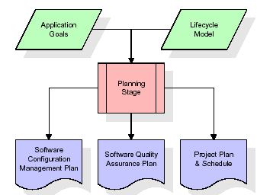
The most critical section of the project plan is a listing of high-level product requirements, also referred to as goals. All of the software product requirements to be developed during the requirements definition stage flow from one or more of these goals. The minimum information for each goal consists of a title and textual description, although additional information and references to external documents may be included. The outputs of the project planning stage are the configuration management plan, the quality assurance plan, and the project plan and schedule, with a detailed listing of scheduled activities for the upcoming Requirements stage, and high level estimates of effort for the out stages.
Designing Stage:
The design stage takes as its initial input the requirements identified in the approved requirements document. For each requirement, a set of one or more design elements will be produced as a result of interviews, workshops, and/or prototype efforts. Design elements describe the desired software features in detail, and generally include functional hierarchy diagrams, screen layout diagrams, tables of business rules, business process diagrams, pseudo code, and a complete entity-relationship diagram with a full data dictionary. These design elements are intended to describe the software in sufficient detail that skilled programmers may develop the software with minimal additional input.

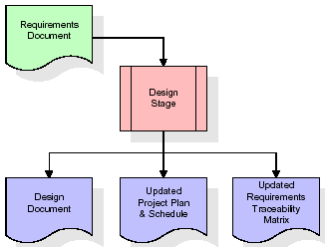

When the design document is finalized and accepted, the RTM is updated to show that each design element is formally associated with a specific requirement. The outputs of the design stage are the design document, an updated RTM, and an updated project plan.
Development (Coding) Stage:
The development stage takes as its primary input the design elements described in the approved design document. For each design element, a set of one or more software artifacts will be produced. Software artifacts include but are not limited to menus, dialogs, and data management forms, data reporting formats, and specialized procedures and functions. Appropriate test cases will be developed for each set of functionally related software artifacts, and an online help system will be developed to guide users in their interactions with the software.

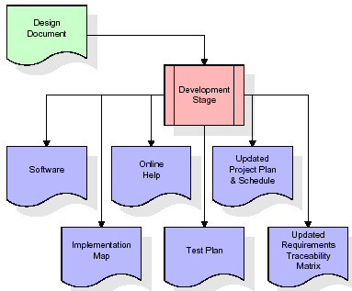
The RTM will be updated to show that each developed artifact is linked to a specific design element, and that each developed artifact has one or more corresponding test case items. At this point, the RTM is in its final configuration. The outputs of the development stage include a fully functional set of software that satisfies the requirements and design elements previously documented, an online help system that describes the operation of the software, an implementation map that identifies the primary code entry points for all major system functions, a test plan that describes the test cases to be used to validate the correctness and completeness of the software, an updated RTM, and an updated project plan.
Integration & Test Stage:
During the integration and test stage, the software artifacts, online help, and test data are migrated from the development environment to a separate test environment. At this point, all test cases are run to verify the correctness and completeness of the software. Successful execution of the test suite confirms a robust and complete migration capability. During this stage, reference data is finalized for production use and production users are identified and linked to their appropriate roles. The final reference data (or links to reference data source files) and production user list are compiled into the Production Initiation Plan.
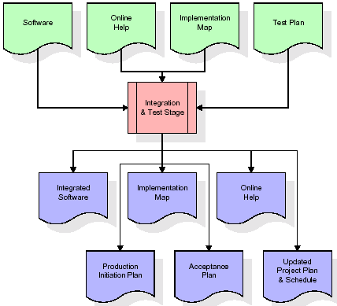
The outputs of the integration and test stage include an integrated set of software, an online help system, an implementation map, a production initiation plan that describes reference data and production users, an acceptance plan which contains the final suite of test cases, and an updated project plan.
- Installation & Acceptance Test:
During the installation and acceptance stage, the software artifacts, online help, and initial production data are loaded onto the production server. At this point, all test cases are run to verify the correctness and completeness of the software. Successful execution of the test suite is a prerequisite to acceptance of the software by the customer.
After customer personnel have verified that the initial production data load is correct and the test suite has been executed with satisfactory results, the customer formally accepts the delivery of the software.
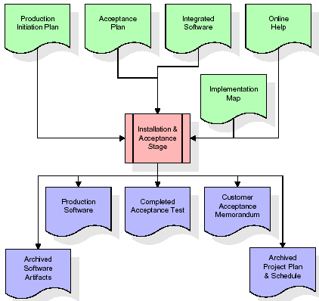
The primary outputs of the installation and acceptance stage include a production application, a completed acceptance test suite, and a memorandum of customer acceptance of the software. Finally, the PDR enters the last of the actual labor data into the project schedule and locks the project as a permanent project record. At this point the PDR "locks" the project by archiving all software items, the implementation map, the source code, and the documentation for future reference.
Maintenance:
Outer rectangle represents maintenance of a project, Maintenance team will start with requirement study, understanding of documentation later employees will be assigned work and they will undergo training on that particular assigned category. For this life cycle there is no end, it will be continued so on like an umbrella (no ending point to umbrella sticks).

PROJECT ARCHITECTURE
UML Diagram:
The Unified Modelling Language allows the software engineer to express an analysis model using the modelling notation that is governed by a set of syntactic semantic and pragmatic rules.
A UML system is represented using five different views that describe the system from distinctly different perspective. Each view is defined by a set of diagram, which is as follows.
  - User Model View
    - This view represents the system from the users perspective.
    - The analysis representation describes a usage scenario from the end-users perspective.
  - Structural Model view
    - In this model the data and functionality are arrived from inside the system.
    - This model view models the static structures.
- Behavioural Model View
It represents the dynamic of behavioural as parts of the system, depicting the interactions of collection between various structural elements described in the user model and structural model view.
- Implementation Model View
In this the structural and behavioural as parts of the system are represented as they are to be built.
- Environmental Model View
In this the structural and behavioural aspects of the environment in which the system is to be implemented are represented.
Class Diagram:
The class diagram is the main building block of object oriented modeling. It is used both for general conceptual modeling of the systematic of the application, and for detailed modeling translating the models into programming code. Class diagrams can also be used for data modeling. The classes in a class diagram represent both the main objects, interactions in the application and the classes to be programmed. In the diagram, classes are represented with boxes which contain three parts:
- The upper part holds the name of the class
- The middle part contains the attributes of the class
- The bottom part gives the methods or operations the class can take or undertake.

Use case Diagram:
A use case diagram at its simplest is a representation of a user's interaction with the system and depicting the specifications of a use case. A use case diagram can portray the different types of users of a system and the various ways that they interact with the system. This type of diagram is typically used in conjunction with the textual use case and will often be accompanied by other types of diagrams as well.

Sequence diagram:
A sequence diagram is a kind of interaction diagram that shows how processes operate with one another and in what order. It is a construct of a Message Sequence Chart. A sequence diagram shows object interactions arranged in time sequence. It depicts the objects and classes involved in the scenario and the sequence of messages exchanged between the objects needed to carry out the functionality of the scenario. Sequence diagrams are typically associated with use case realizations in the Logical View of the system under development. Sequence diagrams are sometimes called event diagrams, event scenarios, and timing diagrams.

Collaboration diagram:
A collaboration diagram describes interactions among objects in terms of sequenced messages. Collaboration diagrams represent a combination of information taken from class, sequence, and use case diagrams describing both the static structure and dynamic behaviour of a system.

Collaboration diagram:
A collaboration diagram describes interactions among objects in terms of sequenced messages. Collaboration diagrams represent a combination of information taken from class, sequence, and use case diagrams describing both the static structure and dynamic behaviour of a system.

Component Diagram:
In the Unified Modelling Language, a component diagram depicts how components are wired together to form larger components and or software systems. They are used to illustrate the structure of arbitrarily complex systems.
Components are wired together by using an assembly connector to connect the required interface of one component with the provided interface of another component. This illustrates the service consumer - service provider relationship between the two components.

Deployment Diagram:
A deployment diagram in the Unified Modeling Language models the physical deployment of artifacts on nodes. To describe a web site, for example, a deployment diagram would show what hardware components ("nodes") exist (e.g., a web server, an application server, and a database server), what software components ("artifacts") run on each node (e.g., web application, database), and how the different pieces are connected (e.g. JDBC, REST, RMI).
The nodes appear as boxes, and the artifacts allocated to each node appear as rectangles within the boxes. Nodes may have sub nodes, which appear as nested boxes. A single node in a deployment diagram may conceptually represent multiple physical nodes, such as a cluster of database servers.

Activity Diagram:
Activity diagram is another important diagram in UML to describe dynamic aspects of the system. It is basically a flow chart to represent the flow form one activity to another activity. The activity can be described as an operation of the system. So the control flow is drawn from one operation to another. This flow can be sequential, branched or concurrent

Upload Dataset

Preprocess Dataset

Features Extraction

Run SVM Algorithm

Run Random Forest Algorithm

Run Naive Bayes
Run XGBOOST
Run Graph
Comparison Graph
Predict From Test Data

DESCRIPTION

Input
The system uses an RGB image-based dataset representing disaster scenarios with collapsed structures. The dataset contains images of human body parts such as head, hand, leg, upper body, and non-human regions found under debris.
Reading
The input images are loaded into the system for further processing. This step ensures that the dataset is correctly accessed and prepared for analysis.
Preprocessing:
Preprocessing operations such as image resizing and normalization are applied to enhance image quality and maintain consistency across the dataset. Data augmentation is also performed to improve robustness against variations in lighting, orientation, and occlusion.
Feature
Transfer learning is applied using a pre-trained ResNet-50 deep learning model to extract meaningful and high-level visual features from the RGB images. This approach reduces the need for large training datasets while maintaining effective feature representation.
Feature
A decision tree-based feature selection technique is used to select the most relevant features from the extracted deep features. This process reduces redundancy and improves classification efficiency.
Classification:
The selected features are classified using machine learning algorithms to determine the presence and type of human victims under debris environments.
Output:
The final output of the system displays the detected human victim class from the input images, supporting rescue teams in identifying trapped victims efficiently.

DATA FLOW DIAGRAM
Data flow diagrams illustrate how data is processed by a system in terms of inputs and outputs. Data flow diagrams can be used to provide a clear representation of any business function. The technique starts with an overall picture of the business and continues by analyzing each of the functional areas of interest. This analysis can be carried out in precisely the level of detail required. The technique exploits a method called top-down expansion to conduct the analysis in a targeted way.
As the name suggests, Data Flow Diagram (DFD) is an illustration that explicates the passage of information in a process. A DFD can be easily drawn using simple symbols. Additionally, complicated processes can be easily automated by creating DFDs using easy-to-use, free downloadable diagramming tools. A DFD is a model for constructing and analyzing information processes. DFD illustrates the flow of information in a process depending upon the inputs and outputs. A DFD can also be referred to as a Process Model. A DFD demonstrates business or technical process with the support of the outside data saved, plus the data flowing from the process to another and the end results.

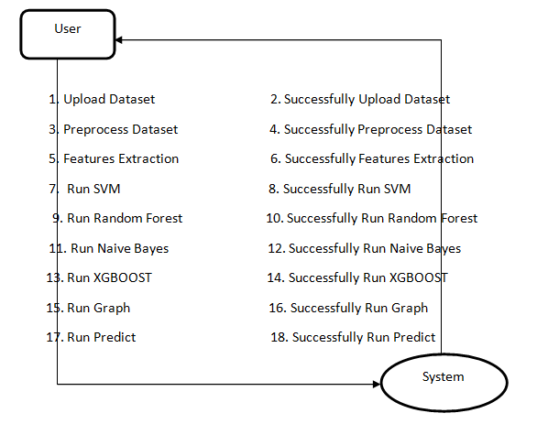

IMPLEMENTATION

IMPLEMENTATION

The implementation phase of a project involves executing the planned strategies and tasks. It requires meticulous coordination, resource allocation, and monitoring to ensure that objectives are met efficiently. Effective implementation is crucial for achieving project goals and delivering expected outcomes within the set timeline and budget constraints.

ALGORITHMS USED
The proposed system uses a combination of deep learning and machine learning algorithms to achieve accurate and efficient human victim detection under debris environments. The algorithms are selected to reduce computational complexity while maintaining high classification accuracy.
ResNet-50 (Transfer Learning)
ResNet-50 is a pre-trained deep learning model used in this project for feature extraction. Instead of training a deep neural network from scratch, transfer learning is applied to reuse the knowledge learned from large-scale image datasets. The ResNet-50 model extracts high-level and discriminative visual features from RGB images of disaster environments. These features represent important visual patterns related to human body parts under debris, enabling effective victim identification with reduced training time and data requirements.
Decision Tree Algorithm (Feature Selection)
The decision tree algorithm is used for feature selection in the proposed system. After deep features are extracted using ResNet-50, the decision tree-based method identifies the most relevant features while removing redundant and irrelevant ones. This step reduces feature dimensionality and computational cost, improving the overall efficiency of the classification process.
Decision Tree Classifier
The decision tree classifier is used to classify the selected features into different victim-related classes. It makes decisions based on a tree-like structure of rules derived from the feature values. This classifier provides fast execution and interpretability, making it suitable for real-time disaster victim detection.
Random Forest Algorithm
Random Forest is an ensemble learning algorithm that combines multiple decision trees to improve classification accuracy and robustness. In this project, it is used to enhance performance by reducing overfitting and improving generalization when classifying human victim data.
Support Vector Machine (SVM)
Support Vector Machine is used as a machine learning classifier to separate different victim classes based on the selected features. SVM is effective in handling high-dimensional feature spaces and contributes to accurate classification in complex disaster environments.
Multilayer Perceptron (MLP)
The Multilayer Perceptron is a neural network-based machine learning classifier used in the system. It consists of multiple layers of neurons that learn non-linear relationships between features, supporting effective classification of human victim and non-human regions.
XGBoost Algorithm
XGBoost is a gradient boosting-based machine learning algorithm used to improve classification accuracy and efficiency. It combines multiple weak learners to form a strong classifier and is included in the system to compare performance with other machine learning algorithms.

To train all algorithm we have used below victim images consist of three folders (Figure 4.1)
called ‘body,leg and hand’ and below screen showing dataset details
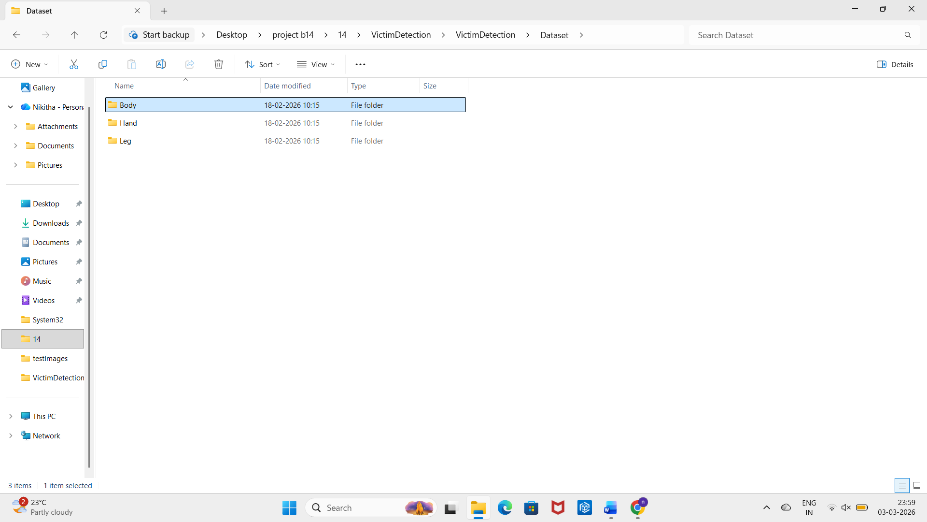

Figure 4.1: Dataset directory structure with folders 'body,hand and leg Content' having all the training examples
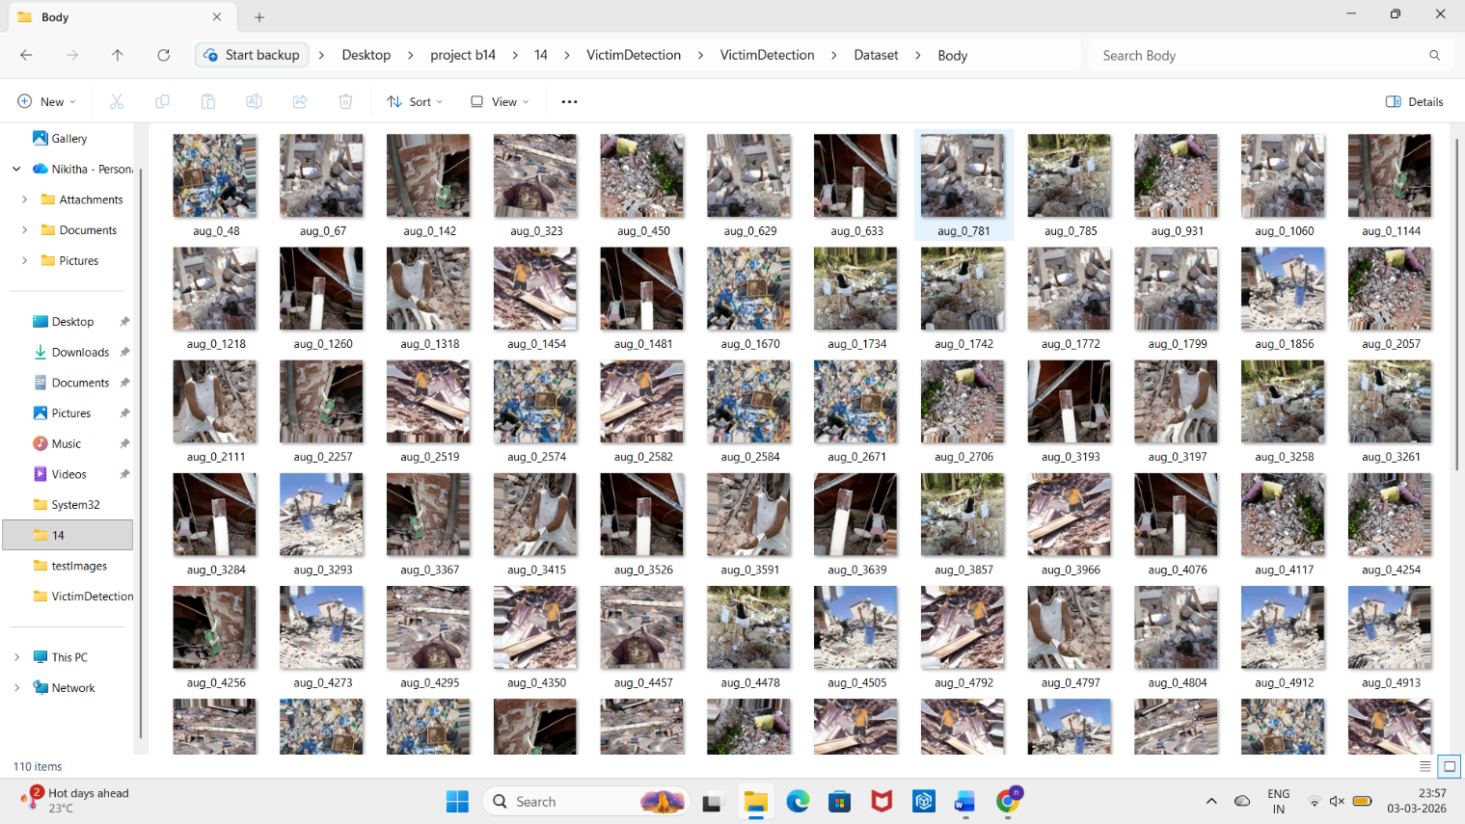
Figure 4.2: Screenshot of the "" Folder Showing Sample Image Files

To implement this project we have designed following modules:
1) Upload Human Victim RGB Image Dataset:
Using this module, the RGB image dataset representing disaster environments is uploaded into the application. The dataset contains images of human body parts such as head, hand, leg, upper body, and non-human regions under debris conditions.
2) Dataset Preprocessing:
In this module, all uploaded images are read and preprocessed. The images are resized to a uniform size to maintain consistency across the dataset. Image normalization is applied to standardize pixel values, and the dataset is shuffled to ensure proper distribution of training and testing samples.
3) Run ResNet-50 Feature Extraction Algorithm:
Using this module, the dataset is divided into training and testing sets. Around 80% of the data is used for training and 20% for testing. The training images are passed to the pre-trained ResNet-50 deep learning model using transfer learning to extract high-level visual features representing human victim characteristics.
4) Run Decision Tree Feature Selection Algorithm:
In this module, the deep features extracted from ResNet-50 are processed using a decision tree-based feature selection method. This step selects the most relevant features and removes redundant ones, reducing computational complexity and improving classification efficiency.
5) Run Machine Learning Classification Algorithms:
The selected features are trained and tested using different machine learning classifiers such as Decision Tree, Random Forest, Support Vector Machine (SVM), Multilayer Perceptron (MLP), and XGBoost. Each classifier predicts whether the image contains human victim body parts or non-human regions.
6) Performance Comparison Graph:
Using this module, the system generates a comparison graph that shows the accuracy performance of different classifiers. This helps in identifying the most effective model for human victim detection.
7) Human Victim Detection from Test Images:
In this module, the user can upload a new test image representing a disaster environment. The trained model analyzes the image and predicts the presence and type of human victim body part or identifies it as a non-human region.

4.2 SAMPLE CODE
from tkinter import *
import tkinter
from tkinter import filedialog
import matplotlib.pyplot as plt
from tkinter.filedialog import askopenfilename
from sklearn.tree import DecisionTreeClassifier
from sklearn.feature_selection import SelectFromModel
import seaborn as sns
import os
from sklearn.metrics import confusion_matrix
import cv2
import numpy as np
from keras.utils.np_utils import to_categorical
from keras.layers import MaxPooling2D
from keras.layers import Dense, Dropout, Activation, Flatten, GlobalAveragePooling2D, BatchNormalization
from keras.layers import Convolution2D
from keras.models import Sequential, load_model, Model
import pickle
from sklearn.metrics import precision_score
from sklearn.metrics import recall_score
from sklearn.metrics import f1_score
from sklearn.metrics import accuracy_score
from sklearn.model_selection import train_test_split
from keras.callbacks import ModelCheckpoint
import keras
from sklearn.metrics import accuracy_score
from sklearn.model_selection import train_test_split
from keras.applications import ResNet50
from sklearn.neural_network import MLPClassifier
from sklearn import svm
from sklearn.ensemble import RandomForestClassifier
import xgboost as xg
import pandas as pd

main = tkinter.Tk()
main.title("A Novel Approach for Disaster Victim Detection Under Debris Environments Using Decision Tree Algorithms With Deep Learning Features")
main.geometry("1200x1200")

labels = ['Body', 'Hand', 'Leg']
global filename, X, Y, X_train, y_train, X_test, y_test
global resnet_model, accuracy, precision, recall, fscore, resnet_features
global X_train, X_test, y_train, y_test

def getLabel(name):
index = -1
for i in range(len(labels)):
if labels[i] == name:
index = i
break
return index

def uploadDataset():
global filename, X, Y
filename = filedialog.askdirectory(initialdir=".")
pathlabel.config(text=filename)
text.delete('1.0', END)
text.insert(END,filename+" loaded\n\n")
if os.path.exists('model/X.txt.npy'):
X = np.load('model/X.txt.npy')
Y = np.load('model/Y.txt.npy')
else:
X = []
Y = []
for root, dirs, directory in os.walk(path):
for j in range(len(directory)):
name = os.path.basename(root)
if 'Thumbs.db' not in directory[j]:
img = cv2.imread(root+"/"+directory[j])
img = cv2.resize(img, (32, 32))
X.append(img)
label = getLabel(name)
Y.append(label)
X = np.asarray(X)
Y = np.asarray(Y)
np.save('model/X.txt',X)
np.save('model/Y.txt',Y)
text.insert(END,"Total images loaded = "+str(X.shape[0])+"\n")
text.insert(END,"Victim Parts Found in Dataset : "+str(labels))
unique, count = np.unique(Y, return_counts = True)
height = count
bars = labels
y_pos = np.arange(len(bars))
plt.figure(figsize=(6,3))
plt.bar(y_pos, height)
plt.xticks(y_pos, bars)
plt.xlabel("Victim Dataset Graphs")
plt.ylabel("Count")
plt.title("Dataset Class Label Graph")
plt.tight_layout()
plt.show()

def processDataset():
global X, Y
text.delete('1.0', END)
X = X.astype('float32')
X = X/255
indices = np.arange(X.shape[0])
np.random.shuffle(indices)
X = X[indices]
Y = Y[indices]
Y = to_categorical(Y)
text.insert(END,"Images pixels shuffling & normalizations completed\n\n")
text.insert(END,"Total features found in each image = "+str(X.shape[1] * X.shape[2] * X.shape[3])+"\n\n")

def featuresExtraction():
global X, Y, resnet_model, resnet_features
resnet_model = ResNet50(input_shape=(X.shape[1], X.shape[2], X.shape[3]), include_top=False, weights='imagenet')
for layer in resnet_model.layers:
layer.trainable = False
resnet_model = Sequential()
resnet_model.add(Convolution2D(32, (3, 3), input_shape = (X.shape[1], X.shape[2], X.shape[3]), activation = 'relu'))
resnet_model.add(MaxPooling2D(pool_size = (2, 2)))
resnet_model.add(Convolution2D(32, (3, 3), activation = 'relu'))
resnet_model.add(MaxPooling2D(pool_size = (2, 2)))
resnet_model.add(Flatten())
resnet_model.add(Dense(units = 256, activation = 'relu'))
resnet_model.add(Dense(units = Y.shape[1], activation = 'softmax'))
resnet_model.compile(optimizer = 'adam', loss = 'categorical_crossentropy', metrics = ['accuracy'])
if os.path.exists("model/resnet_weights.hdf5") == False:
model_check_point = ModelCheckpoint(filepath='model/resnet_weights.hdf5', verbose = 1, save_best_only = True)
hist = resnet_model.fit(X, Y, batch_size = 32, epochs = 20, validation_data=(X, Y), callbacks=[model_check_point], verbose=1)
f = open('model/resnet_history.pckl', 'wb')
pickle.dump(hist.history, f)
f.close()
else:
resnet_model.load_weights("model/resnet_weights.hdf5")
resnet_features = Model(resnet_model.inputs, resnet_model.layers[-2].output)#create resnet model
resnet_features = resnet_features.predict(X) #extracting resnet features
Y = np.argmax(Y, axis=1)
text.insert(END,"Total features extracted by ResNet50 from each Image : "+str(resnet_features.shape[1])+"\n\n")

def featuresSelection():
global resnet_features, Y
global X_train, X_test, y_train, y_test
dt_cls = DecisionTreeClassifier()
selector = SelectFromModel(dt_cls, threshold=0.00000005)
selector.fit(resnet_features, Y)#train algorithm using training features and target value
selected_features = selector.get_support()
resnet_features = resnet_features[:,selected_features] #extract selected features
text.insert(END,"Total features selected by Decision Tree (J48) Algorithm : "+str(resnet_features.shape[1])+"\n\n")
X_train, X_test, y_train, y_test = train_test_split(resnet_features, Y, test_size=0.2)
text.insert(END,"Dataset Training & Testing Details\n\n")
text.insert(END,"80% images for training : "+str(X_train.shape[0])+"\n")
text.insert(END,"20% images for testing : "+str(X_test.shape[0])+"\n")

#function to calculate all metrics
def calculateMetrics(algorithm, testY, predict):
global labels
p = precision_score(testY, predict,average='macro') * 100
r = recall_score(testY, predict,average='macro') * 100
f = f1_score(testY, predict,average='macro') * 100
a = accuracy_score(testY,predict)*100
accuracy.append(a)
precision.append(p)
recall.append(r)
fscore.append(f)
text.insert(END,algorithm+" Accuracy : "+str(a)+"\n")
text.insert(END,algorithm+" Precision : "+str(p)+"\n")
text.insert(END,algorithm+" Recall : "+str(r)+"\n")
text.insert(END,algorithm+" FSCORE : "+str(f)+"\n\n")
conf_matrix = confusion_matrix(testY, predict)
plt.figure(figsize =(6, 3))
ax = sns.heatmap(conf_matrix, xticklabels = labels, yticklabels = labels, annot = True, cmap="viridis" ,fmt ="g");
ax.set_ylim([0,len(labels)])
plt.title(algorithm+" Confusion matrix")
plt.xticks(rotation=90)
plt.ylabel('True class')
plt.xlabel('Predicted class')
plt.show()

def runSVM():
global X_train, X_test, y_train, y_test
global accuracy, precision, recall, fscore
text.delete('1.0', END)
accuracy = []
precision = []
recall = []
fscore = []
svm_cls = svm.SVC(C=102.0, tol=1.9)
svm_cls.fit(X_train, y_train)
predict = svm_cls.predict(X_test)
calculateMetrics("SVM", y_test, predict)

def runRandomForest():
rf_cls = RandomForestClassifier()
rf_cls.fit(X_train, y_train)
predict = rf_cls.predict(X_test)
calculateMetrics("Random Forest", y_test, predict)

def runNaiveBayes():
mlp_cls = MLPClassifier(hidden_layer_sizes=2)
mlp_cls.fit(X_train, y_train)
predict = mlp_cls.predict(X_test)
calculateMetrics("MLP", y_test, predict)

def runExtension():
global accuracy, precision, recall, fscore, X_train, X_test, y_train, y_test
X_train, X_test1, y_train, y_test1 = train_test_split(resnet_features, Y, test_size=0.1)
xg_model = xg.XGBClassifier() #create XGBOost object
xg_model.fit(X_train, y_train)
predict = xg_model.predict(X_test)
calculateMetrics("Extension XGBoost", y_test, predict)

def graph():
global accuracy, precision, recall, fscore, rmse
df = pd.DataFrame([['SVM','Precision',precision[0]],['SVM','Recall',recall[0]],['SVM','F1 Score',fscore[0]],['SVM','Accuracy',accuracy[0]],
['Random Forest','Precision',precision[1]],['Random Forest','Recall',recall[1]],['Random Forest','F1 Score',fscore[1]],['Random Forest','Accuracy',accuracy[1]],
['Naive Bayes','Precision',precision[2]],['Naive Bayes','Recall',recall[2]],['Naive Bayes','F1 Score',fscore[2]],['Naive Bayes','Accuracy',accuracy[2]],
['Extension XGBoost','Precision',precision[3]],['Extension XGBoost','Recall',recall[3]],['Extension XGBoost','F1 Score',fscore[3]],['Extension XGBoost','Accuracy',accuracy[3]],
],columns=['Algorithms','Performance Output','Value'])
df.pivot("Algorithms", "Performance Output", "Value").plot(kind='bar')
plt.show()

def predict():
global resnet_model, labels
filename = filedialog.askopenfilename(initialdir="testImages")
pathlabel.config(text=filename)
text.delete('1.0', END)
img = cv2.imread(filename)
img = cv2.resize(img, (32,32))#resize image
im2arr = np.array(img)
im2arr = im2arr.reshape(1,32,32,3)
img = np.asarray(im2arr)
img = img.astype('float32')
img = img/255 #normalizing test image
predict = resnet_model.predict(img)#now using cnn model to detcet tumor damage
predict = np.argmax(predict)
img = cv2.imread(filename)
img = cv2.resize(img, (600,400))
cv2.putText(img, 'Victim Part Detected : '+labels[predict], (100, 25), cv2.FONT_HERSHEY_SIMPLEX,0.7, (0, 0, 255), 2)
cv2.imshow("Predicted Output", img)
cv2.waitKey(0)

font = ('times', 15, 'bold')
title = Label(main, text='A Novel Approach for Disaster Victim Detection Under Debris Environments Using Decision Tree Algorithms With Deep Learning Features')
title.config(bg='brown', fg='white')
title.config(font=font)
title.config(height=3, width=120)
title.place(x=30,y=5)

font1 = ('times', 13, 'bold')
upload = Button(main, text="Upload Victim Detection Dataset", command=uploadDataset)
upload.place(x=50,y=100)
upload.config(font=font1)

pathlabel = Label(main)
pathlabel.config(bg='brown', fg='white')
pathlabel.config(font=font1)
pathlabel.place(x=480,y=100)

processButton = Button(main, text="Features Processing & Normalizaton", command=processDataset)
processButton.place(x=50,y=150)
processButton.config(font=font1)

resnetButton = Button(main, text="Extract Features from ResNet50", command=featuresExtraction)
resnetButton.place(x=350,y=150)
resnetButton.config(font=font1)

dtButton = Button(main, text="Features Selection Decision Tree", command=featuresSelection)
dtButton.place(x=650,y=150)
dtButton.config(font=font1)

svmButton = Button(main, text="Run SVM Algorithm", command=runSVM)
svmButton.place(x=50,y=200)
svmButton.config(font=font1)

rfButton = Button(main, text="Run Random Forest", command=runRandomForest)
rfButton.place(x=350,y=200)
rfButton.config(font=font1)

nbButton = Button(main, text="Run MLP Algorithm", command=runNaiveBayes)
nbButton.place(x=650,y=200)
nbButton.config(font=font1)

xgboostButton = Button(main, text="Run Extension XGBoost", command=runExtension)
xgboostButton.place(x=50,y=250)
xgboostButton.config(font=font1)

graphButton = Button(main, text="Comparison Graph", command=graph)
graphButton.place(x=350,y=250)
graphButton.config(font=font1)

predictButton = Button(main, text="Victim Detection from Test Image", command=predict)
predictButton.place(x=650,y=250)
predictButton.config(font=font1)

font1 = ('times', 12, 'bold')
text=Text(main,height=20,width=150)
scroll=Scrollbar(text)
text.configure(yscrollcommand=scroll.set)
text.place(x=10,y=300)
text.config(font=font1)

main.config(bg='brown')
main.mainloop()

RESULTS & DISCUSSION

RESULTS & DISCUSSION

The following screenshots showcase the results of our project, highlighting key features and functionalities. These visual representations provide a clear overview of how the system performs under various conditions, demonstrating its effectiveness and user interface. The screenshots serve as a visual aid to support the project's technical and operational achievements.

GUI/Main Interface :
In below screen, click on ‘Upload Victim detection & Inappropriate Content Dataset’
button to upload dataset.

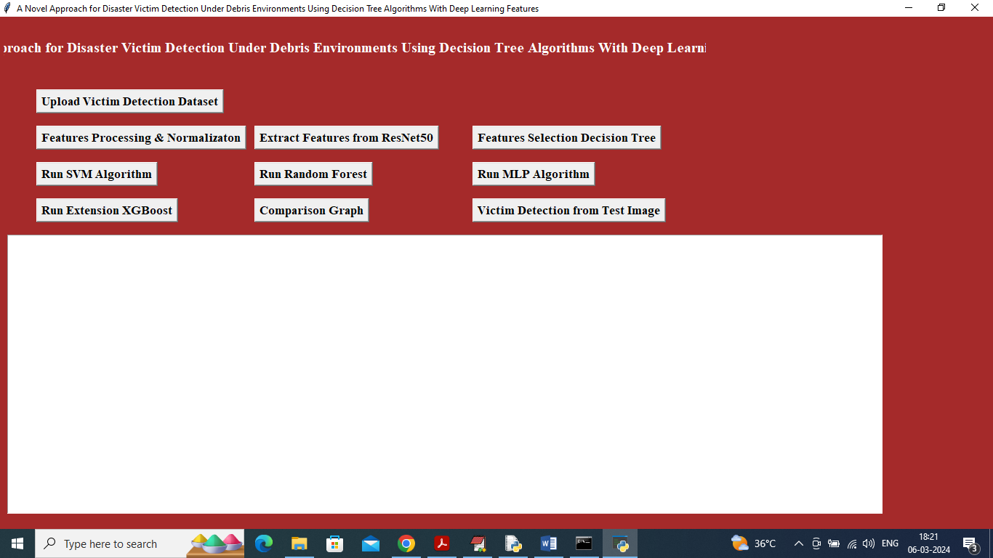

Figure 5.1 : In above screen click on ‘Upload Victim Detection Dataset’ button to upload dataset and get below output

Uploading Dataset :
In below screen, selecting and uploading entire ‘Dataset’ folder and then click on ‘Select Folder’ button to load dataset.

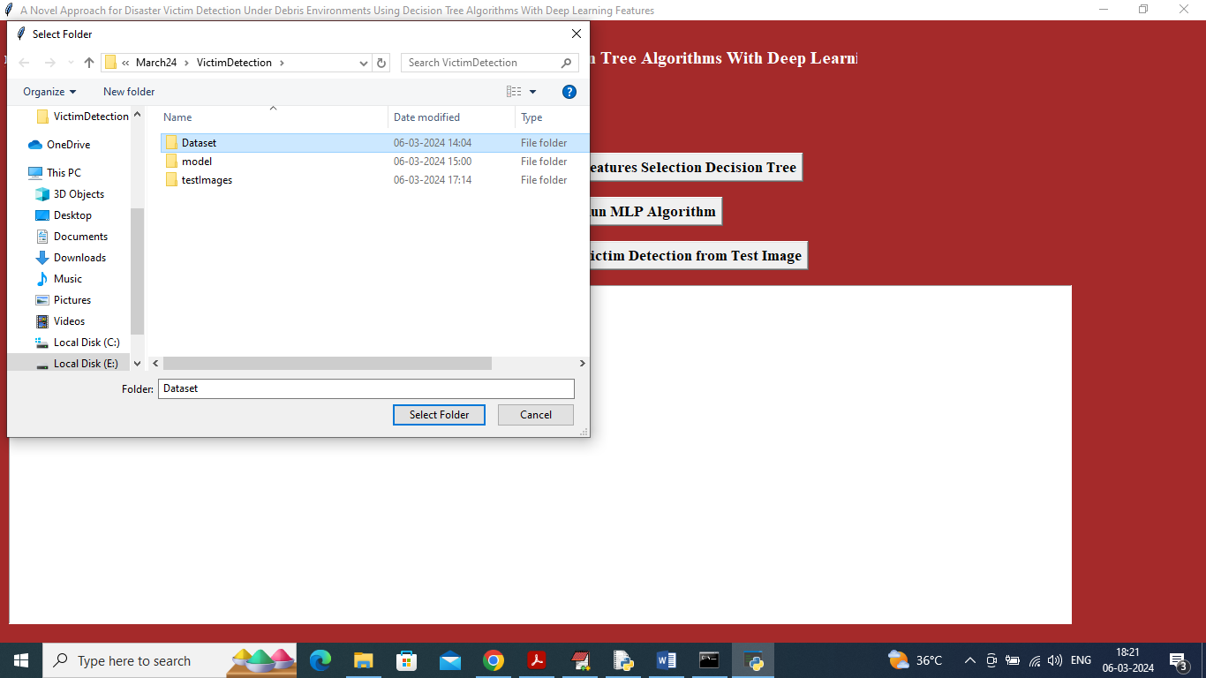

Figure 5.2 : In above screen selecting and uploading Dataset and then click on ‘Select Folder’ button to load dataset and get below page

Dataset :
In below screen, dataset loaded and now click on ‘Dataset Preprocessing’ button to read all images and then processes those images for training.

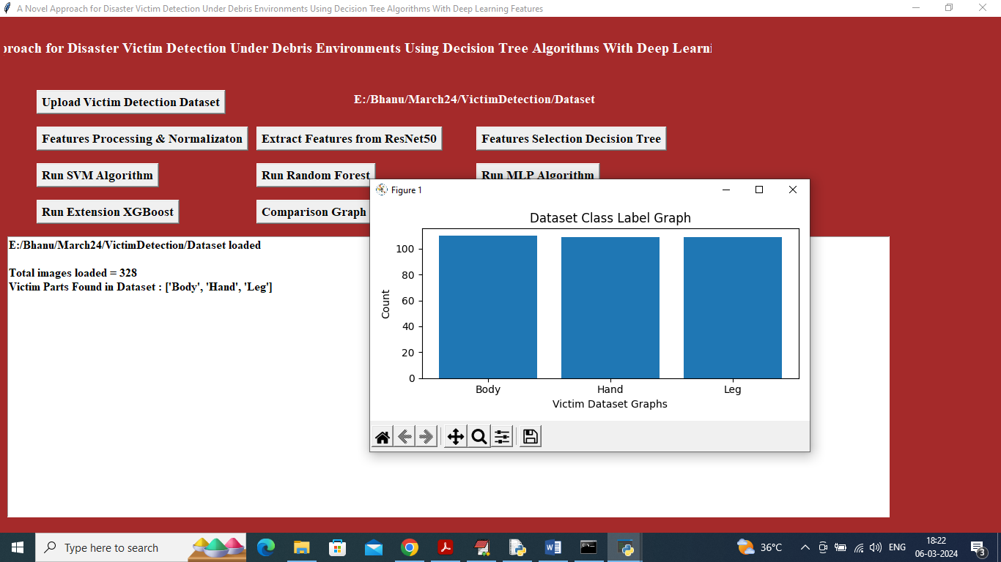

Figure 5.3 : In above screen can see dataset contains 328 images of various part labels and in graph x-axis represents victim part names and y-axis represents count of images under that category and now close above graph and then click on ‘Features Processing & Normalization’ to process features and get below page

Display of No. Of Items and Labels Present:

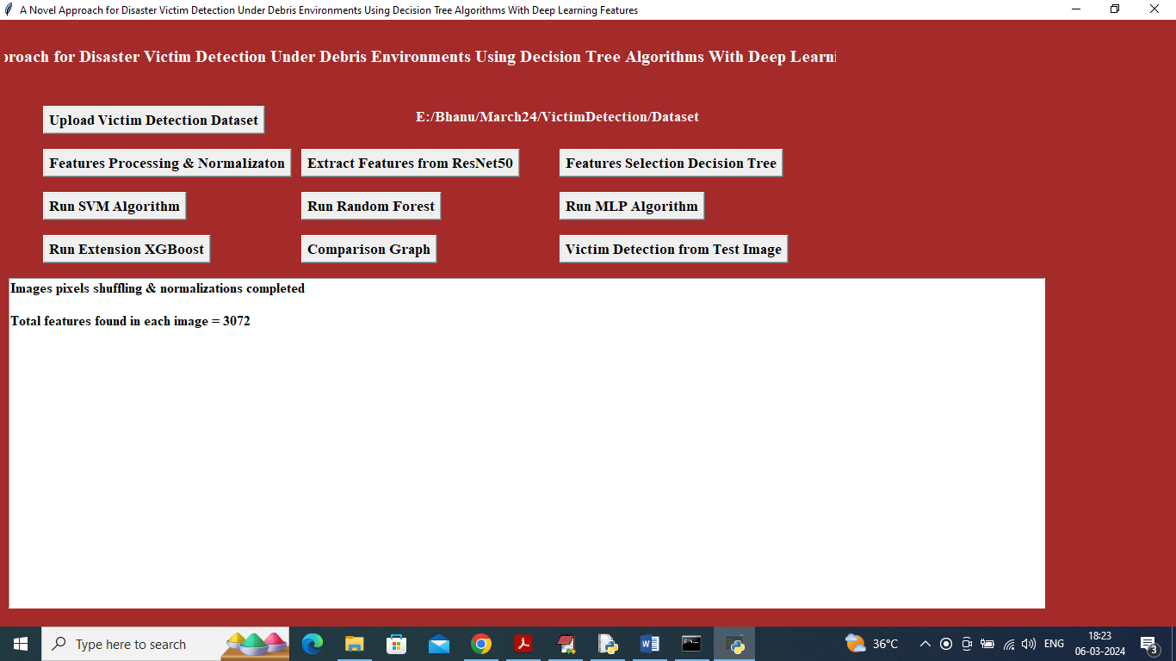

Figure 5.4 : In above screen application read 3072 features from each image and then input this features to ResNet50 algorithm to extract features and get below page

Total features:

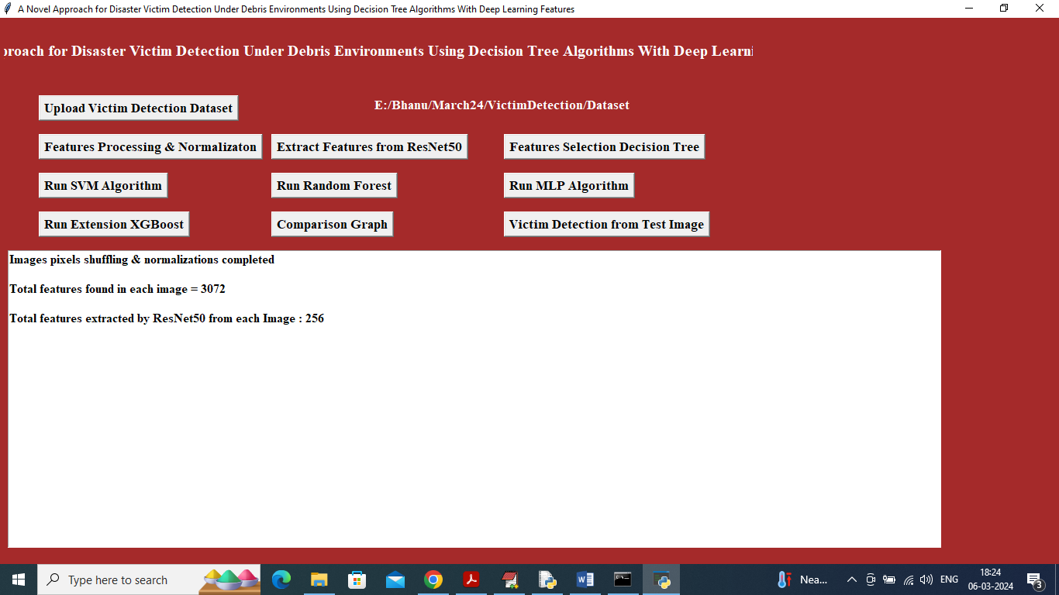

Figure 5.5 : In above screen Resnet50 extracted relevant 256 features from given 3072 original features and now click on ‘Features Selection Decision Tree’ button to select relevant features out of 256

Evaluation Metrics and Confusion Matrix of the proposed EfficientNet-BiLSTM Model :
In below screen, with EfficientNetB7-SVM we got 88% accuracy and in confusion matrix graph we can see in blue boxes that SVM predicted total 24 incorrect prediction so its accuracy is less. Now close above graph and then click on ‘Comparison Graph’ button.

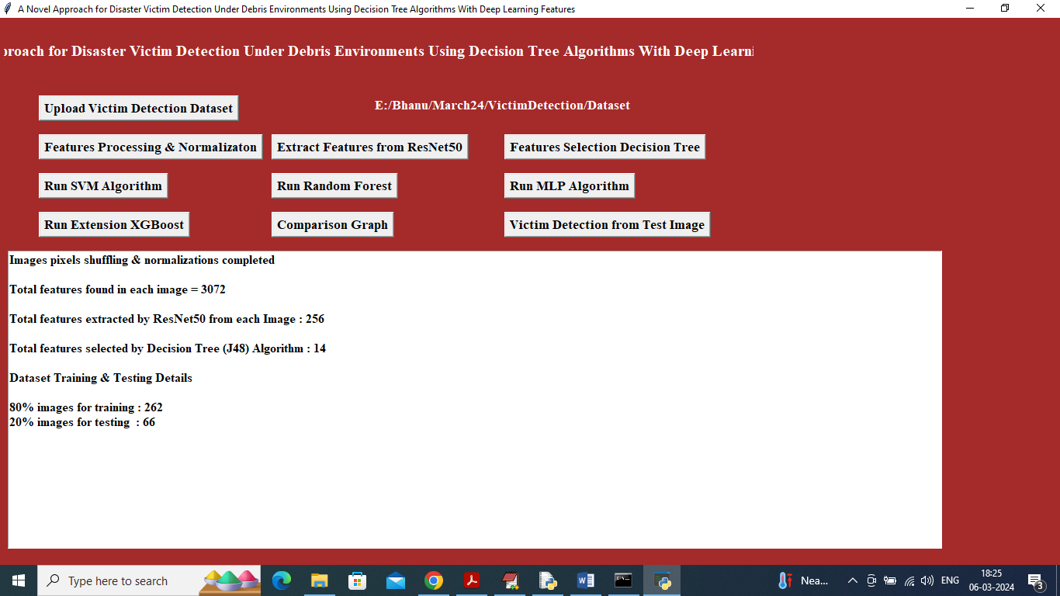
Figure 5.6 :
In above screen from 256 J48 Decision Tree selected 14 features and then can see Train and test size and now click on ‘Run SVM Algorithm’ button to get below page

Evaluation Metrics and Confusion Matrix of the EfficientNet-SVM Model :

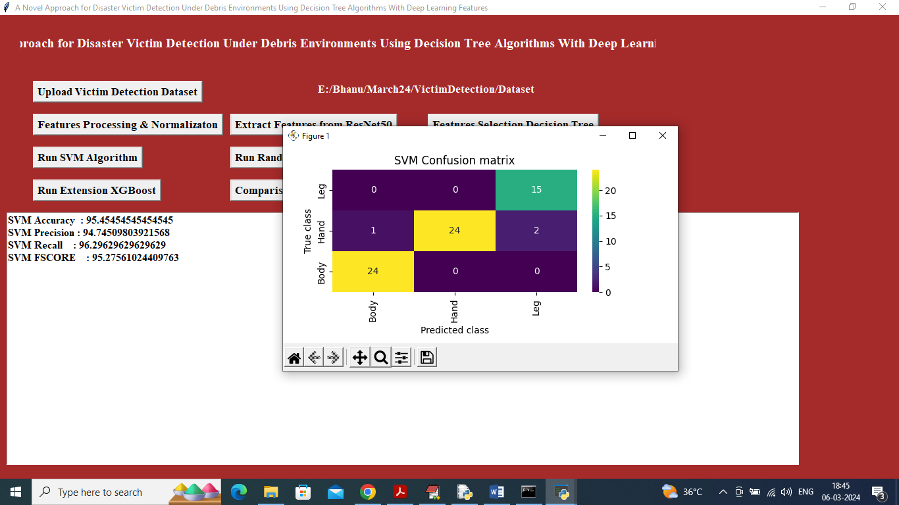

Figure 5.7 : In above screen SVM training completed and it got 95% accuracy on test images and can see other metrics like precision, recall and FSCORE. In confusion matrix graph x-axis represents Predicted Labels and y-axis represents true labels and then all different colour boxes in diagnol represents correct prediction count and remaining all blue boxes contains incorrect prediction count. Now click on ‘Run Random Forest’ button to get below output

Evaluation Metrics and Confusion Matrix of the EfficientNet-Random forest Model :

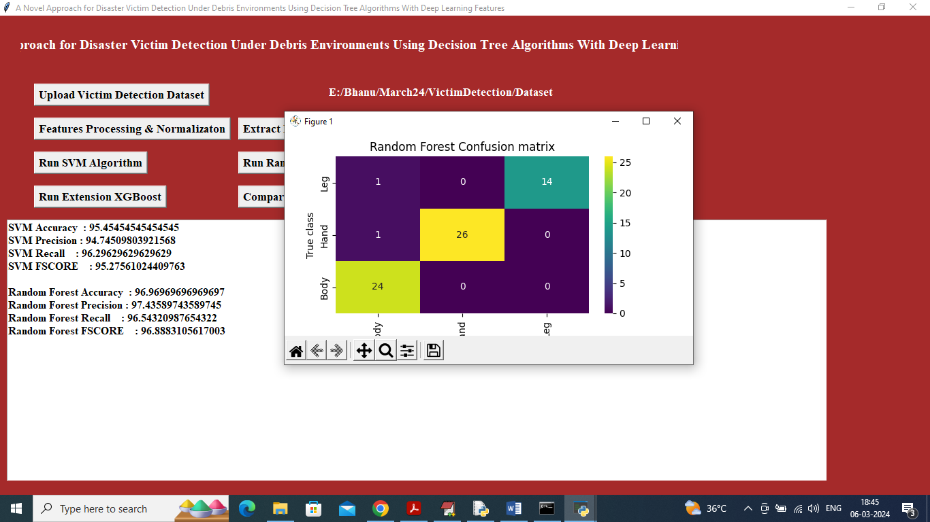

Figure 5.8 : In above screen Random Forest also got 96% accuracy and now click on ‘Run MLP Algorithm’ button to get below output

Run Extension Algorithm :

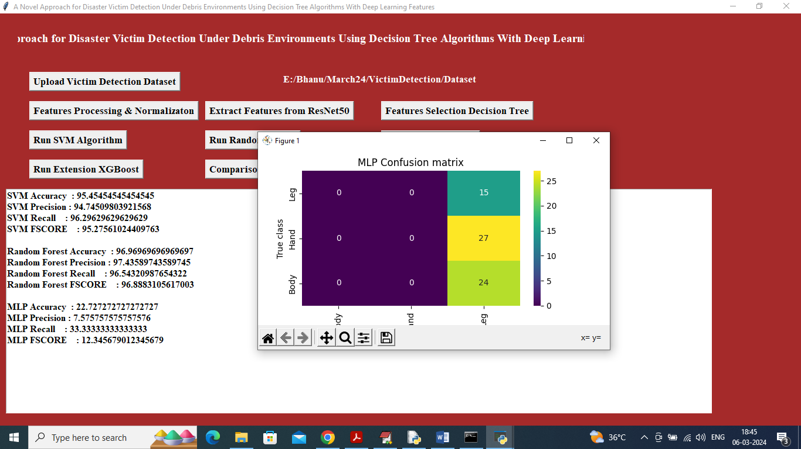

Figure 5.9 : In above screen MLP got 22% accuracy and now click on ‘Run Extension Algorithm’ button to get below output

5.10 Extension XGBOOST Confusion Matrix
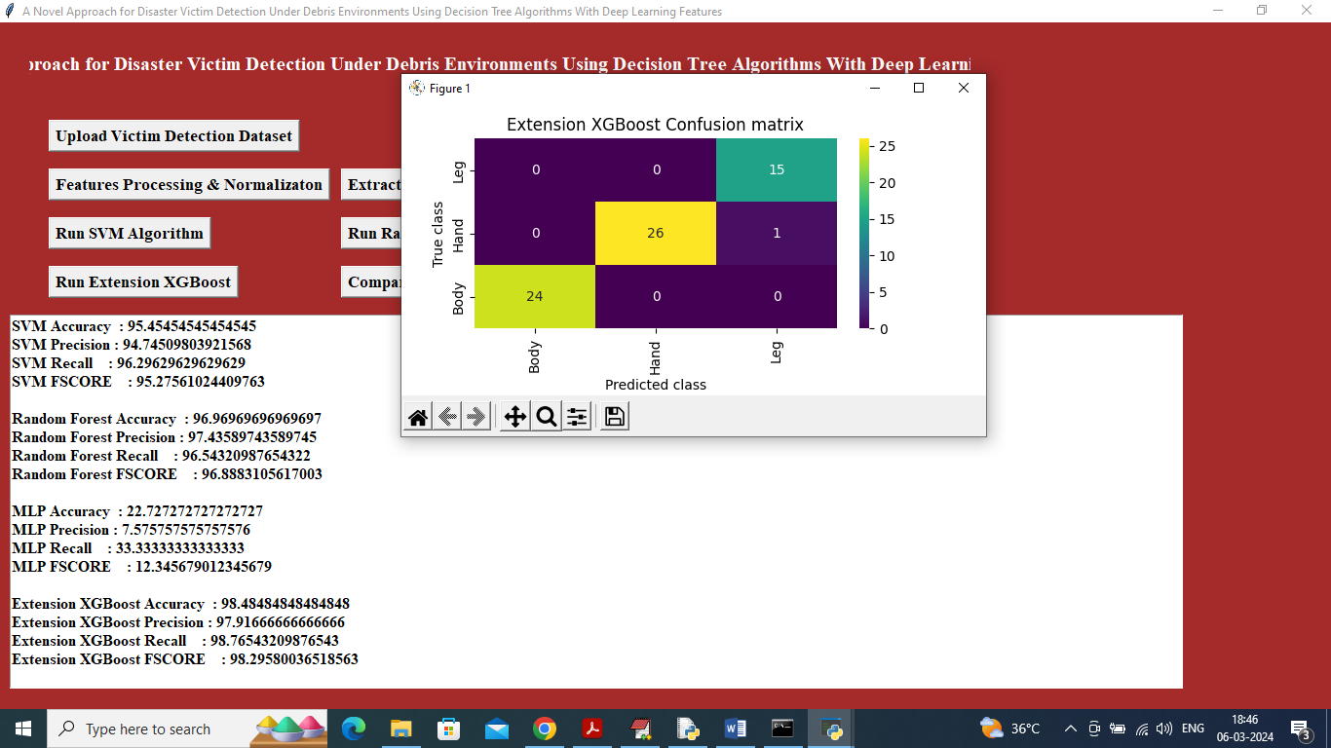

Figure 5.10:In above screen extension XGBOOST got 98% accuracy and can click on ‘Comparison Graph’ button to get below graph

5.11 Comparison of models:

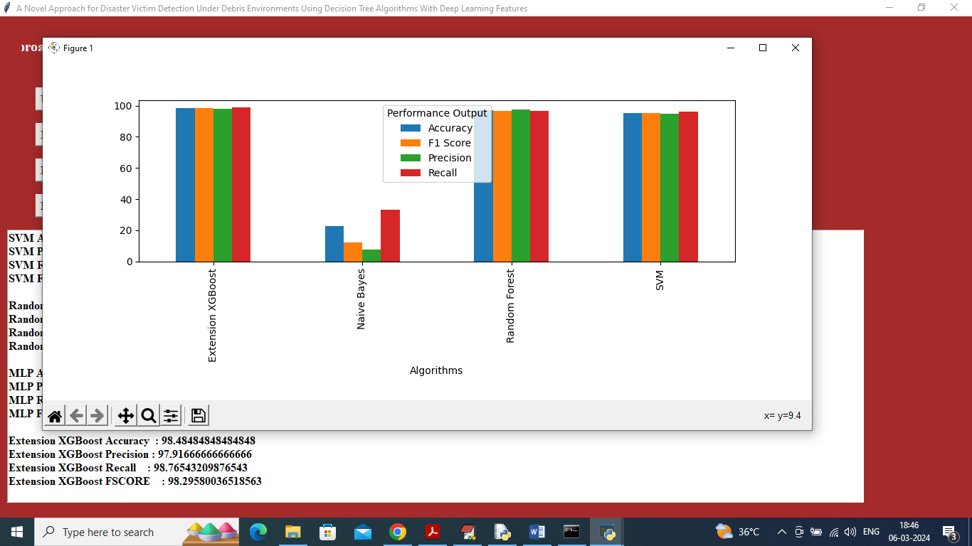

Figure 5.11:In above screen x-axis represents algorithm names and y-axis represents accuracy and other metrics in different colour and in all algorithms XGBOOST got high accuracy and now click on ‘Victim Detection from Test Image’ button to upload test image and get below output

5.12 Selecting and uploading:

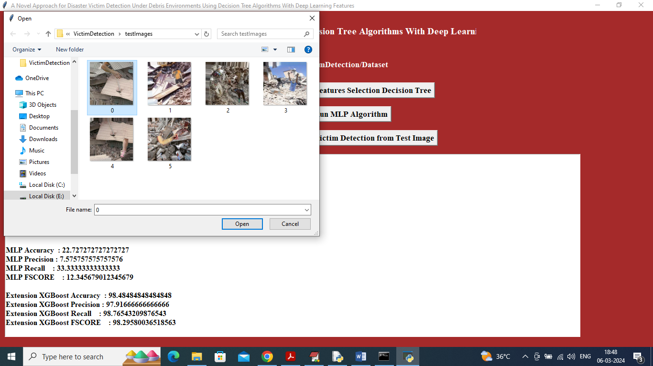

Figure 5.12 : In above screen selecting and uploading 0.jpg file and then click on ‘Open’ button to get below output

5.13 Victim part detected:

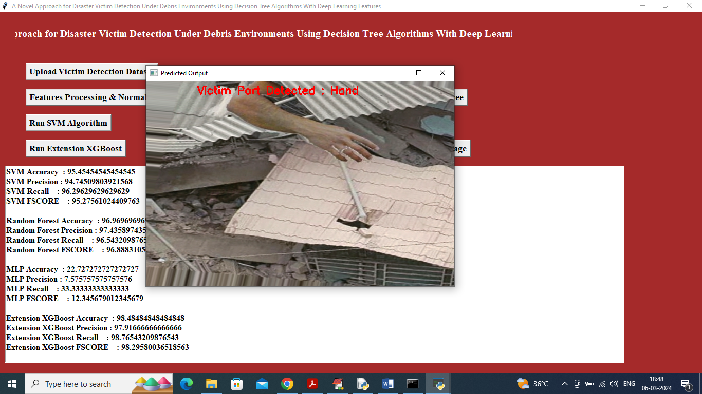
Figure 5.13:In above screen in red colour text can see victim part detected as HAND and similarly you can upload and test other images
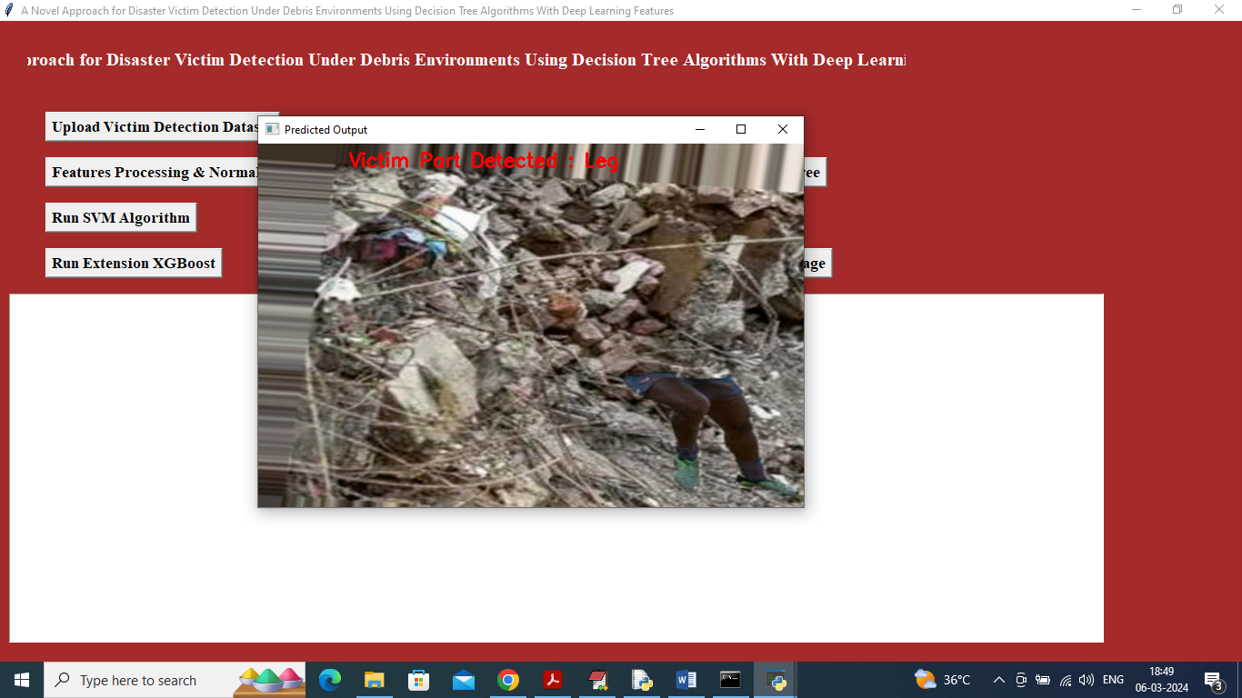
In above screen leg is detected

VALIDATION

VALIDATION

The validation of this project is performed through systematic testing to ensure the accuracy and effectiveness of the human victim detection system. The process includes dataset validation, model performance evaluation, and testing in simulated disaster scenarios. This structured validation approach helps ensure that the system reliably identifies human victims with high accuracy while reducing detection errors.

INTRODUCTION

The dataset is divided into training and testing sets using an 80–20 split. The training set is used to train the deep learning model, while the testing set evaluates its performance on unseen data. K-fold cross-validation is also applied to improve reliability and prevent overfitting, ensuring better generalization.
The system’s performance is measured using evaluation metrics such as precision, recall, F1-score, and confusion matrix analysis. These metrics help assess the accuracy of victim detection and identify classification errors for further improvement.
Finally, the model is tested in simulated real-world conditions to ensure reliable performance in disaster environments. Continuous testing and improvements help maintain high detection accuracy and support faster rescue operations.

6.2 TEST CASES
Testing is the process where the test data is prepared and is used for testing the modules individually and later the validation given for the fields. Then the system testing takes place which makes sure that all components of the system property functions as a unit. The test data should be chosen such that it passed through all possible condition. Actually testing is the state of implementation which aimed at ensuring that the system works accurately and efficiently before the actual operation commence. The following is the description of the testing strategies, which were carried out during the testing period.

TABLE 6.3.1 UPLOADING DATASET

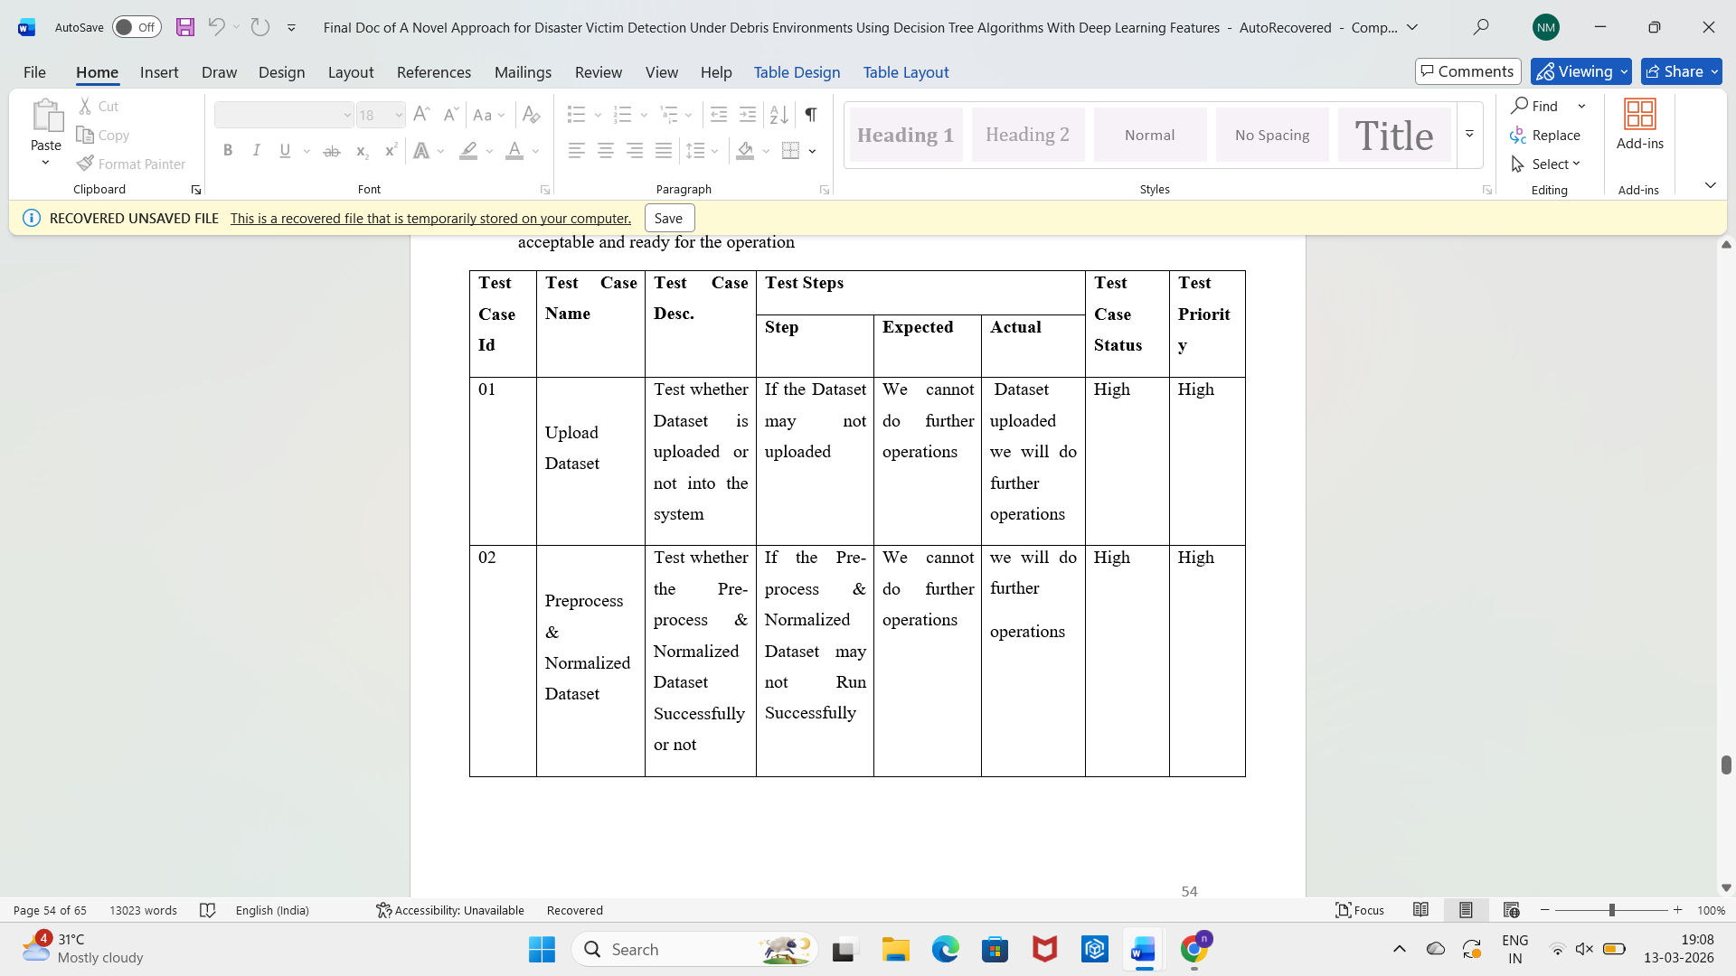



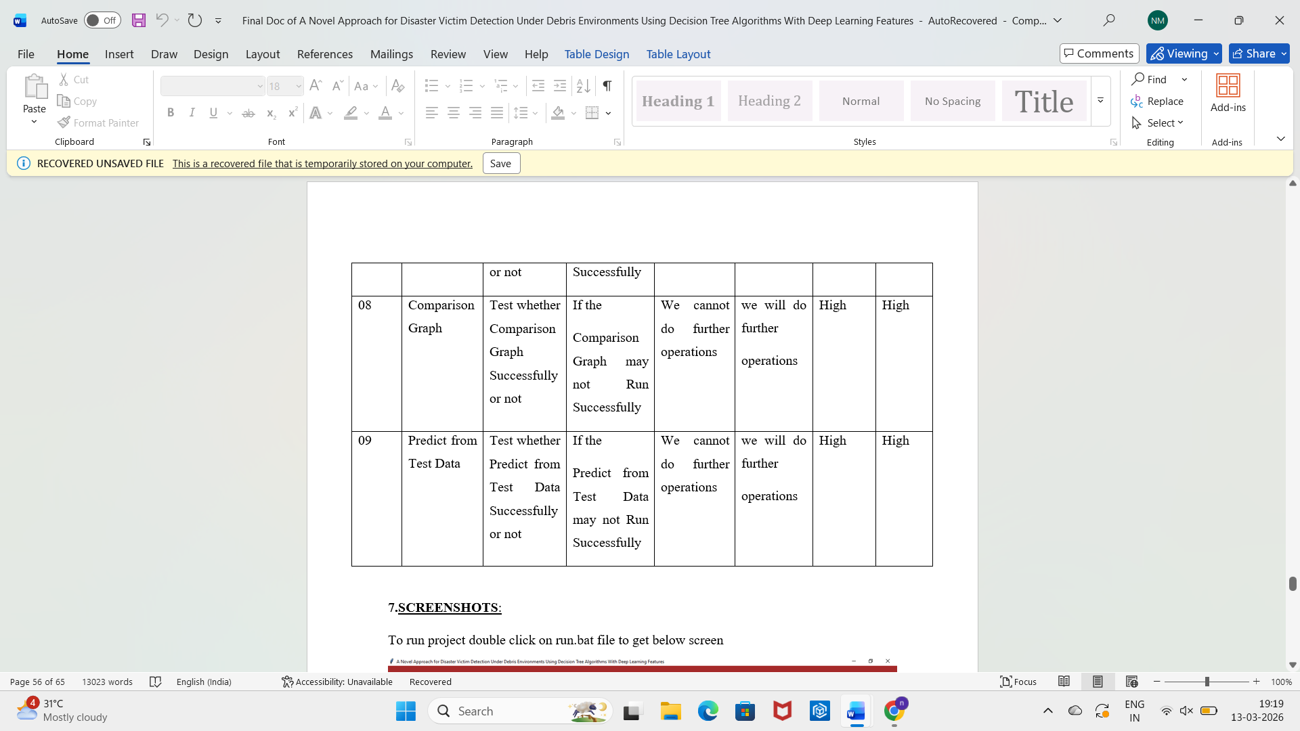

CONCLUSION & FUTURE ASPECTS

CONCLUSION & FUTURE ASPECTS
In conclusion, the project has successfully achieved its objectives, showcasing significant progress and outcomes. The implementation and execution phases were meticulously planned and executed, leading to substantial improvements and insights. Looking ahead, the future aspects of the project hold immense potential. Future developments will focus on expanding the scope, integrating new technologies, and enhancing sustainability. These advancements will not only strengthen the existing framework but also open new avenues for growth and innovation, ensuring the project remains relevant and impactful in the long term. This strategic approach will drive continuous improvement and success.

PROJECT CONCLUSION

This paper proposes a novel approach for disaster victim detection under debris environments using decision tree algorithms with deep learning features on a custom-made Human Victim Detection (HVD) dataset. This model aims to assist Urban Search and Rescue (USAR) teams in quickly finding human casualties in areas with collapsed buildings. The five categories of HVD images were head, hand, leg, whole body, and without the body. The HVD dataset was pre-processed with several data augmentation functions to increase the dataset’s size based on the application conditions, and it was subsequently downsized to fit with the pre-trained ResNet-50 network’s input requirements. To enhance the feature learning procedure, fine-tuning-based transfer learning was applied. The learned features were removed, and only the significant characteristics were selected for additional classifications based on machine learning. Random trees outperformed all other classifiers. Finally, it can be concluded that integrating the TL-based CNN features with ML classifiers can significantly improve classification performance. More accuracy in a shorter amount of time is ensured by the feature extraction method employing pre-trained ResNet-50. A maximum classification accuracy of 99.53% for all five test classes is provided using random tree methods in 0.02s. The results show that the proposed approach is feasible and reliable regarding accuracy and computation time. Though transfer learning is a promising expansion in the field of DL, helping learn features even from small datasets from the knowledge obtained from huge datasets, the proposed Human Victim Detection Approach (HVDA) dataset could be expanded further to include the maximum possible images.

7.2 FUTURE ASPECTS

Although the proposed system shows promising results, several improvements can be made in the future to enhance its performance and practical deployment.
The system can be extended by integrating additional sensor data such as thermal images, infrared cameras, or audio signals to improve detection accuracy in low-visibility environments. Future work can also focus on real-time implementation using drones or robotic rescue systems to automatically scan disaster areas.
Another possible improvement is expanding the dataset with more diverse images representing different disaster scenarios to increase the robustness of the model. Advanced deep learning architectures and hybrid models can also be explored to further improve classification performance.
In addition, integrating the system with disaster management platforms and rescue monitoring systems could provide real-time assistance to rescue teams, helping them locate victims more quickly and efficiently during emergency situations.

BIBLIOGRAPHY

BIBLIOGRAPHY

REFERENCES

[1] D. E. Alexander, Principles of Emergency Planning and Management. Oxford, U.K.: Oxford Univ. Press, 2002.
[2] G. Seeja, A. S. A. Doss, and V. B. Hency, ‘‘A survey on snake robot locomotion,’’ IEEE Access, vol. 10, pp. 112100–112116, 2022.
[3] A. Fung, L. Y. Wang, K. Zhang, G. Nejat, and B. Benhabib, ‘‘Using deep learning to find victims in unknown cluttered urban search and rescue environments,’’ Current Robot. Rep., vol. 1, no. 3, pp. 105–115, Sep. 2020.
[4] H. Liu, J. Liu, W. Yang, J. Chen, and M. Zhu, ‘‘Analysis and prediction of land use in Beijing–Tianjin–Hebei region: A study based on the improved convolutional neural network model,’’ Sustainability, vol. 12, no. 7, p. 3002, Apr. 2020, doi: 10.3390/su12073002.
[5] J. Zhang, S. Chen, R. Zhan, J. Hu, and J. Zhang, ‘‘Feature fusion based on convolutional neural network for SAR ATR,’’ in Proc. ITM Web Conf., 2017, p. 05001, doi: 10.1051/itmconf/20171205001.
[6] T. Arias-Vergara, P. Klumpp, J. C. Vasquez-Correa, E. Nöth, J. R. OrozcoArroyave, and M. Schuster, ‘‘Multi-channel spectrograms for speech processing applications using deep learning methods,’’ Pattern Anal. Appl., vol. 24, no. 2, pp. 423–431, May 2021.
[7] N. Lopac, F. Hržic, I. P. Vuksanovic, and J. Lerga, ‘‘Detection of non-stationary GW signals in high noise from Cohen’s class of timefrequency representations using deep learning,’’ IEEE Access, vol. 10, pp. 2408–2428, 2022.
[8] R. K. Samala, H.-P. Chan, L. M. Hadjiiski, M. A. Helvie, K. H. Cha, and C. D. Richter, ‘‘Multi-task transfer learning deep convolutional neural network: Application to computer-aided diagnosis of breast cancer on mammograms,’’ Phys. Med. Biol., vol. 62, no. 23, pp. 8894–8908, Nov. 2017, doi: 10.1088/1361-6560/aa93d4.
[9] G. De Cubber and G. Marton, ‘‘Human victim detection,’’ in Proc. 3rd Int. Workshop Robot. Risky Intervent. Environ. Surveill.-Maintenance (RISE), Jan. 2009.
[10] A. Kleiner, B. Steder, C. Dornhege, D. Höfer, D. Meyer-Delius, J. Prediger, J. Stückler, K. Glogowski, M. Thurner, M. Luber, M. Schnell, R. Kuemmerle, T. Burk, T. Bräuer, and B. Nebel, ‘‘RoboCupRescue— Robot league team RescueRobots Freiburg (Germany),’’ in Proc. RoboCup (CDROM), 2005, pp. 1–17.
[11] A. Visser, B. Slamet, T. Schmits, L. A. G. Jaime, A. Ethembabaoglu, and M. EarthquakeDisaster, ‘‘Design decisions of the UvA rescue 2007 team on the challenges of the virtual robot competition,’’ in Proc. 4th Int. Workshop Synth. Simul. Robot. Mitigate Earthq. Disaster, 2007, pp. 20–26.
[12] A. Birk, S. Markov, I. Delchev, and K. Pathak, ‘‘Autonomous rescue operations on the IUB rugbot,’’ in Proc. IEEE Int. Workshop Saf., Secur., Rescue Robot. (SSRR). IEEE Press, 2006.
[13] I. R. Nourbakhsh, K. Sycara, M. Koes, M. Yong, M. Lewis, and S. Burion, ‘‘Human–robot teaming for search and rescue,’’ IEEE Pervasive Comput., vol. 4, no. 1, pp. 72–79, Jan./Mar. 2005.
[14] D. R. Hartawan, T. W. Purboyo, and C. Setianingsih, ‘‘Disaster victims detection system using convolutional neural network (CNN) method,’’ in Proc. IEEE Int. Conf. Artif. Intell., Commun. Technol. (IAICT), Jul. 2019, pp. 105–111.
[15] N. Sharma, V. Jain, and A. Mishra, ‘‘An analysis of convolutional neural networks for image classification,’’ Proc. Comput. Sci., 132, pp. 377–384, Jan. 2018.
[16] A. Krizhevsky, I. Sutskever, and G. E. Hinton, ‘‘ImageNet classification with deep convolutional neural networks,’’ Commun. ACM, vol. 60, no. 6, pp. 84–90, May 2017.
[17] D. Han, Q. Liu, and W. Fan, ‘‘A new image classification method using CNN transfer learning and web data augmentation,’’ Exp. Syst. Appl., vol. 95, pp. 43–56, Apr. 2018.
[18] M. Hussain, J. J. Bird, and D. R. Faria, ‘‘A study on CNN transfer learning for image classification,’’ in Proc. UK Workshop Comput. Intell. Cham, Switzerland: Springer, 2018, pp. 191–202.
[19] E. Rezende, G. Ruppert, T. Carvalho, F. Ramos, and P. de Geus, ‘‘Malicious software classification using transfer learning of ResNet-50 deep neural network,’’ in Proc. 16th IEEE Int. Conf. Mach. Learn. Appl. (ICMLA), Dec. 2017, pp. 1011–1014.

GITHUB

https://github.com/Nikitha-mandala/RTRP-project-python-Nikitha

