**Git CI/CD Pipeline Configuration Steps**

* In Repo Go to folder github/workflows which is under Code section

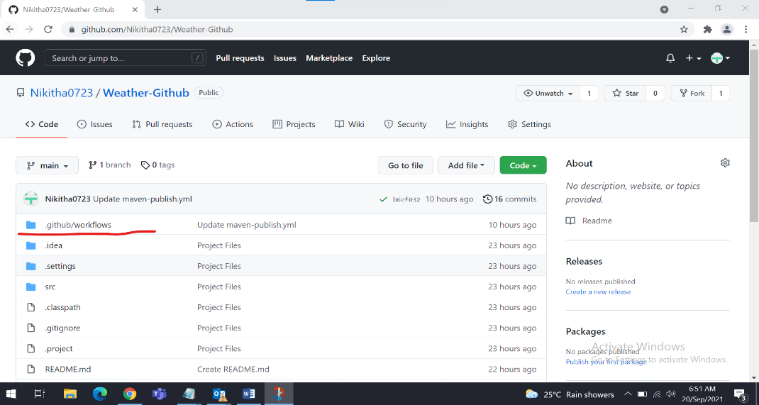

* Go to maven-publish.yml file

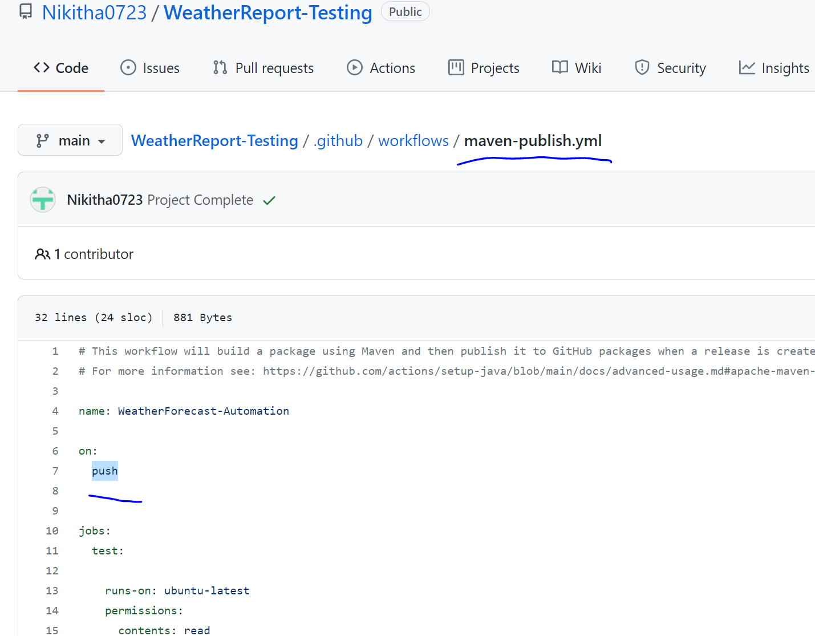

* On every Git commit this pipeline will trigger and we can see the job status under Actions section

