**Lab 8 Assignment**

Login, register and home page in application related to BMI calculator which we use in our project diet planner

Login page

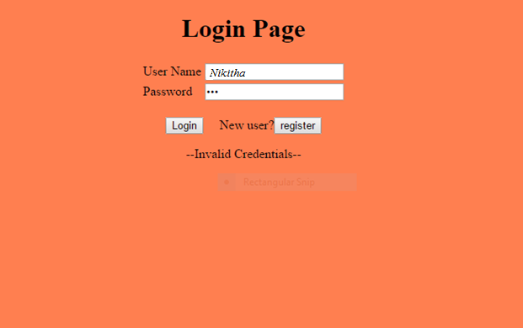

Register Page

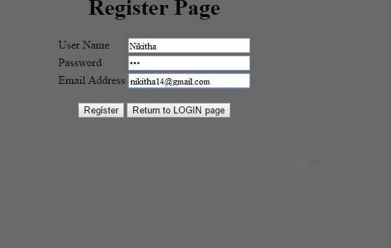

Register page consists of User name, password and email address which on entered and clicking on register, a new user get registered. We can go to login page and enter our results and login in to the application.

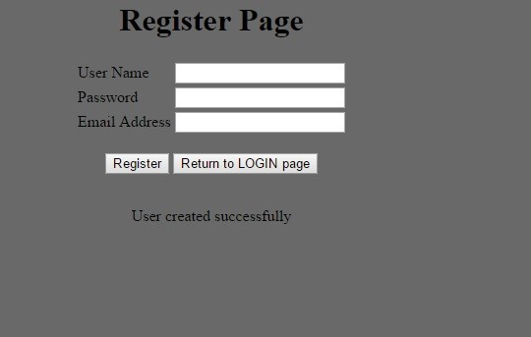

User Created successfully.

Diet Planner BMI (body mass Index) in which on entering height and weight results BMI index



