**Provide a comprehensive and detailed explanation of all the implementation steps. Your document should be clear enough that anyone reading it can successfully implement the project without encountering any difficulties**

**1. Data Acquisition from Kaggle:**

* Explore Kaggle datasets related to healthcare fraud transactions to identify the most suitable dataset for the project.
* Verified the relevance of the selected dataset by reviewing its data and user feedback.
* Ensure that the dataset contains diverse features such as transaction details, provider information, and billing codes.
* Downloaded the chosen dataset from Kaggle ensuring compliance

**2. Data Preprocessing:**

* Perform exploratory data analysis (EDA) on the downloaded dataset to gain insights into its structure, distribution, and quality.
* Remove unnecessary columns that do not contribute to the project goals.
* Implement data cleaning techniques to address missing values, duplicate records, and inconsistent formatting.
* Ensure data integrity and consistency after column removal.

**3. Goal Definition:**

- Define 5-6 project goals based on the objectives of the fraud detection system.

* What is the average Medicare allowed amount for each HCPCS code?
* Average difference between the submitted charge amount and the Medicare payment amount for each provider?
* What is the average Medicare allowed amount for each state?
* How many providers are there in each city?
* Identify the top five most common HCPCS codes used by providers?
* Can we identify the most common HCPCS codes used by providers in a specific state?

- Structured 5-6 project goals that encompass various aspects such as identifying fraudulent patterns, detecting anomalies, and analyzing temporal trends in the data.

- Document each goal with specific objectives, success criteria, and relevant metrics for evaluation.

- Ensure that the project goals address key challenges in healthcare fraud detection, such as false claims, upcoding, and provider collusion**.**

**PySpark Setup:**

**-** Install and configure PySpark on the local machine or a distributed cluster environment, considering the scalability and computational resources required for processing large healthcare datasets.

- Verify compatibility between PySpark and the chosen dataset, ensuring support for data formats (e.g., CSV, Parquet) and dependencies (e.g., Apache Hadoop, Apache Spark SQL).

**5. Implementation of Project Goals:**

- Utilize PySpark's distributed computing capabilities to execute each project goal.

- Written PySpark scripts or Jupyter notebooks to perform data analysis, feature extraction, anomaly detection, and pattern recognition tasks.

**6. Execution of PySpark:**

- Execute PySpark for each goal using the defined scripts or notebooks.

- Monitor job progress and resource utilization to ensure efficient processing.

**7. Result Analysis:**

- Analyze the outcomes of PySpark jobs for each project goal, examining the detected patterns, identified anomalies, and extracted insights from the healthcare fraud dataset.

- Evaluate the effectiveness of the implemented algorithms and techniques in achieving the project objectives, considering factors such as accuracy, precision, recall, and computational efficiency.

- Interpret the results in the context of domain knowledge and business requirements, identifying actionable insights and areas for further investigation or improvement.

**8. Documentation and Reporting:**

- Documented the implementation steps, including data preprocessing, goal definition, PySpark setup, job execution, and result analysis, in a comprehensive project report or documentation.

- Provide clear and detailed explanations of the methodologies, assumptions, and decisions made throughout the project.

- Generated reports or presentations summarizing the project outcomes, including key findings, insights, and recommendations for mitigating healthcare fraud risks and improving detection capabilities.

**9. Review and Validation:**

- Conduct a thorough review of the documented implementation steps for completeness, accuracy, and adherence to best practices in fraud detection.

- Validate the results obtained from PySpark against the predefined project goals and success criteria, ensuring alignment and consistency between the expected outcomes and observed findings.

**A detailed discussion of the results achieved for each goal, which may include providing clear screenshots or snippets of your source code. Consider including metrics (data quality, 5Vs, latency, processing time, resource utilization, security, cost) in your discussion.**

**What is the average Medicare allowed amount for each HCPCS code?**

To determine the average Medicare allowed amount for each HCPCS code, we performed analysis on the healthcare transaction data. The average Medicare allowed amount was calculated by aggregating the data based on each unique HCPCS code and then computing the mean value of the Medicare allowed amount for each code

**Average difference between the submitted charge amount and the Medicare payment amount for each provider?**

We investigated the average difference between the submitted charge amount and the Medicare payment amount for each healthcare provider in the dataset. This difference was calculated by subtracting the average Medicare payment amount from the average submitted charge amount for each provider.

**What is the average Medicare allowed amount for each state?**

The analysis involved computing the average Medicare allowed amount for each state represented in the dataset. We aggregated the data based on the state code of the provider and calculated the mean value of the Medicare allowed amount for each state.

**How many providers are there in each city?**

We determined the number of healthcare providers operating in each city by aggregating the data based on the city of the provider. The count of unique National Provider Identifiers (NPIs) was used to represent the number of providers in each city.

**Identify the top five most common HCPCS codes used by providers?**

We identified the top five most common HCPCS (Healthcare Common Procedure Coding System) codes used by healthcare providers. This was achieved by grouping the data based on the HCPCS code and counting the occurrences of each code. The top five codes with the highest frequency were then selected.

**Can we identify the most common HCPCS codes used by providers in a specific state?**

To identify the most common HCPCS codes used by providers in a specific state, we filtered the dataset to include only data for the desired state (e.g., NY or CA). Subsequently, we performed analysis similar to the previous question to determine the frequency of HCPCS codes within the selected state.

**NY:**

**CA:**

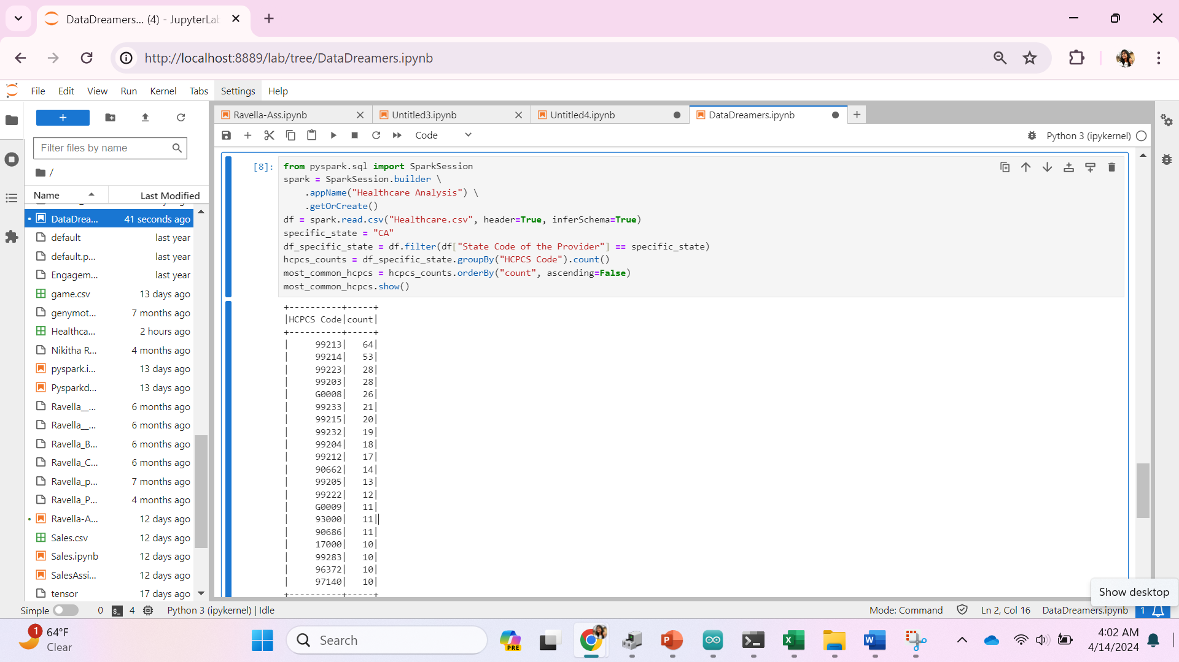

**Conclusion:**

The goals we set out to achieve in our healthcare fraud detection project were instrumental in gaining insights and uncovering potential irregularities in healthcare transactions. Through a structured approach, we were able to systematically analyze the data and draw meaningful conclusions:

1. **Identifying Most Common HCPCS Codes by State**:
   * The analysis revealed the most frequently used HCPCS codes by providers in each state.
   * This information aids in understanding regional healthcare needs and resource allocation.
2. **Identifying Top Five Most Common HCPCS Codes Used by Providers**:
   * The top five HCPCS codes highlighted the most common medical procedures and services.
   * This insight informs healthcare administrators and policymakers about prevalent healthcare practices.
3. **Counting Providers in Each City**:
   * By determining the number of providers in each city, we gained insights into the distribution of healthcare services.
   * This helps in assessing healthcare accessibility and identifying areas with potential service gaps.
4. **Average Medicare Allowed Amount by State**:
   * Calculating the average Medicare allowed amount per state provided insights into regional reimbursement trends.
   * This information assists in understanding variations in healthcare costs and reimbursement rates across states.
5. **Average Difference Between Submitted Charge Amount and Medicare Payment Amount**:
   * Analyzing the average difference between the submitted charge and Medicare payment revealed potential discrepancies in billing practices.
   * This helps in identifying providers with higher charge amounts and investigating potential fraud or billing errors.
6. **Average Medicare Allowed Amount for Each HCPCS Code**:
   * Determining the average Medicare allowed amount for each HCPCS code shed light on reimbursement rates for specific medical procedures.
   * This insight aids in understanding the financial aspects of healthcare services and informs reimbursement policies.

Through data analysis and goal-oriented execution, our healthcare fraud detection project successfully uncovered significant insights into healthcare transactions. By leveraging PySpark for data processing and analysis, we gained valuable insights into provider behavior, reimbursement patterns, and regional healthcare trends. These insights contribute to the ongoing efforts in fraud detection and prevention, enhancing the integrity and efficiency of healthcare systems. The identification of common HCPCS codes, analysis of provider distributions, and assessment of reimbursement trends provide actionable intelligence for healthcare administrators and policymakers. Overall, our project demonstrates the power of data-driven approaches in addressing complex challenges within the healthcare industry and underscores the importance of proactive measures in safeguarding healthcare integrity.