**Problem Statement 1**:

Execute any 5 queries on books dataset.

**Instancedir and collection**

https://github.com/NikithaPateel/Big_Data_Programming/raw/master/ICP_6/1.JPG

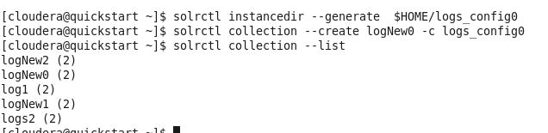

**Query 1:**

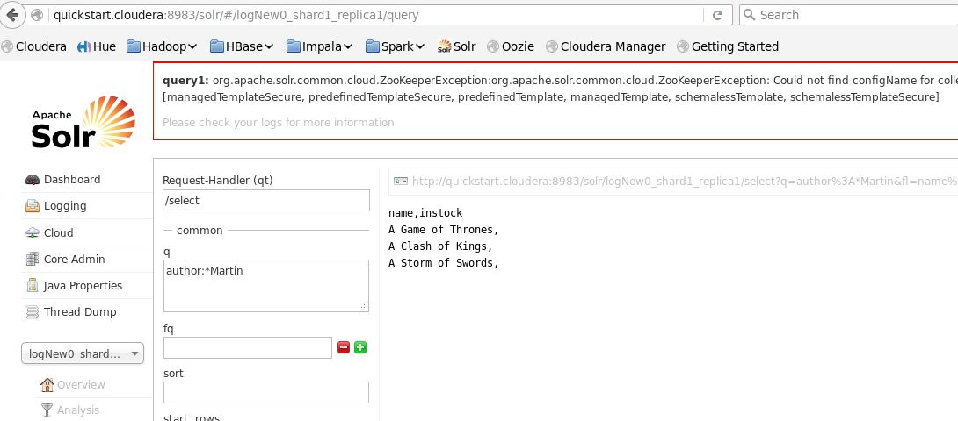

**Query 2:**

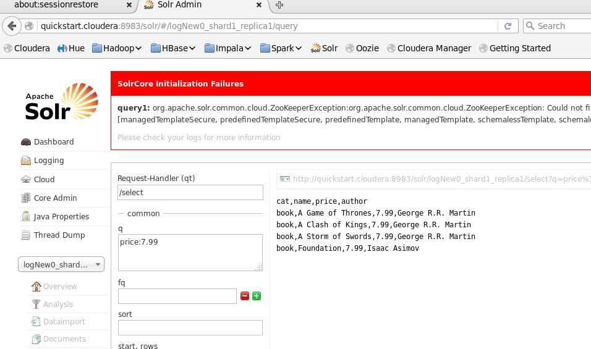

**Query 3:**

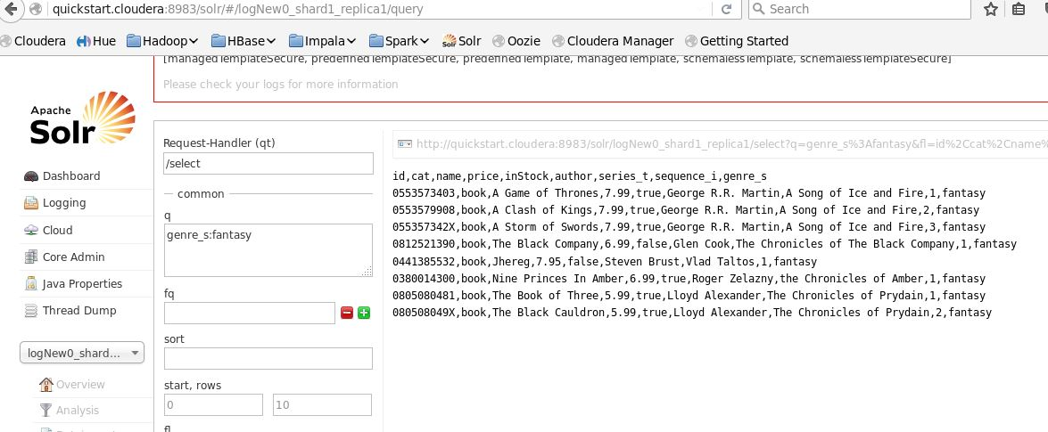

**Query 4:**

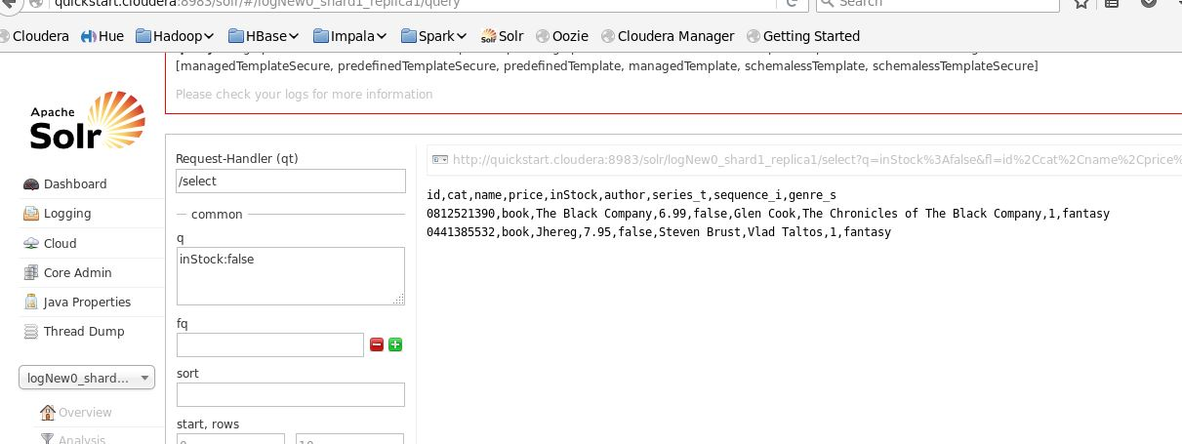

**Query 5:**

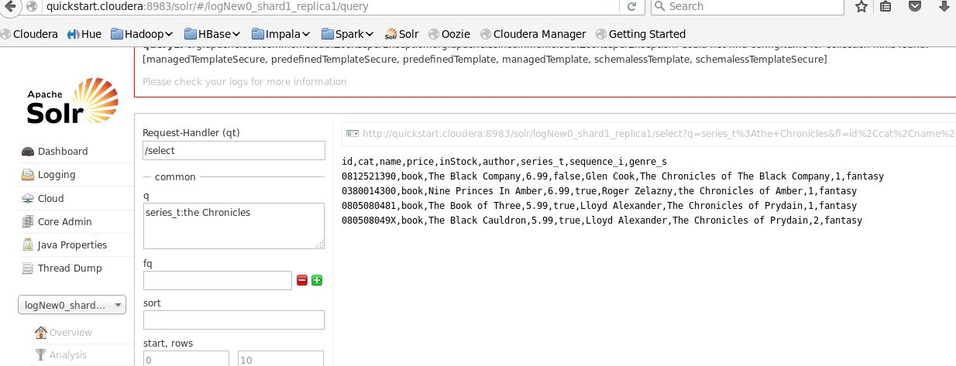

**Problem statement 2:**

Execute any 5 queries on books dataset.

**Instancedir and collection**

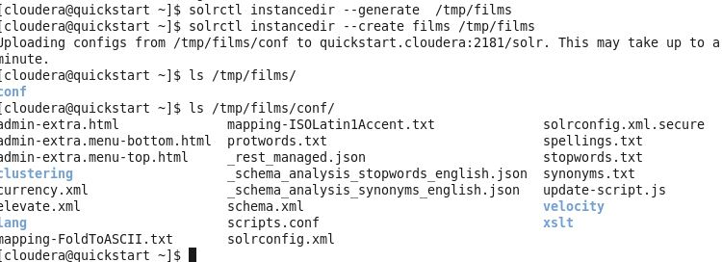

**Edit Schema:**

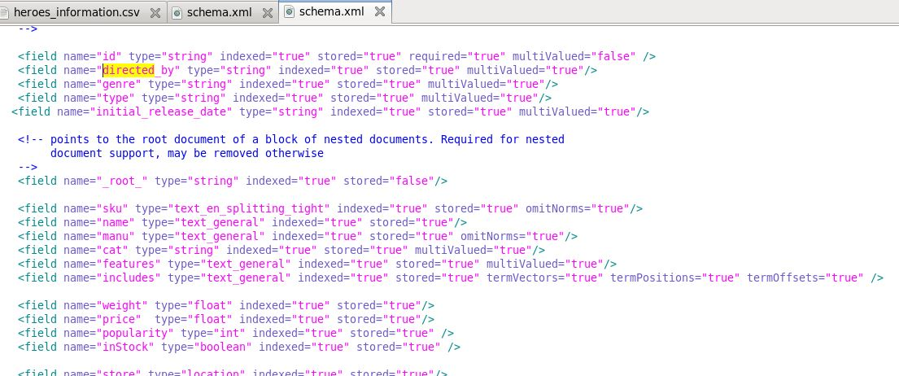

**Query 1:**

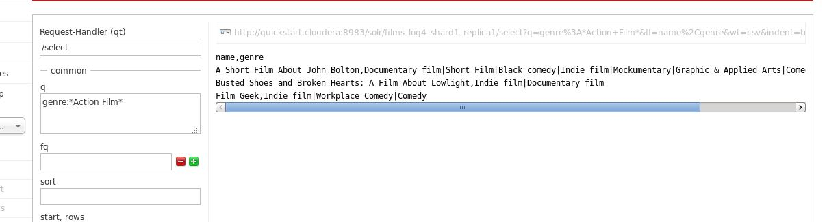

**Query 2:**

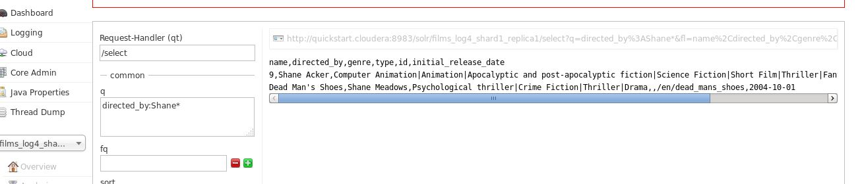

**Query 3:**

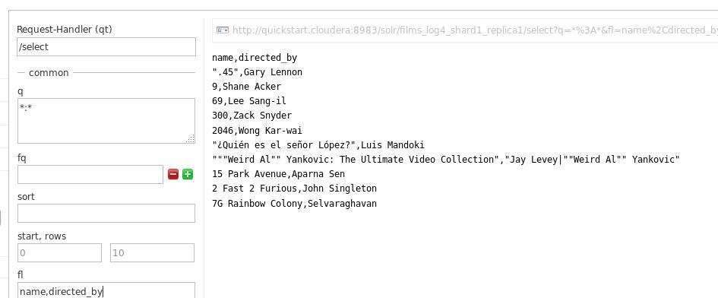

**Query 4:**

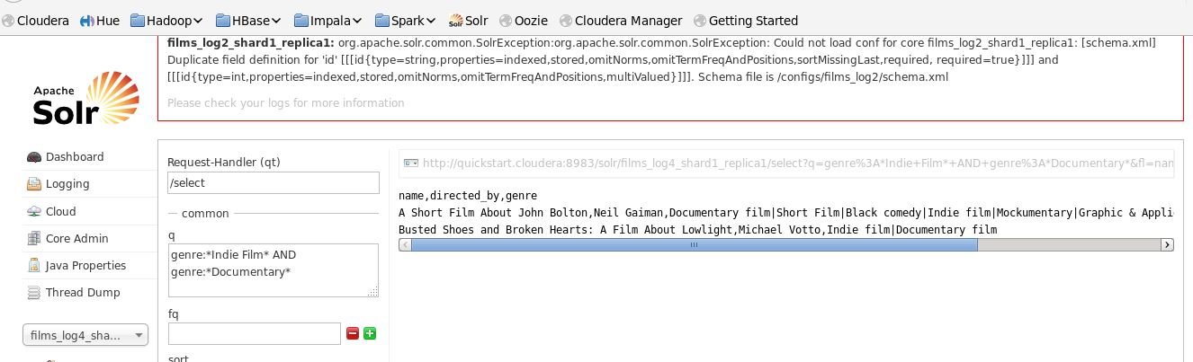

**Query 5:**

