**Problem_Statement:**

Demonstrate the cassandra querries by creating the table,copying the data from local into table and manipulating the data.

CREATE KEYSPACE:

https://github.com/NikithaPateel/Big_Data_Programming/raw/master/ICP_7/screenshots/Keyspace.JPG

CREATE TABLE:

https://github.com/NikithaPateel/Big_Data_Programming/raw/master/ICP_7/screenshots/create_table.JPG

LOAD DATA INTO TABLE:

https://github.com/NikithaPateel/Big_Data_Programming/raw/master/ICP_7/screenshots/load_data.JPG

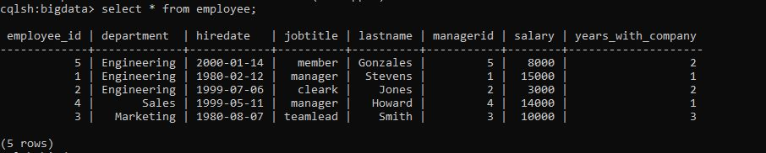

1.List the empno,ename,jobtitle,and hiredate of employee from the employee table.

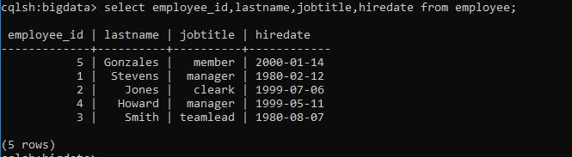

2.List the name,salary of the employees who are clerks

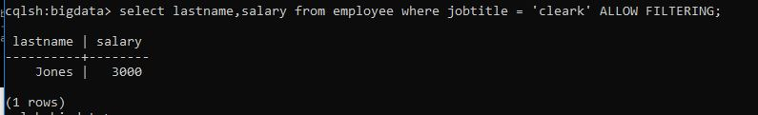

3.List the name,job,salary of every employee joined on ‘december 2,1980’

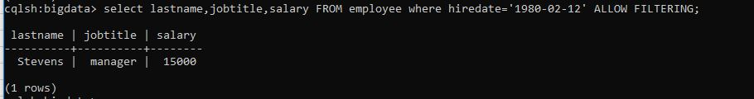

4.List name and annual salary of all the employees.5.

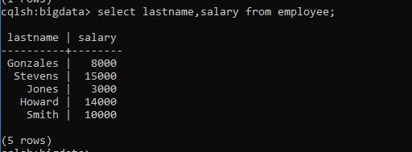

5.List the department name & deptno for departments having managerid.>=3

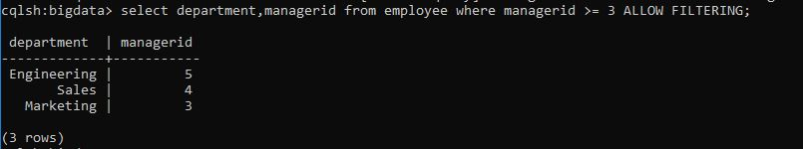

6.Display employees’ names, salary and manager values of those employees whose salary is 5000 from EMP table using SELECT statement

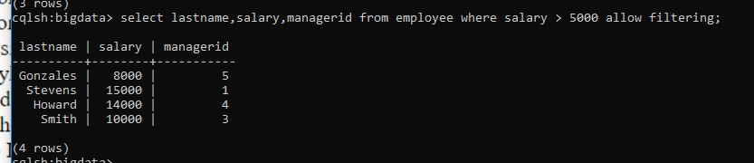

**FEATURE:**

* Best performance
* Fault tolerant
* No Single Point of Failure
* Data replication and can be clustered into multiple data centers.