USN:1NT19IS178
Date:31-03-2022

To check whether MongoDB is intsalled on the system or not :

mongo –version

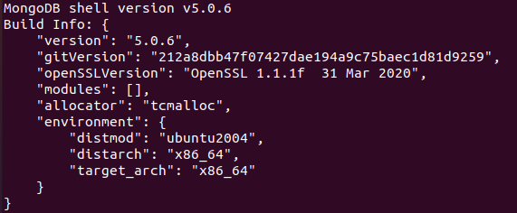

To start MongoDB on shell :

mongo

To create a database and use it :

use 1NT19IS178

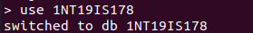

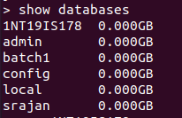

To insert one document :

db.mycollection.insertOne()

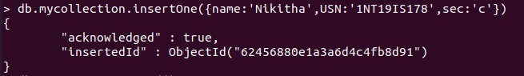

To insert many documents into a collection at same time :

db.mycollection.insertMany()

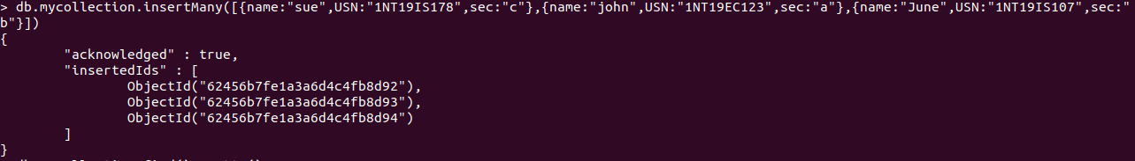
To display the inserted values :

db.mycollection.find()
db.mycollection.find().pretty()

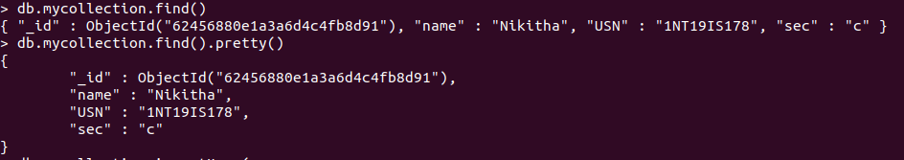
To display with some condition :

db.mycollection.find(<condition>).pretty()

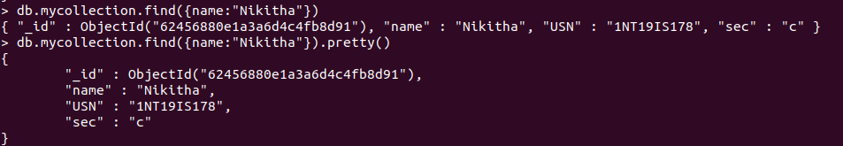

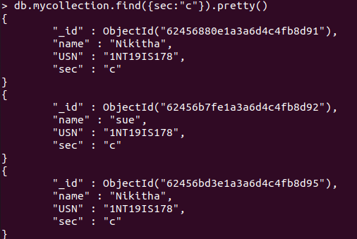

To update a particular document :

To delete a document :

db.mycollection.delete(<condition>)

