Name: Thatekalva Nikitha
USN: 1NT19IS178
Date: 02-06-2022

1.Problem Statement & Dataset

Create a collection named "Employee" under the "EmployeeDB" database with each document in the format shown below Table

use 1NT19IS178_EmployeeDB
db.createCollection("Employee")
show collections

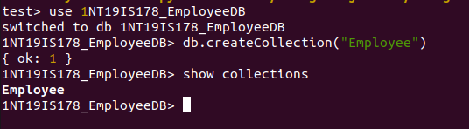

2. Queries

1.Populate the database with atleast 15 documents.

db.Employee.find()

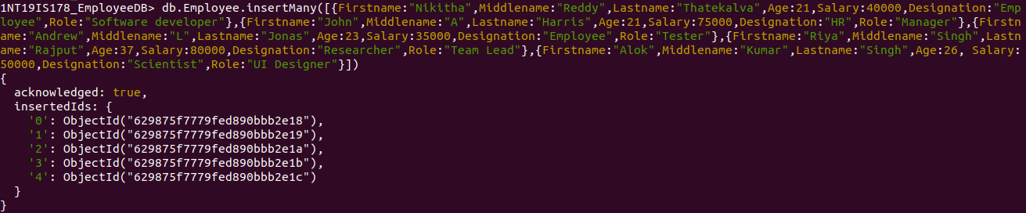

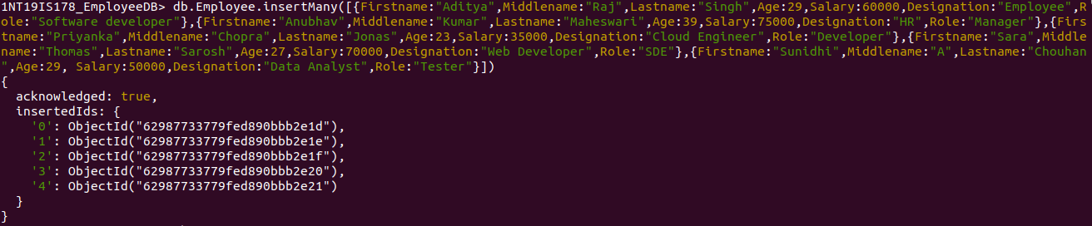

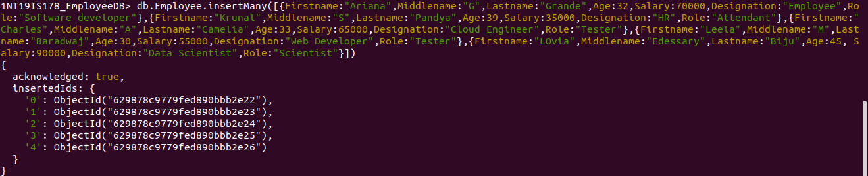

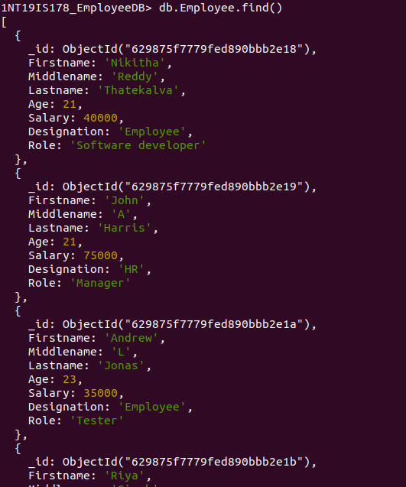

2. List all the records having salary in the range of 20000 – 35000(Exclusive)

db.Employee.find({$and:[{Salary:{$gt:20000}},{Salary:{$lt:35000}}]})

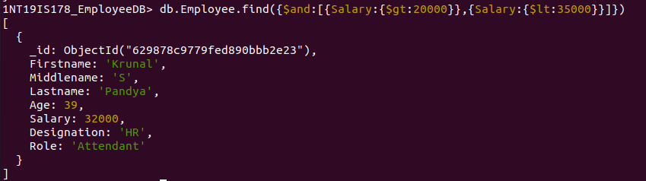
3. List all the Employee whose Middle name is "Kumar"

db.Employee.find({Middlename:"Kumar"})

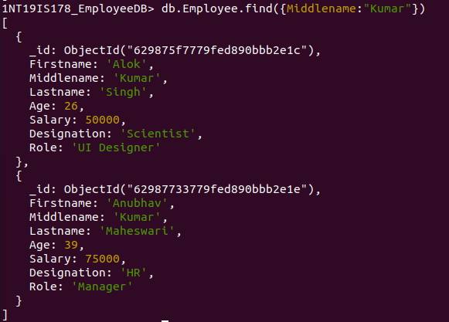

4. Count the number of Employees who has a role "Manager" in the Role field

db.Employee.count({Role:"Manager"})

5. Find out all the documents who have age < 35 and salary in the range of 30000-50000

db.Employee.find({$and:[{Salary:{$gt:30000}},{Salary:{$lt:50000}},{Age:{$lt:35}}]})

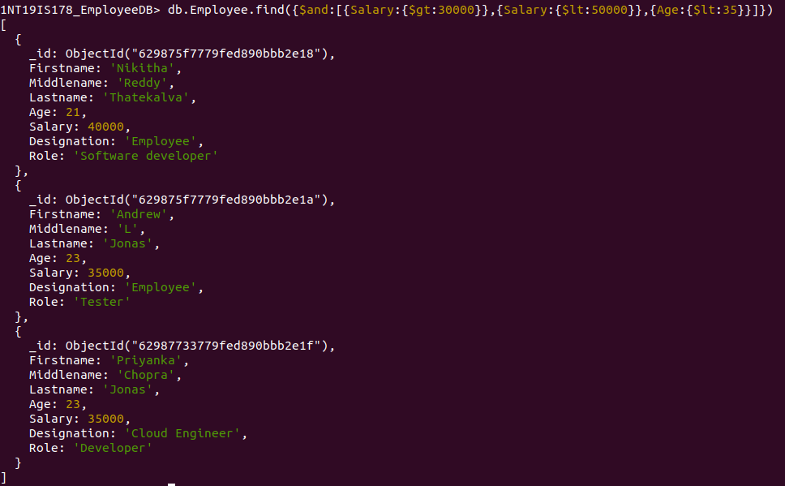
6. Delete an Employee whose "Firstname" is "Rajesh" and having the designation as "Scientist"

db.Employee.deleteOne({$and:[{Firstname:"Rajesh"},{Designation:"Scientist"}]})

7. Update all the Employees whose role is "Team Lead" with a salary of 55650 INR

db.Employee.updateMany({Role:"Team Lead"},{$set:{Salary:55650}})
db.Employee.find({Role:"Team Lead"})

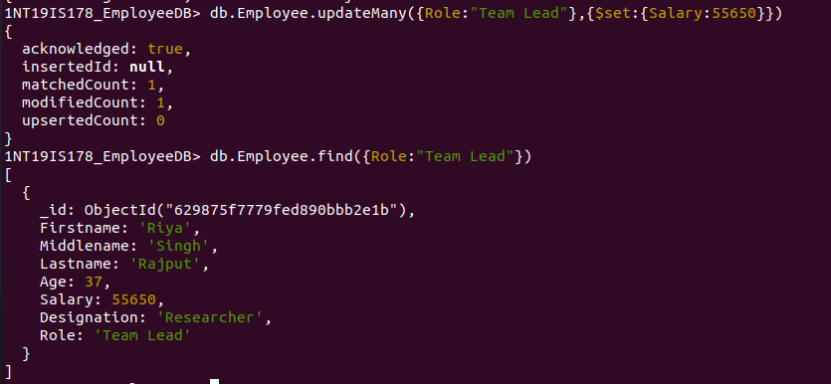

8. Group all the Employees by their age(common age should be there) and calculate the average salary obtained in the each group

db.Employee.aggregate([{$group:{_id:"$Age",Average:{$avg:"$Salary"}}}])

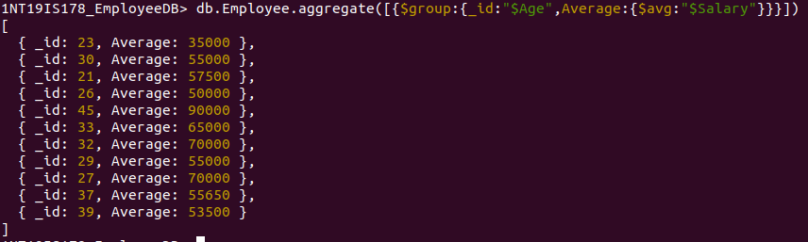

9. Apply the map-reduce to perform the above operation and obtain the results

var mapfunction=function(){emit(this.Age,this.Salary)}
var reducefunction=function(key,values){return Array.avg(values)}
db.Employee.mapReduce(mapfunction,reducefunction,{'out':'Final'})

db.Final.find()

