BIG DATA
Date : 28.06.2022
T NIKITHA
1NT19IS178
Experiment:5

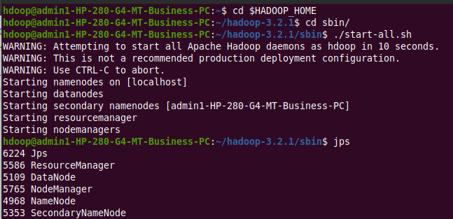

To drop a database
>rm -rf metastore_db

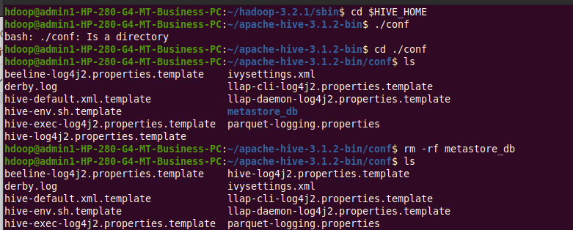

schematool -initSchema -dbType derby
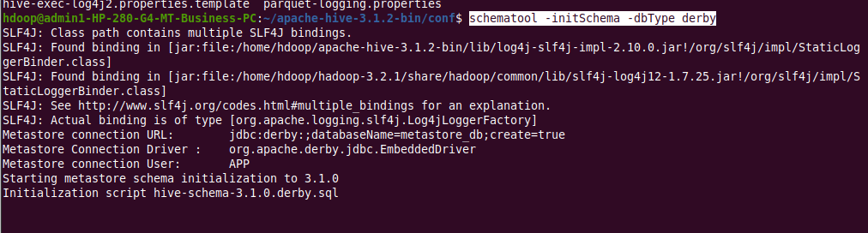

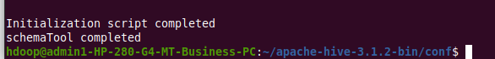

>hive
To view databases
>show databases;

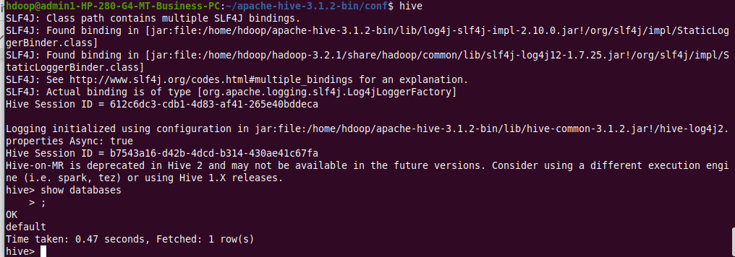

1.1.To create database
>create database if not exists salesdb;
>use salesdb;

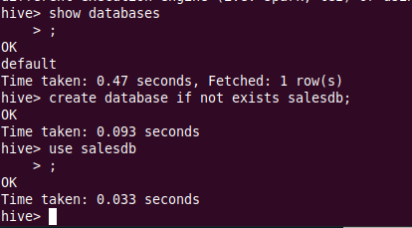

2.1.To create table
>create table sales(product string,price int,payment_type string,name string,city string,state string,country string);
>desc sales;

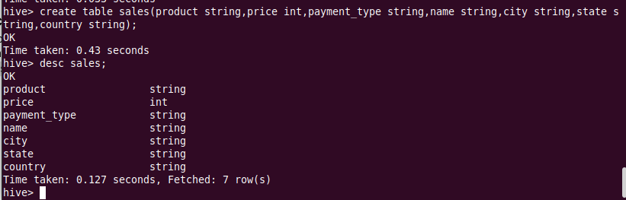

Inserting values:
hive> insert into sales values('product200',5000,'Mastercard','madhu','Astoria','California','USA');

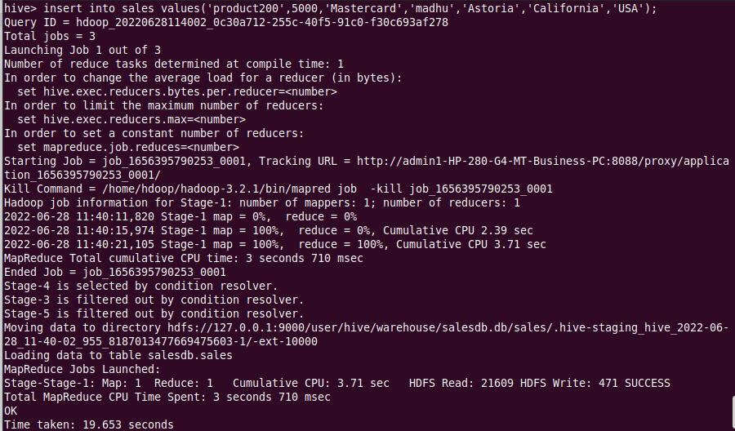

insert into sales values('product201',1000,'Visa','Nikitha','Bangalore','Karnataka','India');
insert into sales values('product202',8000,'Visa','Laisha','Amalapuram','Andhra Pradesh','India');
insert into sales values('product203',2000,'Diners','Madeeha','Raichur','Andhra Pradesh','India');
insert into sales values('product204',2000,'Mastercard','Isha','Mangalore','Karnataka','India');

Queries:
hive> select * from sales;

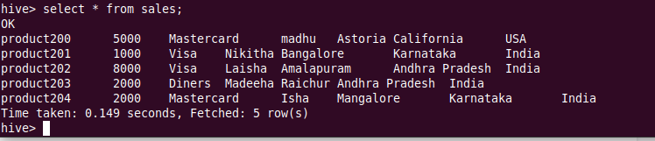

hive> select count(*) as count,Country from sales group by Country;

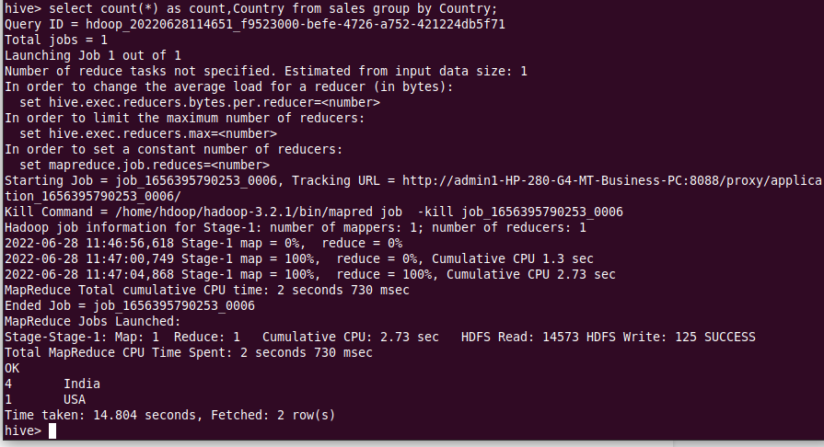
hive> select count(*) as count,State from sales group by State;

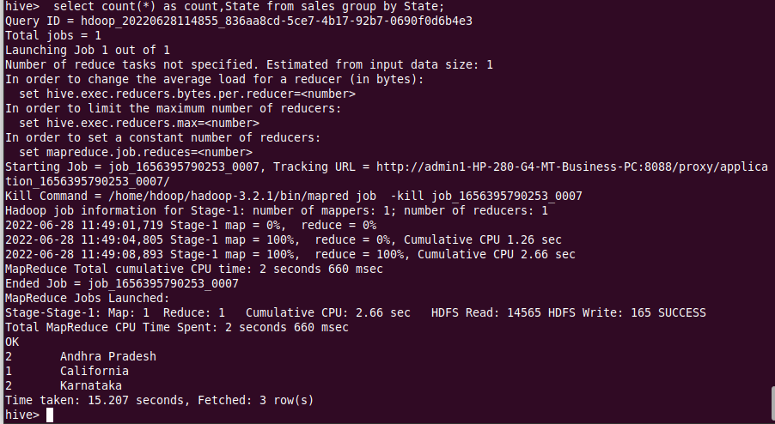

hive> select Product,Name from sales group by Product,Name;
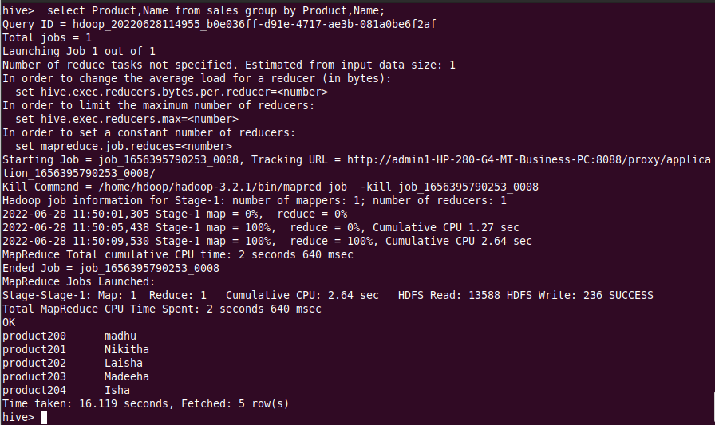

5.views
hive> create view visa as select * from sales where Payment_Type='Visa';
Select * from Visa;
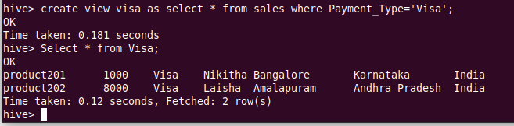

select price from sales where city='Bangalore';
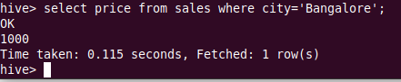

2.2.Alter table
hive> alter table sales rename to 1NT19IS178sales;
show tables;
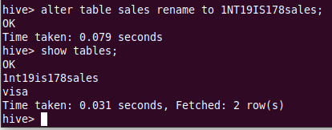

2.3.Drop a table:
create table salest(product string,price int,payment_type string,name string,city string,state string,country string);

Show tables;

Drop table salest;

Show tables;

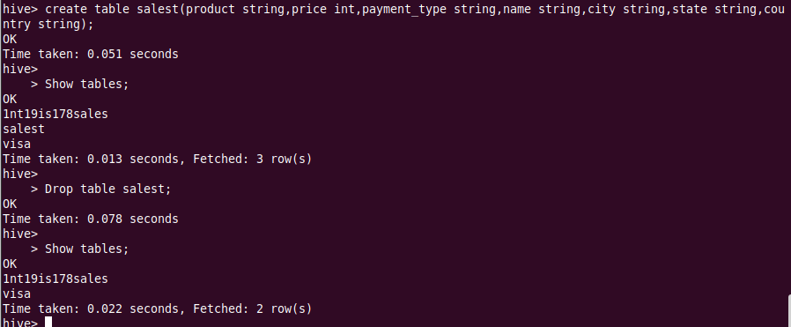

3.Built-in operators:

Arithmetic operators
Addition
select product,name,price+700 from 1nt19is178sales;

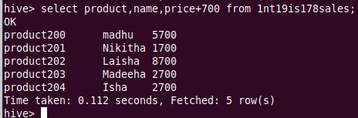

Relational operators
( > )

select * from 1nt19is178sales where Price>4500;
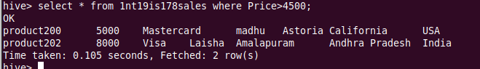

(between)
select count(*) from 1nt19is178sales where Price between 100 and 5000;
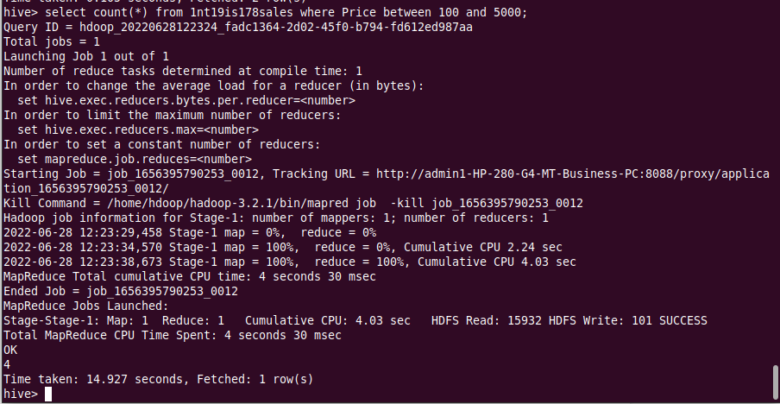

4.built-in functions
Mathematical functions
avg
hive> select avg(Price) from 1nt19is178sales;

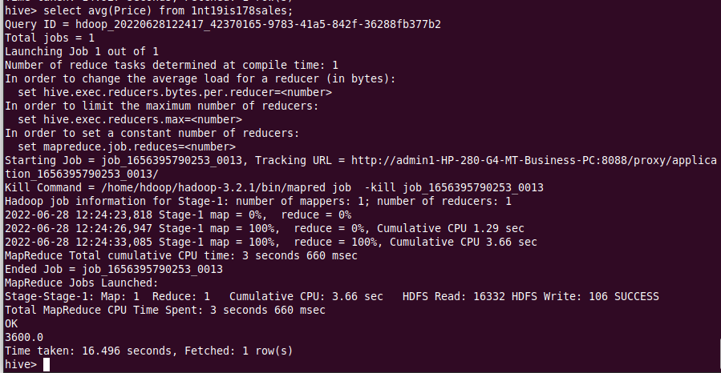

Aggregate functions:
Max
hive>select max(Price) from 1nt19is178sales where state='Karnataka' group by city;
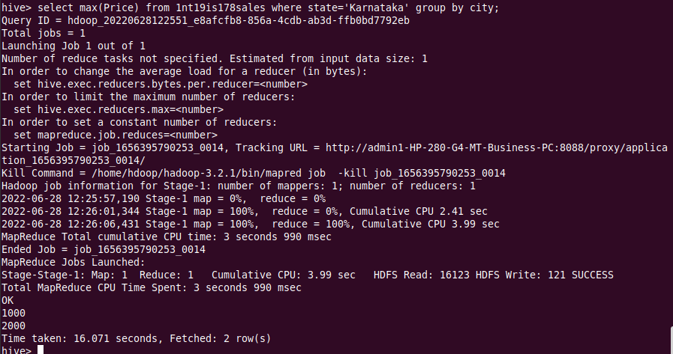

Other built-in functions
hive> select product, upper(Name) from 1NT19IS178sales;
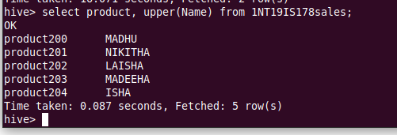

hive> select concat(Name,Country) from 1NT19IS178sales;
