NAME:Thatekalva Nikitha
USN:1NT19IS178
DATE:26-05-2022

MongoDB Aggregate pipelining:

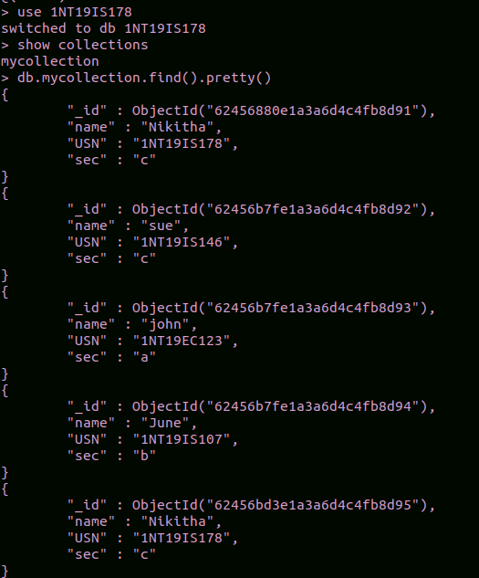

Count:

To count the number of students from c sec

db.mycollection.aggregate([{$match:{sec:c}},{$count:"Number of students from sec C ":}])

Sum:

To find the sum of ages of all c section students.

db.mycollection.aggregate([{$match:{sec: "c"}},{$group:{_id : null,sum :{$sum:"$age"}}}])

To find the sum of ages of all students.

db.mycollection.aggregate([{$match:{}},{$group:{_id : null,sum:{$sum:"$age"}}}])

Average:

To find average of age of all students.

db.mycollection.aggregate([{$match:{}},{$group:{_id : null,avg:{$avg:"$age"}}}])

Maximum And Minimum:

To find maximum and minimum ages in the database:

db.mycollection.aggregate([{$group:{_id : "age",aggregate_age:{$min:"$age"}}}])

db.mycollection.aggregate([{$group:{_id : "age",aggregate_age:{$max:"$age"}}}])

First And Last Attributes:

To find the first USN in the table:

db.mycollection.aggregate([{$group:{_id: "USN" ,aggregate_Name:{$first:"$USN"}}}])

To find last USN in the table:
db.mycollection.aggregate([{$group:{_id: "USN" ,aggregate_Name:{$last:"$USN"}}}])
MAP REDUCE FUNCTIONS

Average:

var map=function(){emit(this.name,this.age)};
var reduce=function(name,age){return Array.avg(age);};
db.mycollection.mapReduce(map,reduce,{out:"newcollection"});
db.newcollection.find()

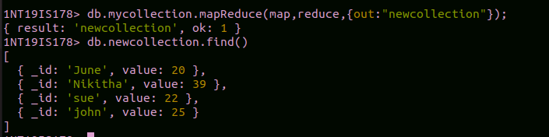

SUM:

var map=function(){emit(this.name,this.age)};
var reduce=function(name,age){return Array.sum(age);};
db.mycollection.mapReduce(map,reduce,{out:”newcollection”});
db.newcollection.find()

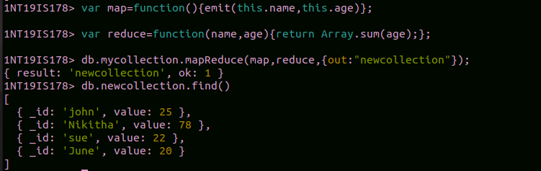

HADOOP

Check whether hadoop is installed in the system or not

hadoop version

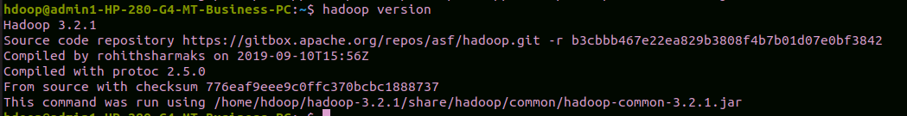
start-dfs.sh

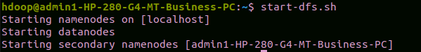
Creating a directory
hadoop fs -mkdir /nikitha
This creates a directory with name nikitha
Listing all files in the directory
hadoop fs -ls /

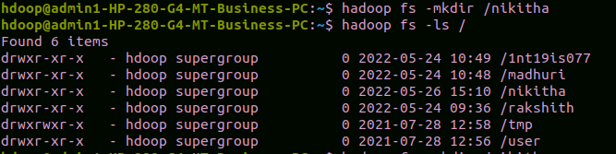

Adding a sample file to the directory and list it using ls command

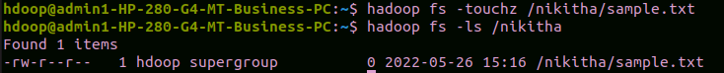

Creating a directory inside another directory

hadoop fs -mkdir /nikitha/1NT19IS178
This creates a directory named 1NT19IS178 inside nikitha

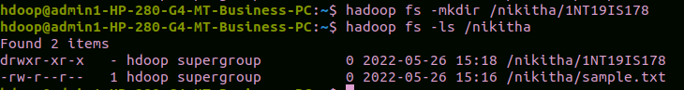

Creating a file in local system and giving the text to be placed in the system.

cat > nikitha_1NT19IS178.txt

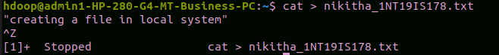

Creating a file inside the nested directory

hadoop fs -touchz /nikitha/1NT19IS178/sample2.txt
hadoop fs -ls /nikitha/1NT19IS178
This creates a file sample2 inside 1NT19IS178 directory

Copying files from hdfs to local system

hadoop fs -copyToLocal /nikitha/1NT19IS178/sample2.txt
This command copies sample2 file from hdfs and put in local system

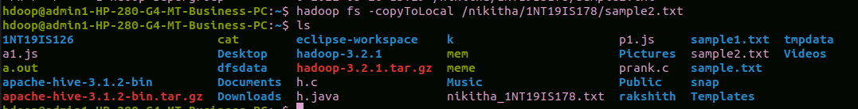
Use mv command to move files from local system and hdfs file system
hadoop fs -mv /nikitha/sample.txt /nikitha/1NT19IS178
hadoop fs -ls /nikitha/1NT19IS178

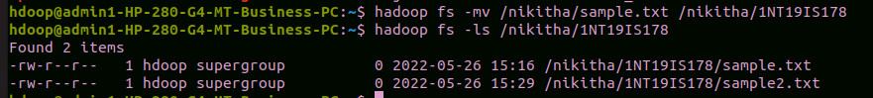
To display size of all files in the directory

hadoop fs -du /nikitha
hadoop fs -du -s /nikitha
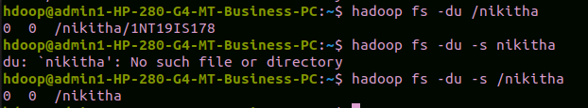

To append one file to another file

hadoop fs -appendToFile one.txt /nikitha/1NT19IS178/sample2.txt
hadoop fs -cat /nikitha/1NT19IS178/sample2.txt
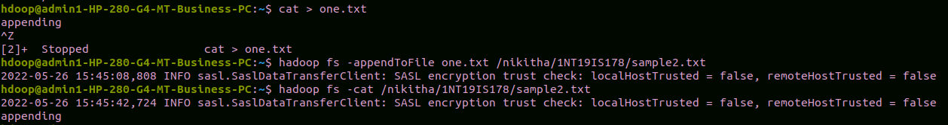

Here one.txt file has been created and that file is been appended to sample2.txt file.

