LAB Logbook
Report link

Lab 1
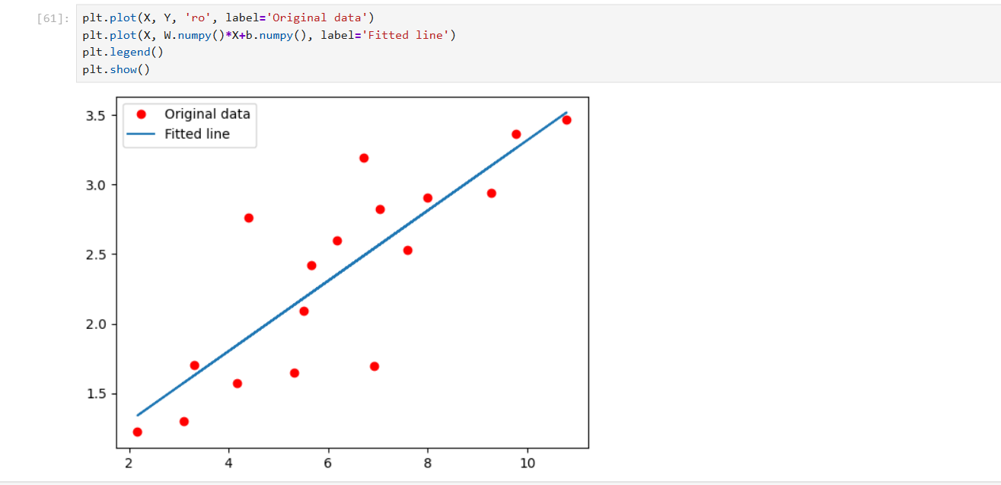
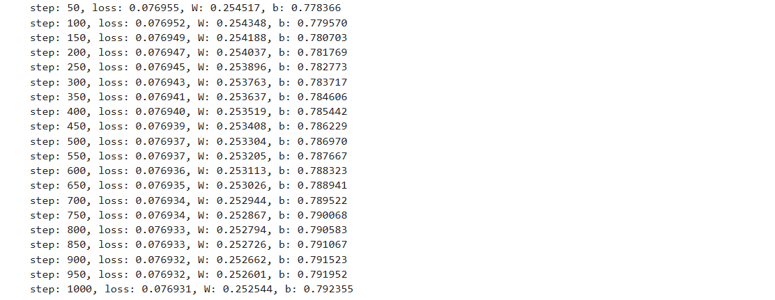

Lab 2
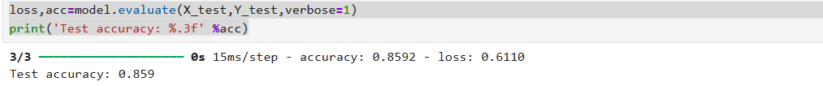
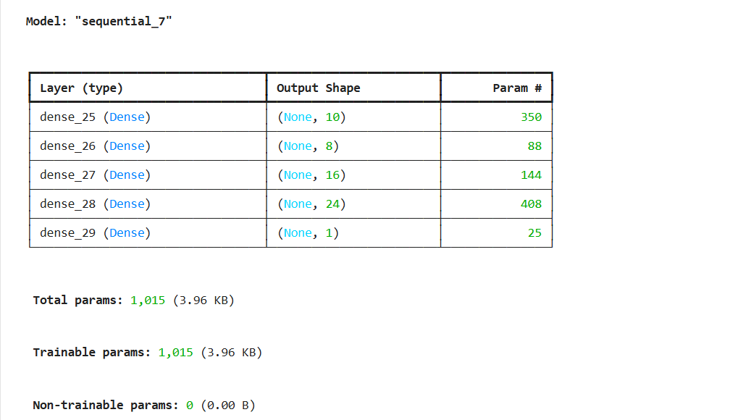
Output of neural network task2: 0.798

Lab 3
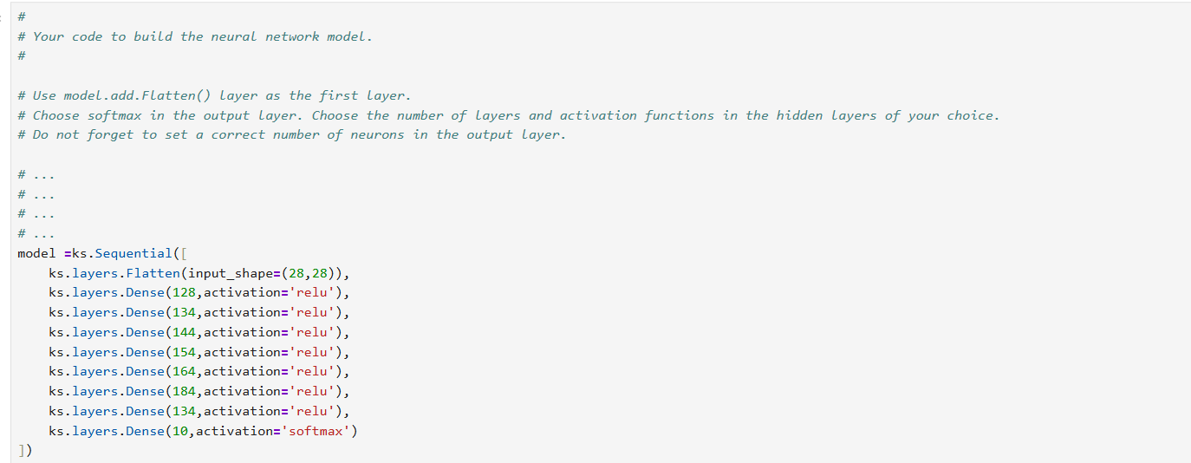
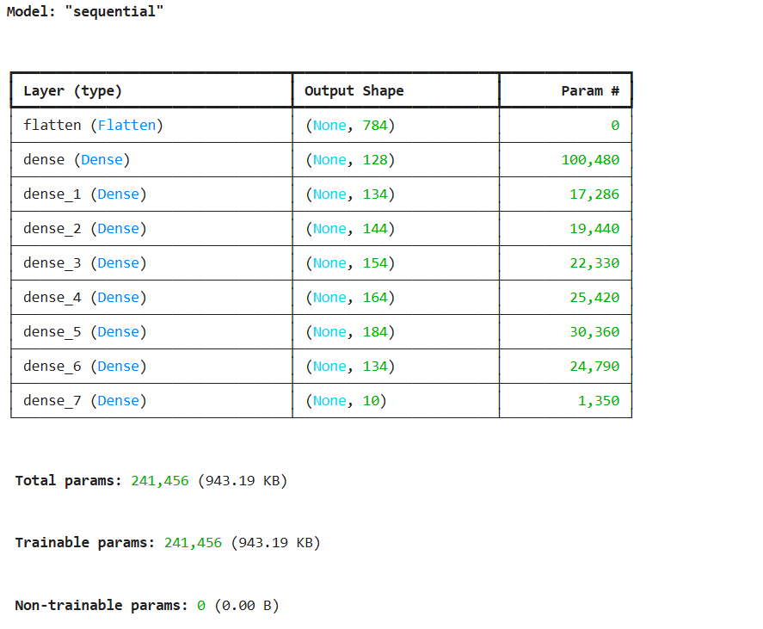
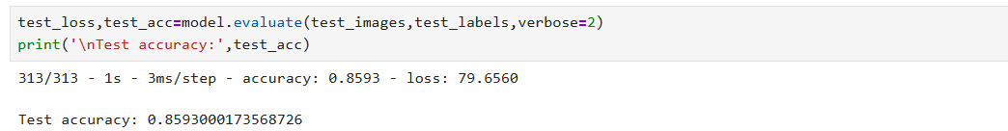

Lab 4

Lab 5

Lab 6

Lab 7

Lab 8

Lab 9

Lab 10

Lab 11

Lab 12

