Day-4
Objective
The objective of Day 4 was to learn the fundamentals of Lightning Web Components (LWC) and build the first user interface for the Gym Management System. We learned how to create an LWC, display data using JavaScript variables, and respond to user actions with button click events. LWC uses HTML, JavaScript, and an XML configuration file to create reusable UI components.

Component Created
Component Name
gymHome
Folder Structure
force-app
└── main
└── default
└── lwc
└── gymHome
├── gymHome.html
├── gymHome.js
└── gymHome.js-meta.xml

Files Used
gymHome.html
- Creates the user interface.
- Displays gym details and member information.
- Contains Lightning base components such as lightning-card, lightning-button, and lightning-input.
gymHome.js
- Stores JavaScript variables.
- Handles business logic.
- Responds to user actions.
gymHome.js-meta.xml
- Makes the component available in Lightning App Builder.
- Defines supported page types such as App Page, Home Page, and Record Page.

Dashboard Created
🏋️ FitLife Gym Management

Welcome to FitLife Gym

Member Name : Kushal Konchada

Trainer Name : Rahul Sharma

Membership : Gold Membership

[ Show Welcome ]
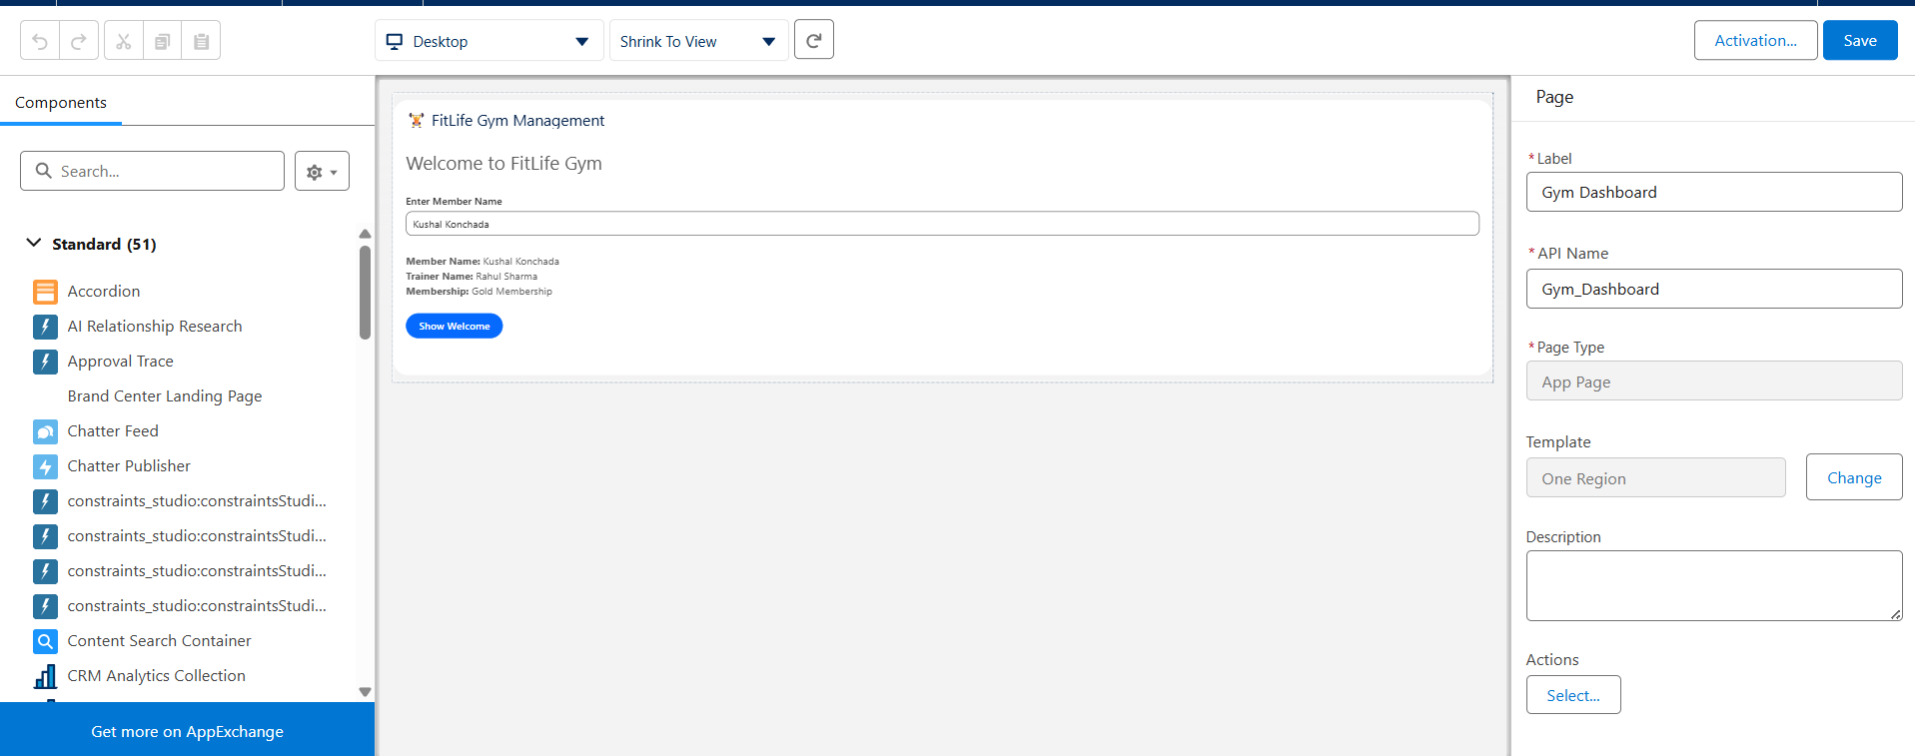

Topics Learned
1. Lightning Web Components (LWC)
LWC is Salesforce's modern framework for building fast, reusable user interfaces using web standards like HTML, JavaScript, and CSS.

2. Data Binding
Data binding connects JavaScript properties to the HTML template using curly braces {}.
Example:
<p>{memberName}</p>
memberName = 'Kushal Konchada';
When the JavaScript property changes, the UI updates automatically.

3. Event Handling
Events allow a component to respond to user actions such as button clicks.
Example:
<lightning-button
label="Show Welcome"
onclick={showWelcome}>
</lightning-button>
showWelcome() {
this.message = 'Welcome to FitLife Gym!';
}
LWC handles button clicks using onclick and JavaScript methods.

4. User Input
lightning-input is used to collect information from the user.
Example:
<lightning-input
label="Member Name"
onchange={handleNameChange}>
</lightning-input>
The entered value is accessed through:
event.target.value
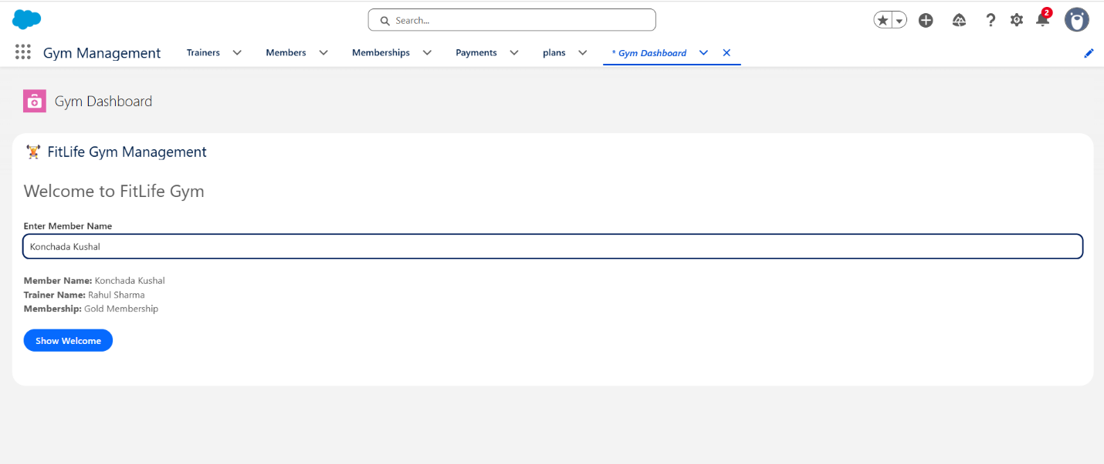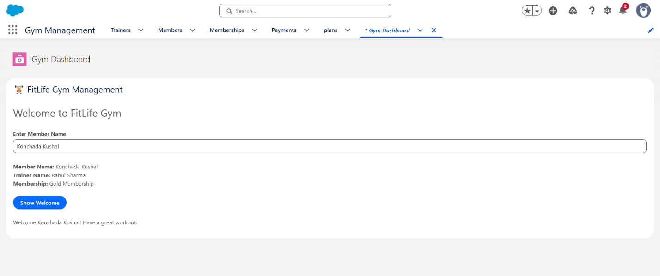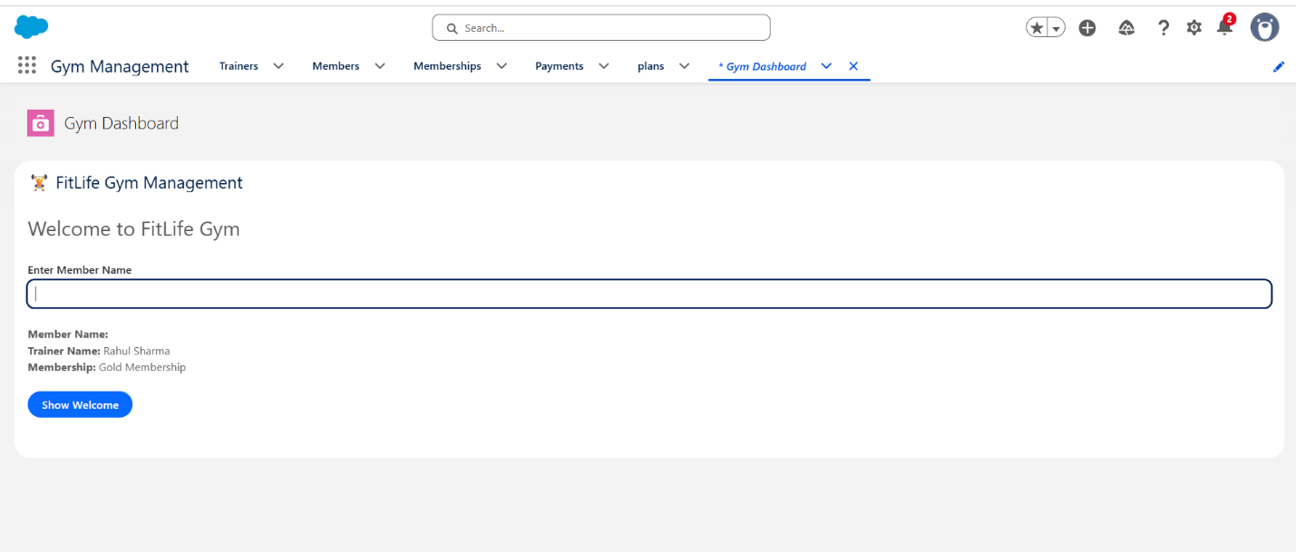
Mini Project Progress
Completed Features
✅ Created first LWC
✅ Deployed component to Salesforce Org
✅ Added component to Lightning App Builder
✅ Displayed member details
✅ Used JavaScript variables
✅ Implemented data binding
✅ Implemented button click event

Interview Questions
1. What is LWC?
Lightning Web Components is Salesforce's modern UI framework for creating reusable components using HTML, JavaScript, and CSS.

2. What is Data Binding?
Data binding is the process of displaying JavaScript data inside HTML using {}. When the property changes, the UI updates automatically.

3. What is Event Handling?
Event handling is the process of responding to user actions such as clicking a button or entering data. Events are handled using attributes like onclick and onchange with JavaScript methods.

4. What is event.target.value?
event.target.value retrieves the current value entered by the user in a lightning-input component.

5. Which files are mandatory in an LWC?
- componentName.html
- componentName.js
- componentName.js-meta.xml

