Wireshark HTTP Traffic Analysis Report
Title
Wireshark Packet Analysis and HTTP Traffic Inspection

Objective
To capture and analyze network packets using Wireshark and TShark, inspect HTTP traffic, study TCP handshakes, and understand packet-level communication.

Tools Used
- Wireshark
- TShark
- Windows Command Prompt

Procedure
Step 1: Start Packet Capture
- Opened Wireshark.
- Selected the active network interface (Wi-Fi).
- Started packet capture.
Screenshot:
Figure 1 – Wireshark Capture Started
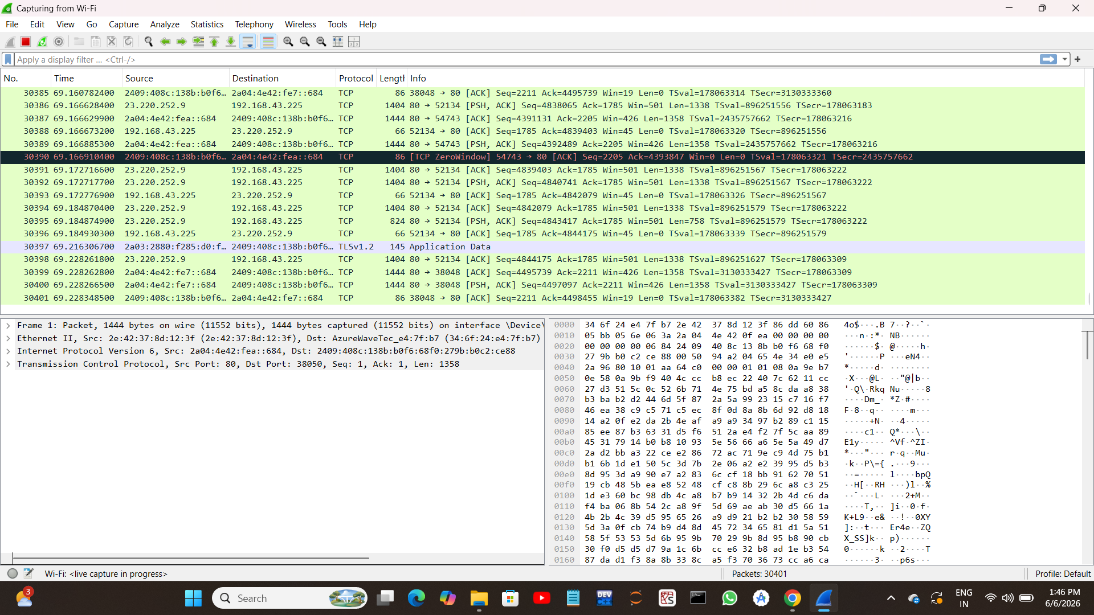

Step 2: Filter HTTP Traffic
Applied the following filter in Wireshark:
http
This displayed only HTTP packets.
Screenshot:

Figure 2 – HTTP Traffic Filtered

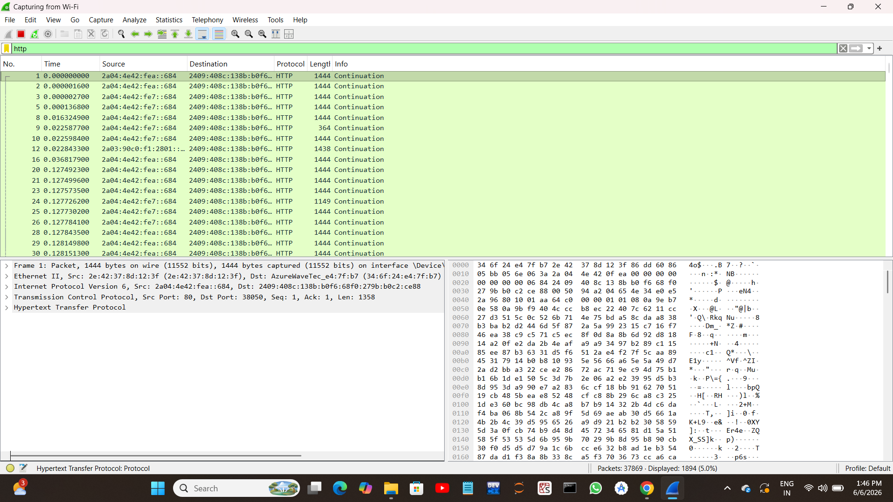

Step 3: Analyze HTTP Request Packet
Selected an HTTP packet and expanded:
- Internet Protocol Version 4
- Transmission Control Protocol
- Hypertext Transfer Protocol
Observed request details such as:
- Request Method
- Host Header
- User-Agent

Screenshot:

Figure 3 – HTTP Request Packet Details

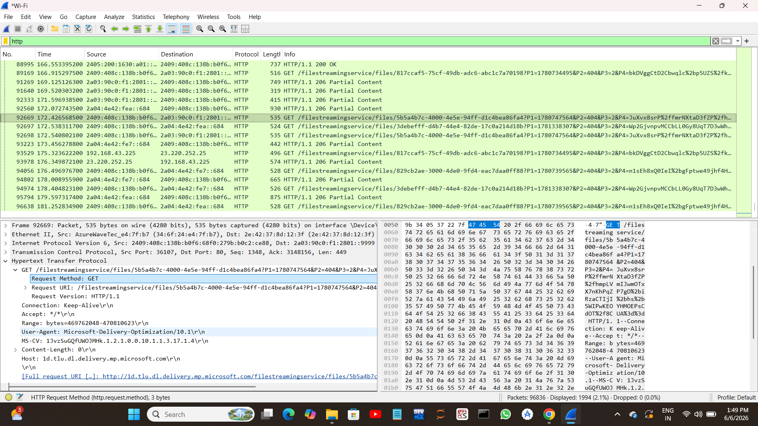

Step 4: Analyze TCP Three-Way Handshake
Used TCP filters to observe:
- SYN
- SYN-ACK
- ACK
This process establishes a TCP connection between client and server.

Screenshot:

Figure 4 – TCP Three-Way Handshake
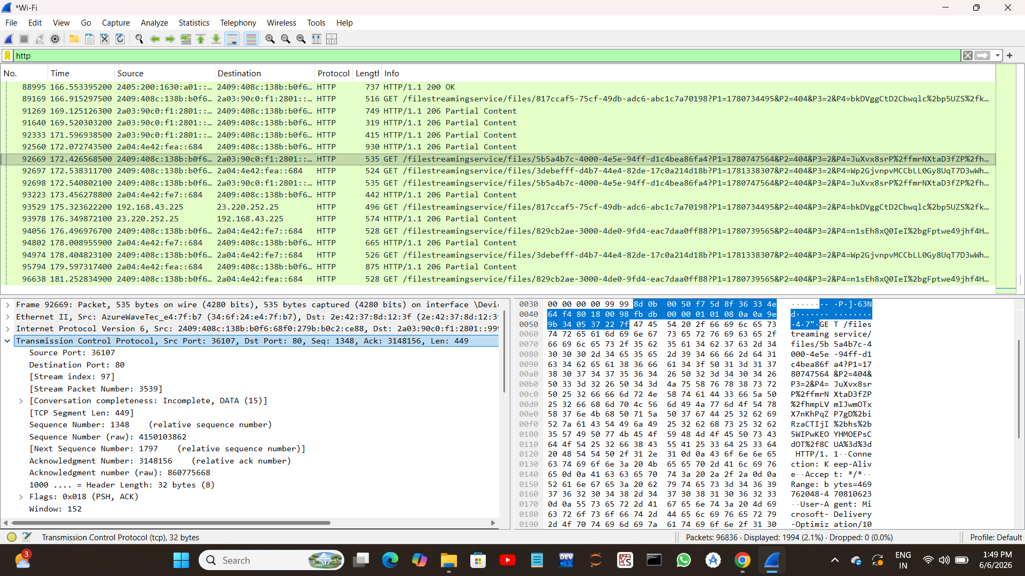

Step 5: Follow TCP Stream
Used:
Right Click → Follow → TCP Stream
Observed complete communication between client and server.
Screenshot:
Figure 5 – TCP Stream Analysis



Step 6: TShark Command-Line Analysis
Executed the following commands in Command Prompt:
tshark -D
.\tshark.exe -r "..\capture.pcapng"
Displayed captured packets using TShark.
Screenshot:
Figure 6 – TShark Command-Line Packet Analysis

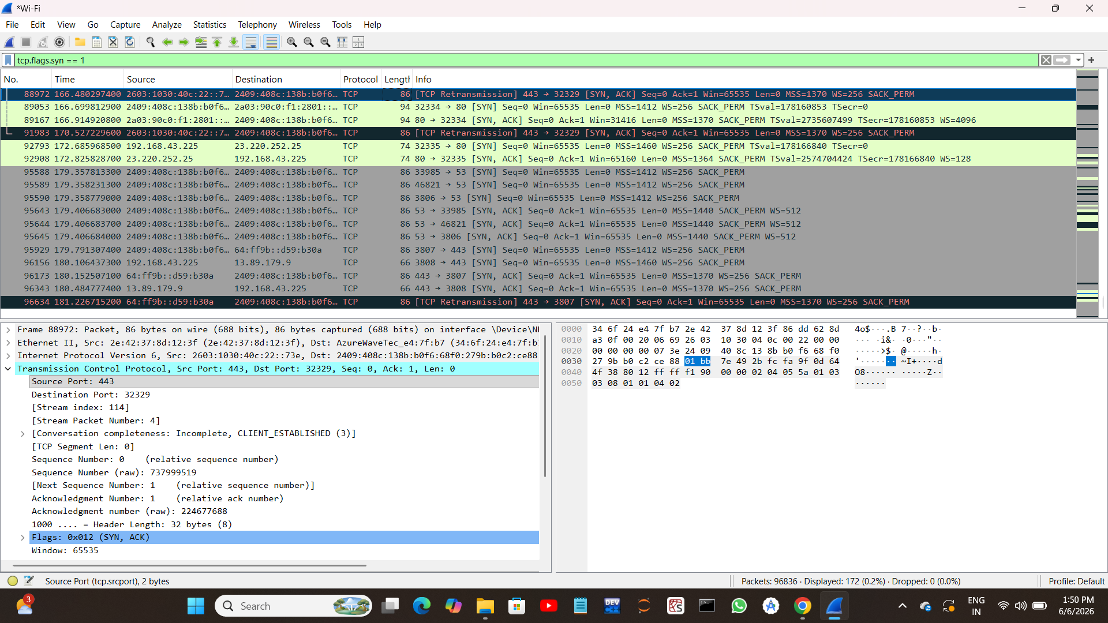

Observations
- HTTP traffic can be viewed in plaintext.
- TCP uses a three-way handshake for connection establishment.
- Wireshark and TShark provide detailed packet-level analysis.
- Packet filtering simplifies network inspection.

Outcome
Successfully captured and analyzed network traffic using Wireshark and TShark. Learned packet-level analysis, HTTP inspection, TCP handshake analysis, and command-line packet analysis techniques.

Conclusion
This project demonstrated how network packets are captured and analyzed using Wireshark and TShark. The analysis helped in understanding HTTP communication, TCP connection establishment, and traffic monitoring techniques used in cybersecurity and network analysis.

