Reconnaissance & Nmap Scanning Report
Title
Reconnaissance and Network Scanning using Nmap
Objective
To set up a vulnerable virtual machine environment using VirtualBox and perform reconnaissance using Nmap to identify live hosts, open ports, running services, and operating system details.
Tools Used
- Kali Linux
- Nmap
- Oracle VirtualBox
- VulnHub – Kioptrix Level 1
Procedure
Step 1: Download and Configure Vulnerable Machine
- Downloaded the Kioptrix Level 1 virtual machine from VulnHub.
- Extracted the downloaded archive.
- Imported the virtual machine into Oracle VirtualBox.
Screenshot:

Figure 1 – Kioptrix VM Added in VirtualBox

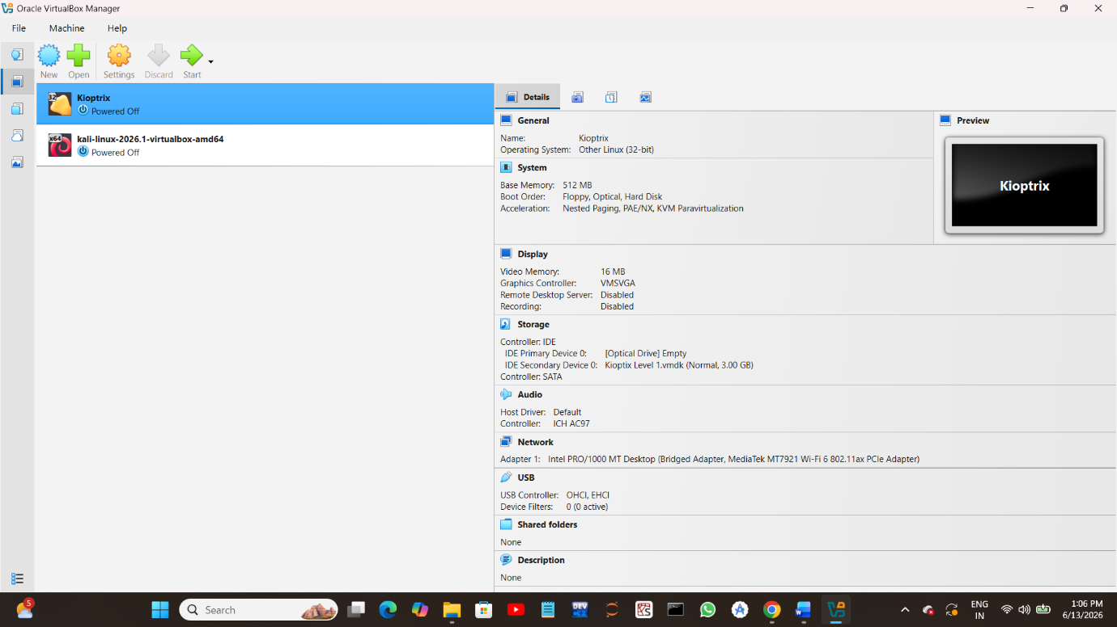

Step 2: Configure Kali Linux
- Downloaded Kali Linux VirtualBox image.
- Imported Kali Linux into VirtualBox.
- Started the Kali Linux virtual machine.
Screenshot:

Figure 2 – Kali Linux Running

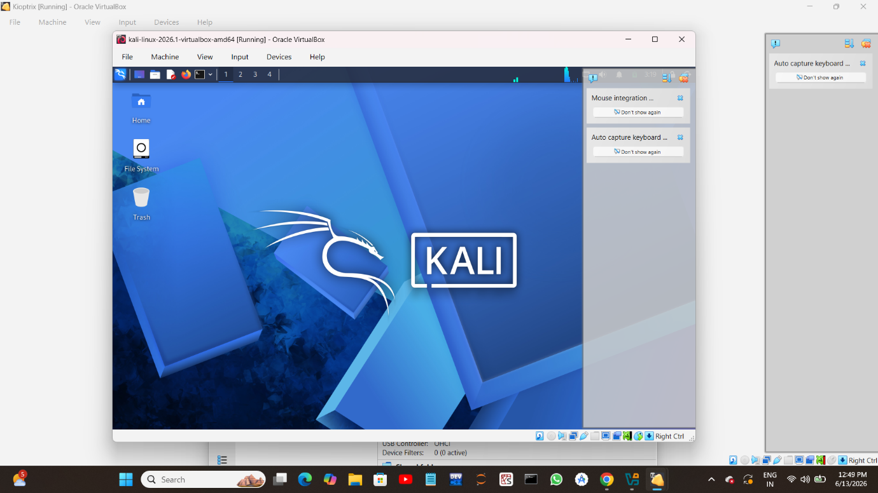

Step 3: Verify Network Configuration
Checked the IP address assigned to Kali Linux using:
ip a
Observed the assigned IP address for network communication.

Screenshot:
Figure 3 – Kali Linux IP Address
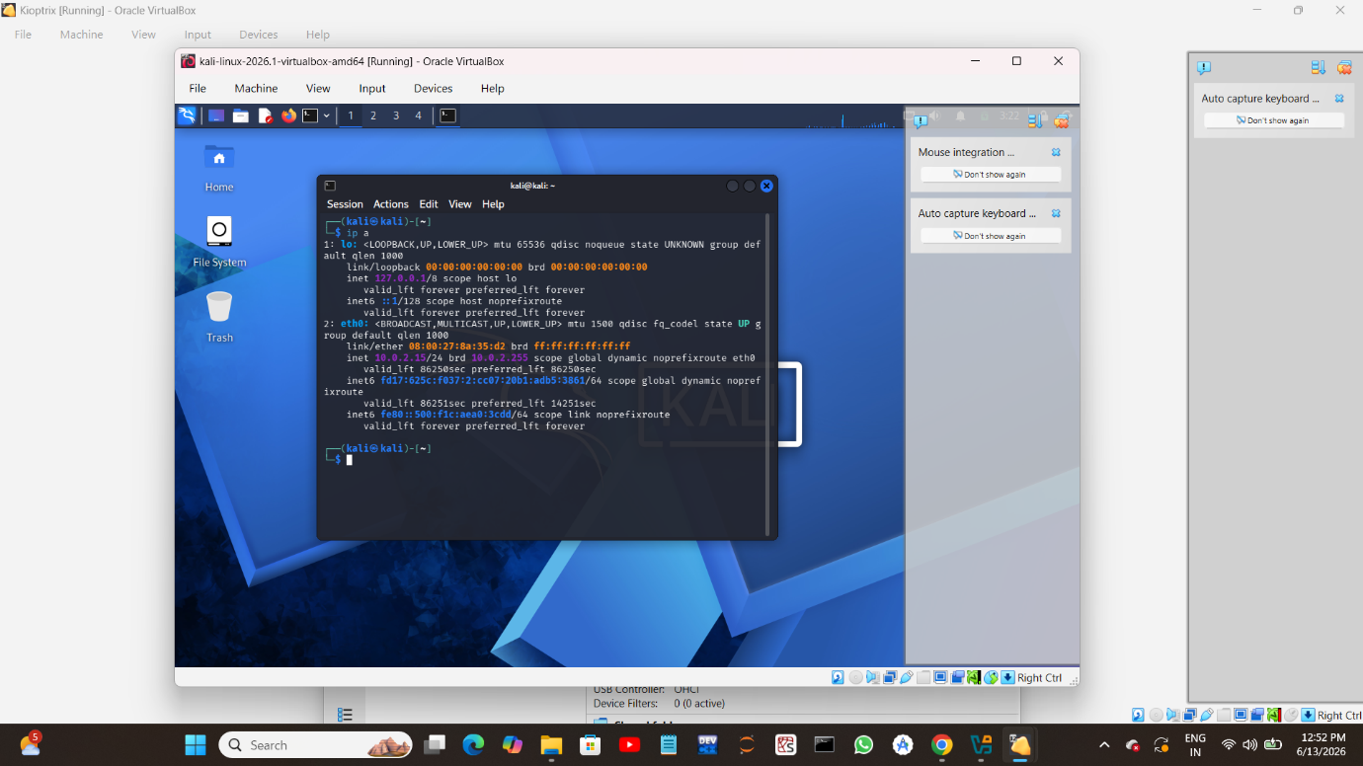
Step 4: Perform Host Discovery Scan
Executed the following Nmap command to identify active hosts in the network:
sudo nmap -sn 10.0.2.0/24
The scan detected active hosts connected within the subnet.
Screenshot:
Figure 4 – Host Discovery Scan

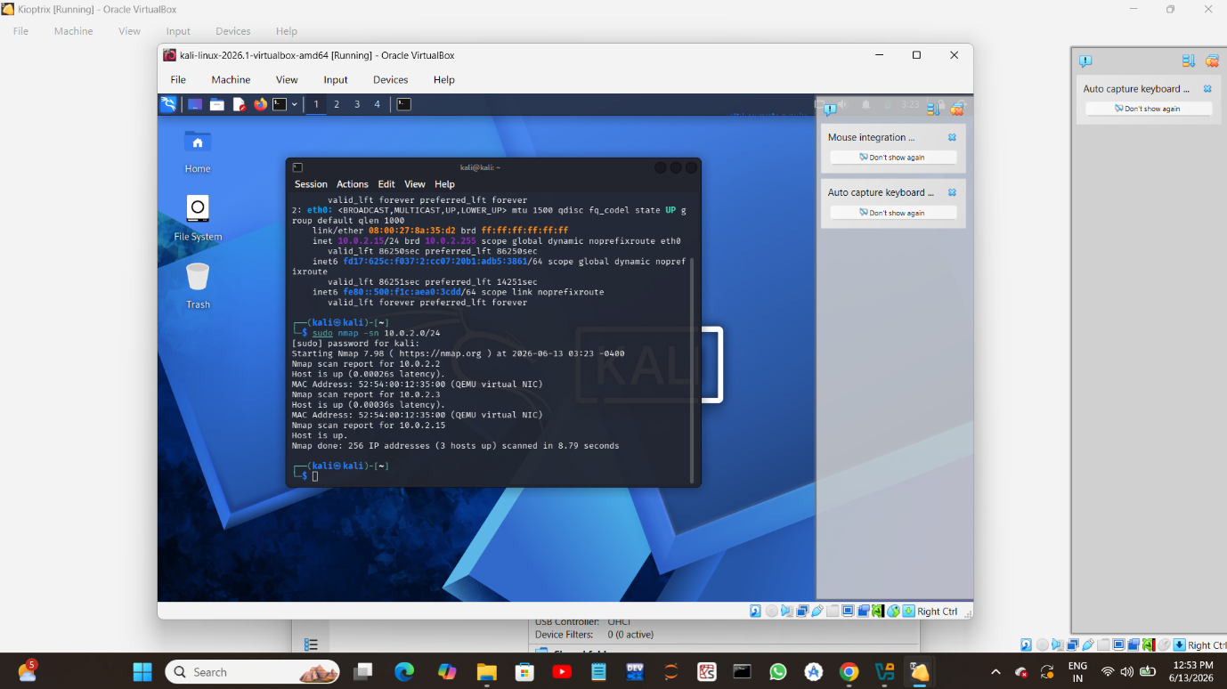

Step 5: Perform Aggressive Nmap Scan
Executed aggressive Nmap scans against discovered hosts:
sudo nmap -A -T4 10.0.2.2
sudo nmap -A -T4 10.0.2.3
The scan performed:
- Service Detection
- Version Detection
- OS Detection
- Script Scanning
- Traceroute

Screenshot:

Figure 5 – Aggressive Nmap Scan Results

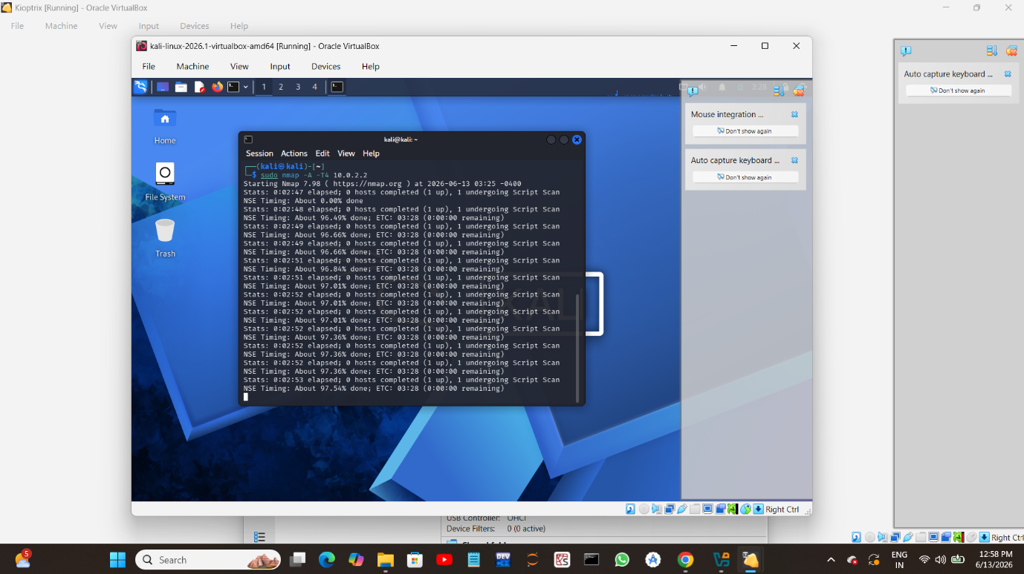

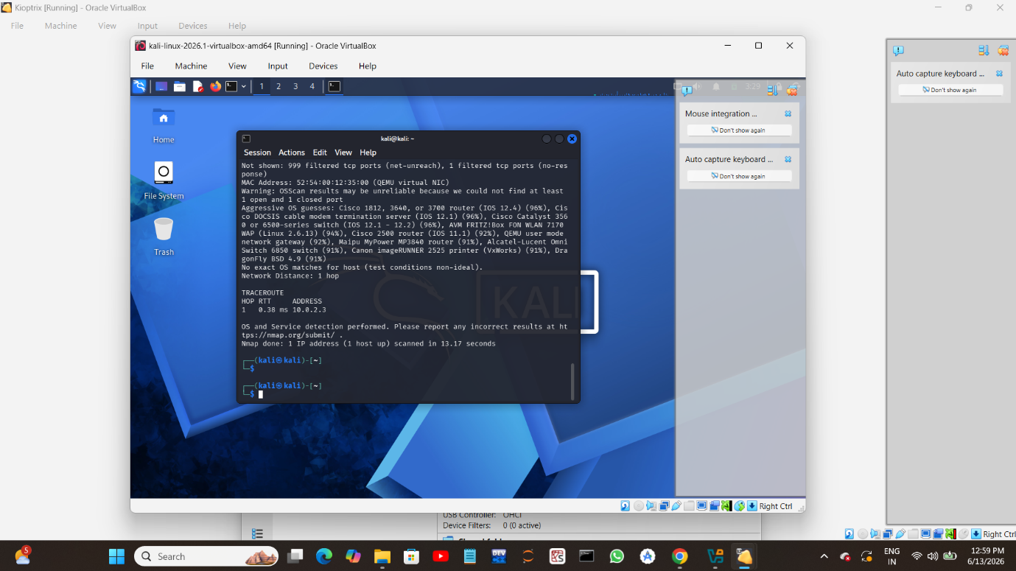
Observations
- Active hosts were successfully identified in the network.
- Nmap detected operating system and service information.
- Aggressive scanning provided detailed reconnaissance data.
- Open and filtered ports were identified.
- Network mapping and attack surface analysis were performed successfully.

Outcome
Successfully created a virtual penetration testing lab using Kali Linux and Kioptrix. Performed reconnaissance and network scanning using Nmap to identify live hosts, services, and operating system information.

Conclusion
This project demonstrated practical network reconnaissance techniques using Nmap in a controlled virtual environment. The activity helped in understanding host discovery, service enumeration, operating system detection, and attack surface mapping used in cybersecurity and penetration testing.

