1.The class Movie is stated below. An instance of class Movie represents a film. This class has the following three properties:

* title, which is a String representing the title of the movie
* studio, which is a String representing the studio that made the movie
* rating, which is a String representing the rating of the movie (i.e. PG­13, R, etc)

a) Write a constructor for the class Movie, which takes a String representing the title of the movie, a String representing the studio, and a String representing the rating as its arguments, and sets the respective class properties to these values.

b) The constructor for the class Movie will set the class property rating to "PG" as default when no rating is provided.

c) Write a method getPG, which takes an array of base type Movie as its argument, and returns a new array of only those movies in the input array with a rating of "PG". You may assume the input array is full of Movie instances. The returned array need not be full.

d) Write a piece of code that creates an instance of the class Movie with the title “Casino Royale”, the studio “Eon Productions”, and the rating “PG­13”

        //a.

        class Movie{

            constructor(title,studio,rating){

                this.title=title;

                this.studio=studio;

                // this.rating=rating

                //b.

                if(rating==undefined){

                    this.rating="PG"

                }else{

                    this.rating=rating

                }

            }

    //c.

    getPG(arr){

        console.log(arr)

        let pgResult=[]

        for(var i=0;i<arr.length;i++){

            if(arr[i].rating=="PG"){

                pgResult.push(arr[i])

            }

        }

        console.log(pgResult)

    }

}

let film1=new Movie("ABC Royale","XYZ Productions")

let film2=new Movie("XYZ Royale","PQR Productions","PG24")

let film3=new Movie("Casino Royale","Eon Productions","PG23")

let film4=new Movie("UIO Royale","DFG Productions","PG25")

let film5=new Movie("PLM Royale","YHN Productions")

let film6=new Movie("OPI Royale","FHH Productions","PG26")

let film7=new Movie("ERT Royale","KJH Productions","PG")

//which takes an array of base type Movie as its argument

const array=[film1,film2,film3,film4,film5,film6,film7]

film1.getPG(array)

    </script>

</body>

</html>

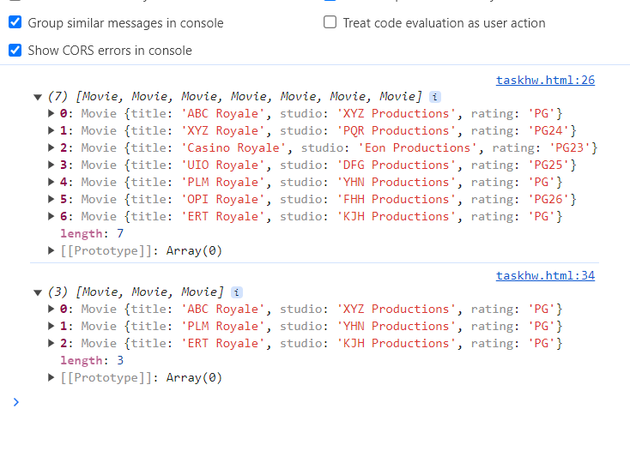

1. write a class to calculate the Uber price.

class Uber{

    constructor(km){

        this.km=km,

        this.price=km*3.34

        console.log(this.km,this.price.toFixed())

    }

    getPrice(){

        console.log(`Ride cost is ${this.price.toFixed()}`)

    }

    //methods

    applyDiscount(){

        console.log("Discount Calculation")

        let discount=(25/this.price)*100

        // console.log(doiscount)

        let priceAfterDiscount=this.price-discount

        // console.log(`As a privelge customer, I got a discount and Price after discount is Rs.${priceAfterDiscount.toFixed()}`)

        return `As a privelge customer, I got a discount and Price after discount is Rs.${priceAfterDiscount.toFixed()}`

   }

}

let ride=new Uber(30)

ride.getPrice()

// ride.applyDiscount()

console.log(ride.applyDiscount())



Write a “person” class to hold all the details

class person{

        constructor(name,DOB,age,contactno){

            console.log("Constructor")

            this.name=name,

            this.DOB=DOB

            this.age=age

            this.contactno=contactno

            console.log(name)

        }

        getDetails2(){

            console.log(`this person ${this.name} born in ${this.DOB}, age ${this.age} and contact no.${this.contactno}`)

        }

    }

    let s3= new person("nikitha",9_10_2001,23,9842452853)

    console.log(s3)

    s3.getDetails2()

