**SOFTWARE ENGINEERING PROJECT MANAGEMENT -18CSC206J**

**NAME OF THE PROJECT:** ONLINE BUS PASS SYSTEM

**1.1 PROBLEM STATEMENT:**

INTRODUCTION: -

As per the previous system the user had to do each and every process manually, but this system helps the user to make the work bit faster. The user can then take print out of this bus pass from their mail id and use them. The bus pass will be differ for different types of users. In this bus pass, all the required details such as candidate name, address, date of birth, mail id, name of the school(government/private), validity period, amount paid (free for government school students) and photo copy of the candidate are provided. Instead of school details, working organization details will be provided in employees bus pass. The renewal process can be done either monthly or yearly as per user wish. Based on that renewal period amount will be deducted.

PROBLEM:

The present conventional method of ticketing is tedious. Since the volume of passengers is very high. Manual ticket buying concept involves a lot of time, effort and manpower. This system is highly unsuitable when there is a huge rush of commuters and many times, lot of commuter’s fail to catch their Bus. This is not only affecting the efficiency of people at their work place but also affecting them psychologically by less respect to co-passengers, staff members and at the end of the day at home.

PROPOSAL:

The commuters of Public Transport can be categorized in to two categories namely:

1. Regular commuters
2. Short Time Commuters

Nowadays, we are using more network and communications with high speed data exchange we are introducing it in a new way to use for ticketing in Public Transport System. In Online Ticketing, a commuter will use his or her Online System to access the bus pass of entry and exit of bus stations. It may be done using mobile network / Net connection. The fair for distance travelled will be deducted from available balance of Debit card/credit cards. Anyone can avail this service by registering account from his or her mobile in a specified registration guidelines and they can start travelling after activation of service. Using Online for ticketing , it will help to overcome billing hurdles and its fast and widely available network will suitable for communication and information exchange among entry and exit stations, Transport Service Provider Data Centre and Mobile Service Provider for billing purpose.

**1.2 BUSINESS CASE**

|  |  |
| --- | --- |
| **DATE** | **03/02/2021** |
| SUBMITTED BY : | NIKITH KUMAR (480)  VIGNESH (468)  ROHITH (474) |
| TITLE : | Online Registration of Bus Pass |

THE PROJECT:

This Project “Online Registration of Bus Pass “is a real time project which is useful for the commuters who are facing problems with the current manual work of bus system. It makes the passenger easy to travel with the ticket QR code with the mobile. So that even if the passenger loses the ticket at the time of checking he can show the QR code. The TTE can check the QR code with the admin whether it matches or not.

THE HISTORY:

Older days, Commuters are used spend more time in Que to register their bus pass. Lots of commuter are lose to catch their buses. This is not only affecting the efficiency of people at their work place but also affecting them psychologically by less respect to co-passengers, staff members and at the end of the day at home.

LIMITATIONS:

* Volume of the Commuter’s is Very High.
* Manual buying ticket/bus pass requires lots of time, Effort and Manpower.
* Lots of travelers are lose to approach their buses at the time.

APPROACH:

* Permission from Authentication process.
* Software requirement to build an application.
* Permission from Transport Service Provider Data Centre

BENEFITS:

* We can save time.
* Quick to catch their booked buses.
* This system helps people to make the work a bit faster.

**2.1 STAKEHOLDER AND USER DESCRIPTION:**

STAKE HOLDERS:

User:

The users are the persons, who are using the online web or online services to register the bus pass.

Sponsor:

A sponsor is the person or group that provides the financial resources in kind or in cash for the project.

Program Manager**:**

They are responsible for managing related project in a coordinated way to obtain benefits and control.

Project Team:

A project team is comprised of the project manager, project management team and other team members who carry out the work.

Function Manager:

They are key individual who play a management role within an administrative or functional area of the business such as human resources, finance, accounting or procurement.

Transporters and Commuters management system:

This system is responsible for generating a message alert to the Bus pass Holders.

Registered Users:

After the Bus Pass Holder/Commuters has book their tickets/bus pass they can receive their ticket number (QR code)/bus pass application number.

**2.2 USER STORY**

User’s End:

After Registration bus pass, the user will receive the message to their registered mobile or mail ID.

Advertising:

This agency promote the service through call centers, newspapers and even through the display the posters near bus stations.

IT Executive:

The agents will help to solve the Queries of the Commuters.

Technical Department:

The Employees in the technical department will be updating the web browser and solve the technical glitches/problems when raised.

MODULE:

* Operating Module:
  + Secure payment
  + Application management
  + Receives message alert notification for renewal of bus pass.
* User Module:
  + Registering User
  + Updating Information
  + Generating pass
  + Renewal pass
  + Generating PDF
  + Generating QR Code
* Problems faced:
  + Delaying in creation and deletion of message notification.
  + Tedious procedure for issuing/renewing passes.

**REGISTRATION PROCESS:**



**2.4 COMPARISON BETWEEN WATERFALL AND AGILE MODEL**

WHY AGILE MODEL IS BETTER THAN WATERFALL MODEL??????

1. The Agile Model is based on iterative development and hence it divides the entire project into smaller parts which reduces the risk factor which is not the case in waterfall model.

2. The Waterfall model cannot accept the changes in requirements but in agile model it is easy to change the system requirements.

3. In agile model, the entire project is divided into smaller parts which helps to minimize the project risk and to reduce the overall project delivery time requirements.

4. In waterfall model since risk factor is high, it is not suitable for complex projects.

5. In waterfall model the testing is done in later stage it does not allow identifying the challenges and risks in the earlier phase, so the risk reduction strategy is difficult to prepare, which is not the case in agile model.

6. In waterfall model, it follows a sequential approach whereas in agile model it explains the process in order of incremental approach.

7. In agile it performs the testing concurrently with software development whereas in waterfall model the testing comes after the build phase only.

8. In agile model the distance between the customer and developer is in short whereas in waterfall model it is long.

9. In agile there can be done any change in the project but in waterfall model there is no changes throughout the project work.

**3.1 IDENTIFYING THE REQUIREMENTS FROM THE PROJECT STATEMENT**

**REQUIREMENTS:**

The requirement definition is concerned with the analysis of the existing system with the aim of determining and structuring the requirement of the proposed system. It is achieved with the aid of user requirement.

Requirement analysis determines the needs to be fulfilled and what the prepared document should do after completion. For the better understanding of the requirements we will draw the context diagram then build a prototype, analyses the requirements and lastly finalize them. In feasibility we analyses the feasibility of the project in terms of economic feasibility, technical feasibility and operational feasibility.

**SYSTEM REQUIREMENTS:**

* List of City/Local Busses and Bus Stations.
* GPS Tracker supported for the city busses.
* Alert message generating System (For Renewal Process /Any maintenance Work).

**FUNCTIONAL REQUIREMENTS:**

* REGISTERING USER
* UPDATING INFORMATION
* GENERATING PASS
* RENEWING PASS
* AUTHENTICATION OF USER
* LOG IN
* ONLINE PAYMENT
* GENERATING PDF
* GENERATING QR CODE

**NON-FUNCTIONAL REQUIREMENTS:**

* RELIABILITY.
* AVALIABILITY.
* THIS WEB APPLICATION WILL BE AVALIABLE IN FEW LANGUAGES.
* SECURITY.
* STABILITY

**PROJECT PLAN AND PROJECT EFFORT BASED ON RESOURCES**

**PROJECT NAME:**

Online Registration of Bus Pass

**PROJECT MEMBERS:**

VIGNESH P –RA1911003020468

NIKITH S -RA1911003020480

ROHITH S -RA1911003020474

**BUDGET:**

|  |  |
| --- | --- |
| **Resource Requirements** | **Cost** |
| **Computer higher CPU and a Windows 10 or higher OS** | **Rs.30000** |
| **Printing** | **Rs.500** |
| **Node.Js** | **FREE** |
| **File** | **Rs.50** |
| **TOTAL** | **Rs.30550** |

**MODULES:**

* + Login
  + Update
  + Display
  + Check

**SCHEDULING**:

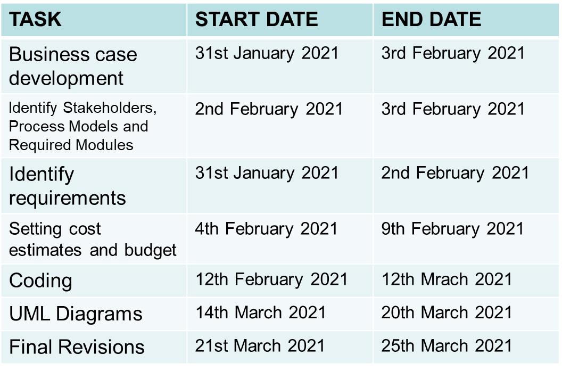

**SOFTWARE AND HARDWARE REQUIREMENTS FOR THE SYSTEM**:

* QR code Scanner.
* Web Application.
* PHP.
* Any Operating System.
* MySQL Databases.
* JAVASCRIPT, HTML, Graphics Supported Browser.
* System must be connected to the Server.
* At least 1GB RAM is required.

**IDENTIFY JOB ROLES AND RESPONSIBLITIES**:

|  |  |
| --- | --- |
| **Members** | **Roles and Responsibilities** |
| VIGNESH P | Team Leader  -Technical Lead  -Web Developer |
| NIKITH S | Team Member  -Web Developer |
| ROHITH S | Team Member  -Tester |

**JOB ROLES AND RESPONSBILITIES**

**PROJECT SPONSOR:**

Project sponsor is the one who provides the financial support for the whole project development and execution. They also monitor the process and clarifies scope questions. They also provide expert judgement and dictate milestones, key events, or the project end date.

Sponsor:: BHANU PRAKASH (STUDENT)

**SUBJECT MATTER EXPERTS (SME):**

SME is a person who has a special skills or knowledge on particular job or topic. They have a deep understanding of particular process, function or machine and hence they help to solve the technical challenges faced by the project.

SME:: ROHITH S (TEAM MEMBER)

**PROJECT MANAGER (PM):**

A project manager is a professional in the field of project management. Project managers have the responsibility of the planning, procurement and execution of a project, in any undertaking that has a defined scope.

PM:: VIGNESH P (TEAM LEADER)

**TECHNICAL LEAD:**

This person is responsible for overall planning, execution and success of overall complex software solutions to meet customer’s needs. They have to implement best practice and coding standards to the project.

Technical Lead:: NIKITH S (TEAM MEMBER)

**SOFTWARE DEVELOPERS:**

Individual who builds and creates an application is called software developers. They write, debug and then execute the source code of the software application.

Developers:: VIGNESH P (TEAM LEADER)

NIKITH S (Team member)

**SOFTWARE TESTERS:**

Their main role is to check if the actual result match the expected result and to ensure the software system is defect free.

Tester:: ROHITH S (TEAM MEMBER)

**WEB DEVELOPER:**

A web developer is a programmer who specializes in, or is specifically engaged in, the development of World Wide Web applications using a client–server model.

Web developer:: VIGNESH P (TEAM LEADER)

NIKITH S (TEAM MEMBER)