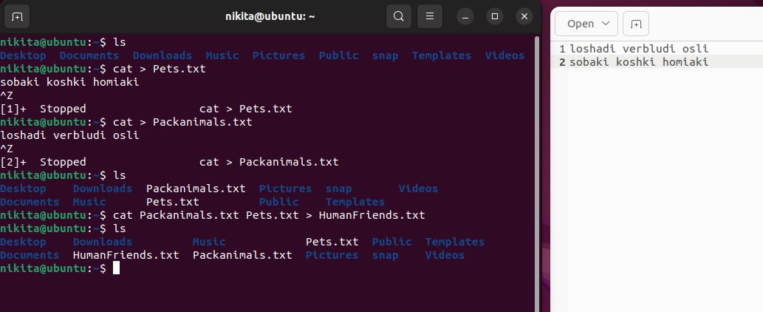

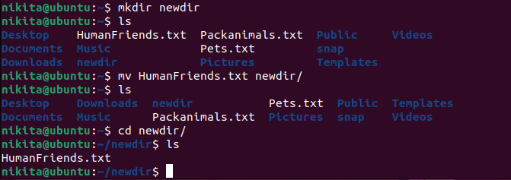

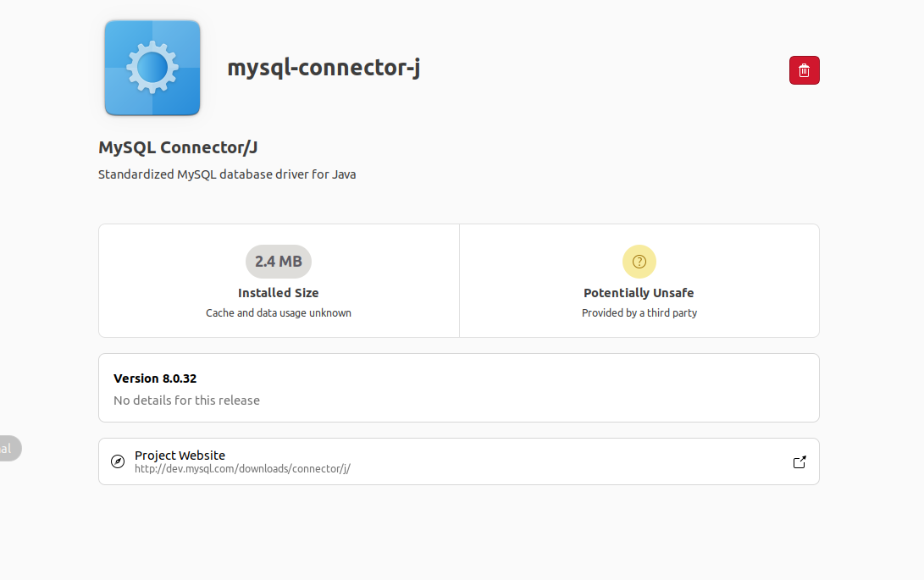

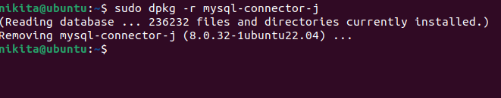

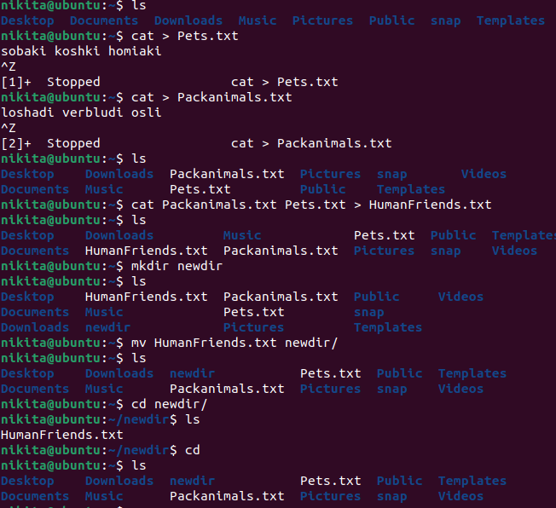

158 cat > Pets.txt

159 cat > Packanimals.txt

160 ls

161 cat Pets.txt Packanimals.txt > Humanfiends.txt

162 ls

163 cat > Pets.txt

164 cat > Packanimals.txt

165 ls

166 cat Packanimals.txt Pets.txt > HumanFriends.txt

167 ls

168 mkdir newdir

169 ls

170 mv HumanFriends.txt newdir/

171 ls

172 cd newdir/

173 ls

174 cd

175 ls

176 sudo apt install mysql-server

177 sudo apt update

178 sudo apt apgrade

179 sudo apt upgrade

180 reboot

181 ls

182 sudo apt install mysql-server

183 systemctl status mysql

184 sudo dpkg -i mysql-connector-j_8.0.32-1ubuntu22.04_all.deb

185 sudo dpkg -r mysql-connector-j

186 history