Creating scene templates for Varwin in Unity

[Переключить на русский](https://docs.google.com/document/d/1ymOBGuzSWDeqsZWAVpmpa5OjbUcPeKY0vwr_D87WhMQ)

1. Select an asset from Asset Store. Download and import it.

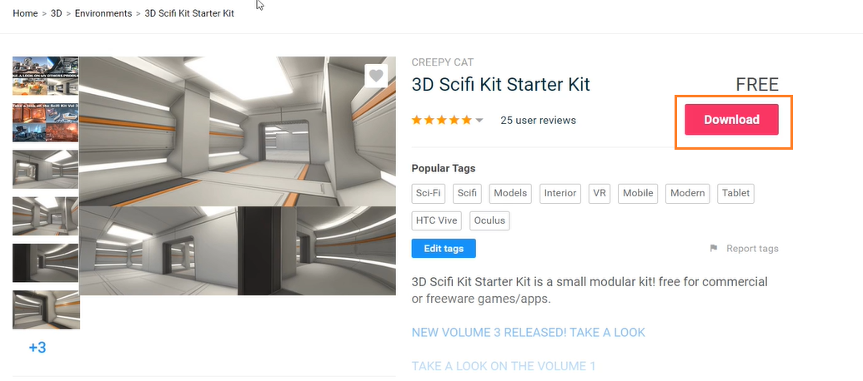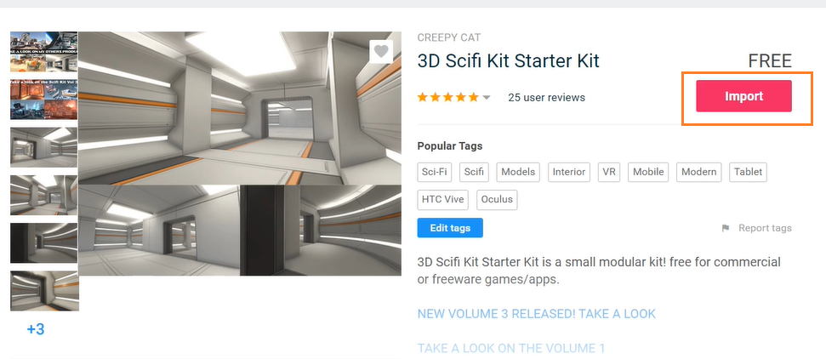

2. Open test scene that comes with the asset.

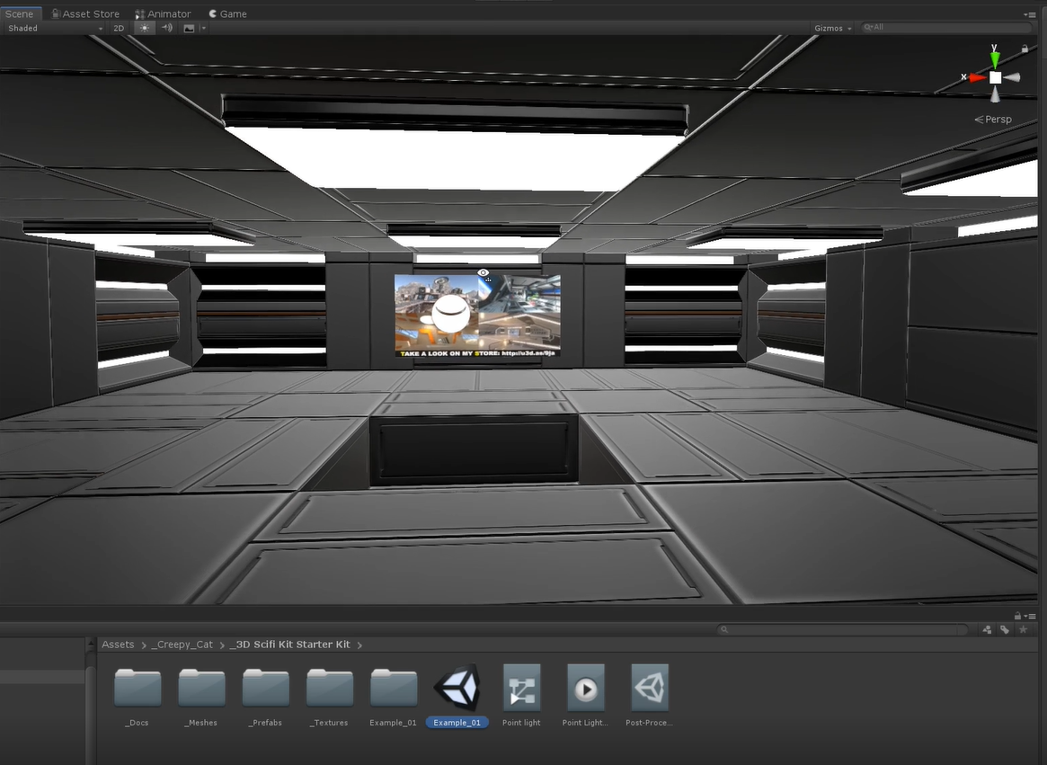

You can create a scene template for Varwin from virtually and Unity scene with game objects.

Restrictions:

* the scene can’t have any scripts that don’t belong to Varwin SDK
* there can be no cameras on the scene

Don’t forget about light baking.

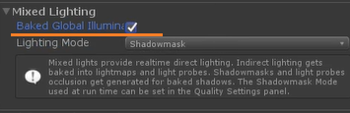

3. Mark those colliders to which a player will be able to teleport with TeleportArea tag. 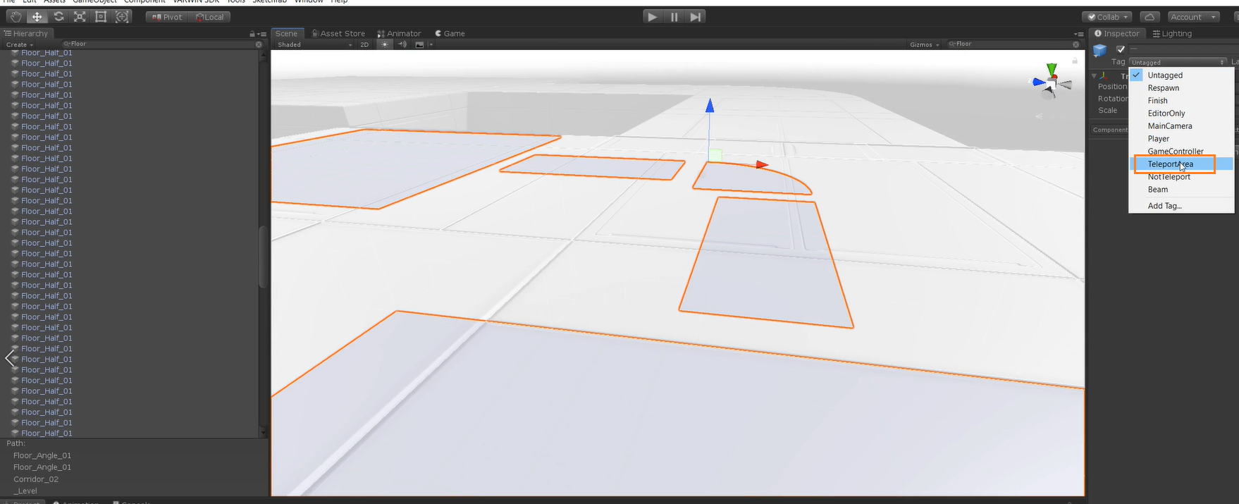

4. Now you can build the scene template. Open Varwin SDK - Create - Scene Template.

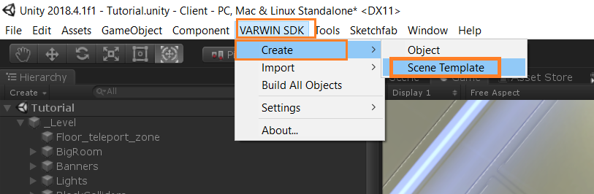

5. A window will open where you can name the scene template and give it a description. Fill in the information about the author of the scene template. You’ll also see a preview that will be used as an icon for your scene template.

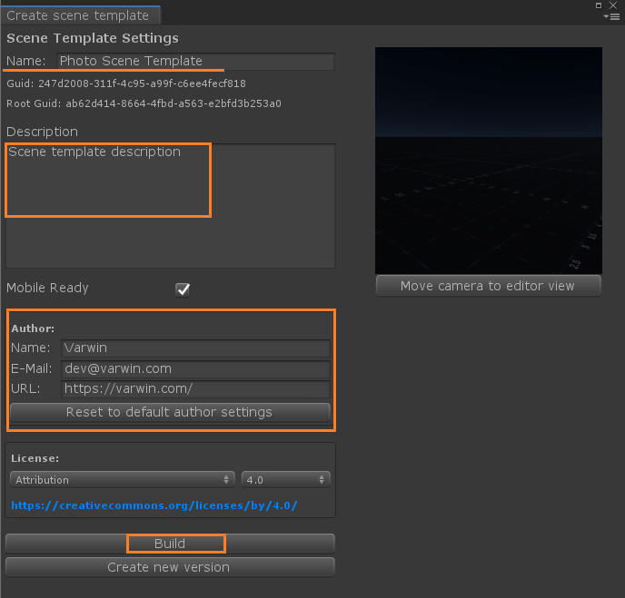

At this stage, World Descriptor that contains 2 objects are automatically added:

* preview camera - the only camera that can be placed at the scene. You can put it anywhere to get a nice preview.

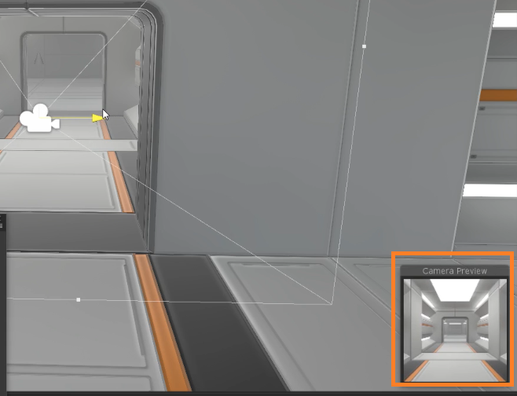

* spawn point - point where the player will appear when the scene template loads. The direction of the blue arrow shows the direction of the player’s eyes at the moment of spawn.

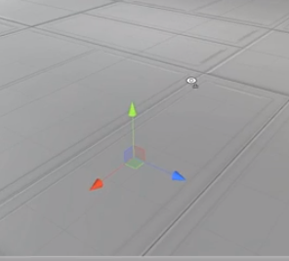

.

6. When everything is ready, click Build and wait for the scene template file to be built.

7. Upload the file into Varwin library.

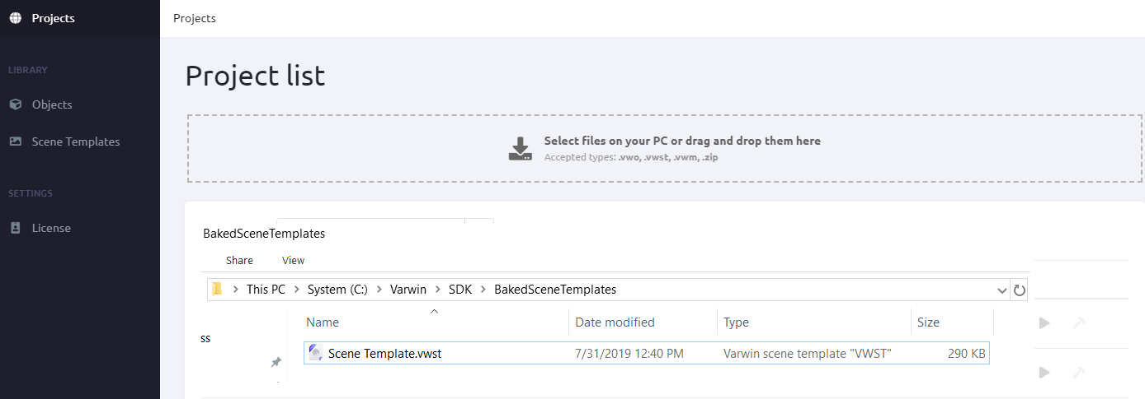

8. Now you can create a project ([manual](https://drive.google.com/open?id=1ji8IlKHhGR5aJDMzmPGu1I-DVEx0i7xq8PQAft2oDqo)) and use your new scene template in it.

9.Create new versions of existing objects/scene templates.

* [Objects, scene templates versioning](https://docs.google.com/document/d/1173FW8w7Yf8jQLwJXJqffxpf_xFNhDjAVosemPjr3Bo): instruction

**Additional:** [**Video guide**](https://www.youtube.com/watch?v=o1Gtf1KcnG4&list=PLz2Z4tRuWcpWOhy-z19iBZurvaW95FXcD&index=6&t=0s)