FAQ: Possible technical issues

[Переключить на русский](https://docs.google.com/document/d/1nFkmWVYxjEHAd8lg3hw0oOnx_vBmHMJBziBYwffnZ0U/edit)

Contents

Installation and launch

Can’t install Varwin

Can’t launch Varwin

Varwin RMS interface is not displayed / is displayed incorrectly

Issues with files

Can’t import a file into the library

VR client launch

Can’t launch VR client

VR client is running, but headset displays black screen

VR client is running, but nothing happens

Other VR client issues

Controllers are not displayed

Controllers are displayed in incorrect place

Incorrect floor or horizon level

VR client crashes (no error notification)

VR client displays error

Compilation error / Logic execution failure / Logic initialization failure

Can't read command line arguments / Server disconnected / Can't save / Server is unavailable

Can't load object

Can't load scene template / Player spawn point not found

World configuration error / Unknown error

# Installation and launch

## Can’t install Varwin

1. Check if your PC complies with [system requirements (link)](https://drive.google.com/open?id=1YnVCUts-NDuexkL_8lpMPlc_u6LR5m7oym-3rylly-g)
2. Contact Varwin technical support at [support@varwin.com](mailto:support@varwin.com). Describe your issue (we recommend to attach a screenshot of the error.)

## Can’t launch Varwin

* A yellow dot on the Varwin icon means the program is launching. This may take several minutes.



* A red dot on the icon means an error has occurred during the launch.



In this case, try the following *(hereinafter, try each successive action if the preceding one hasn’t helped)*:

1. Open Varwin menu by right- or left-clicking on Varwin icon. Restart Varwin

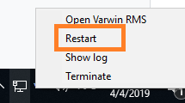

1. Restart Windows
2. Make sure you’ve allowed access to Varwin services in Windows Firewall*

*At the first launch, you will get several notifications from Windows Firewall. Select “Allow access” (by doing this, you allow access to certain Varwin services, without which the platform won’t run.

1. Open Varwin menu, select Show Log

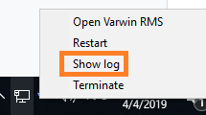

1. Contact Varwin technical support at [support@varwin.com](mailto:support@varwin.com) and send them the log (internet connection required)

## Varwin RMS interface is not displayed / is displayed incorrectly

1. Contact Varwin technical support at [support@varwin.com](mailto:support@varwin.com). Describe your issue (we recommend to attach a screenshot of the error.)

# Issues with files

## Can’t import a file into the library

If the file has been archived: make sure the archive was unpacked before the import.

# VR client launch

## Can’t launch VR client

1. Check if your VR equipment and your PC comply with [system requirements (link)](https://drive.google.com/open?id=1YnVCUts-NDuexkL_8lpMPlc_u6LR5m7oym-3rylly-g)
2. Reinstall Varwin platform

## VR client is running, but headset displays black screen

1. *For Windows Mixed Reality equipment*: check your equipment manual
2. *For HTC Vive equipment:* check if your base stations are on and you are inside their coverage area
3. Restart Steam VR
4. Restart your PC
5. Check if other VR apps work well with your equipment.
   1. If yes: contact Varwin technical support at [support@varwin.com](mailto:support@varwin.com).
   2. If no: contact customer support of the manufacturer of your equipment.

## VR client is running, but nothing happens

Choosing an integrated graphics card in the computer system can cause this error (see screenshot.) It will be seen in the VR. Varwin platform will run the VR client, but it won’t operate.

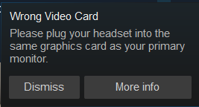

In this case, switch to discrete graphics:

1. Right-click on Windows desktop, select the NVIDIA control panel from the menu.

2. Select “Manage 3D settings.”

3. Select “Global Settings, then in the section “Preferred graphics processor” select “High-performance processor”.

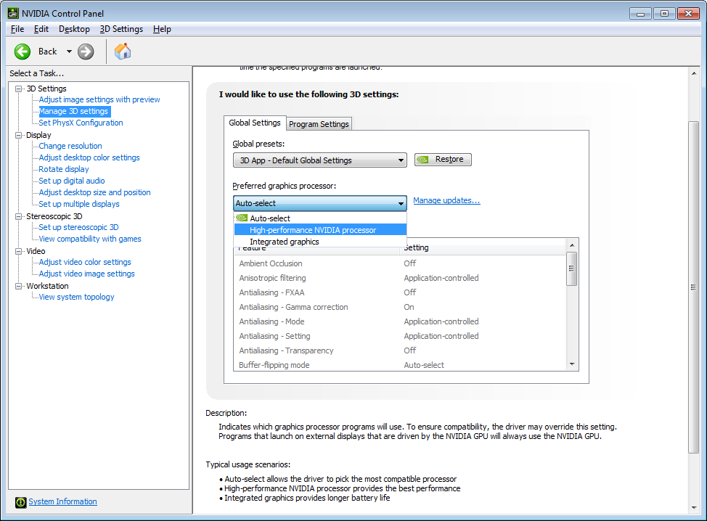

# Other VR client issues

## Controllers are not displayed

1. Make sure the controllers are charged and switched on.
2. Restart VR client.
3. Restart Steam VR.

## Controllers are displayed in an incorrect place

1. Move the controllers and headset a little.
2. Restart VR client.
3. Restart Steam VR.
4. Restart your PC
5. Recalibrate your headset (check your equipment manual)

## Incorrect floor or horizon level

1. Move the controllers and headset a little.
2. Restart VR client.
3. Restart Steam VR.
4. *For Windows Mixed Reality (floor):*
   1. In VR, enter Mixed Reality Portal
      1. For that, press the Windows button on your controller, after that click ‘Home’ button in VR.
      2. Please note: Varwin app will be closed.
   2. Enter ‘All Apps’
   3. Run ‘Room Adjustment’ or ‘Floor Adjustment’ (precise name depends on your Windows version)
   4. Rectify floor level, following the instruction that will appear.

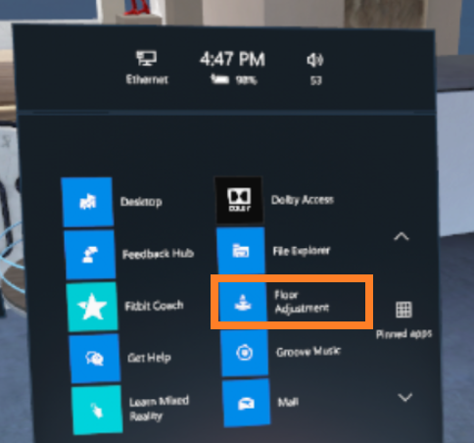

1. *For Windows Mixed Reality (horizon):* 
   1. Out of VR, open Mixed Reality Portal (it usually runs along with your Varwin VR client, in a separate window)
   2. Click ‘Menu’ button (three lines in the upper left part of the screen)
   3. Select ‘Run Setup’ or ‘Set up Room Boundary’ (the precise name depends on your Windows version)
   4. Rectify your headset settings, following the instruction that will appear.

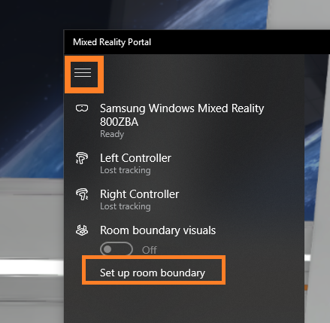

1. Recalibrate your headset (check your equipment manual)
2. Restart your PC

## VR client crashes (no error notification)

1. Make sure SteamVR / Oculus Rift / Windows Mixed Reality is running
2. Contact Varwin technical support at [support@varwin.com](mailto:support@varwin.com). Please attach your logs (‘Show Log’ in Varwin menu)



# VR client displays error

## Compilation error / Logic execution failure / Logic initialization failure

Check your Blockly scenario. Please note: blocks with issues will be illuminated.

## Can't read command line arguments / Server disconnected / Can't save / Server is unavailable

1. Restart Varwin.
2. Reinstall Varwin.
3. Contact Varwin technical support at [support@varwin.com](mailto:support@varwin.com)

## Can't load object

Contact the creator of the object.

## Can't load scene template / Player spawn point not found

Contact the creator of the scene template.

## World configuration error / Unknown error

Contact Varwin technical support at [support@varwin.com](mailto:support@varwin.com). Please attach your logs (‘Show Log’ in Varwin menu)

