Objects, scene templates versioning

[Переключить на русский](https://docs.google.com/document/d/1utUxQtT-oUgqt-zBynnQwBD6DjZC8pignqPbwZ8Nwkg)

* Before you create the first version of a new object/scene template, you can’t create another version of it.

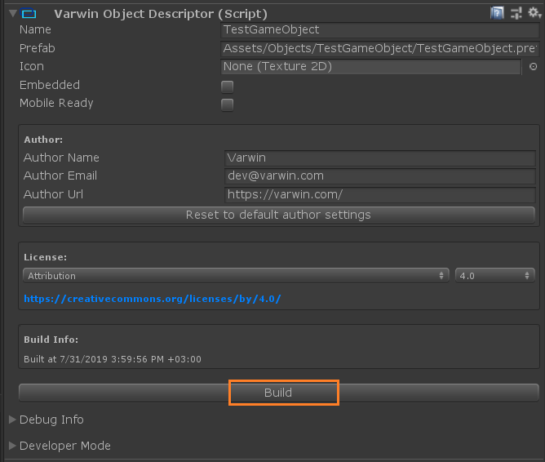

* When you’ve built a new object/scene template, an option of creating another version appears.

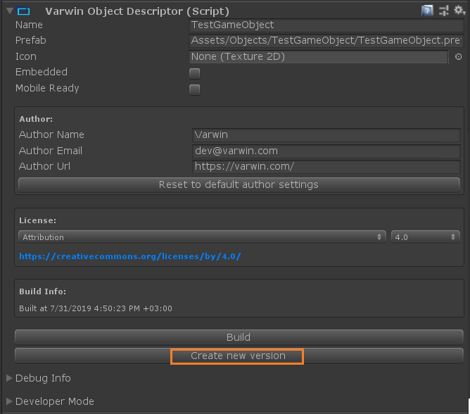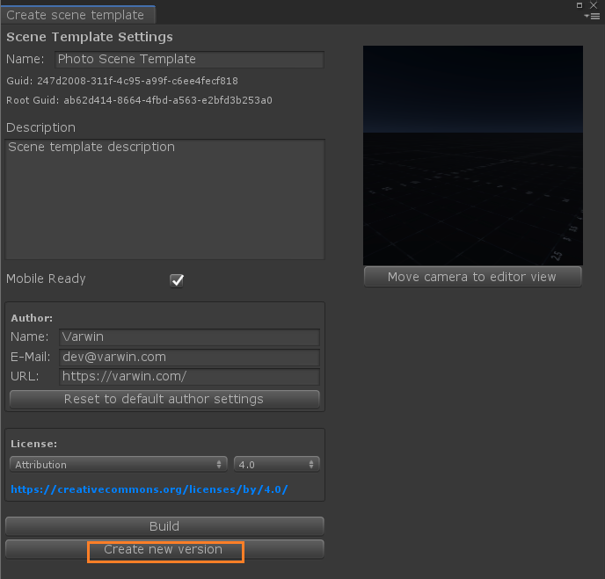

*Object Scene template*

* When you click Create New Version button, you will be asked to confirm. Then the system will ask if you’d like to build the new version immediately.

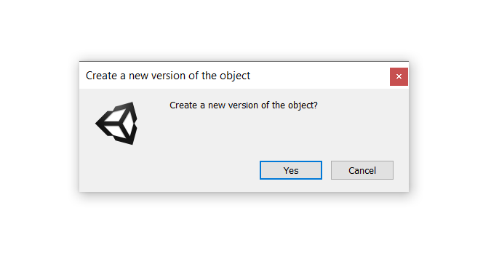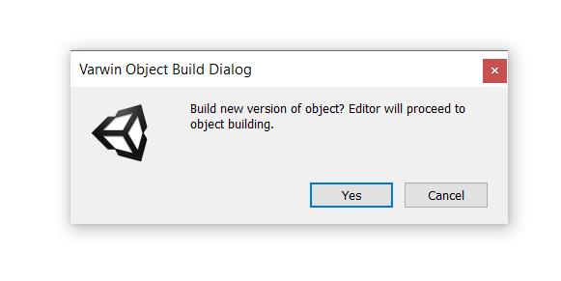

* If you don’t confirm building of the new version, the button will become inactive and stay that way until the version is built. To return to building the version, click Build.

