Public interfaces

[Переключить на русский](https://docs.google.com/document/d/1wofkNbrO0Rv2UHWv5kRNKue_l9qTOJhCuKwgAxq31KI)

Contents

Method for pressing trigger (Use)

Method for releasing trigger

Method for pressing Grip button (Start of dragging)

Method for releasing Grip button (End of dragging)

Object in hand position

Method for controller entering object (Touching object with controller)

Method for controller exiting object (End of touch)

Method for clicking on object with pointer

Method for controller pointer entering object area

Method for controller pointer exiting object area

Subscription for mode switch (Edit, Preview, View)

# Method for pressing trigger (Use)

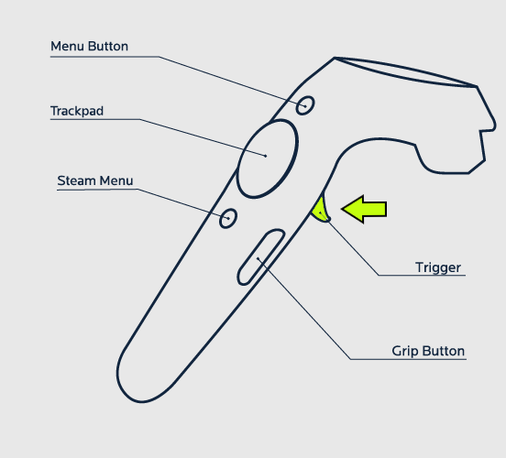

public interface IUseStartAware

{

//Controller interacting with object

//possible to receive link to gameObject of the controller

void **OnUseStart**(UsingContext context);

}

# Method for releasing trigger

public interface IUseEndAware

{

void **OnUseEnd**();

}

# Method for pressing Grip button (Start of dragging)

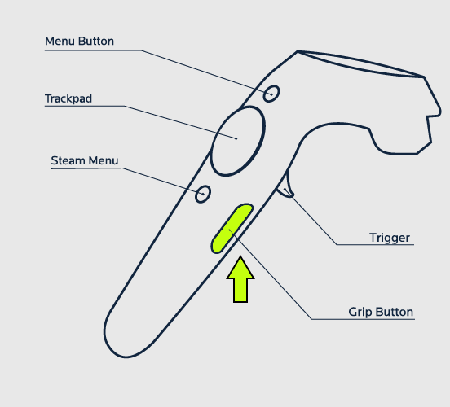

*By calling this interface, we switch on dragging of an object*

public interface IGrabStartAware

{

//Controller interacting with object

//possible to receive link to gameObject of the controller

void **OnGrabStart**(GrabingContext context);

}

# Method for releasing Grip button (End of dragging)

*By calling this interface, we switch on dragging of an object*

*public interface IGrabEndAware*

{

void **OnGrabEnd**();

}

# Object in hand position

Specify coordinates of the point where the controller will adhere to object when the object is grabbed

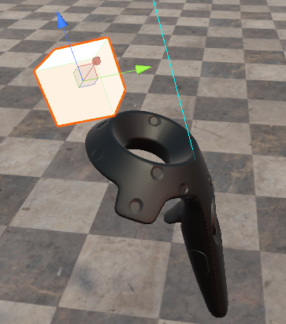

public interface IGrabPointAware

{

//left controller

Transform **GetLeftGrabPoint**();

//right controller

Transform **GetRightGrabPoint**();

}

# Method for controller entering object (Touching object with controller)

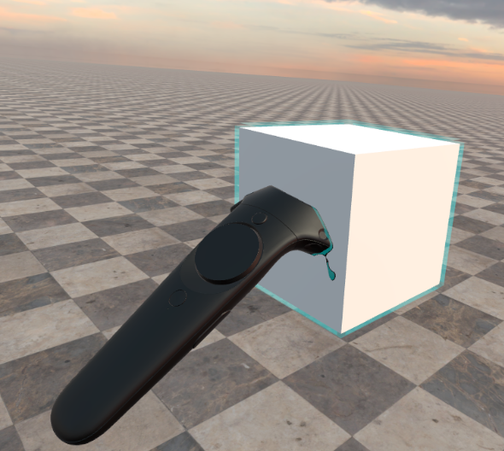

public interface ITouchStartAware

{

void **OnTouchStart**();

}

# Method for controller exiting object (End of touch)

public interface ITouchEndAware

{

void **OnTouchEnd**();

}

# Method for clicking on object with pointer

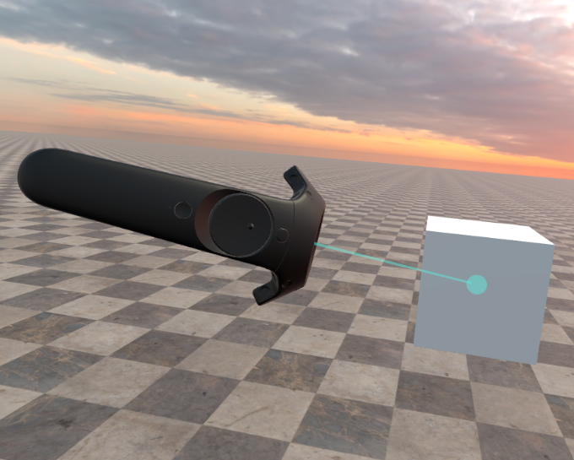

public interface IPointerClickAware

{

void **OnPointerClick**();

}

# Method for controller pointer entering object area

public interface IPointerInAware

{

void **OnPointerIn**();

}

# Method for controller pointer exiting object area

public interface IPointerOutAware

{

void **OnPointerOut**();

}

# Subscription for mode switch (Edit, Preview, View)

public interface ISwitchModeSubscriber

{

//mode before - mode after

void **OnSwitchMode**(GameMode newMode, GameMode oldMode);

}