Uploading content into Varwin library from Unity

[Переключить на русский](https://docs.google.com/document/d/17CKZ5dYyO-mgdwuhf-kv7v9qGFkkgrEUyzwv6D1PSi8)

1. Open the object in Unity. Click Build.

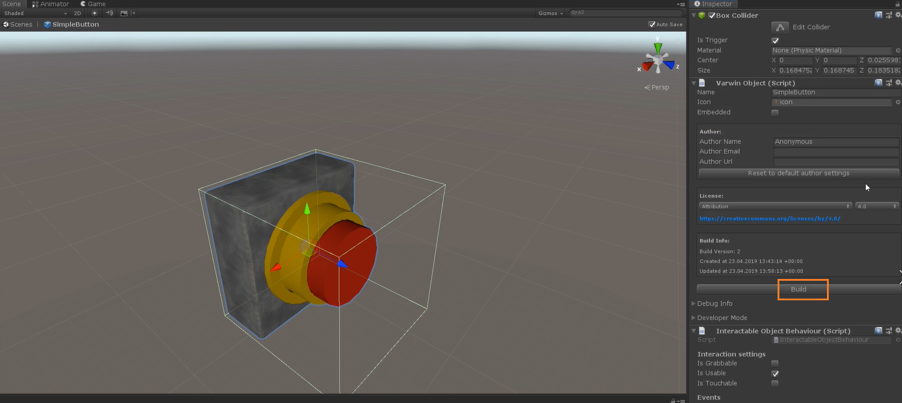

1. When the object is ready, the folder containing it will open. Open Varwin RMS app and drag-and-drop the object into the library.

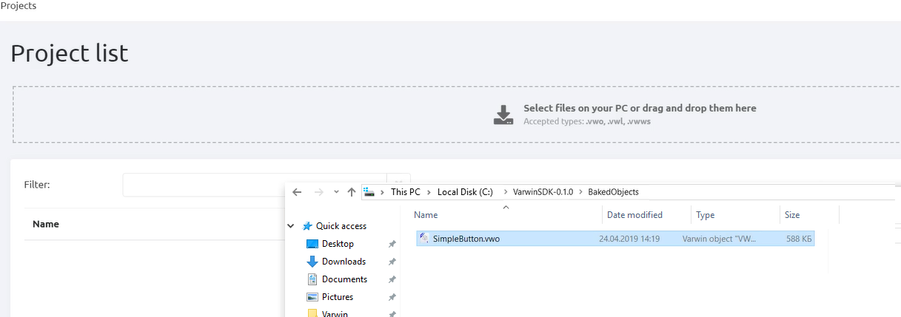

1. The object appeared in the library

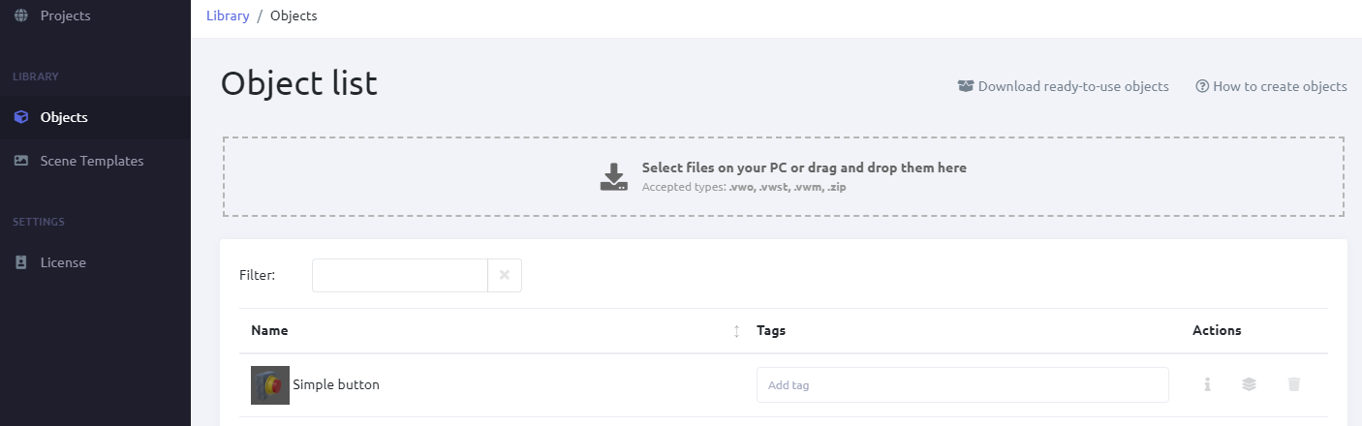

1. You can perform bulk upload

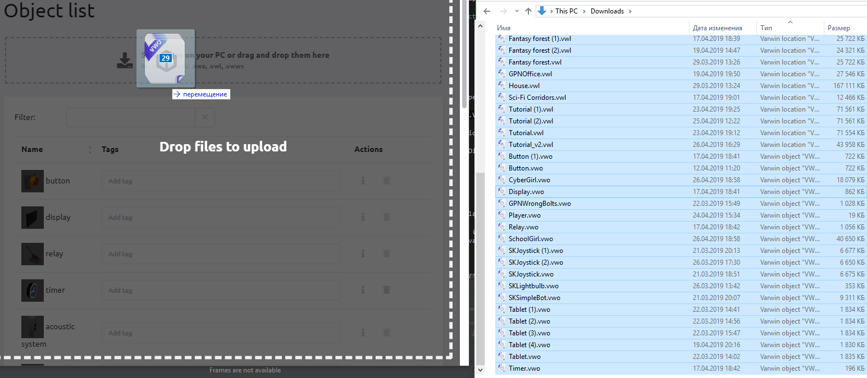

1. You can simultaneously upload different types of files: objects (.vwo files,) scene templates (.vwst,) metadata (.vwm). You can also upload zip archives with files.

