Using VR controllers

[Переключить на русский](https://docs.google.com/document/d/1Rdx0wPDI8pDRWhKYmDF_w4OefUSKc5qWwZzO9NZ0INM)

Contents

Equipment

HTC Vive controllers

Grab object

Action

Teleportation

Turn

Menu

Also

Oculus controllers

Grab object

Action

Teleportation

Turn

Menu

Also

WMR controllers

Grab object

Action

Teleportation

Turn

Menu

Also

Further reading

# Equipment

Varwin platform can be managed with the following controllers:

* **HTC Vive**

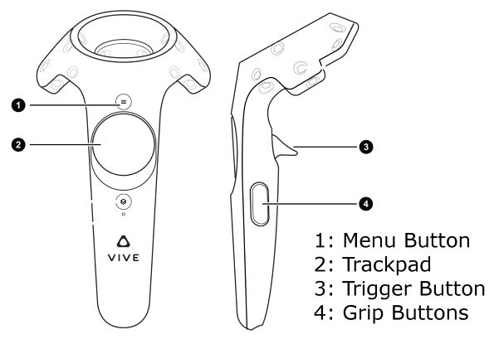

* **Oculus**

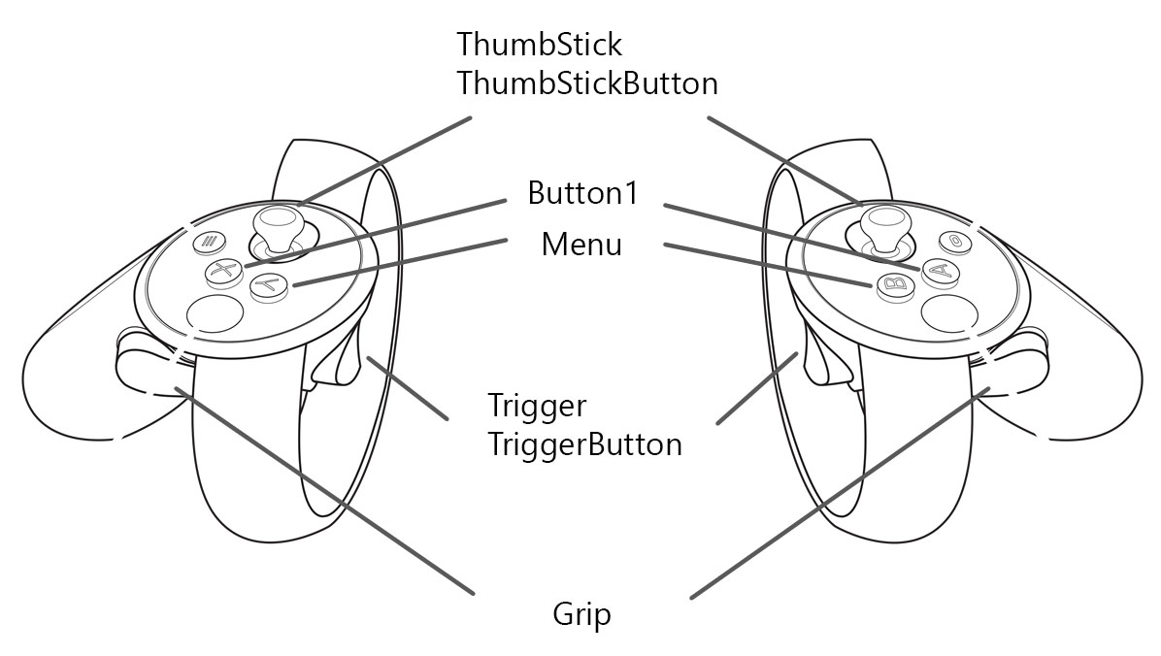

* **Windows Mixed Reality (WMR)** *(any manufacturer)*

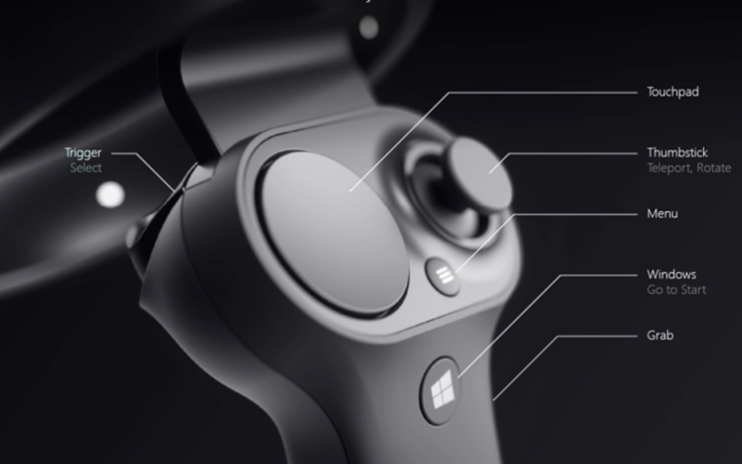

# HTC Vive controllers

## Grab object

* Press Grip
* To carry the grabbed object:
  + Preview, View mode: Hold down Grip button
  + Edit mode: No need to hold down Grip button
* To put the object down:
  + Preview, View mode: Release Grip button
  + Edit mode: Press Trigger button

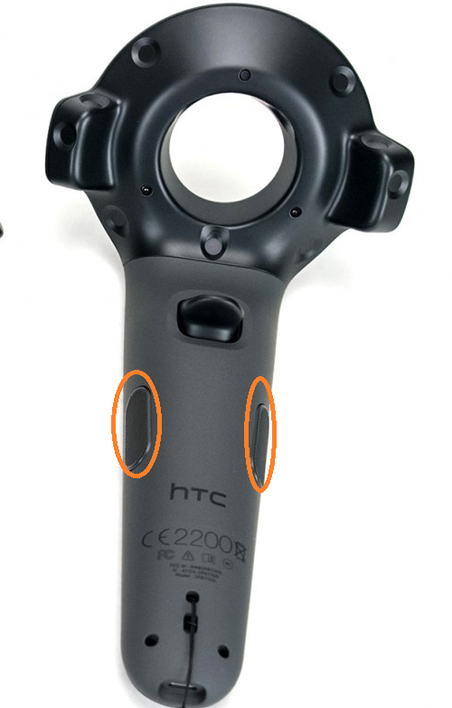

## Action

* Press Trigger

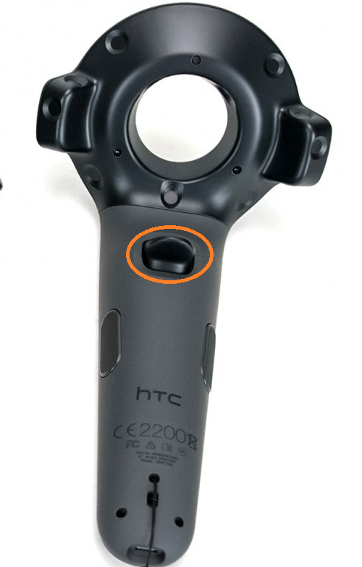

## Teleportation

* Press the **central area** of trackpad.
* The pointer will appear. While holding down the trackpad, point the ray to the area where you need to teleport to. If the ray is colored green, teleportation is possible.
* For teleportation, release the trackpad.

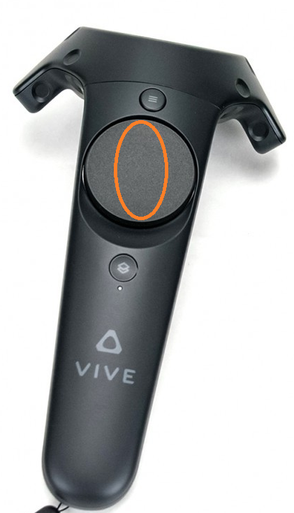

## Turn

* Press the left side of the trackpad for an incremental turn to the left, right side - for an incremental turn to the right.

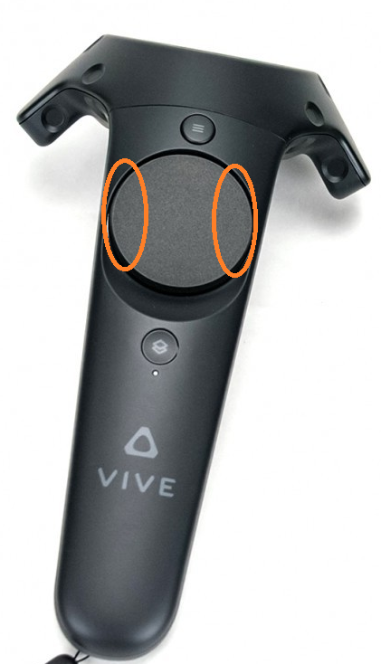

## Menu

* Menu button on the **left** controller:
  + Edit mode: press to display menu, press again to exit menu
  + Preview mode: displays button for switching to Edit mode.

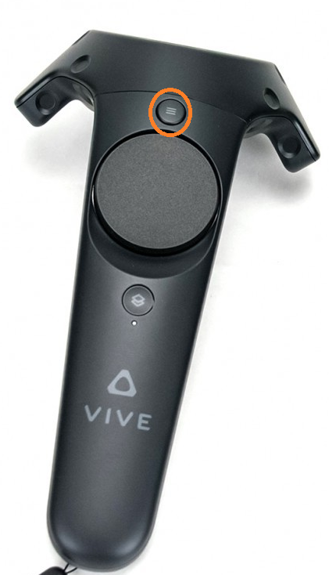

## Also

* System button displays Vive system menu (unconnected to Varwin platform)
* If pressed by mistake: press again to get back.

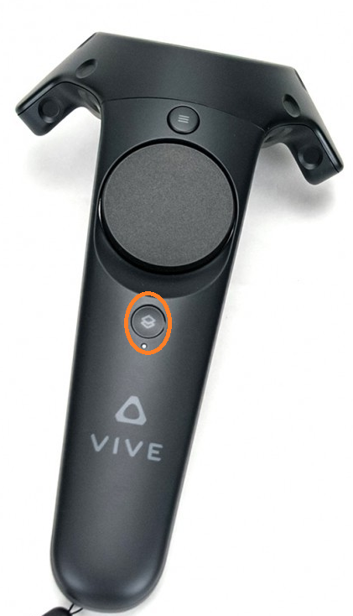

# Oculus controllers

## Grab object

* Press Grip
* To carry the grabbed object:
  + Preview, View mode: Hold down Grip button
  + Edit mode: No need to hold down Grip button
* To put the object down:
  + Preview, View mode: Release Grip button
  + Edit mode: Press Trigger button

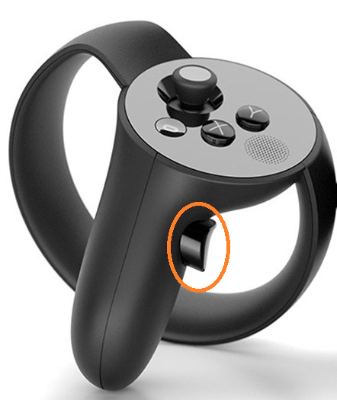

## Action

* Press Trigger

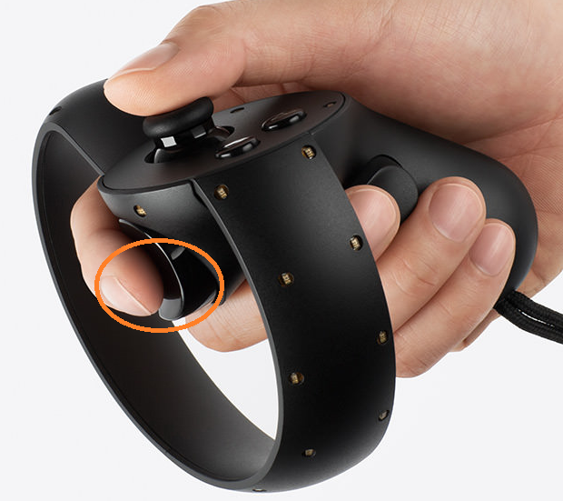

## Teleportation

* Press Thumbstick.
* The pointer will appear. While holding down the thumbstick, point the ray to the area where you need to teleport to. If the ray is colored green, teleportation is possible.
* For teleportation, release the thumbstick.

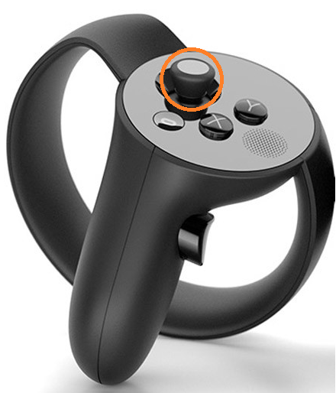

## Turn

* Press thumbstick leftward for an incremental turn to the left, rightward - for an incremental turn to the right.



## Menu

* Y button (left controller) displays the menu.

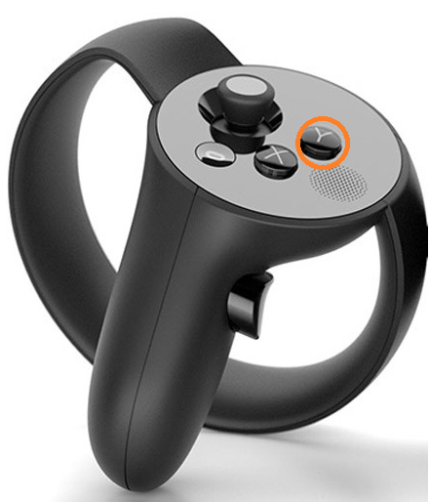

## Also

* System button displays Oculus system menu (unconnected to Varwin platform)
* If pressed by mistake: press again to get back.

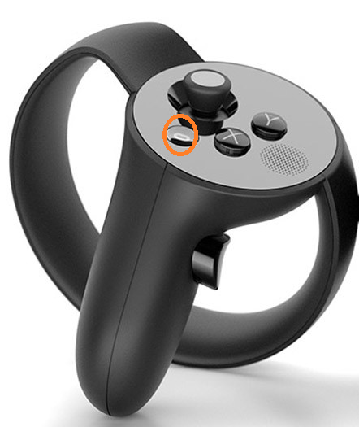

# WMR controllers

## Grab object

* Press Grab
  + To carry the grabbed object:
    - Preview, View mode: Hold down Grab button
    - Edit mode: No need to hold down Grab button
  + To put the object down:
    - Preview, View mode: Release Grab button
    - Edit mode: Press Trigger button

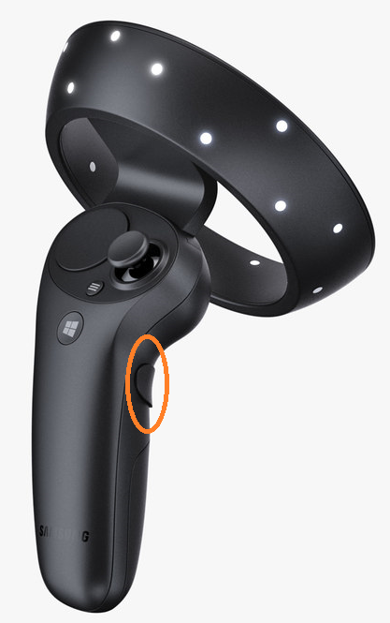

## Action

* Press Trigger

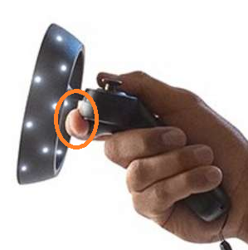

## Teleportation

* Press the **central area** of the touchpad.
* The pointer will appear. While holding down the touchpad, point the ray to the area where you need to teleport to. If the ray is colored green, teleportation is possible.
* For teleportation, release the touchpad.

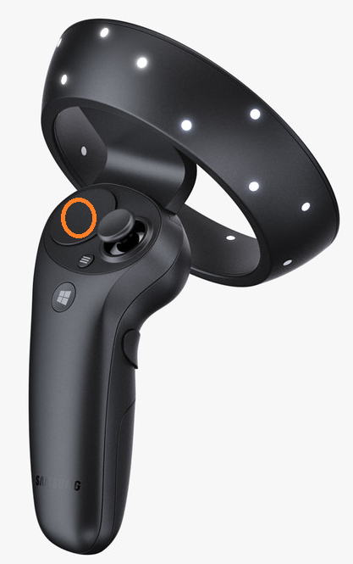

## Turn

* Press the left side of the touchpad for an incremental turn to the left, right side - for an incremental turn to the right.

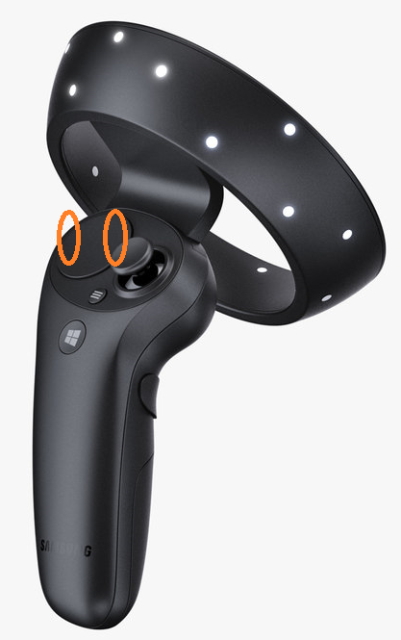

## Menu

* Menu button on the **left** controller:
  + Edit mode: press to display menu, press again to exit menu,
  + Preview mode: displays button for switching to Edit mode.

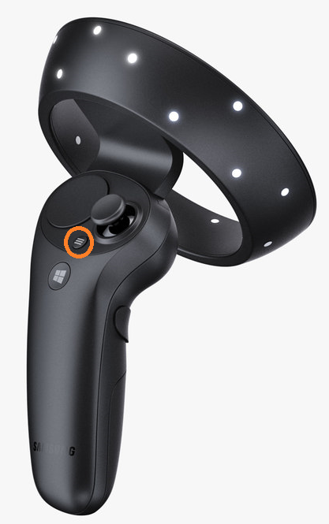

## Also

* System button displays the Windows system menu (unconnected to Varwin platform)
* If pressed by mistake: press again to get back.

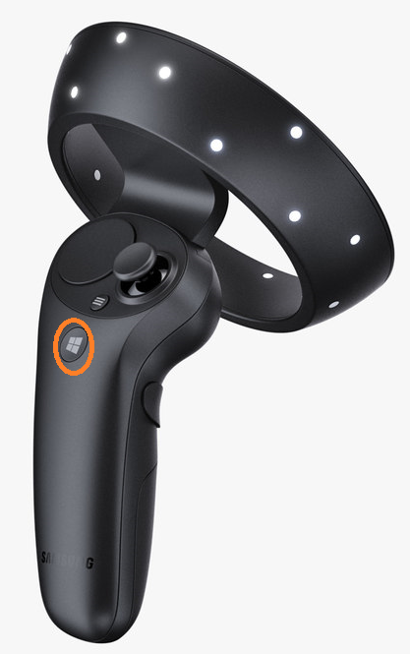

# Further reading

[About the VIVE controllers (vive.com)](https://www.vive.com/us/support/vive/category_howto/about-the-controllers.html)

[Controllers in Windows Mixed Reality (support.microsoft.com)](https://support.microsoft.com/en-us/help/4040517/windows-10-controllers-windows-mixed-reality)