Varwin SDK

[Переключить на русский](https://docs.google.com/document/d/1DypdjAmDuXyqFeLg7Pq66hhkEYmU0fYgVRPfgzfgwGQ/edit)

Contents

What this is

Installation

Creating objects

Object file

Creating scene templates

Scene template file

Importing models

Objects, scene templates versioning

Bulk build of objects

Additional materials

# What this is

SDK (software development kit) is a set of development tools that allows creating apps for certain program suite.

Varwin SDK is a set of tools for creating content (objects, scene templates) for Varwin in the Unity development platform. In order to work with Varwin SDK, [Unity](https://unity3d.com/get-unity/download/archive?_ga=2.19733694.707766669.1553265932-456492208.1549287338) ver. 2018.4.1f1 has to be installed on your PC.

# Installation

Varwin SDK comes as a Unity archive file (VarwinSDK.unitypackage). The file is attached to the letter you received while [installing the Varwin RMS](https://docs.google.com/document/d/154fkmOUdvtJHYM0NmCNBLEfukRp2kzetg4Zc6PGXNBE/edit#heading=h.6pzhcaqjibjv).

* [How to install the Varwin SDK](https://drive.google.com/open?id=15_MIL6kOdS-BHaJs7M0eDz_XHCuBDrRLSxmBrYGYDlU)

# Creating objects

Create objects for Varwin platform on Unity. Any prefab can be used as a base for creating an object.

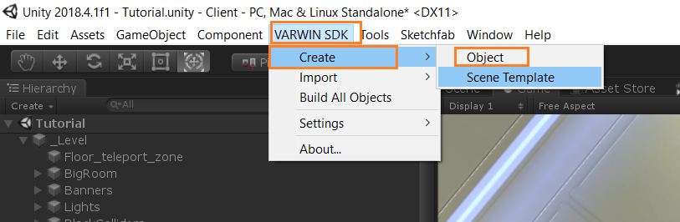

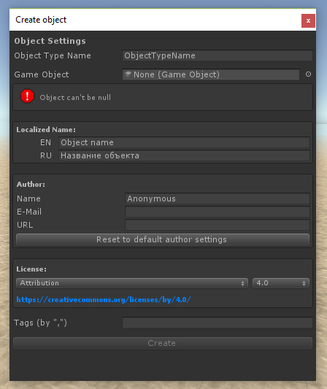

* [Creating Varwin objects in Unity](https://drive.google.com/open?id=1hsiaY3RPNxpEiCmi49X1WuThOj3C-a0yksD43CJXfFc): manual

## Object file



Created objects are packed as files with name suffix .vwo. These files can be uploaded to Varwin.

* [Uploading content into Varwin library from Unity](https://drive.google.com/open?id=1mvkpk0t4nBP0NpLNd2PJF2Qnd50U_8rKKRfS_74dEEs): manual

**The file contains:**

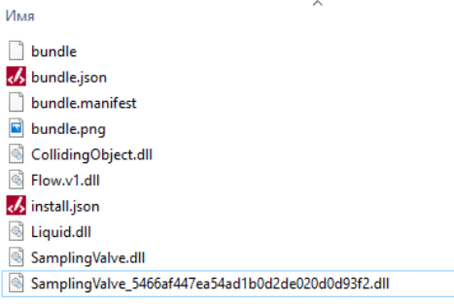

* bundle - complete model of a certain game object (not including code).
* bundle.manifest - metadata for the bundle.
* bundle.json - technical file; contains a description of the program code and remarks on bundle file contents.
* bundle.png - object icon. It’s displayed in Blockly and in the spawn menu.
* install.json - file for Blockly. It is used for automatic creation of blocks for Blockly (learn more: [Working with Blockly - Blocks for objects](https://docs.google.com/document/d/1J6C6y2byfLWf3ojLXNg2hGarLVvGczTvG4e_aG42Hi4/edit#heading=h.2s8eyo1)).
* .dll files - executable fragments of the object.

# Creating scene templates

Create scene templates for Varwin platform on Unity.

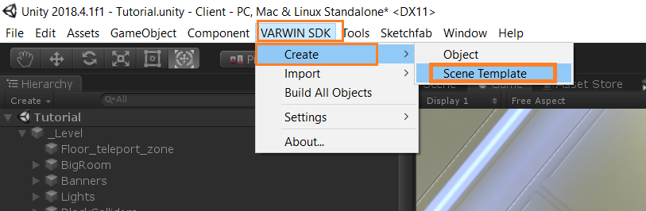

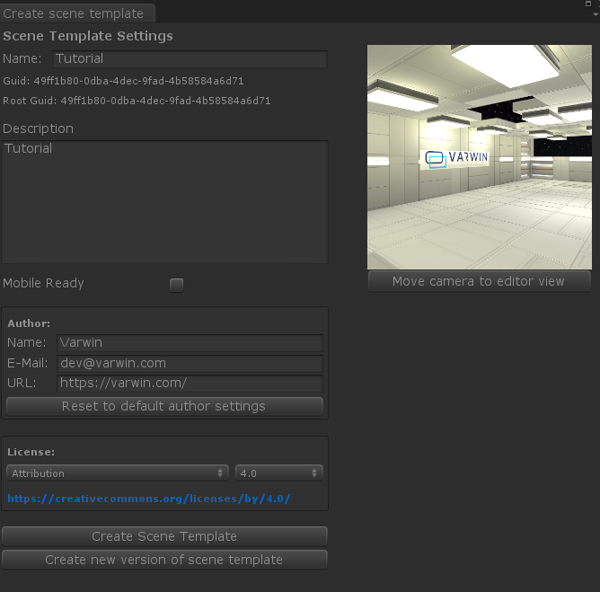

## Scene template file



Created scene templates are packed as files with name suffix .vwst. These files can be uploaded to Varwin.

# Importing models

Import models FBX, obj, blend and glTF through Unity into Varwin, one by one or in bulk.

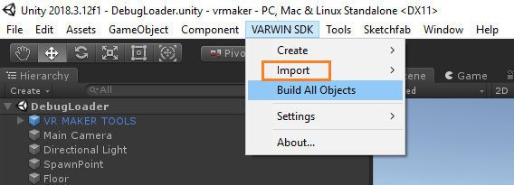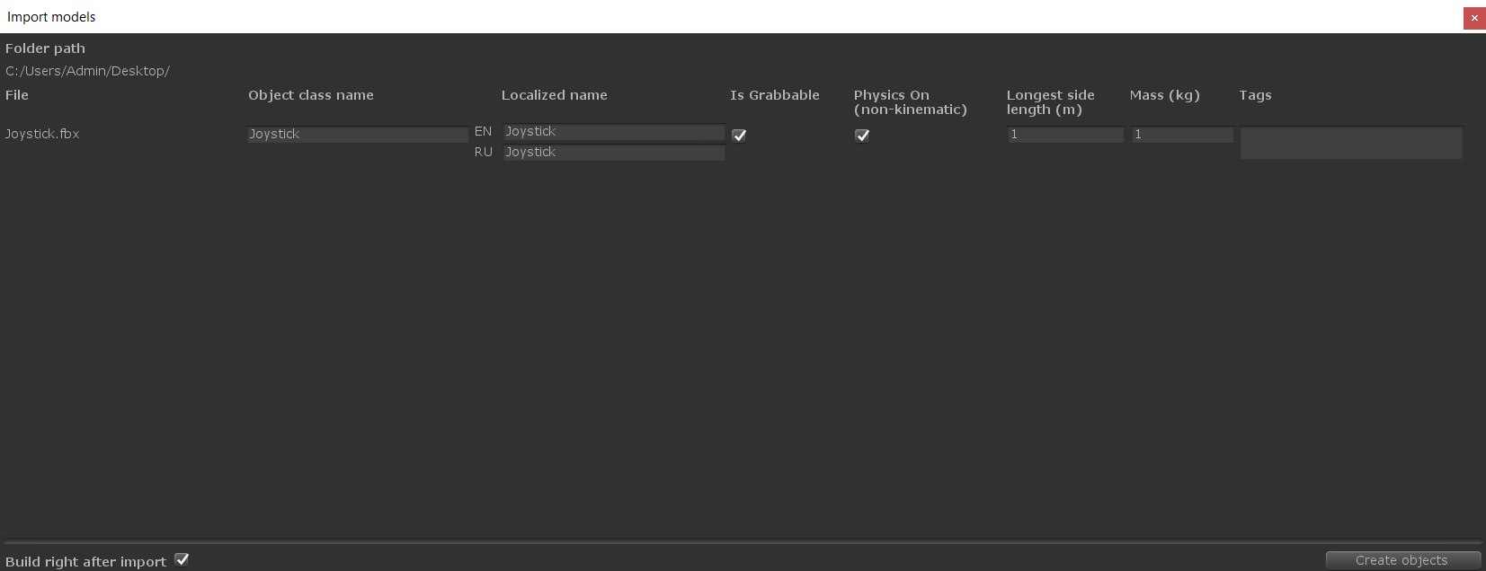

Specify the object’s name, weight, dimensions, whether it can be moved or used, whether it has physical properties.

# Objects, scene templates versioning

Create new versions of existing objects/scene templates.

* [Objects, scene templates versioning](https://docs.google.com/document/d/1173FW8w7Yf8jQLwJXJqffxpf_xFNhDjAVosemPjr3Bo): instruction

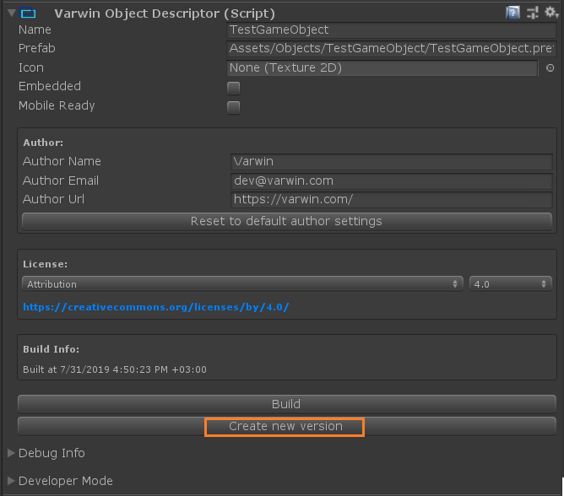

# Bulk build of objects

Perform bulk build of all the objects you’ve created for Varwin.

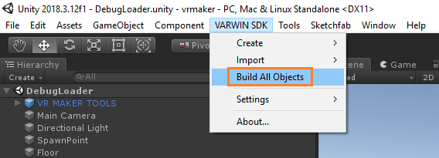

# Additional materials

Creating an object: video guides [1](https://www.youtube.com/watch?v=-pbF88u06pI&list=PLz2Z4tRuWcpWOhy-z19iBZurvaW95FXcD&index=1), [2](https://www.youtube.com/watch?v=pTngHii9jqY&list=PLz2Z4tRuWcpWOhy-z19iBZurvaW95FXcD&index=2), [3](https://www.youtube.com/watch?v=YtiJ_O792dU&list=PLz2Z4tRuWcpWOhy-z19iBZurvaW95FXcD&index=3)

[Creating a scene template: video guide](https://www.youtube.com/watch?v=o1Gtf1KcnG4&list=PLz2Z4tRuWcpWOhy-z19iBZurvaW95FXcD&index=6&t=0s)