# Varwin SDK installation

[Переключить на русский](https://docs.google.com/document/d/1CoIx6BhLCtkpc9Tu8avR0xLfnCY5g6XhBbzWoi59HfY/edit#)

Varwin SDK comes as a Unity archive file (VarwinSDK.unitypackage). The file is attached to the letter you received while [installing the Varwin RMS](https://docs.google.com/document/d/154fkmOUdvtJHYM0NmCNBLEfukRp2kzetg4Zc6PGXNBE/edit#heading=h.6pzhcaqjibjv). Download this file.

In order to install SDK:

* In Unity 2018.4.1f1 open Assets - Import Package - Custom Package, and select the archive with SDK that you’ve downloaded

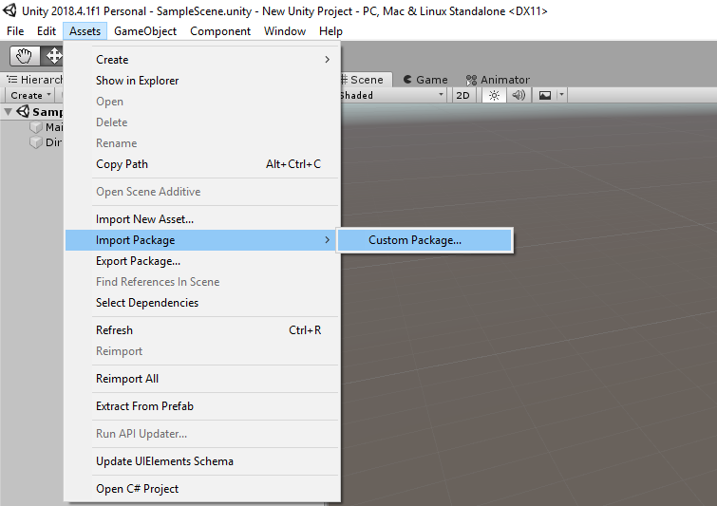

* You’ll see a window with a list of elements for installation. Click Import

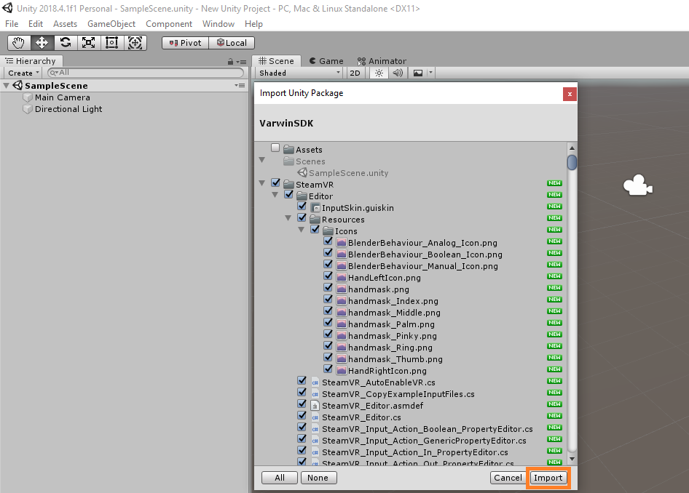

* Then you’ll see a window with the recommended project settings. Click Accept All

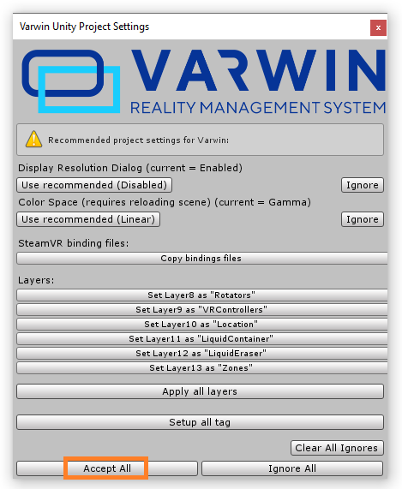

* When the installation is complete, Varwin SDK section will appear in the Unity menu.

