Varwin installation and launch

[Переключить на русский](https://docs.google.com/document/d/1dgOK8-xAkveASEHpaUgxAV9BikJExMCDh1uIb764hRg/edit#)

Contents

Preparing your PC

Steam installation

SteamVR installation

For WMR equipment: Windows Mixed Reality for SteamVR installation

For Oculus equipment: Oculus software installation

Unity installation

Varwin platform installation

Launching the platform

# Preparing your PC

1. Check if your PC complies to our [system requirements](https://docs.google.com/document/d/1YnVCUts-NDuexkL_8lpMPlc_u6LR5m7oym-3rylly-g/edit#heading=h.3znysh7)
2. The following software must be installed on your PC in order for the Varwin system to operate:
   1. Steam
   2. SteamVR
   3. Unity 2018.4.1f1 (for creating objects and/or scene templates)

## Steam installation

1. Download and run [Steam installer](https://steamcdn-a.akamaihd.net/client/installer/SteamSetup.exe) following this link from [official source](https://store.steampowered.com)
2. Enter your Steam account. If you don’t have one, please register.

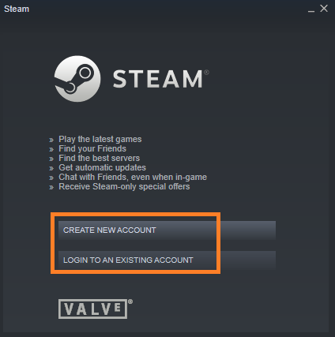

## SteamVR installation

1. Open Steam installed on your PC. Go to the Store section and search for SteamVR (no space between the words.)
   1. Check if your PC complies to SteamVR requirements (run SteamVR Performance Test) if necessary.
   2. Download SteamVR.

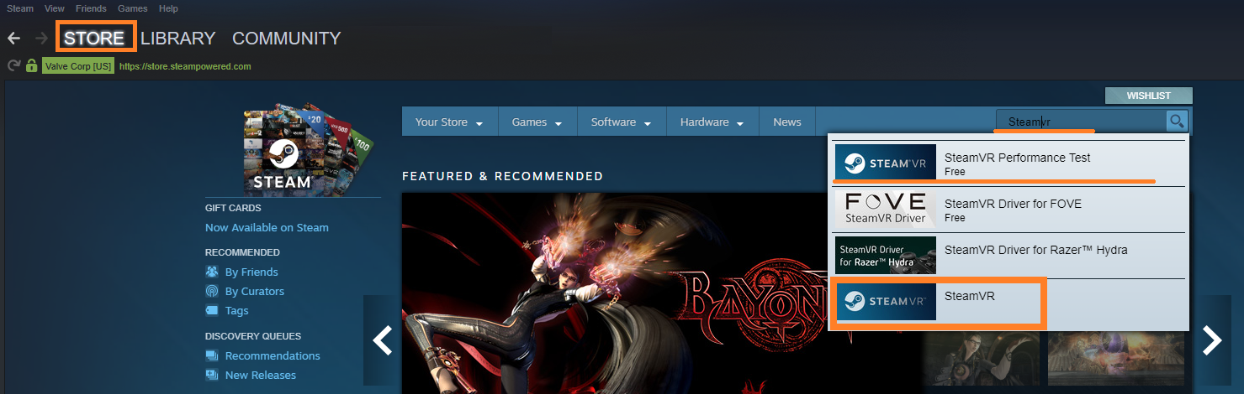

1. When SteamVR is downloaded, you’ll be notified that it is in your library. Click “Play Now” in order to install SteamVR.

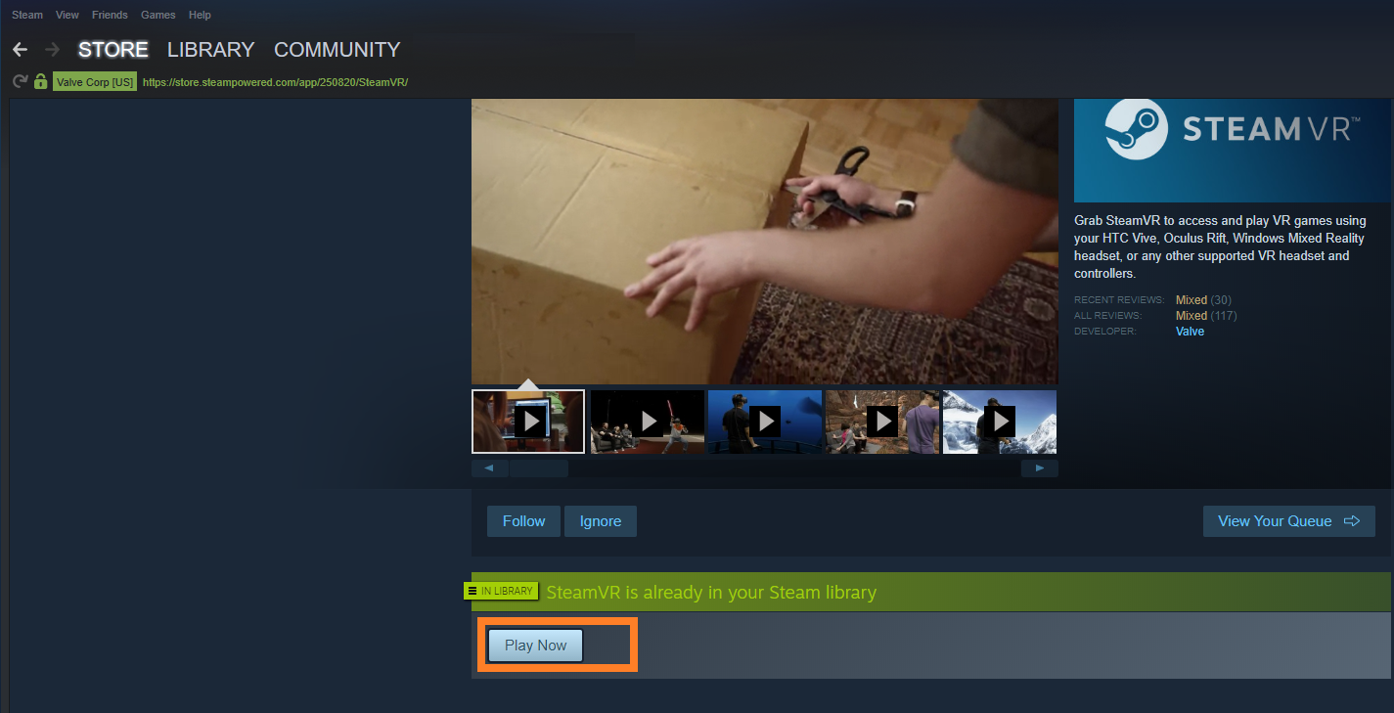

1. Follow the instructions of the installer to install SteamVR.

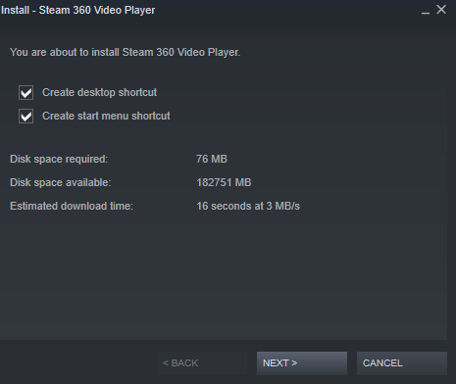

## For WMR equipment: Windows Mixed Reality for SteamVR installation

Those using Windows Mixed Reality equipment will have to install one more program: Windows Mixed Reality for SteamVR. The installation process is equivalent to that of SteamVR.

1. Open Steam installed on your PC. Go to the Store section and search for Windows Mixed Reality for SteamVR. Download this program.

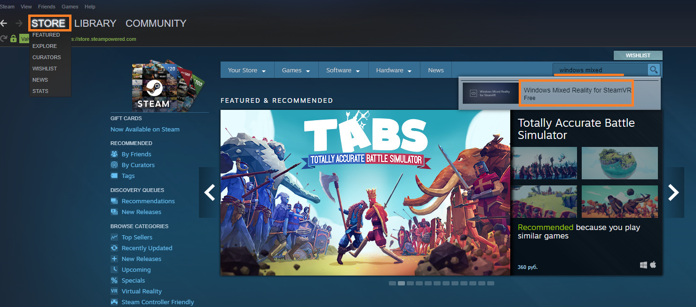

1. When the program is downloaded, you’ll see a notification that you can now Use it. Click “Free” in order to install Windows Mixed Reality for SteamVR.

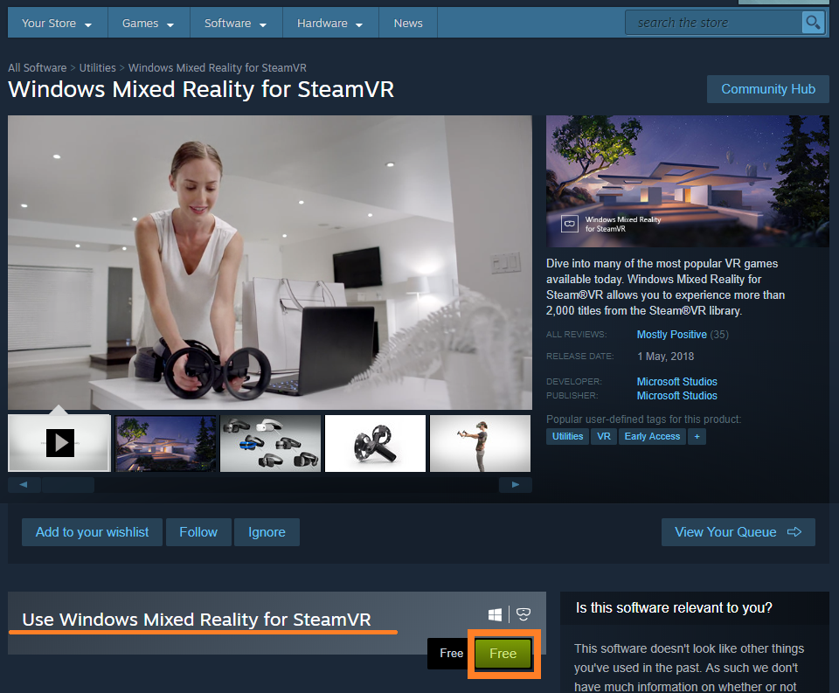

1. Follow the instructions of the installer to install Windows Mixed Reality for SteamVR.

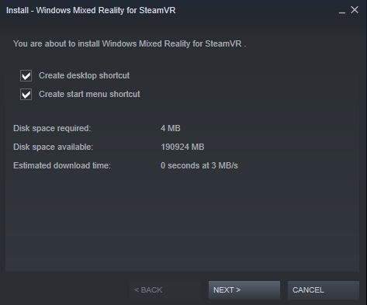

## For Oculus equipment: Oculus software installation

Those using Oculus equipment will have to install one more program: Oculus software. Download it from official Oculus site using this link: [Get Started with Rift](https://www.oculus.com/rift/setup/)

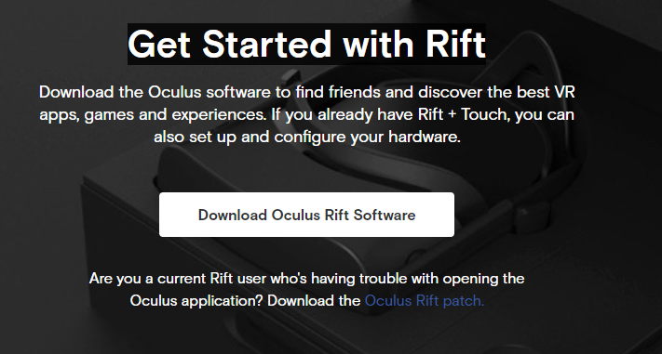

## Unity installation

Follow this [link from official source](https://unity3d.com/get-unity/download/archive?_ga=2.19733694.707766669.1553265932-456492208.1549287338) to install Unity 2018.4.1f1.



# Varwin platform installation

1. Go to [Varwin official website](https://varwin.com/). Click “Prices” and select one.
2. You’ll see the registration form. Please fill it in (all fields are required.)

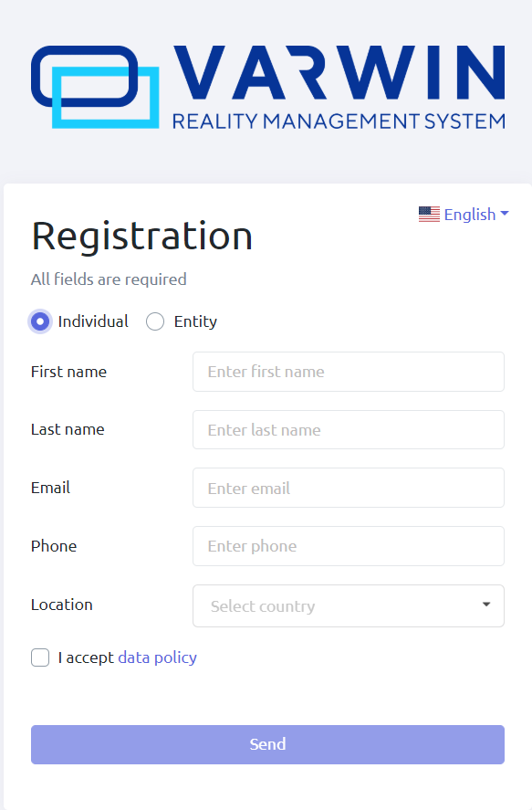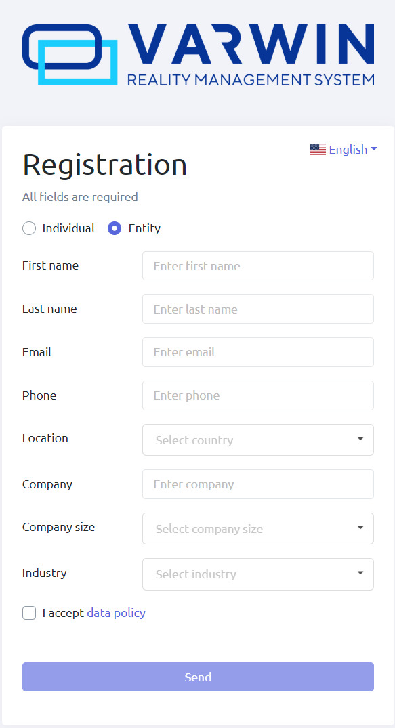

1. Check your email. You must have received a letter containing links for downloading Varwin installer and a license key. If you haven’t received the letter, please check your Spam folder.
   1. This email will include an attached file necessary for Varwin SDK installation. If you need to install the Varwin SDK, download the file. [How to install the Varwin SDK](https://drive.google.com/open?id=15_MIL6kOdS-BHaJs7M0eDz_XHCuBDrRLSxmBrYGYDlU)

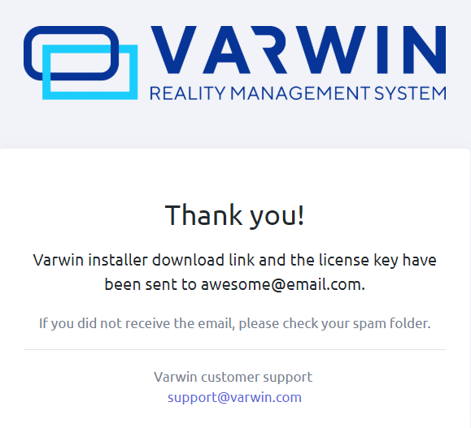

1. Follow the link you’ve received to download Varwin installer. This may take several minutes.
2. Follow the instructions of the installer to install Varwin platform. This may take several minutes.

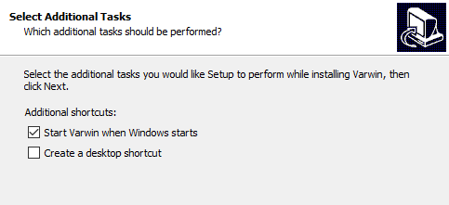

1. When Varwin is installed, its icon will appear in the notification area in the bottom right corner of the screen. While the program is launching, there will be a yellow dot on the icon. When the program is work-ready, the dot will disappear.



# Launching the platform

1. Launch Varwin by double-clicking on the icon on your desktop, or by double-clicking on the icon in the notification area, or via the menu.
   1. When Varwin is installed, you can open the menu by right- or left-clicking on the icon in the notification area

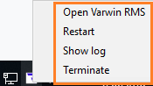

1. At the first launch, you will get several notifications from Windows Firewall. Select “Allow access” (by doing this, you allow access to certain Varwin services, without which the platform won’t run.)

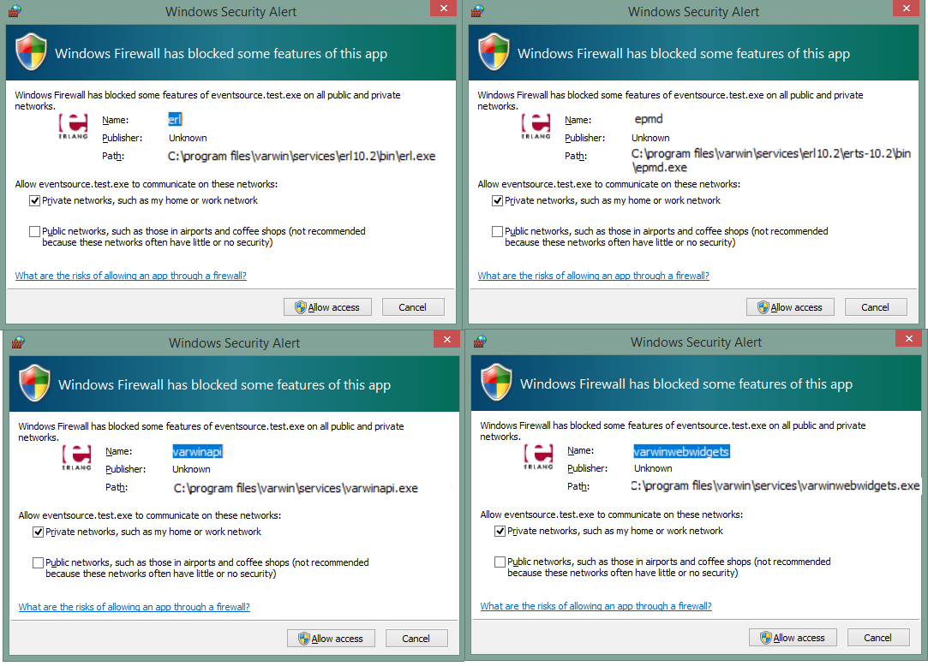

1. You’ll see a license key window. Enter the key you’ve received in the letter.

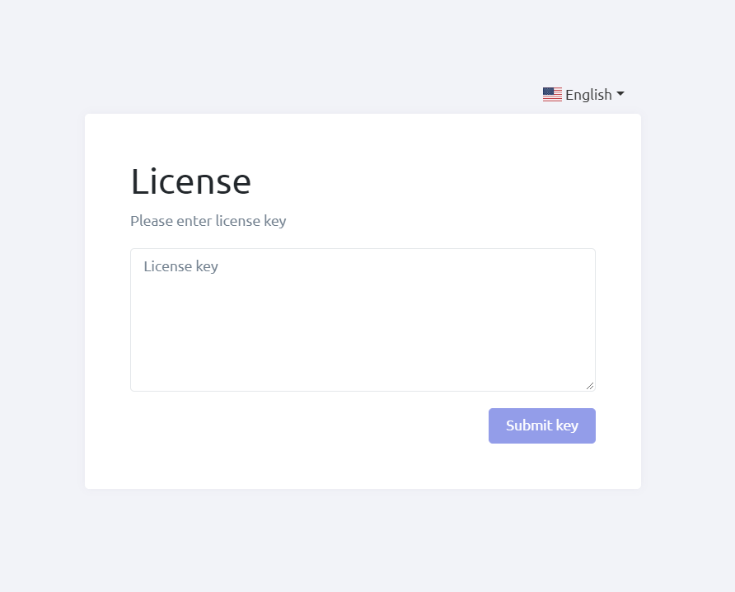

1. You have successfully installed and launched Varwin.