OUTPUT OF THE PROJECT

<http://65.0.87.120> – AWS INSTANCE CREATED

1. Opening the link

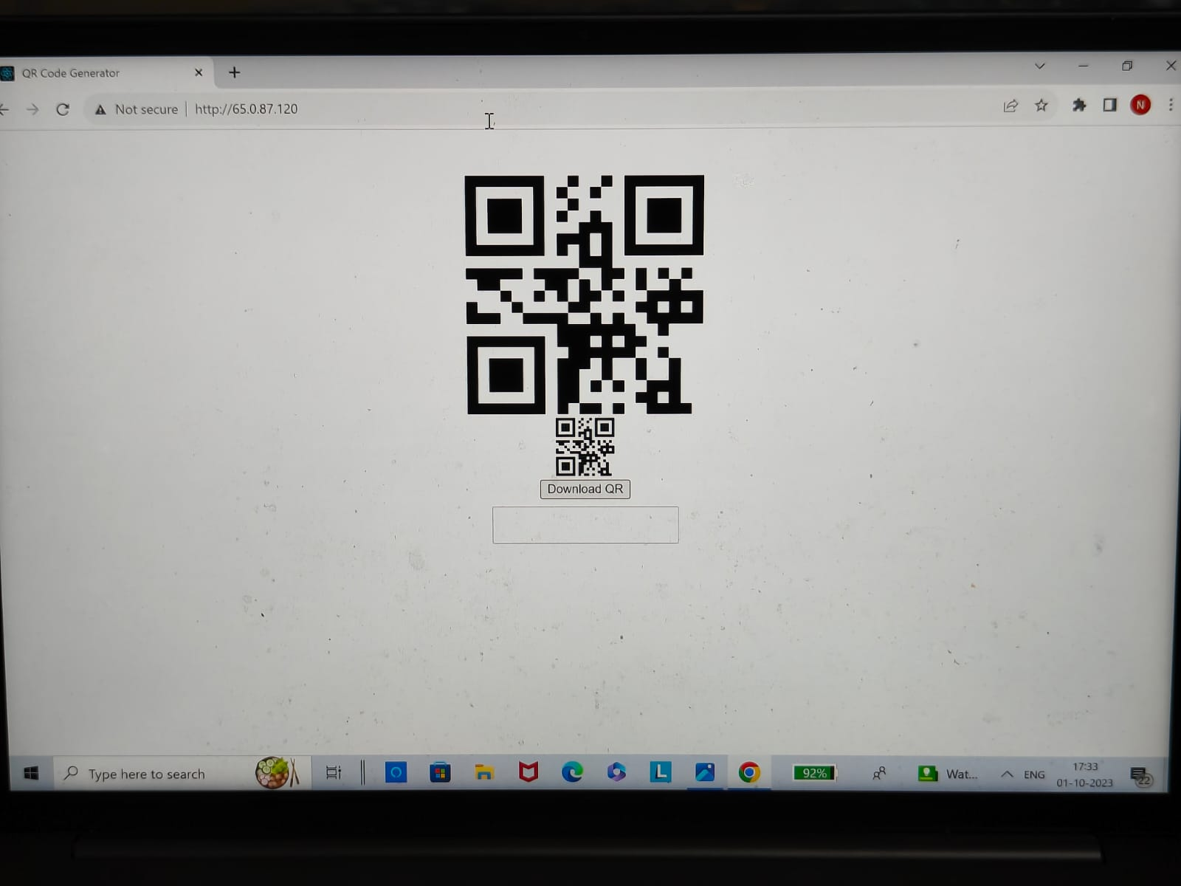

2)Including the Text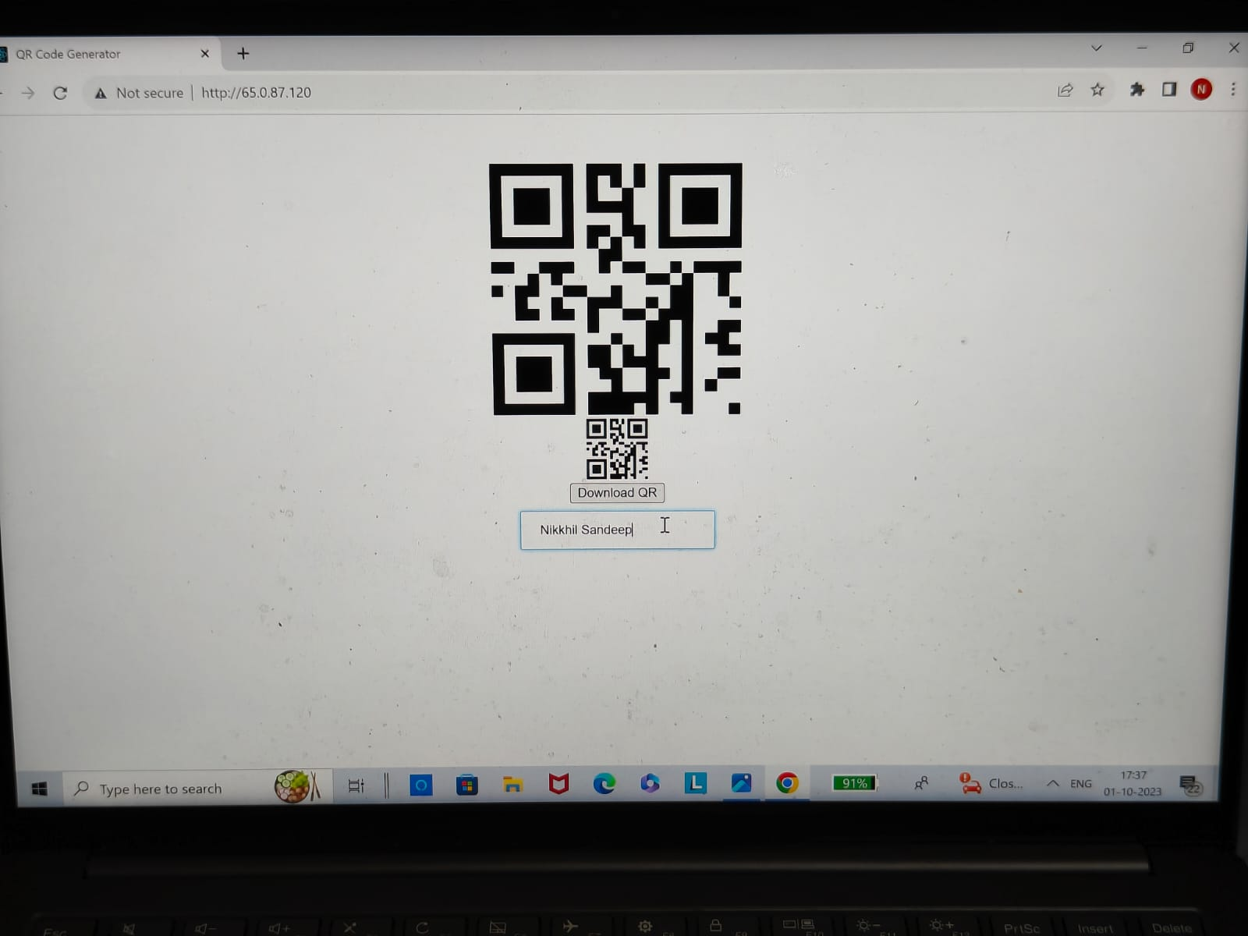

3)Downloading the QR code

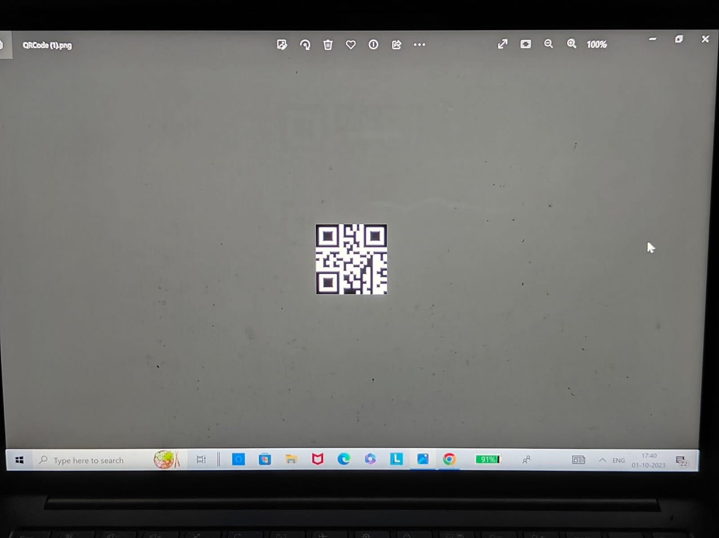

4)After Scanning the Qr code using the Qr code scanner

