

**Internet of Things Lab (IOT)**

**Project**

For

B.Tech. CSE

On the topic

**Sign to speech gloves using flex sensors and image processing**

**Submitted to: Submitted by:**

Dr. Purnendu Pandey Shreya Jain

Atluri Nikhitha Chowdhary

Ashi Khetan

Abstract

We, human beings share our beliefs and ideas through speech and body gestures with the people around us. There are 1.5 billion people of the total population of India who are physically challenged and are either deaf and dumb or are blind. Sign language is a nonverbal form of communication method which is found among all deaf and dumb communities in world. Dumb individual all through the world uses gesture-based communication for the correspondence. Deaf and hard-of-hearing people do not have the luxury of absorbing new information and knowledge through the daily noises, conversations and language that is spoken around them. Our project – ‘Sign to Speech Glove using flex sensors and image processing’ will give those people a medium to communicate. Hand gestures plays an important role as compare to the other gestures (arm, face, head and body) because it expresses the user's views in less time.

Introduction

Many people feel alienated from a group when they are unable to react quickly. Being physically challenged doesn’t mean they are debarred from having access to the fun side of life. According to the survey of 2011, there are 1.6 million citizens who can’t speak as well as 1.2 million citizens who can’t listen in India. More than 70% of the Deaf population of India is working in Government as well as Private sectors. They are dependent on sign language for communication. popularly Indian Sign Language is used in India. This sign language is also used in many other countries in the South Asian Region. People who have been trained in this language can only understand. In the rest of the population of India, not many citizens are able to use Indian Sign Language to communicate with the physically challenged, as they really never learned sign language. This causes a communication gap between the unable and able person. This leads to the incompetence of hearing impaired from mainstream of the society. Usually, to overcome this problem a communication assistant is required, to convert Sign Language to auditory speech. Some systems were previously designed to achieve similar results but they had disadvantages such as being practically not implantable or expensive and immobile. All previous systems were focused on half-duplex communication. In this paper, thus, we propose a hardware system to complete this need.

The proposed system is completely portable and focuses on efficient communication. The system is being proposed with the use of flex sensors and image processing. The objective of the system is to convert hand gestures to speech for communication between the mute people and the rest. The system includes two modules. The first module is a hand glove with flex sensors and Arduino Uno to convert hand gestures to auditory speech. The second module is image processing which captures the video frame of hand gestures and detects the meaning in the text. The system is based on Indian Sign Language and covers all the words required in day to day life. But in the prototype, we show the working with some of the words and sentences only ( future training) due to the deadline.

This framework offers a reliable source of communication to the individual who can't talk. Deaf and dumb individuals use gesture based communication for the same reason. Communication through signaling uses signals rather than sound to pass on data. “This dialect incorporates consolidating hand shapes, hand developments, outward appearances to express person's considerations”. In this framework flex sensors does the half part and image processing the other. Flex sensors are joined to the glove using needle and thread and duct tape. Flex sensors are the sensors whose resistivity changes with the measure of the bent made ..”In this project, Arduino microcontroller is used to take input from flex sensors and then this analogue data is converted to digital form by using microcontroller”.Every information from the flex sensors is stored in a a data sheet and accordingly calculated to identify the meaning of the signs as text/speech. This will eradicate correspondence gap between the Normal and Deaf and stupid groups. Here in this prototype, Arduino Uno atmega328 microcontroller used as focal unit. Flex sensors are put on to each of the fingers after which data is produced on the basis of bent made as the finger moves. Microcontroller can work over this information to analyze it and send it to the android application utilizing Bluetooth module. Also our algorithm for image processing gives a pillar in checking the accuracy of the system. “Language representation by hand Hard of hearing and Dump individual and ordinary individual correspondence is as same as two distinct people from various nations utilize two unique dialects for correspondence with no regular dialect then they will have issue of seeing each other. Almost totally senseless populace is an aftereffect of the physical incapacity of hearing for hard of hearing individuals and inability of representing idiotic individuals. Due to absence of correspondence between typical individual and hard of hearing and dump individual, the proportion is diminishing of Literate and Employed Deaf and Dump. What's more, Dump individual uses gesture based communication for correspondence, which isn't known to typical individual for correspondence they require an interpreter physically, which isn't generally helpful to organize. To beat this issue, we designed and built this kind of application. Our application demonstrate fill in as an alluring Interpreter used to deciphers Sign Language in type of Gesture by a Dumb Person to Synthesized English Word which has a relating importance in Sign Language which translates a specific thing, as an android application for giving content of hint transformation..”

Literature survey

This section introduces the previously developed systems with the same objective. Keeping the same social issue in mind many developers have come up with their own innovative systems. Few of such systems are as follows:

**A. Interactive Glove.** This system was developed in November 2015. This system only converts alphabet from sign language to audio. So, this system creates limitation by only allowing alphabets and no words and sentences to get recognized.

**B**. **Embedded Based Hand Talk Assisting System for Deaf and Dumb**. This system was invented in March 2014. This system has a simple architecture and works by storing and running audio using keypad. The drawback of the system is that it does not make use of sign language.

**C. Sign language to speech converter**. This system was invented in May 2014. This system converts the gesture to audio with the help of MATLAB. But the major drawback about the system is that it always requires a computer for conversion, hence, making it non portable and expensive.

**D. Talk Aloud Gloves**. This system was developed April 2016.This system senses gestures with the flex sensors and audio is produced with the help of computer. The major drawback of this system is that it requires computer making it non- portable and expensive and also there is no way for other person to communicate.

People used different combination of sensors and used different software and hardware platforms to achieve the one common goal . The goal is to eradicate the communication between the deaf and dumb and the rest of the population.

IOT Architecture

A very simple proposed flow diagram to explain the whole architecture is as follows:

# Flow Diagram:

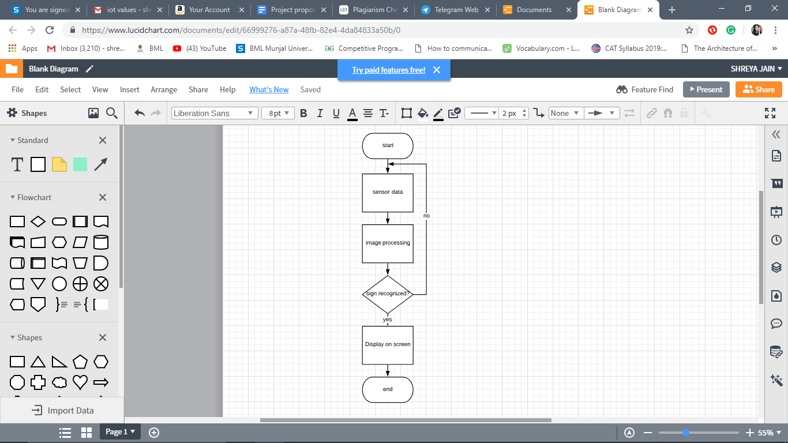

The glove has flex sensors attached to it which gives the value of resistance based on the hand movements. Once the sensor data is captured, the sign is recognised based on the combination of each flex sensor present on the fingers. Simultaneously, the sign is captured on a camera which is verified through an image processing algorithm. This is done to increase the accuracy of the system.If both the outputs match, the system is very reliable and accurate. The combined result is then displayed on the whole to the user.

Proposed algorithm

# Image Processing Algorithm:

**Steps to execute image processing for capturing hand gestures are:**

1. Open camera (cv2):- cv2 is an interface of OpenCV( Open Source computer Vision Libary). OpenCV is a library in Python used to solve problems of computer vision. OpenCV-Python uses Numpy, a highly optimized library with a MATLAB-style syntax for numerical operations. All structures of the OpenCV array are converted from and to Numpy arrays.
2. Frame capturing using a rectangle window:- Within the camera video interface, a rectangular area is created within which the background elimination and other operations are performed to process the image.
3. Pre- processing (gaussian - blur):- Image pre-processing is done to reduce noise from the image. For this purpose, gaussian blur is used to reduce the details of image by blurring it so as to reduce the noise from it.
4. Background /noise elimination( foreground detection):- In this step, we eliminate the background, that is, we separate the background from the foreground to get the foreground object.

Image at time t: I(u,v,t)

Background at time t: B(u,v,t)

The estimated background is taken to be the previous frame , that is, B(u,v,t)=I(u,v,t-1)

|Current image - Background|>Threshold → Foreground

|I(u,v,t)-I(u,v,t-1)|>Th→ Foreground

1. Conversion of BGR image to HSV (masking)

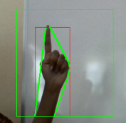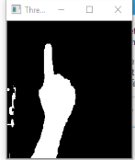

The Blue,Green, Red components of an image are related to the intensity of light. It is necessary to separate this luminance with colour components.The dependence of RGB components on the luminance makes the identification of the object difficult. Hence, the Hue,Saturation,Value(HSV) format is used.

The formula to convert an RGB image to HSV is

Red' = Red/255

Green' = Green/255

Blue' = Blue/255

Cmaximum = max(Red', Green', Blue')

Cminimum = min(Red', Green', Blue')

Delta = Cmaximum - Cminimum

**Hue**= 60o*(((Green’-Blue’)/Delta)mod6) , Cmaximum=Red’

60o*(((Blue’-Red’)/Delta)+2), Cmaximum= Green’

60o*(((Red’-Green’)/Delta)+4), Cmaximum=Blue’

**Saturation**= 0 if Cmaximum=0

= (delta/Cmaximum) if not 0

**Value**= Cmaximum

For example, colour magenta has RGB coordinates, (255,0,255). Using, the above formula , its HSV coordinates are (300o, 100% ,100%)

1. Morphological transformation:- Morphological transformation refers to the transformations made in the shape of an image due to certain non-linear operations on it. In our project, we have used two kinds of such transformations:

* Erosion: Erosion is used to erode away the boundaries of the objects in foreground.

Since the pixels of images are represented as matrices in the system so we perform erosion on the matrices. Let X and Y are two sets in A² where Y is the structuring element of X , erosion of X by Y, denoted by X ⊖ Y is defined as:

X ⊖ Y = {a | (Y)ₐ ⊆ X}

This gives set of all points a such that Y, translated by a, is contained in X

* Dilation: Dilation is reverse of erosion. It increases the boundaries of the objects in foreground.

As pixels of images are represented as matrices ,let X and Y be sets in A² , dilation of X by Y where Y is the structuring element of X, denoted by X ⊕ Y is defined as:

X ⊕ Y = {a | (Y’)ₐ ∩ X ≠ ∅}

Here we reflect Y about the origin, and shift the reflection by a. Dilation is the set of all the displacements a such that Y and X overlap by at least one element.

1. Contours (building up boundary)

Contours form the boundary of an image by linking the edges. In order to find contours of the foreground, we have applied Ramer–Douglas–Peucker algorithm on the boundaries of our foreground. The Ramer-Douglas – Peucker algorithm is an algorithm designed to reduce the number of points in a curve approximated by a number of points. It does so by thinking of a line in a set of points that make up the curve between the first and the last point. It checks which point is farthest from this line in the middle. If the point (and all other intermediate points as follows) is closer than the' epsilon' distance, it removes all these intermediate points. On the other hand, if this outlier point is more distant than epsilon from our imaginary line, the curve is divided into two parts:

* From the first point to the outlier point
* The outlier and the other points.

On both resulting curves, the function is recursively called, and the two reduced curve shapes are put back together. When the recursion is completed, it is possible to generate a new output curve consisting of all and only those points marked as kept.

1. Building up a convex hull

Convex Hull is the envelope around a particular set of points to define the boundary. To build this boundary, we first found the minimum and maximum points(minimum- junction between two fingers. Then, connect these two points. The junction between two fingers is always different. Based on the length of the line from the reference line, the finger is identified. Alongside, the number of maximas are counted to know the number of fingers which are unbent. The combination of these two findings gives us the sign that has been shown.

1. This result is finally displayed on the output web cam screen.

# Arduino (flex sensors code)

The flex sensors are connected to two analog pins A0 and A1. The sensor values are read and checked which category of combination(sign) would the values belong to. The range for a sign was determined from the data set collected for each sign. The average was noted from the dataset and a deviation till the maximum and minimum values were set.

void setup() {

Serial.begin(9600);

}

void loop() {

int a = analogRead (A0);

int b = analogRead(A1);

if(((212<a)&&(a<255)) && ((86<b)&&(b<105)))

{Serial.println("peace"); }

else if(((72<a)&&(a<133)) && ((36<b)&&(b<67)))

{ Serial.println("Water Please");

//**If the sensor values (both a and b) lie in these ranges, it is identified to be this sign.** }

else if(((198<a)&&(a<230)) && ((31<b)&&(b<62)))

{Serial.println("Need Help"); }

// Serial.println(a);

// Serial.println(b);

delay(700);

}

Experiment and Simulation Setup

**Components used:**

1. Arduino Uno
2. 2 8.2K ohm resistors
3. 2 flex sensors
4. Breadboard
5. Glove
6. Needle and thread

**Fig 1:Glove with flex sensors**

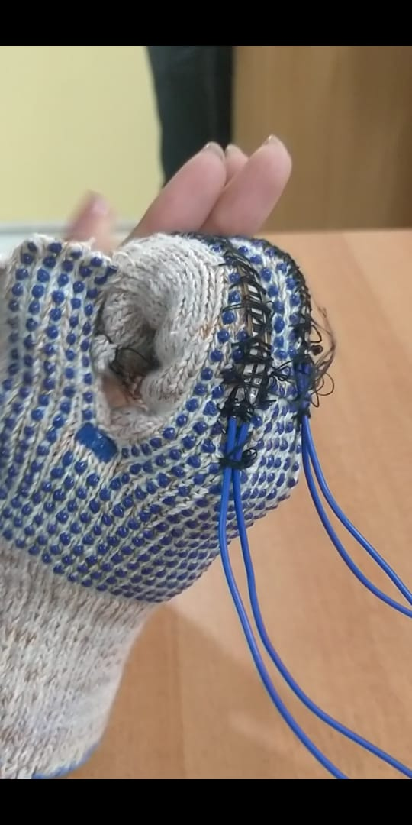

**Fig 2: Connection of flex sensors**

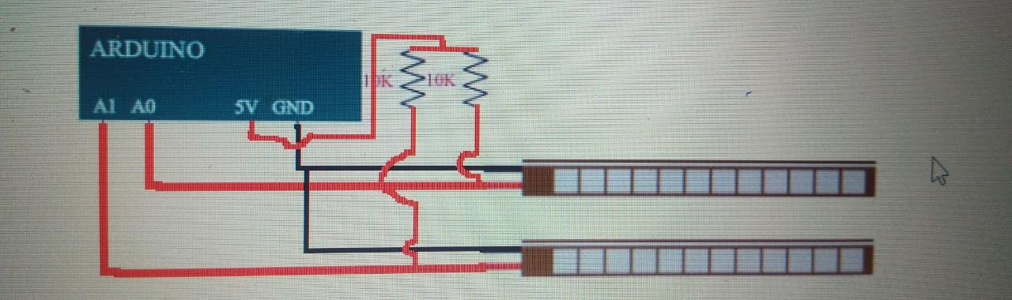

Results and Analysis

After running our arduino code for flex sensors, we got some data regarding the bent, We made a .csv for it and analyzed it which we further used to create data sets and combinations for signs and their respective meanings.

**Fig 4: sign and its corresponding meaning example:**

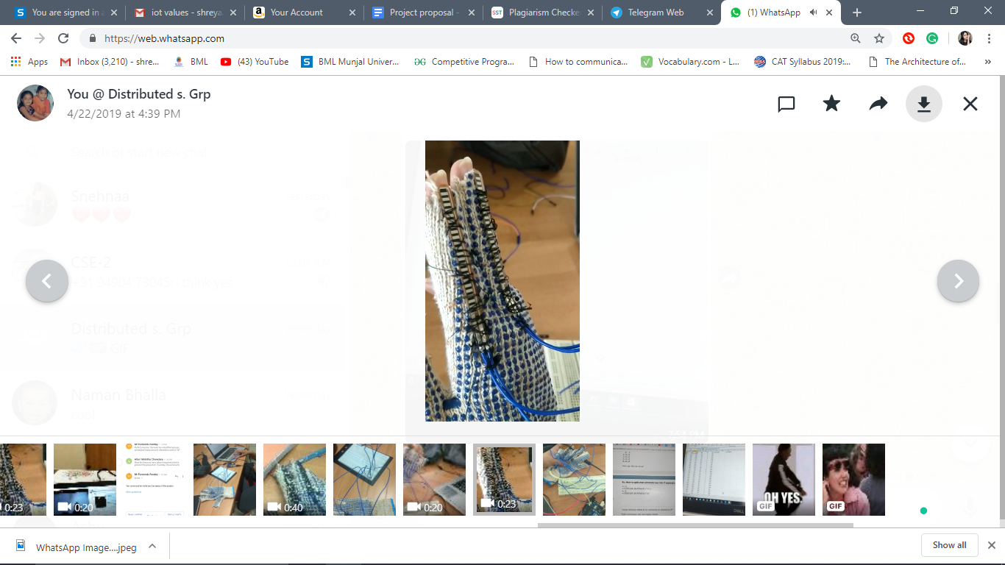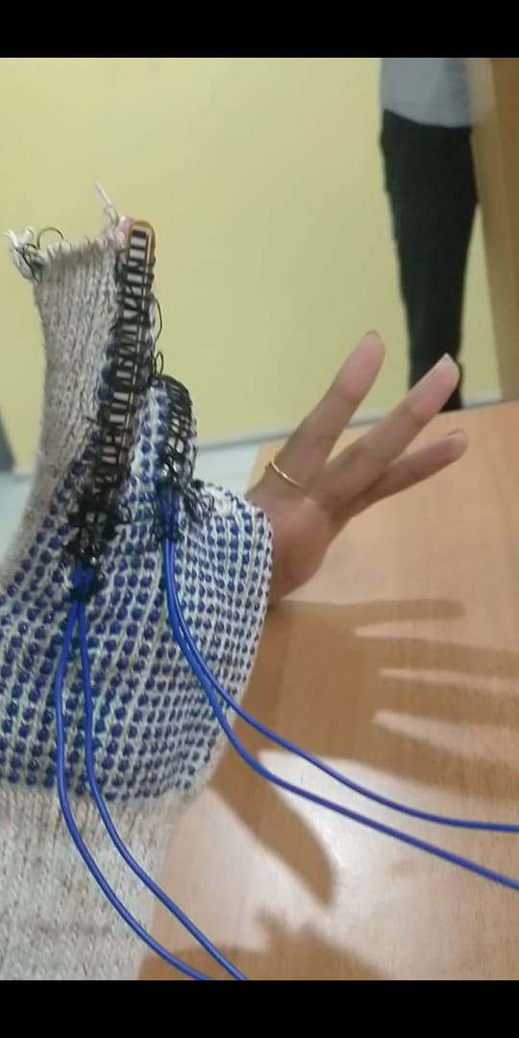

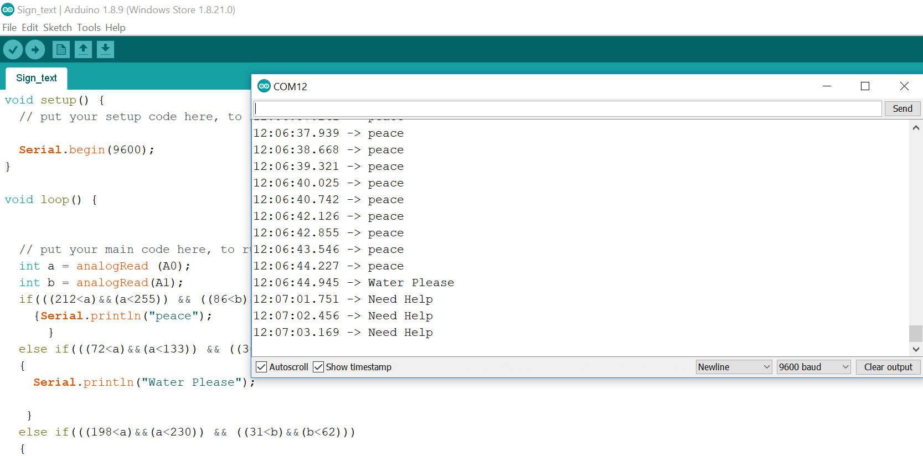

**DATA-:**

The dataset for each sign is collected using Tera-Term. The initial values included data of both sensors in one column. The first sensor values could be extracted from the column using =IF(ISODD(ROW(A1)),A1,””). The ISEVEN function is used to separate the second sensor values. Column A contains the values of first sensor(index finger) and column B contains the value of the second sensor(at middle finger).The average of both these columns is first calculated and then the lowest and the highest value of each sensor is noted to predict the range of sensor values of each sign.

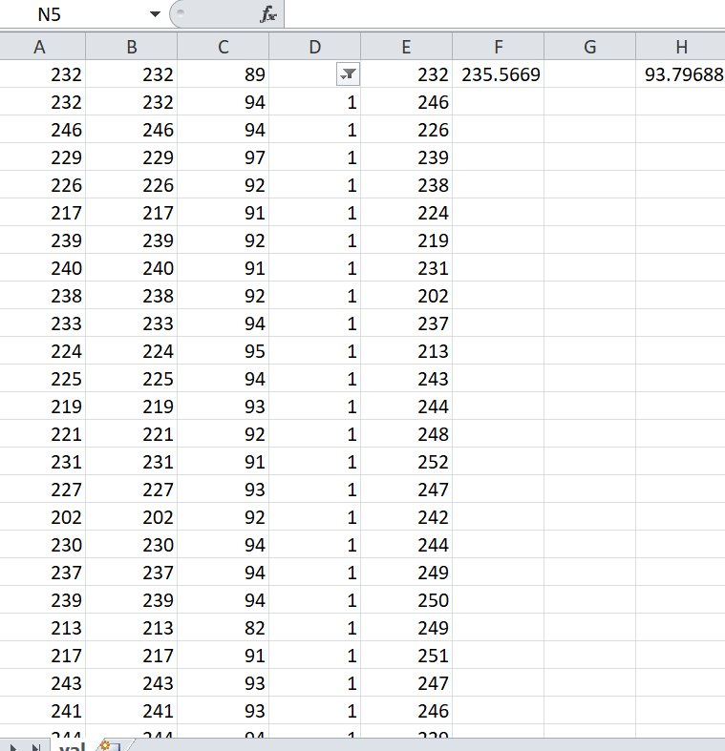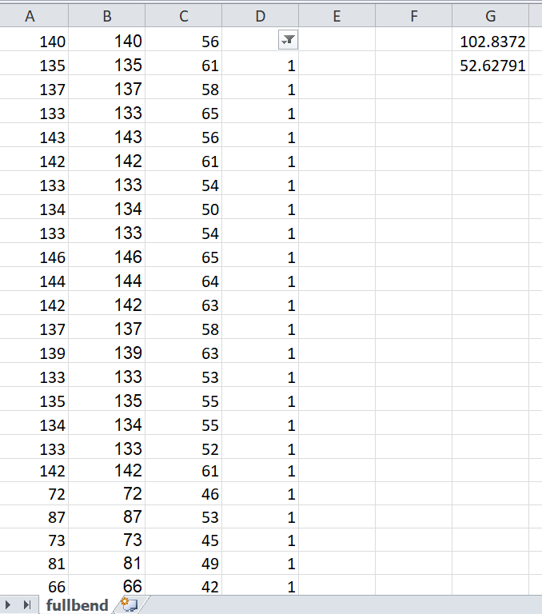**ii)**

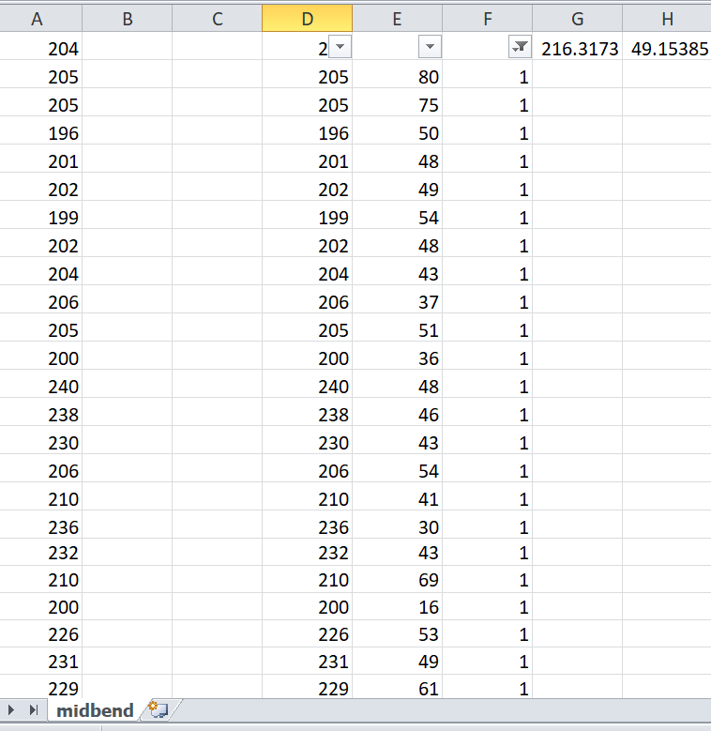**Fig 3: data set i)Straight(Reference)**

**ii)fullbend fingers iii)index finger straight**

**Image processing**

1. **First sign**

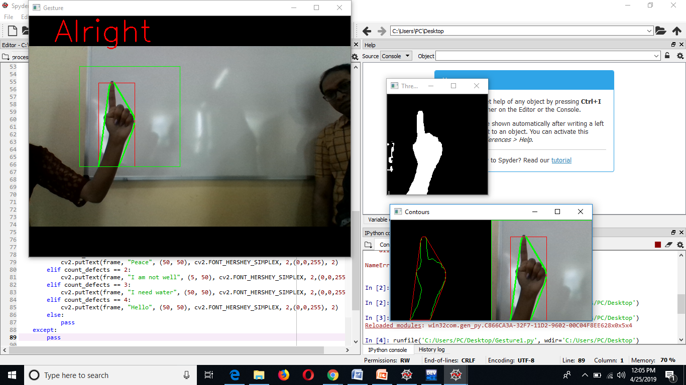

**B. Second sign**

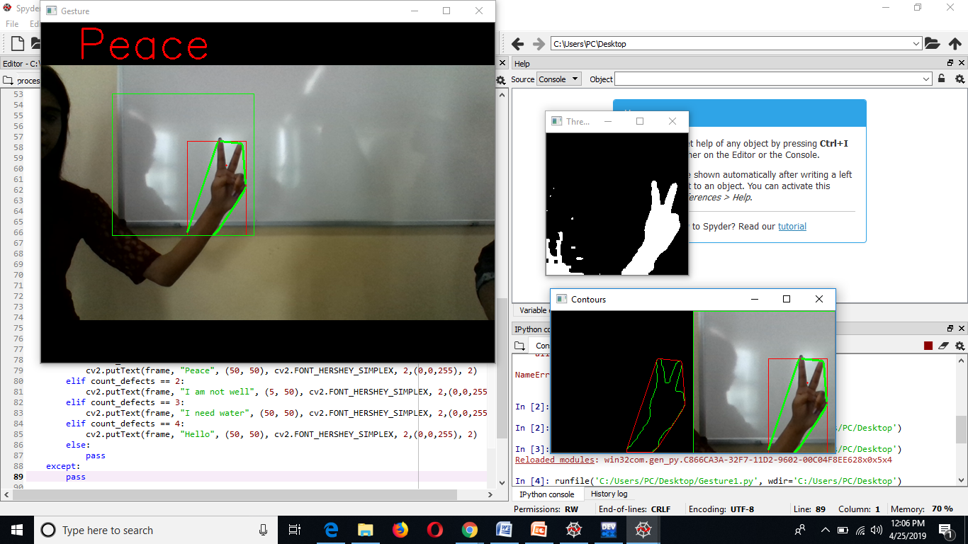

**C. Third Sign**

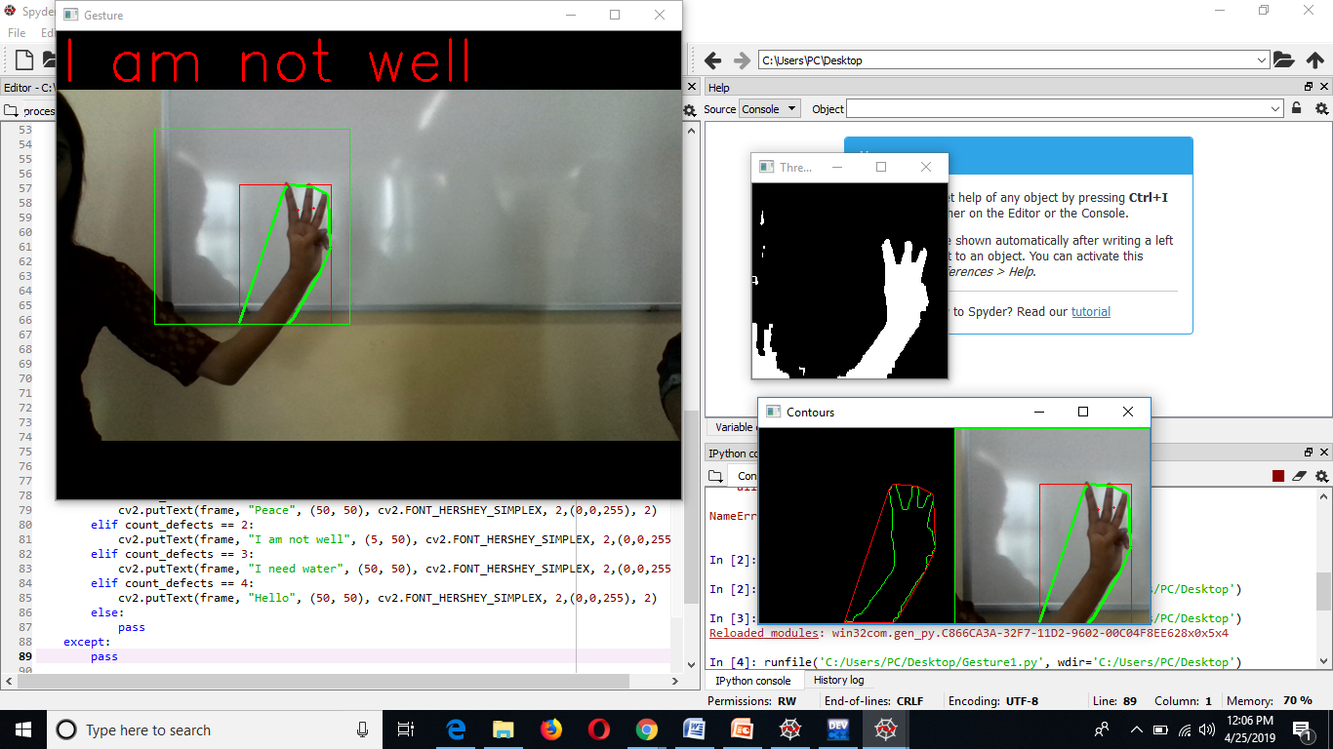

**D. Fourth Sign**

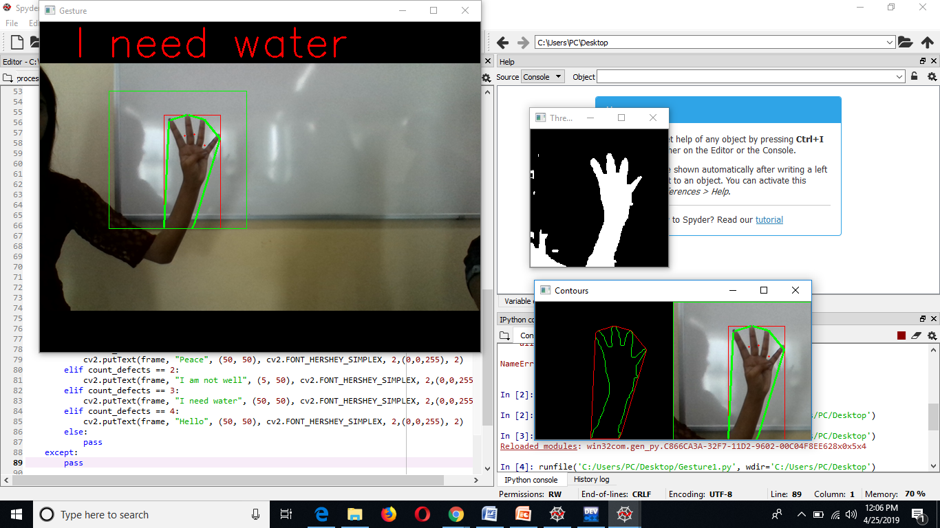

**E. Fifth Sign**

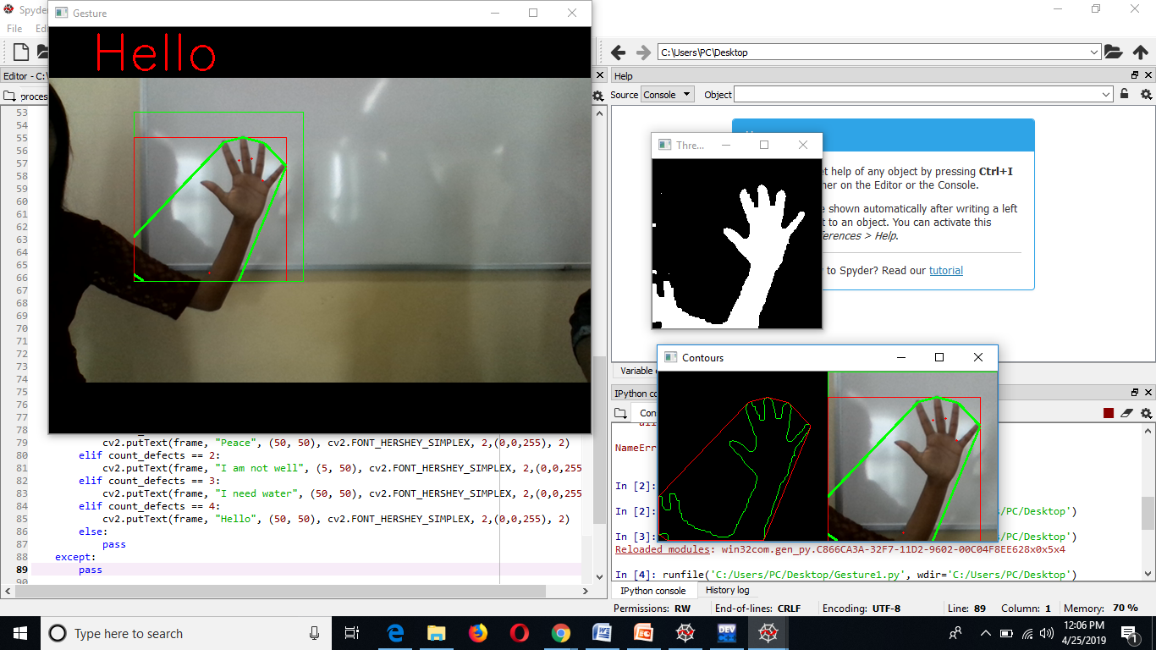

Conclusion and Future Work

Concluding, we have created a way for physically challenged people to communicate without being forced to hire a physical instructor. With the utilization of flex sensors and image processing algorithms we have made surety about accuracy. The system can be further made better by adding some more advancements.

**Some of the ideas the we plan to work upon in the future are:**

1. Combing bluetooth module to make the device portable.
2. Combining image processing and flex sensors environment to make the glove more handy.
3. Using gyroscope and accelerometer for further accuracy.
4. Making the glove material more and more comfortable in the terms of fabric.
5. Making the glove more reliable by adding speakers.
6. Integrating a more powerful microcontroller.
7. Training it further to british sign language.

References:

1. <https://components101.com/sensors/flex-sensor-working-circuit-datasheet>
2. <https://www.irjet.net/archives/V4/i3/IRJET-V4I3252.pdf>
3. <http://www.ijircce.com/upload/2018/march/158_IMPLEMENTATION_IEEE.pdf>
4. <https://www.engineersgarage.com/contribution/sign-language-glove-voice-synthesizer>
5. <https://arxiv.org/ftp/arxiv/papers/1503/1503.03614.pdf>
6. <https://juniperpublishers.com/raej/pdf/RAEJ.MS.ID.555609.pdf>
7. <https://ieeexplore.ieee.org/document/7754766>
8. <https://www.ijireeice.com/upload/2016/may-16/IJIREEICE%20107.pdf>
9. <https://mybtechprojects.tech/hand-gesture-recognition-using-image-processing/>