Affordable & Competent Courses | iNeuron.ai

**E-Commerce Dashboard**

**Architecture Design**

|  |  |
| --- | --- |
| Written By | **Nikki Mittal** |
| Document Version | 0.1 |
| Last Revised Date |  |

Affordable & Competent Courses | iNeuron.ai**DOCUMENT CONTROL**

**Change Record:**

|  |  |  |  |
| --- | --- | --- | --- |
| **VERSION** | **DATE** | **AUTHOR** | **COMMENTS** |
| 0.1 | 10th January, 2023 | Author 1 | Architecture Document Designed |
|  |  |  |  |

**Reviews:**

|  |  |  |  |
| --- | --- | --- | --- |
| **VERSION** | **DATE** | **REVIEWER** | **COMMENTS** |
|  |  |  |  |

**Approval Status:**

|  |  |  |  |  |
| --- | --- | --- | --- | --- |
| **VERSION** | **REVIEW**  **DATE** | **REVIEWED BY** | **APPROVED BY** | **COMMENTS** |
|  |  |  |  |  |

Affordable & Competent Courses | iNeuron.ai**CONTENTS**

1. Introduction………………………………………4
   1. What is Architecture Design Document?......4
   2. Scope……………………………………….4
2. Architecture………………………………….…5-8
   1. Excel Worksheet……………………….…5-6
   2. Excel Worksheet Components……………6-7
   3. Excel Features Used………………………...8
3. Deployment……………………………………….8

Affordable & Competent Courses | iNeuron.ai

1. **Introduction**
   1. **What is Architecture Design Document?**

Any software that depicts software design must have an architectural design. "The process of identifying a collection of hardware and software components and their interfaces to provide the foundation for the creation of a computer system," according to IEEE, is what architectural design is. One of these numerous architectures may be displayed by software created for computer-based systems.

Each style will outline a group of systems that includes:

A collection of parts (such as a database or computing modules) that work together to carry out a specific task for the system.

* The set of connectors will support component cooperation, coordination, and communication.
* Requirements for integrating components into the system.
* Semantic models that aid in the designer's comprehension of the system's general characteristics.
  1. **Scope**

An architecture design method that incorporates an iterative refinement process is called an Architecture Design Document (ADD). Data structures, necessary software architecture, source code, and finally performance algorithms can all be designed using this method. Overall, during requirement analysis, the design concepts may be established, and then they may be improved upon throughout architectural design work.

1. **Affordable & Competent Courses | iNeuron.aiArchitecture**

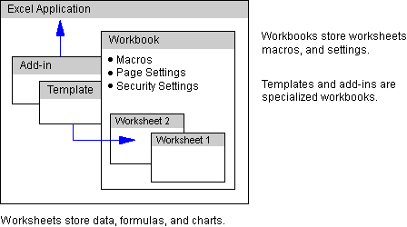

**Source: http://informationworker.ru/ork97.en/036/036.htm**

* 1. **Excel Worksheet**

Microsoft Excel is a spreadsheet tool included in the Microsoft Office family. Spreadsheets are columns and rows of numbers that can have their values updated numerically using basic and sophisticated arithmetic operations.

Workbooks are Excel documents. Worksheets, chart sheets, and Visual Basic for Applications modules are all included in a workbook. The worksheet serves as the workbook's main data storage area. Each spreadsheet has cells that can hold formulas, data, and charts that display data graphically. There

**Affordable & Competent Courses | iNeuron.ai**

are formatting options for each cell and chart item, including fonts, colours, and layout possibilities.

A workbook can be saved as a template. A template offers a structure for making fresh workbooks. Additionally, workbooks can be saved as add-ins that automate the addition of specific functionality to Excel.

* 1. 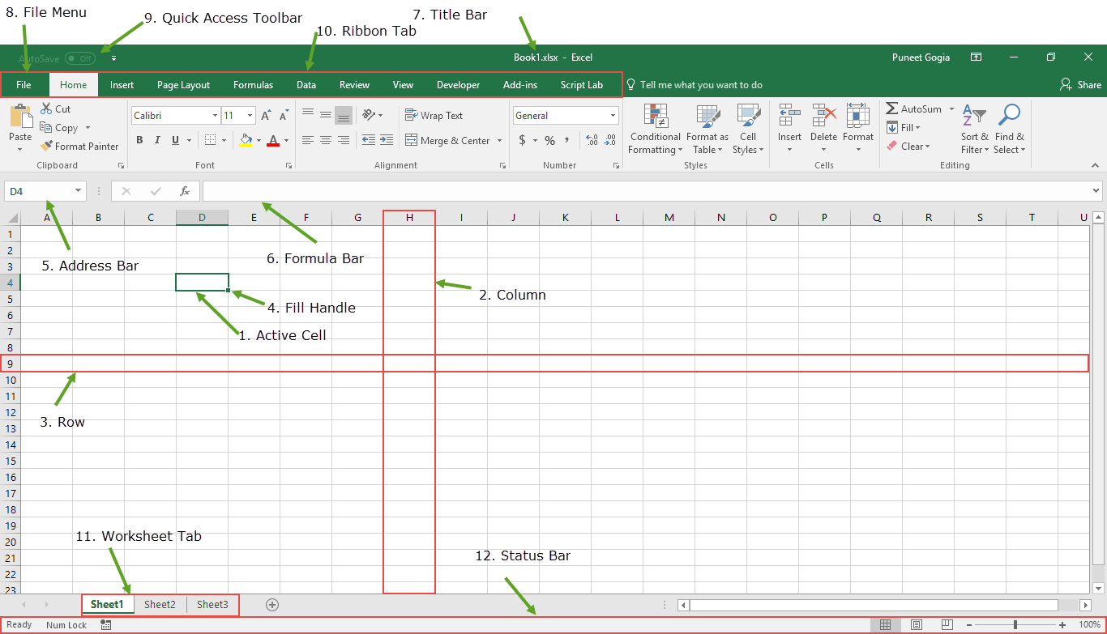**Excel Worksheet Components**

**Source: https://excelchamps.com/excel-basics/**

**Excel 2019 Version**

Affordable & Competent Courses | iNeuron.ai

1. Cell: A cell that is now chosen is said to be "active." A rectangle box will be used to emphasise it, and the address will be displayed in the address bar. Clicking on a cell or using arrow buttons will activate it.
2. Column: A column is a group of cells arranged vertically. Each column's identity alphabet is unique.
3. Row: A row is a line of cells that is horizontal. Total rows in a worksheet are 1048576.
4. Title Bar: The title bar will display the name of the workbook, followed by the name of the corresponding application.
5. File Menu: Just like all other apps, the file menu is a straightforward menu. It offers possibilities such as (Save, Save As, Open, New, Print, Excel Options, Share, etc).
6. Toolbar: A toolbar that gives quick access to features that are often used is called a quick access toolbar.
7. Ribbon: Ribbon tabs are a collection of distinct choice groups that also include the option.
8. Worksheet Tab: This tab displays each and every worksheet that is included in the workbook.
9. Status Bar: The Excel window's status bar is a brief bar at the bottom.
10. Fill Handle: The active cell's lower right corner has a tiny dot that serves as the fill handle. It aids in the filling of numerical values, text series, range inserts, serial number inserts, etc.
11. Address Bar: It displays the active cell's address.
12. Formula Bar: Below the ribbon, the formula bar is an input bar. It allows to enter a formula in a cell and displays the content of the currently active cell.

Affordable & Competent Courses | iNeuron.ai

* 1. **Excel Features Used**
* SUMIFS Function
* Combo Box
* Chart

1. 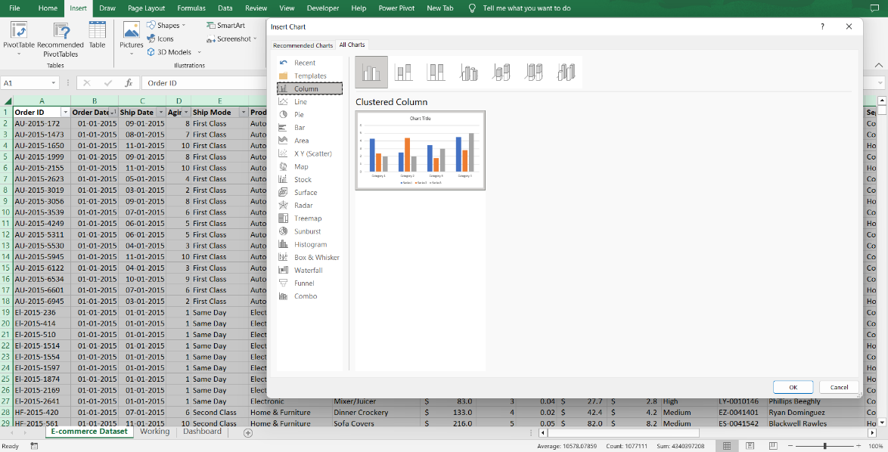**Deployment**

