Affordable & Competent Courses | iNeuron.ai

**E-Commerce Dashboard**

Wireframe Documentation

Affordable & Competent Courses | iNeuron.ai

Dashboard

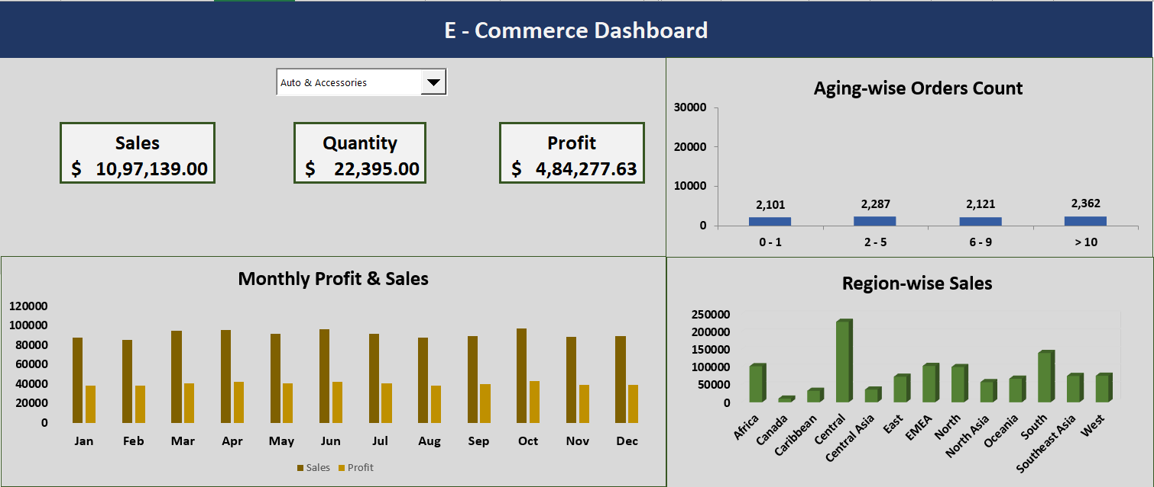

Affordable & Competent Courses | iNeuron.ai

1. Monthly Sales and Profits Trend Chart:

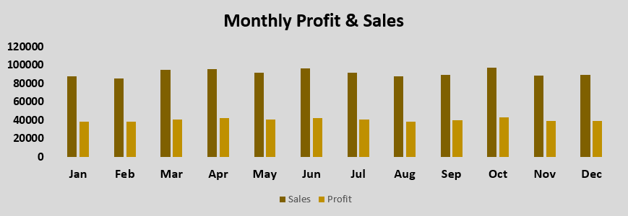

1. 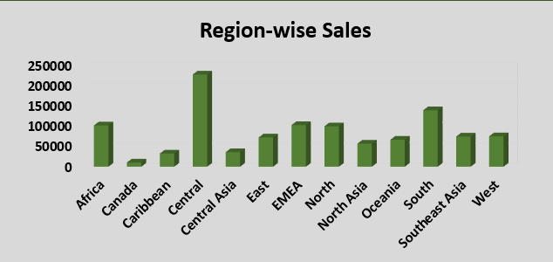Region-wise Sales Distribution Chart:

Affordable & Competent Courses | iNeuron.ai

1. User Control Combo Box for Product Category:



1. 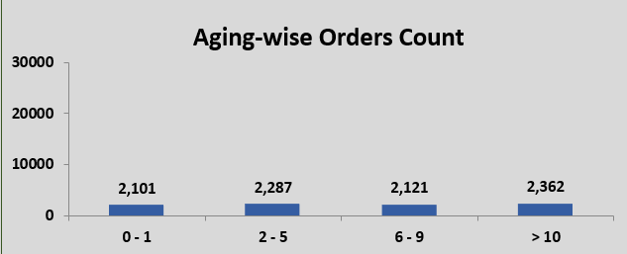Aging-wise Orders Count Chart:

Affordable & Competent Courses | iNeuron.ai

1. Different Metrics:

