**Assessment Task 1: Design Problem**

**Aim**

The goal of this assessment is to apply your problem-solving skills to a simple programming problem. This will give you practice and experience at using the tools introduced in the first week materials, which will be critically important in the main assignment for this course.

**Task**

Read the problem description below. You are to identify possible sections which could be separated out into functions and create an IPO chart for each, using the template provided here. In addition to the function planning you are also required to outline the behaviour of each function (there is no need to provide detailed pseudocode or flowcharts, but a sample of a solution has been provided as a guide).

**Detailed instructions**

We have been asked to create a simple statistical tool for use in a small school project. Students will have a small set of data to enter (they will type it in at the keyboard) and our program needs to produce one of two reports (depending on menu choices) in the format shown below:

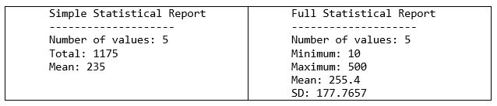

When the program is run the user will see a welcome menu, similar to the one shown here:

*Welcome to The Basic Statistician!*

*Please choose from the following options:*

*1 – Read Instructions*

*2 – Generate a Simple Report*

*3 – Generate a Full Report*

*4 - Quit*

Option 4 will exit the program, every other option will do some task and then display the menu again until the user chooses 4 at this menu.

Choosing option 1 will display the instructions (not given here, just mention this in the plan) and then the menu will display again.

Choosing option 2 will ask the user for 5 numerical values and then print a simple report (as shown above) to the screen.

Choosing option 3 will again ask the user for 5 numerical values and then print a more complex report (as shown above) to the screen.

After displaying either report the menu will be displayed again.

Because this program is only a simple tool it is not going to deal with negative numbers, so every number entered by the users will be 0 or higher. If they try to enter a negative number you need to display an error message, and ask for that number again.

**Submission**

Your completed solution should be submitted to JCU Online in either Word (.docx) or PDF (.pdf) format.

You are free to use any editor you like, but please ensure you export/save your file in one of those two formats. Please name your file LastnameFirstname.ext (for example John Smith’s word document would be named SmithJohn.docx).