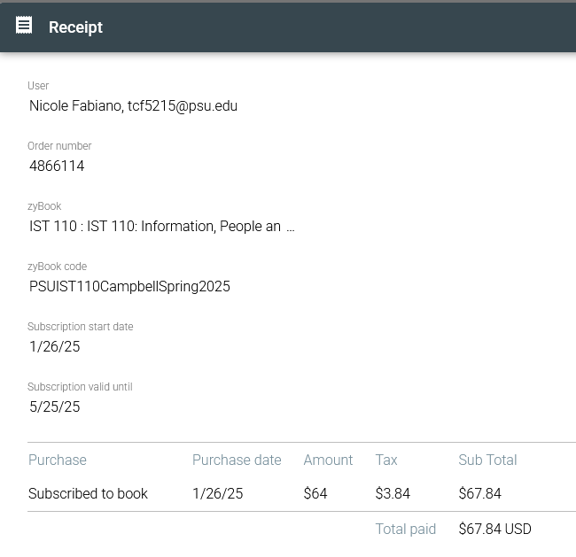  
  
Most of the material this chapter was about programs and file types I knew quite a bit about already and use often daily. I use image editing software daily and regularly share files through compressing and sharing zip files.