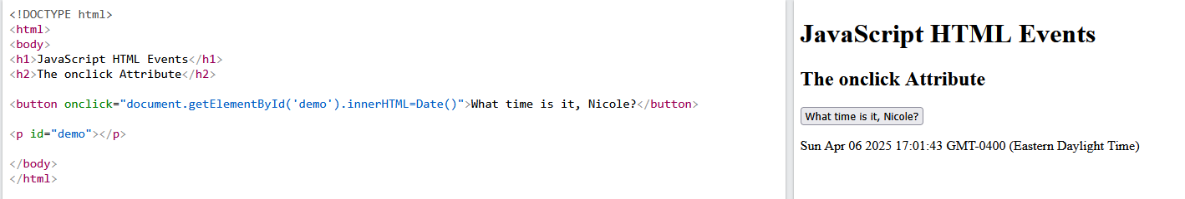

The code in the event example is pulling information stored in the webpage’s DOCUMENT interface. Things like the date and time are by default stored in the DOC and can be pulled from using JS code. The actual effect of the code did not change, because all we did was adjust the HTML which determines what text would be displayed on the button.  
  
If Else Statements are commonplace in coding languages and are similarly applicable in JS, which determines how a user can interact with a website. There is not necessarily a “best control structure”, it comes down to what you need your website to be able to do while accounting for edge cases and making a seamless functional experience for the user. If statements are a simple logic operator which evaluates a condition and then determines what code to execute based on whether it passed or failed.