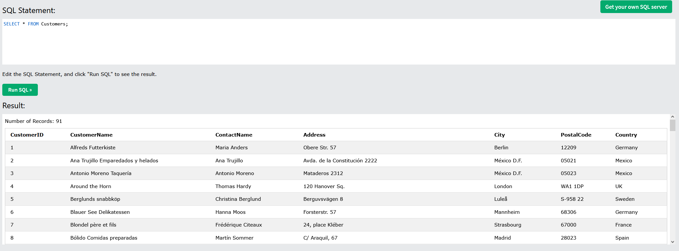

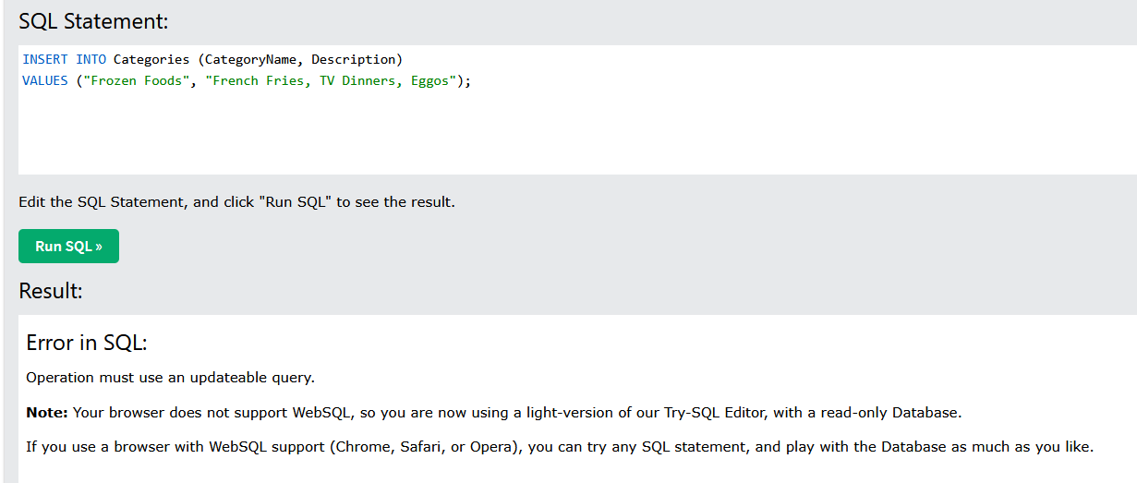

Note: I had to test this result in my own SQL database, because WebSQL has been depreciated from both Firefox and all Chromium browsers. I also do not own any apple products to test it on Safari.  
  
Similarly can’t demonstrate the output on this site, but can confirm that this statement works in an SQL database.