**Лабораторна робота №4**

**Котелевська Вероніка ІН-82**

**Завадння 1. Побудова поверхонь**

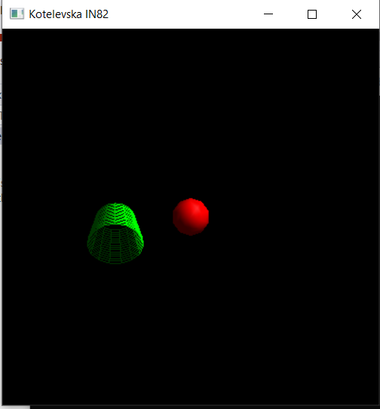

void CALLBACK display(void)

{

GLUquadricObj* quadObj;

quadObj = gluNewQuadric();

glClear(GL_COLOR_BUFFER_BIT | GL_DEPTH_BUFFER_BIT);

glPushMatrix();

glColor3d(1, 0, 0);

gluQuadricDrawStyle(quadObj, GLU_FILL);

gluSphere(quadObj, 0.5, 10, 10);

glTranslated(-2, 0, 0);

glRotated(45, 1, 0, 0);

glColor3d(0, 1, 0);

gluQuadricDrawStyle(quadObj, GLU_LINE);

gluCylinder(quadObj, 0.5, 0.75, 1, 15, 15);

glPopMatrix();

gluDeleteQuadric(quadObj);

auxSwapBuffers();

}

**Завадння 2** **Вправа "Сфера, циліндр і диски"**

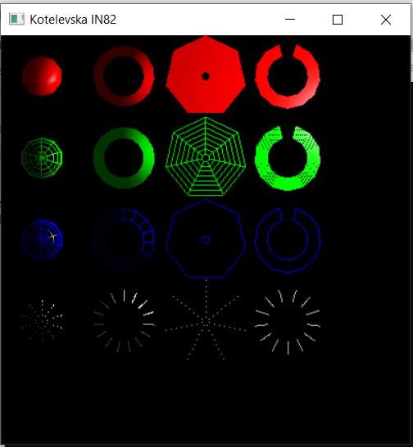

void CALLBACK display(void)

{

GLUquadricObj* quadObj;

quadObj = gluNewQuadric();

glClear(GL_COLOR_BUFFER_BIT | GL_DEPTH_BUFFER_BIT);

glPushMatrix();

glTranslated(-4, 4, 0);

glColor3d(1, 0, 0);

gluQuadricDrawStyle(quadObj, GLU_FILL);

gluSphere(quadObj, 0.5, 10, 10);

glTranslated(2, 0, 0);

gluCylinder(quadObj, 0.5, 0.75, 1, 15, 15);

glTranslated(2, 0, 0);

gluDisk(quadObj, 0.1, 1, 7, 7);

glTranslated(2, 0, 0);

gluPartialDisk(quadObj, 0.5, 0.8, 12, 12, 15, 330);

glTranslated(-6, -2, 0);

glColor3d(0, 1, 0);

gluQuadricDrawStyle(quadObj, GLU_LINE);

gluSphere(quadObj, 0.5, 10, 10);

glTranslated(2, 0, 0);

gluCylinder(quadObj, 0.5, 0.75, 1, 15, 15);

glTranslated(2, 0, 0);

gluDisk(quadObj, 0.1, 1, 7, 7);

glTranslated(2, 0, 0);

gluPartialDisk(quadObj, 0.5, 0.8, 12, 12, 15, 330);

glTranslated(-6, -2, 0);

glColor3d(0, 0, 1);

gluQuadricDrawStyle(quadObj, GLU_SILHOUETTE);

gluSphere(quadObj, 0.5, 10, 10);

glTranslated(2, 0, 0);

gluCylinder(quadObj, 0.5, 0.75, 1, 15, 15);

glTranslated(2, 0, 0);

gluDisk(quadObj, 0.1, 1, 7, 7);

glTranslated(2, 0, 0);

gluPartialDisk(quadObj, 0.5, 0.8, 12, 12, 15, 330);

glTranslated(-6, -2, 0);

glColor3d(1, 1, 1);

gluQuadricDrawStyle(quadObj, GLU_POINT);

gluSphere(quadObj, 0.5, 10, 10);

glTranslated(2, 0, 0);

gluCylinder(quadObj, 0.5, 0.75, 1, 15, 15);

glTranslated(2, 0, 0);

gluDisk(quadObj, 0.1, 1, 7, 7);

glTranslated(2, 0, 0);

gluPartialDisk(quadObj, 0.5, 0.8, 12, 12, 15, 330);

glPopMatrix();

gluDeleteQuadric(quadObj);

auxSwapBuffers();

}

**Завадння 3 Інтерполяція кольорів**

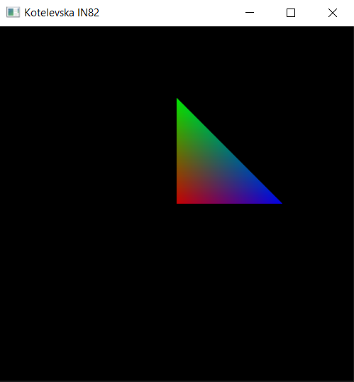

void CALLBACK display(void)

{

glClear(GL_COLOR_BUFFER_BIT | GL_DEPTH_BUFFER_BIT);

glBegin(GL_TRIANGLES);

glColor3d(1, 0, 0);

glVertex2d(0, 0);

glColor3d(0, 1, 0);

glVertex2d(0, 3);

glColor3d(0, 0, 1);

glVertex2d(3, 0);

glEnd();

auxSwapBuffers();

}

**Завадння 4 Інтерполяція кольорів**

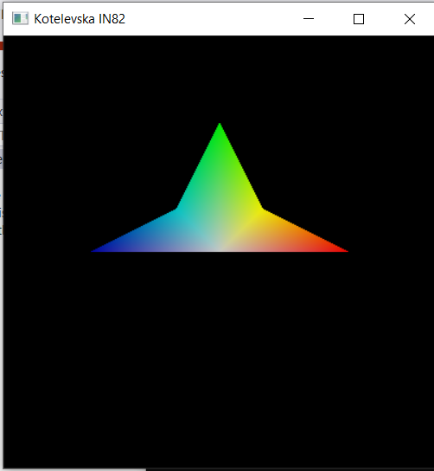

void CALLBACK display(void)

{

glClear(GL_COLOR_BUFFER_BIT | GL_DEPTH_BUFFER_BIT);

glBegin(GL_TRIANGLE_FAN);

glColor3d(1, 1, 1);

glVertex2d(0, 0);

glColor3d(1, 0, 0);

glVertex2d(3, 0);

glColor3d(1, 1, 0);

glVertex2d(1, 1);

glColor3d(0, 1, 0);

glVertex2d(0, 3);

glColor3d(0, 1, 1);

glVertex2d(-1, 1);

glColor3d(0, 0, 1);

glVertex2d(-3, 0);

glEnd();

auxSwapBuffers();

}

**Завадння 5 Прозорість**

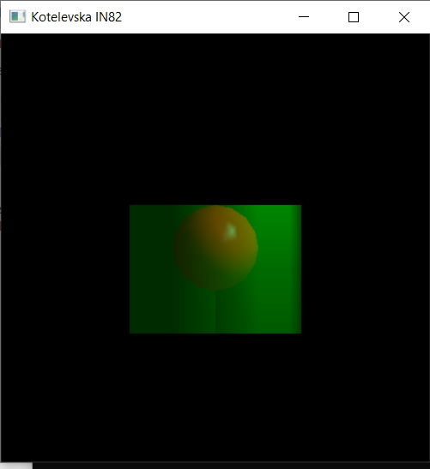

void CALLBACK display(void)

{

glClear(GL_COLOR_BUFFER_BIT | GL_DEPTH_BUFFER_BIT);

glEnable(GL_ALPHA_TEST);

glEnable(GL_BLEND);

glBlendFunc(GL_SRC_ALPHA, GL_ONE_MINUS_SRC_ALPHA);

glColor4d(1, 0, 0, 1);

auxSolidSphere(1);

glColor4d(0, 1, 0, 0.6);

auxSolidCylinder(2, 3);

glDisable(GL_BLEND);

glDisable(GL_ALPHA_TEST);

auxSwapBuffers();

}

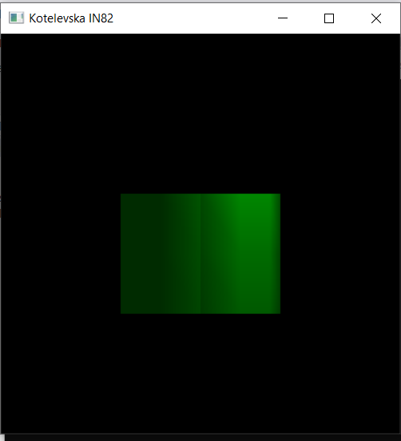

void CALLBACK display(void)

{

glClear(GL_COLOR_BUFFER_BIT | GL_DEPTH_BUFFER_BIT);

glEnable(GL_ALPHA_TEST);

glEnable(GL_BLEND);

glBlendFunc(GL_SRC_ALPHA, GL_ONE_MINUS_SRC_ALPHA);

glColor4d(0, 1, 0, 0.6);

auxSolidCylinder(2, 3);

glColor4d(1, 0, 0, 1);

auxSolidSphere(1);

glDisable(GL_BLEND);

glDisable(GL_ALPHA_TEST);

auxSwapBuffers();

}

**Завадння 6 Прозорість**

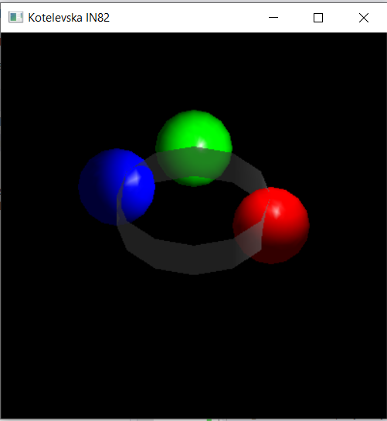

void CALLBACK display(void)

{

glClear(GL_COLOR_BUFFER_BIT | GL_DEPTH_BUFFER_BIT);

glEnable(GL_ALPHA_TEST);

glEnable(GL_BLEND);

glBlendFunc(GL_SRC_ALPHA, GL_ONE_MINUS_SRC_ALPHA);

glPushMatrix();

glTranslated(2, 0, 0);

glColor4d(1, 0, 0, 1);

auxSolidSphere(1);

glTranslated(-2, 2, -5);

glColor4d(0, 1, 0, 1);

auxSolidSphere(1);

glTranslated(-2, -1, 4);

glColor4d(0, 0, 1, 1);

auxSolidSphere(1);

glPopMatrix();

glPushMatrix();

glRotated(40, 1, 0, 0);

glColor4d(1, 1, 1, 0.6);

auxSolidCylinder(2, 1);

glPopMatrix();

glDisable(GL_BLEND);

glDisable(GL_ALPHA_TEST);

auxSwapBuffers();}