ls-command:

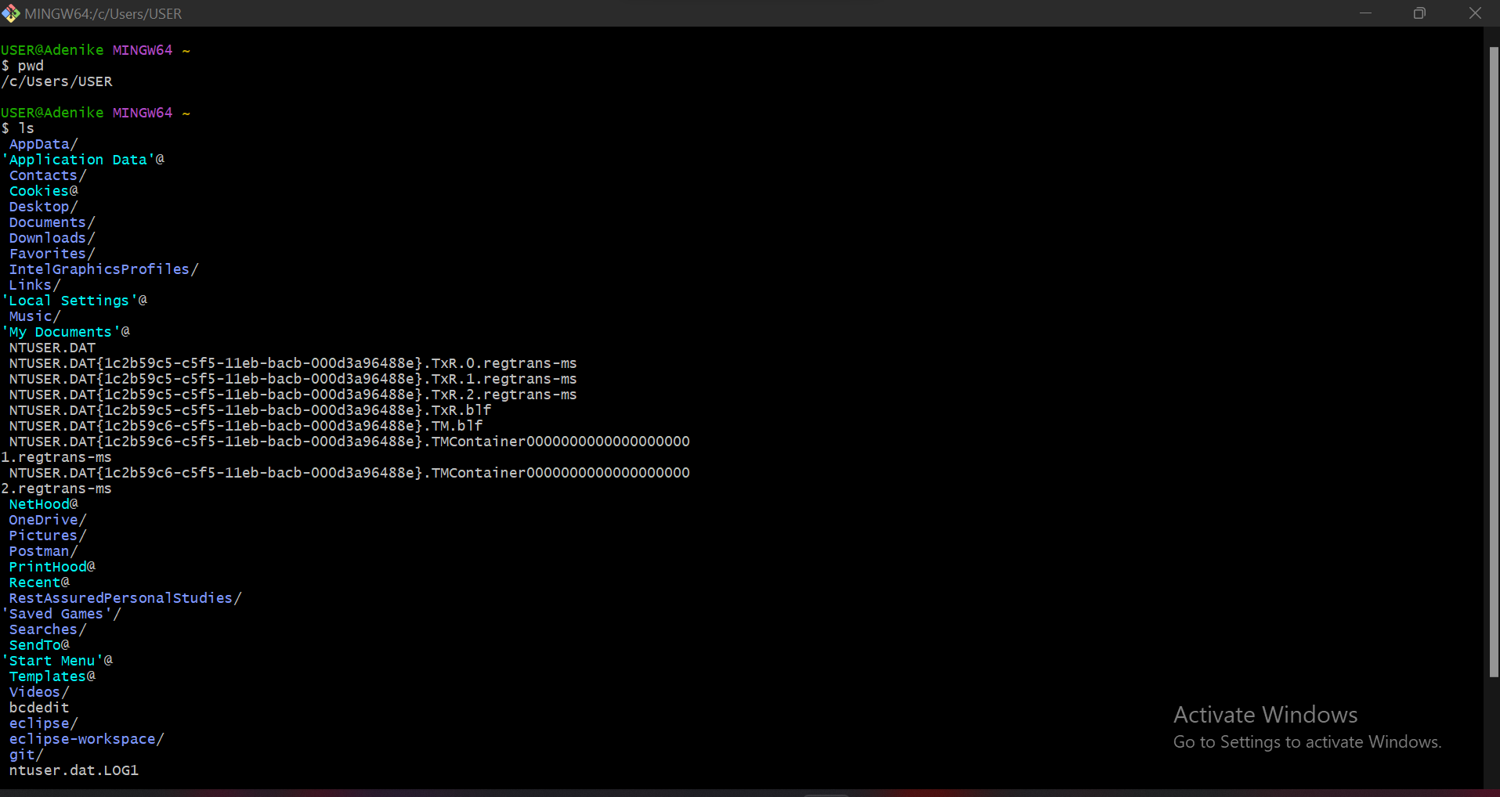

cd-command

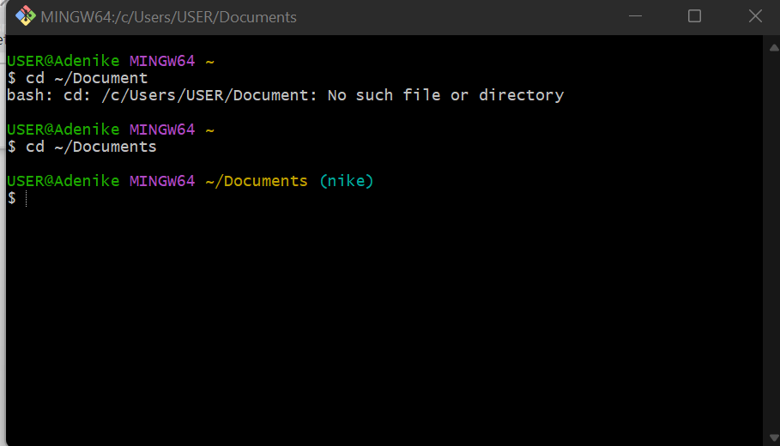

Grep : Grep searches for a given string in a file

Grep I, grep-r:searches a given string recursively

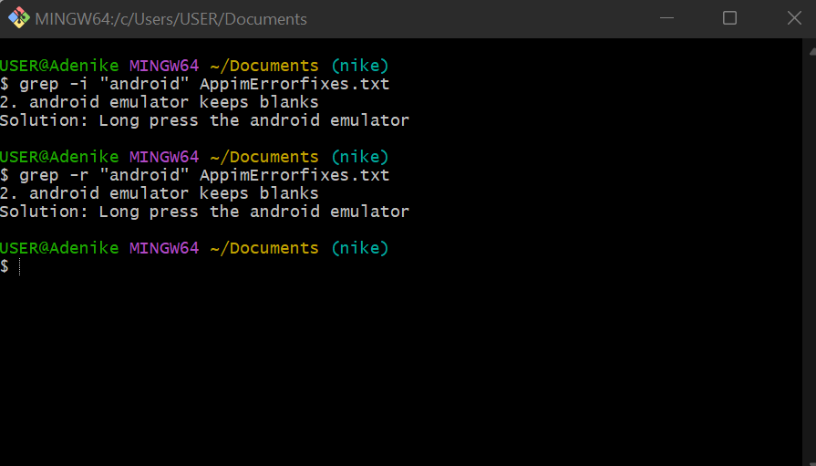

touch: it is used to create an empty file

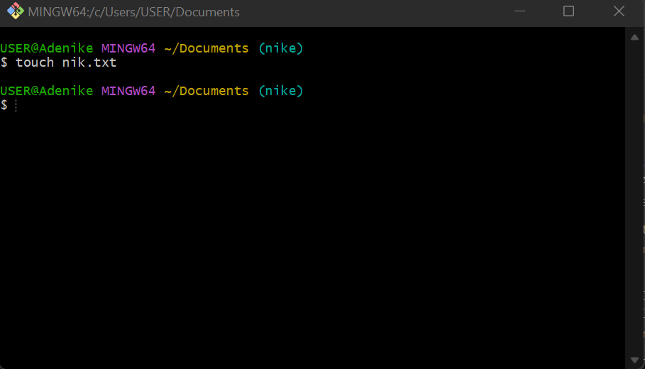

Mkdir: It is used create a new folder

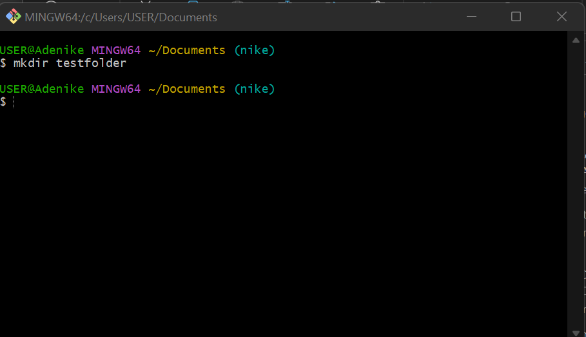

Cp: cp is used copy files

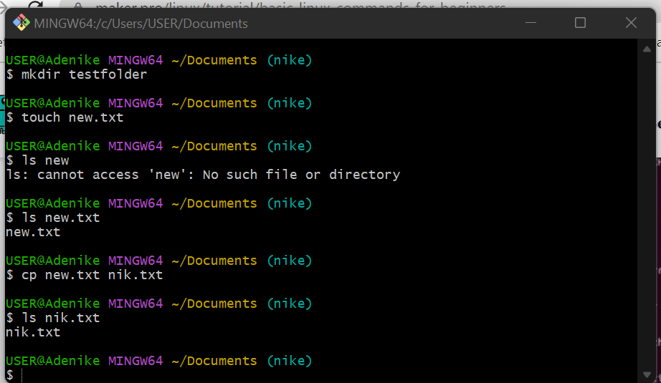

mv: It is used to move or rename file A to File B

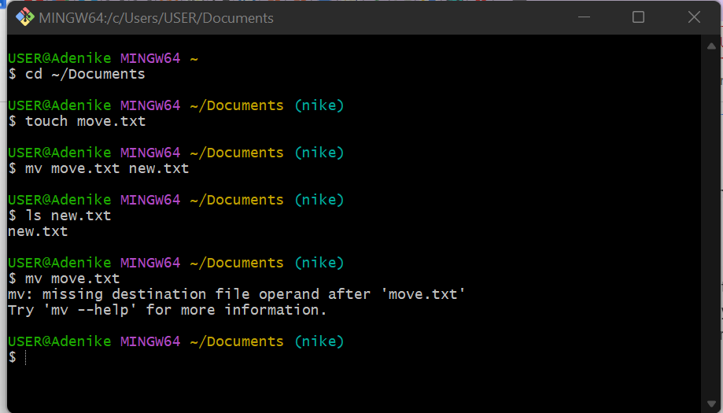  
echo : echo is also used to move some data usually text into a file

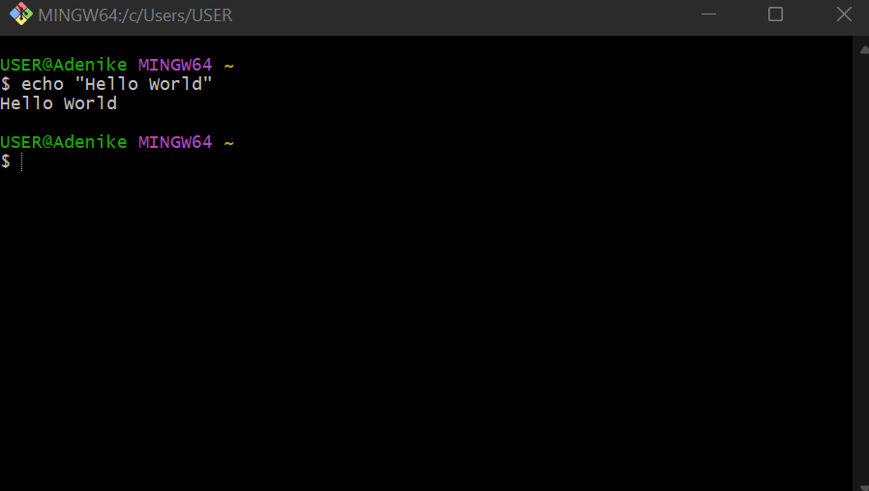

cat: It is used to display the content of a file.

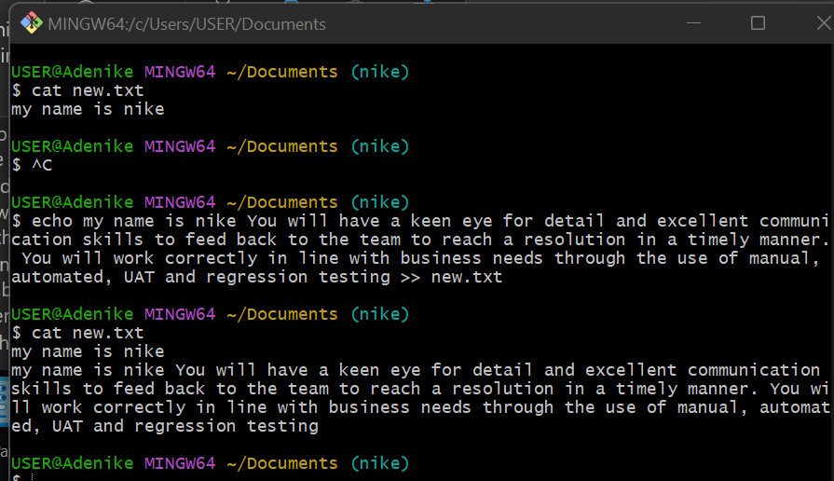

Ikt.txt

ps: It lists processes currently running on current shell session

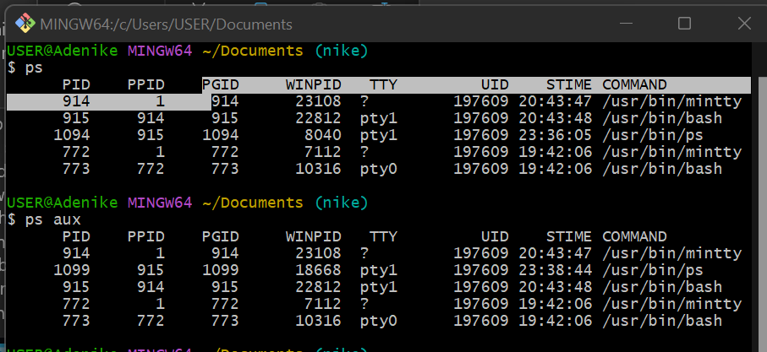

Sed: It is used to transform or parse tesxt

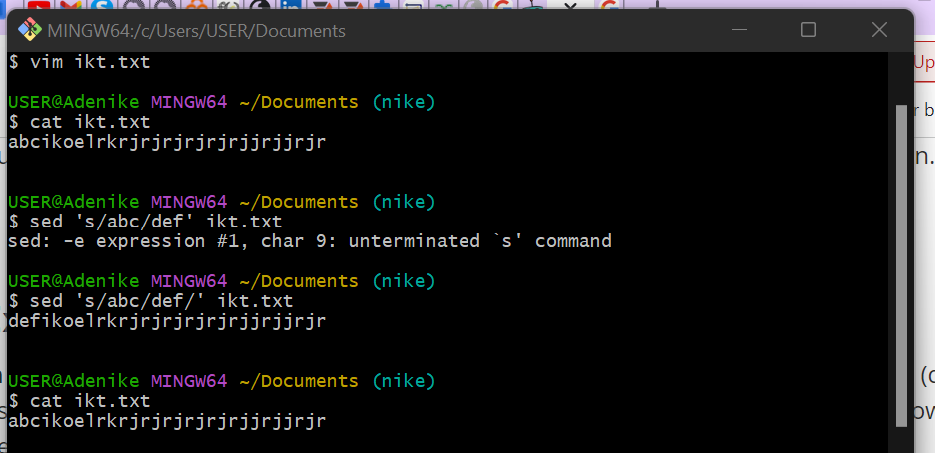

Cut: It is used for cutting out section from each line of files and writing the result to standard output

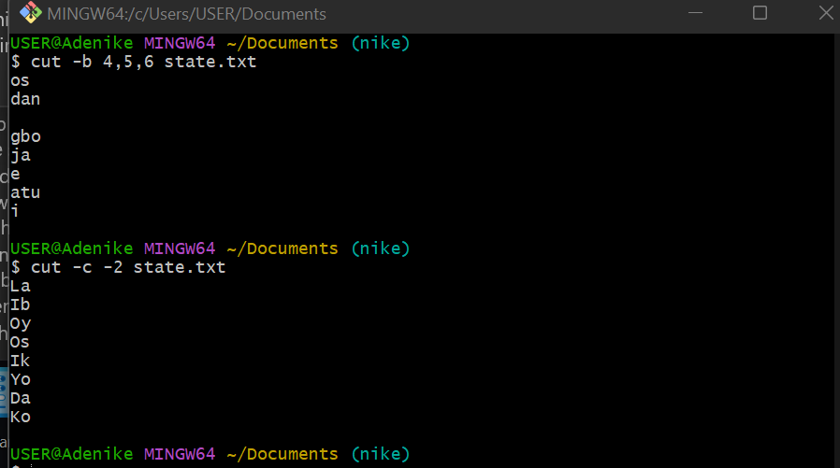

Wc: It is used to find out number of lines, word count ,bytes and character count

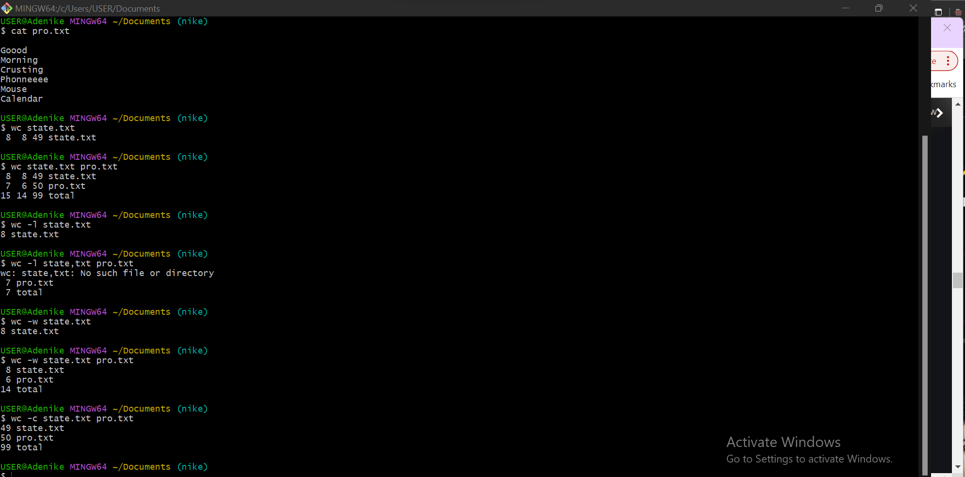

Lsof: used to list open file . This is not recognized on windows

