# lumira-extension-da-google-and-youtube-analytics

A Lumira Data Access Extension (SDK_V2) to access YouTube Analytics and Google Analytics

Google/YouTube Analytics Extension - SAP Lumira Data Access Extension SDK V2

==========================================================

This extension provides a working example of consuming GoogleAnalytics Core Reporting and YouTube Analytic Reports in Lumira 1.25 and above.

Install the Sample Extension

-----------------

* Open Extension Manager, `File > Extensions`

* Click `Manual Installation`

* Select the zip file from `\target`

* Restart SAP Lumira Desktop

* If you do not have a Google API Client ID and API Key (required) please create them:

Go to: <https://console.developers.google.com/>

You will need to create a Public API access Key and Create a Client ID for web applications.

You also need to add a javascript origin (e.g. <http://127.0.0.1:8082>)

(the port depends on what SAP Lumira Desktop is using could also be: 64783)

Once you have both add them in:

‘WebContent\com\sap\bi\da\extension\googleanalyticsextension\ExtensionUtils.js’ like this:

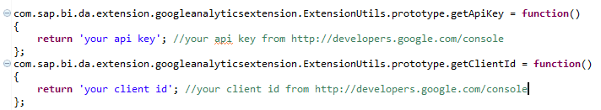

* Back in SAP Lumira Desktop Select `File > New Dataset`

* Select `Google Analytics and YouTube Analytics` from the list of connectors:

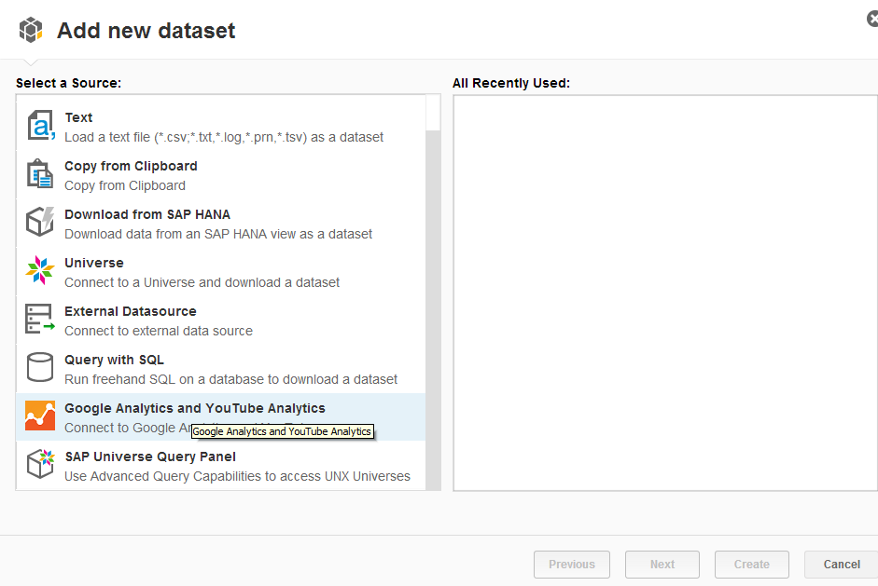

* The Google login dialog will open: (enter user/password)

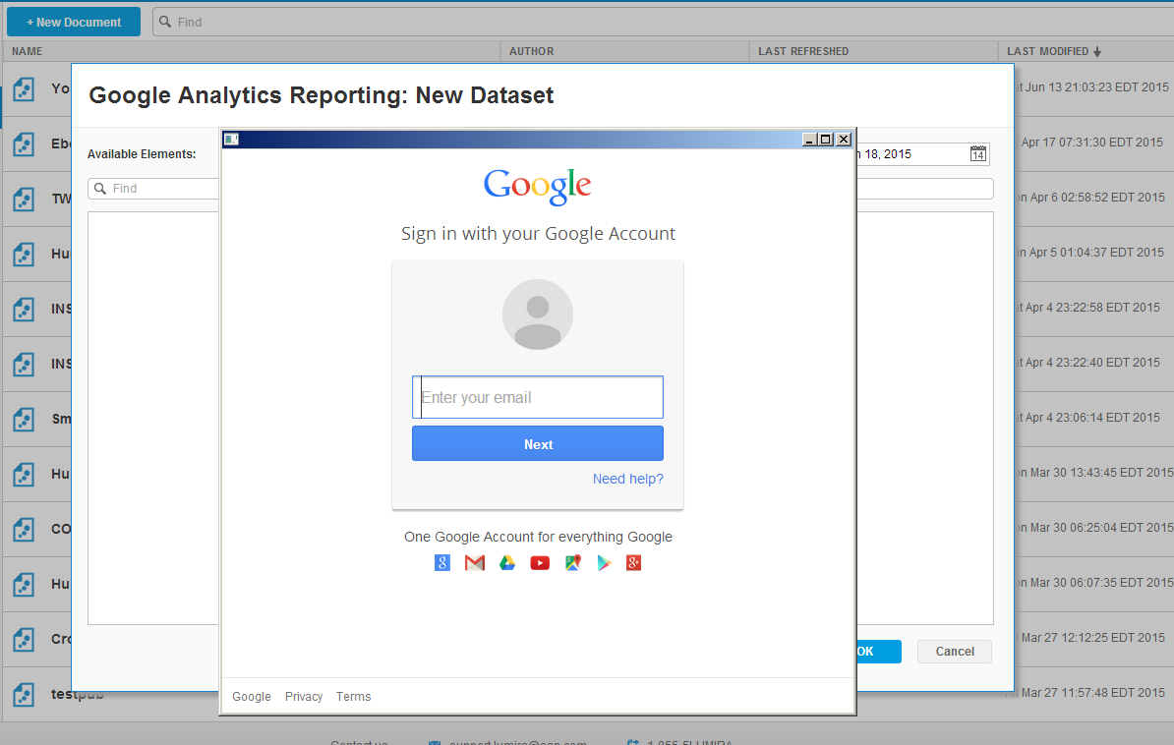

* Depending on what you have access to, you will see either a GA Web Profile or YouTube Channel or both(pick one depending which you want to access). Another dialog may open asking you to authorize Lumira to access the selected account’s data:

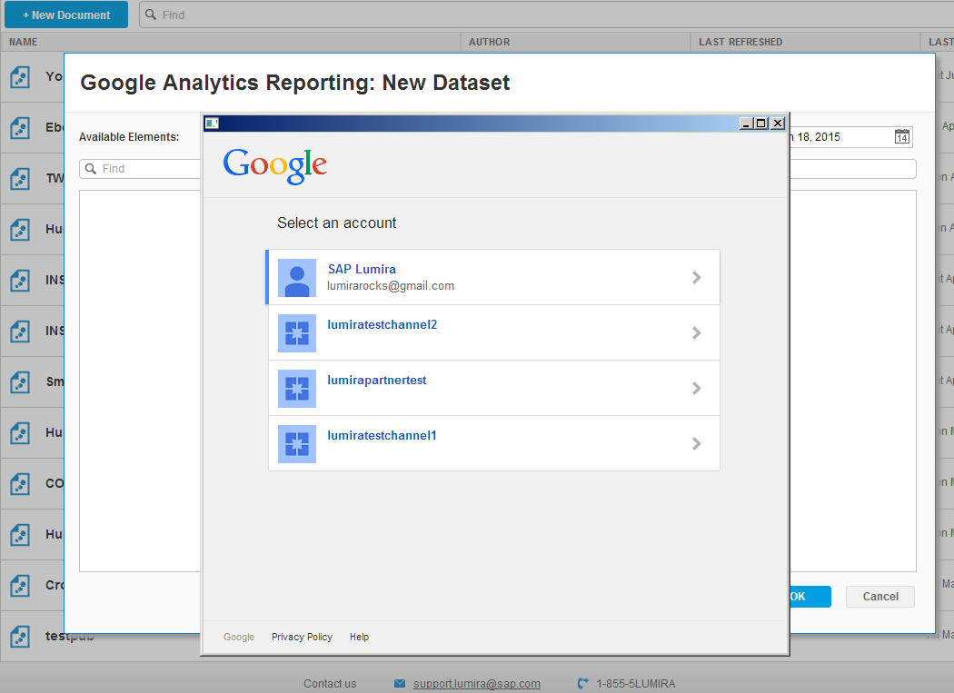

* If you picked Google Analytics the metadata will be queried and the dimension/metric selection dialog will open where you can choose the data elements and date range:

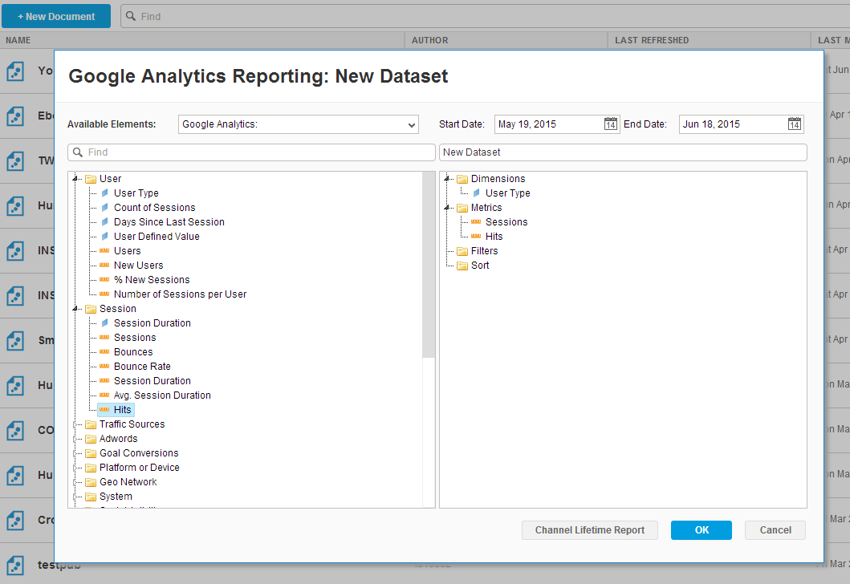

* Click OK to acquire the data and create a new visualization:

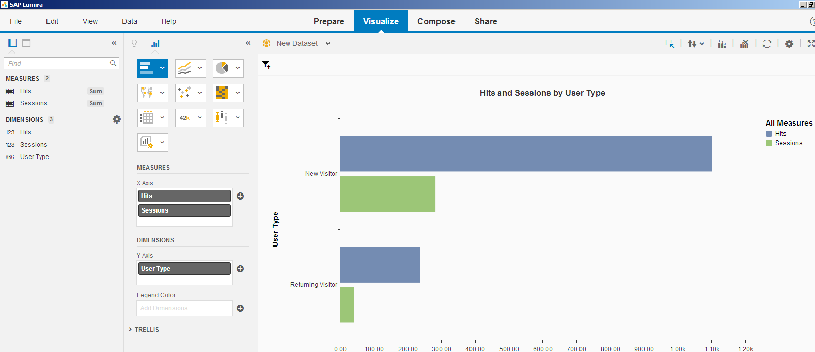

* If you picked YouTube the metadata will look like this:

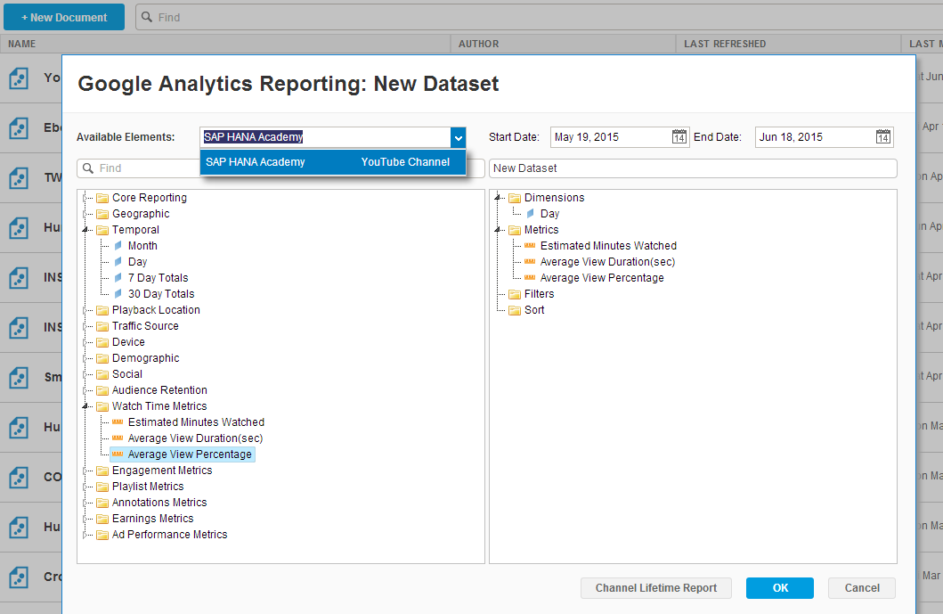

For More info on the types of queries you can run please go to: (<https://developers.google.com/youtube/analytics/v1/available_reports>)

Development Environment Setup

-----------------

* Requirements

+ SAP Lumira 1.25

+ Java Development Kit 7, Update 75 or later

+ Eclipse Luna IDE for Java EE Developers

* Edit `docs\eclipse.bat`

+ Set `ECLIPSE_HOME` to your eclipse installation

+ Set `JAVA_HOME` to your JDK installation

Build the Extension

------------------

* Import project into eclipse

+ Open the file `platform.target`

+ Click `Set as Target Platform` button in the top right

+ Ignore any errors displayed on `plugin.xml`

* Run `export.xml` using Ant `Run As > Ant Build`

* Install the extension zip generated in the `target` folder

Resources

-----------

* Documentation - [help.sap.com/lumira](http://help.sap.com/lumira)

* Developer Guide - [SAP Lumira v2 Data Access Extension SDK Developer guide](http://help.sap.com/businessobject/product_guides/vi01/en/lum_125_dae_dev_en.pdf)

* SCN Blog post - [Coming soon](http://www.sap.com)

License

---------

Copyright 2015, SAP SE

Licensed under the Apache License, Version 2.0 (the "License");

you may not use this file except in compliance with the License.

You may obtain a copy of the License at

http://www.apache.org/licenses/LICENSE-2.0

Unless required by applicable law or agreed to in writing, software

distributed under the License is distributed on an "AS IS" BASIS,

WITHOUT WARRANTIES OR CONDITIONS OF ANY KIND, either express or implied.

See the License for the specific language governing permissions and

limitations under the License.

[1]: https://github.com/SAP/lumira-extension-da-sample