Analysis of HB CE decision rules

Niklaus Meier

Februar 17, 2025

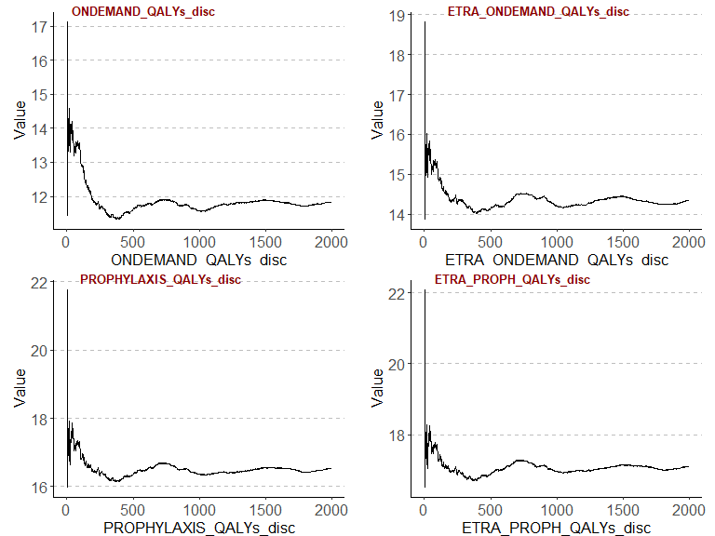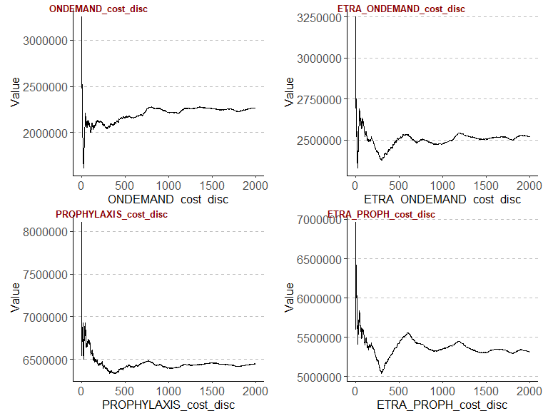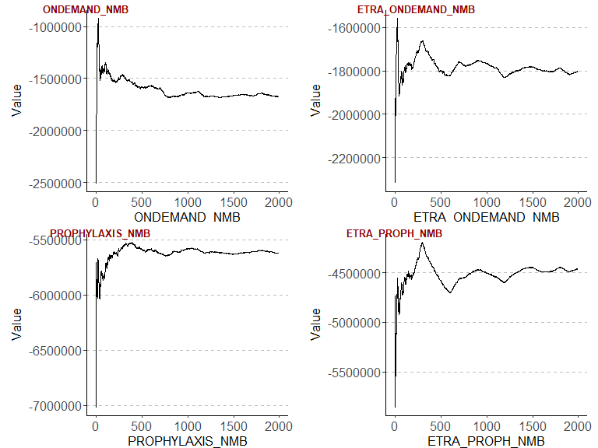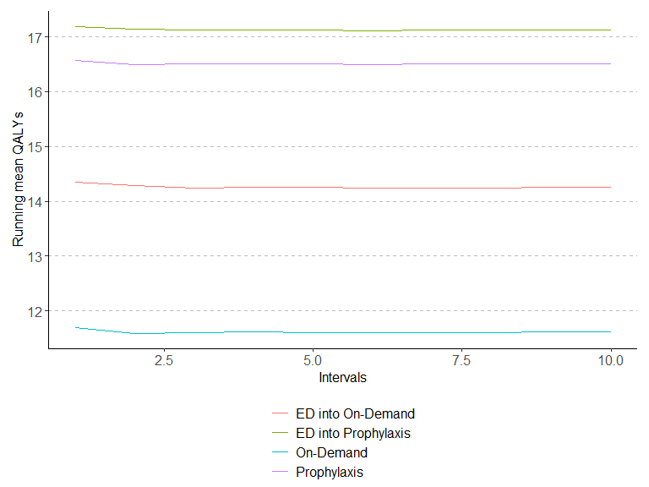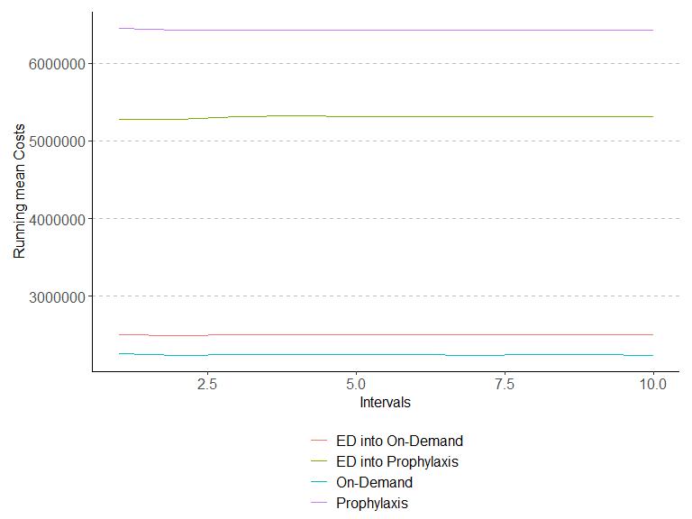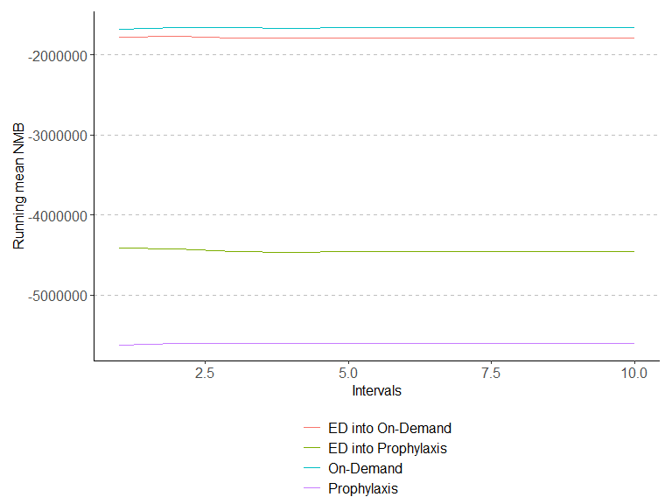

Convergence QALYs

| ONDEMAND_QALYs_disc | ETRA_ONDEMAND_QALYs_disc | PROPHYLAXIS_QALYs_disc | ETRA_PROPH_QALYs_disc |
| --- | --- | --- | --- |
| 0 | 0 | 0 | 0 |
| 0 | 0 | 0 | 0 |
| 0 | 0 | 0 | 0 |
| 0 | 0 | 0 | 0 |
| 0 | 0 | 0 | 0 |
| 0 | 0 | 0 | 0 |
| 0 | 0 | 0 | 0 |
| 0 | 0 | 0 | 0 |
| 0 | 0 | 0 | 0 |
| 0 | 0 | 0 | 0 |

Convergence Costs

| ONDEMAND_cost_disc | ETRA_ONDEMAND_cost_disc | PROPHYLAXIS_cost_disc | ETRA_PROPH_cost_disc |
| --- | --- | --- | --- |
| 0 | 0 | 0 | 0 |
| 1 | 0 | 0 | 0 |
| 0 | 0 | 0 | 0 |
| 0 | 0 | 0 | 0 |
| 0 | 0 | 0 | 0 |
| 0 | 0 | 0 | 0 |
| 0 | 0 | 0 | 0 |
| 0 | 0 | 0 | 0 |
| 0 | 0 | 0 | 0 |
| 0 | 0 | 0 | 0 |

Convergence NMB

| ONDEMAND_NMB | ETRA_ONDEMAND_NMB | PROPHYLAXIS_NMB | ETRA_PROPH_NMB |
| --- | --- | --- | --- |
| 0 | 0 | 0 | 0 |
| 1 | 0 | 0 | 0 |
| 0 | 1 | 0 | 0 |
| 0 | 0 | 0 | 0 |
| 0 | 0 | 0 | 0 |
| 0 | 0 | 0 | 0 |
| 0 | 0 | 0 | 0 |
| 0 | 0 | 0 | 0 |
| 0 | 0 | 0 | 0 |
| 0 | 0 | 0 | 0 |

## CP nsplit rel error xerror xstd  
## 1 0.43831508 0 1.0000000 1.0000000 0.002835703  
## 2 0.20532081 1 0.5616849 0.5616849 0.002397416  
## 3 0.01145018 2 0.3563641 0.3565858 0.002003633

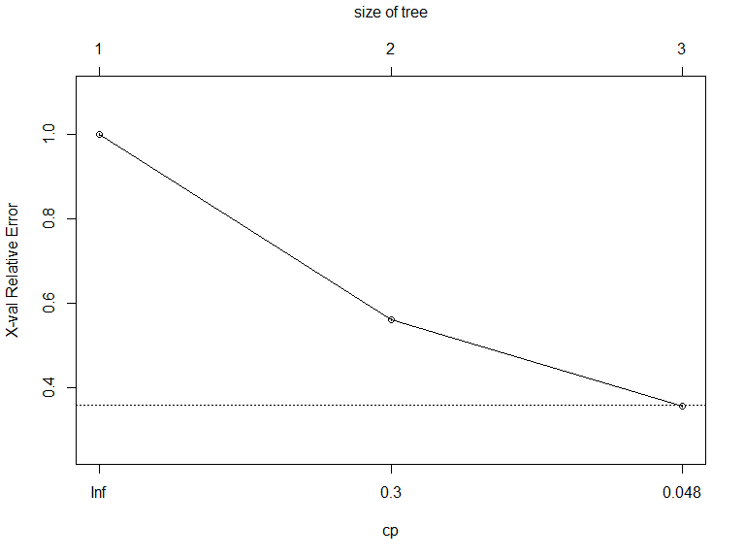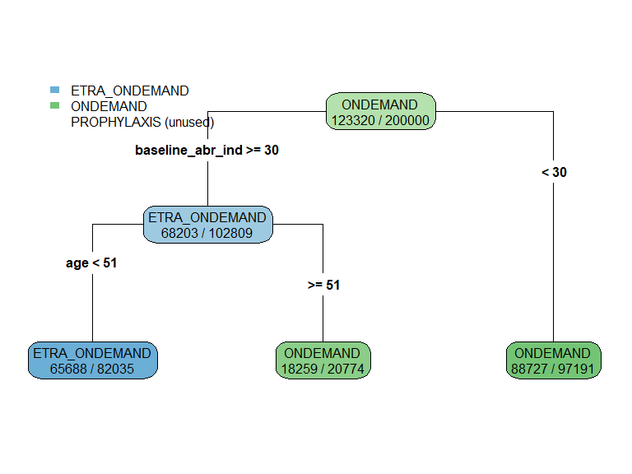

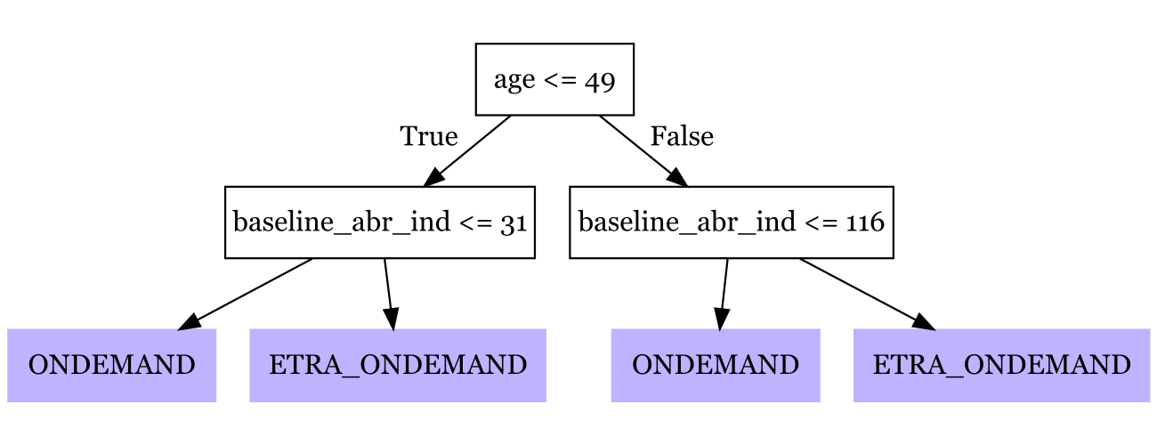

| **term** | **estimate** | **std.error** | **statistic** | **p.value** |
| --- | --- | --- | --- | --- |
| (Intercept) | 2,553,620.99 | 57,256.20 | 44.60 | 0.00 |
| baseline_abr_ind | -151,564.09 | 1,591.08 | -95.26 | 0.00 |
| age | -131,139.06 | 4,914.54 | -26.68 | 0.00 |
| sex | -848,877.16 | 12,395.70 | -68.48 | 0.00 |
| ETRA_ONDEMAND | -1,867,488.93 | 167,177.71 | -11.17 | 0.00 |
| PROPHYLAXIS | -7,471,854.03 | 167,177.71 | -44.69 | 0.00 |
| ETRA_PROPH | -4,180,060.63 | 79,447.36 | -52.61 | 0.00 |
| baseline_abr_ind_INT_age | 847.42 | 2.78 | 304.75 | 0.00 |
| baseline_abr_ind_INT_sex | 1,404.91 | 168.74 | 8.33 | 0.00 |
| age_INT_sex | 16,937.99 | 234.86 | 72.12 | 0.00 |
| ETRA_ONDEMAND_INT_baseline_abr_ind | 62,190.71 | 2,234.34 | 27.83 | 0.00 |
| ETRA_ONDEMAND_INT_age | 34,436.72 | 19,425.65 | 1.77 | 0.08 |
| ETRA_ONDEMAND_INT_sex | 118,121.97 | 8,408.64 | 14.05 | 0.00 |
| PROPHYLAXIS_INT_baseline_abr_ind | 130,971.36 | 2,234.34 | 58.62 | 0.00 |
| PROPHYLAXIS_INT_age | 92,046.29 | 19,425.65 | 4.74 | 0.00 |
| PROPHYLAXIS_INT_sex | -683,117.16 | 8,408.64 | -81.24 | 0.00 |
| ETRA_PROPH_INT_baseline_abr_ind | -111,407.76 | 2,234.34 | -49.86 | 0.00 |
| ETRA_PROPH_INT_age | 37,407.80 | 6,941.11 | 5.39 | 0.00 |
| ETRA_PROPH_INT_sex | -225,074.31 | 8,408.64 | -26.77 | 0.00 |
| baseline_abr_ind_power2 | 1,596.78 | 72.39 | 22.06 | 0.00 |
| ETRA_ONDEMAND_INT_baseline_abr_ind_power2 | -845.40 | 102.37 | -8.26 | 0.00 |
| PROPHYLAXIS_INT_baseline_abr_ind_power2 | -1,856.61 | 102.37 | -18.14 | 0.00 |
| ETRA_PROPH_INT_baseline_abr_ind_power2 | 7,064.26 | 102.37 | 69.01 | 0.00 |
| baseline_abr_ind_power3 | -19.16 | 1.42 | -13.46 | 0.00 |
| ETRA_ONDEMAND_INT_baseline_abr_ind_power3 | 11.63 | 2.01 | 5.78 | 0.00 |
| PROPHYLAXIS_INT_baseline_abr_ind_power3 | 21.14 | 2.01 | 10.50 | 0.00 |
| ETRA_PROPH_INT_baseline_abr_ind_power3 | -126.56 | 2.01 | -62.86 | 0.00 |
| baseline_abr_ind_power4 | 0.13 | 0.01 | 10.35 | 0.00 |
| ETRA_ONDEMAND_INT_baseline_abr_ind_power4 | -0.09 | 0.02 | -5.20 | 0.00 |
| PROPHYLAXIS_INT_baseline_abr_ind_power4 | -0.13 | 0.02 | -7.73 | 0.00 |
| ETRA_PROPH_INT_baseline_abr_ind_power4 | 0.93 | 0.02 | 53.47 | 0.00 |
| baseline_abr_ind_power5 | 0.00 | 0.00 | -8.75 | 0.00 |
| ETRA_ONDEMAND_INT_baseline_abr_ind_power5 | 0.00 | 0.00 | 4.97 | 0.00 |
| PROPHYLAXIS_INT_baseline_abr_ind_power5 | 0.00 | 0.00 | 6.36 | 0.00 |
| ETRA_PROPH_INT_baseline_abr_ind_power5 | 0.00 | 0.00 | -44.94 | 0.00 |
| age_power2 | 3,547.98 | 147.13 | 24.11 | 0.00 |
| ETRA_ONDEMAND_INT_age_power2 | 16.38 | 862.81 | 0.02 | 0.98 |
| PROPHYLAXIS_INT_age_power2 | -4,508.85 | 862.81 | -5.23 | 0.00 |
| ETRA_PROPH_INT_age_power2 | -619.77 | 208.07 | -2.98 | 0.00 |
| age_power3 | -31.56 | 1.56 | -20.22 | 0.00 |
| ETRA_ONDEMAND_INT_age_power3 | -33.32 | 18.29 | -1.82 | 0.07 |
| PROPHYLAXIS_INT_age_power3 | 108.64 | 18.29 | 5.94 | 0.00 |
| ETRA_PROPH_INT_age_power3 | 11.45 | 2.21 | 5.19 | 0.00 |
| ETRA_ONDEMAND_INT_age_power4 | 0.48 | 0.19 | 2.59 | 0.01 |
| PROPHYLAXIS_INT_age_power4 | -0.96 | 0.19 | -5.15 | 0.00 |
| age_power5 | 0.00 | 0.00 | 10.81 | 0.00 |
| ETRA_ONDEMAND_INT_age_power5 | 0.00 | 0.00 | -2.68 | 0.01 |
| PROPHYLAXIS_INT_age_power5 | 0.00 | 0.00 | 3.91 | 0.00 |
| ETRA_PROPH_INT_age_power5 | 0.00 | 0.00 | -8.00 | 0.00 |

Comparison of treatment assignments and decision rules

|  | QALYs | Costs | NMB | Goodness |
| --- | --- | --- | --- | --- |
| ONDEMAND | 11.62 | 2,238,940.48 | -1,657,944.49 | 265,235.39 |
| ETRA_ONDEMAND | 14.26 | 2,499,796.58 | -1,786,915.54 | 394,206.44 |
| PROPHYLAXIS | 16.51 | 6,427,659.72 | -5,601,952.15 | 4,209,243.05 |
| ETRA_PROPH | 17.13 | 5,308,144.04 | -4,451,697.16 | 3,058,988.06 |
| OPTIMAL | 12.84 | 2,034,709.87 | -1,392,709.10 | 0.00 |
| LASSO | 12.83 | 2,092,625.56 | -1,450,973.32 | 58,264.22 |
| POLICY_TREE | 12.70 | 2,082,204.32 | -1,447,263.85 | 54,554.75 |
| RECURSIVE_PARTITIONING | 12.83 | 2,090,196.74 | -1,448,847.51 | 56,138.41 |

## baseline_abr_ind age   
## 18 36

## baseline_abr_ind age   
## 61 60

## 2.5%   
## 21

## 97.5%   
## 46

## 2.5%   
## 42

## 97.5%   
## 56

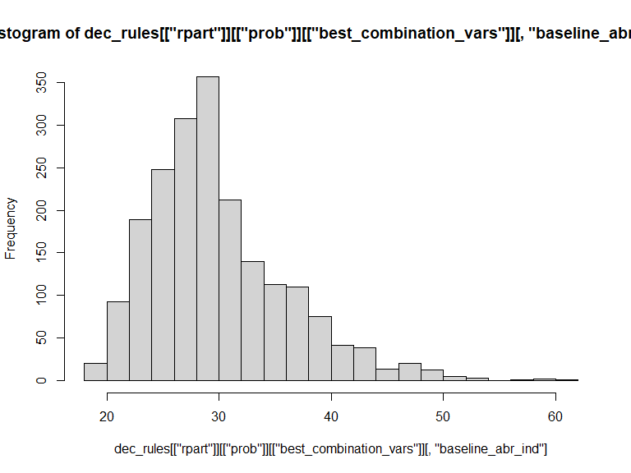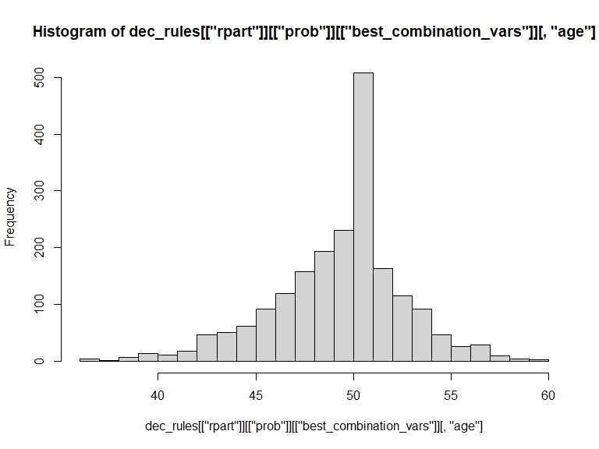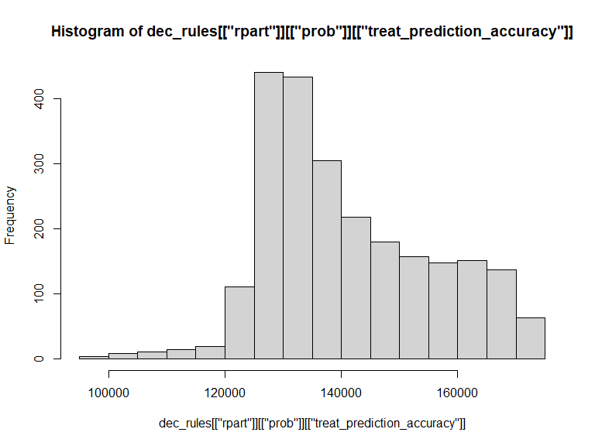

## Warning: Using `size` aesthetic for lines was deprecated in ggplot2 3.4.0.  
## ℹ Please use `linewidth` instead.  
## This warning is displayed once every 8 hours.  
## Call `lifecycle::last_lifecycle_warnings()` to see where this warning was generated.

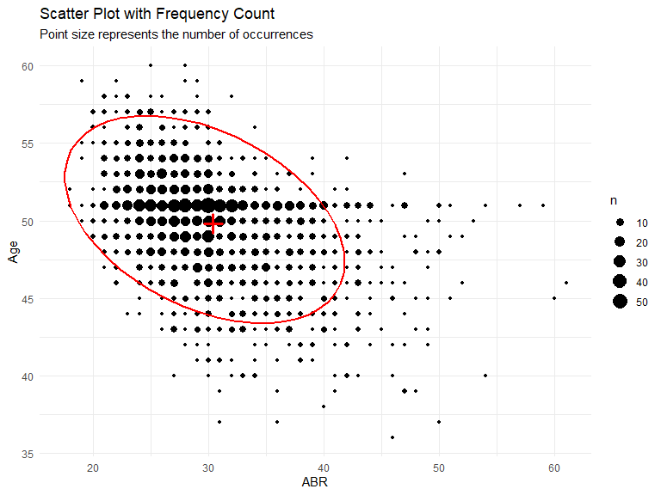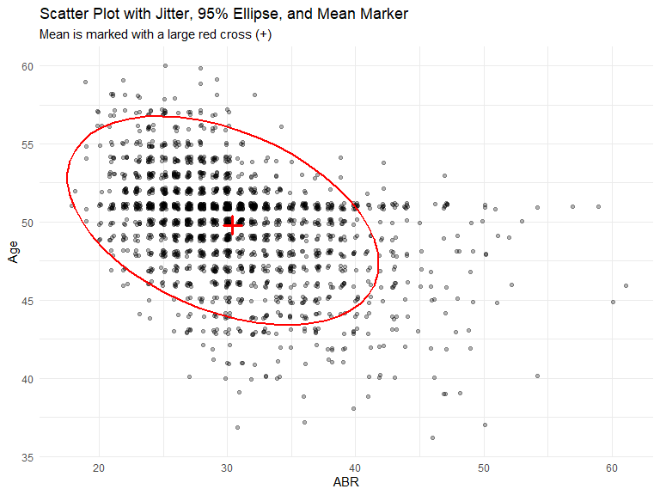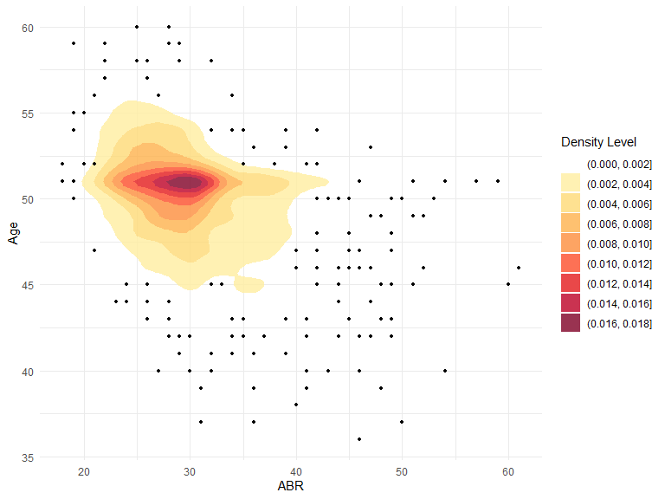

# System information

Sys.info()

sysname release version nodename machine login user   
 "Windows" "10 x64" "build 19045" "M04486" "x86-64" "min1" "min1"

effective_user “min1”

sessionInfo(package = NULL)

R version 4.3.1 (2023-06-16 ucrt) Platform: x86_64-w64-mingw32/x64 (64-bit) Running under: Windows 10 x64 (build 19045)

Matrix products: default

locale: [1] LC_COLLATE=German_Switzerland.utf8 LC_CTYPE=German_Switzerland.utf8 LC_MONETARY=German_Switzerland.utf8 [4] LC_NUMERIC=C LC_TIME=German_Switzerland.utf8

time zone: Europe/Zurich tzcode source: internal

attached base packages: [1] stats graphics grDevices utils datasets methods base

other attached packages: [1] MASS_7.3-60 dplyr_1.1.2 scales_1.3.0 flextable_0.9.3 broom_1.0.5 DiagrammeRsvg_0.1 [7] fastDummies_1.7.3 glmnet_4.1-8 Matrix_1.6-0 rattle_5.5.1 bitops_1.0-7 tibble_3.2.1  
[13] rpart.plot_3.1.2 rpart_4.1.19 policytree_1.2.2 grf_2.3.2 mgcv_1.8-42 nlme_3.1-162  
[19] kableExtra_1.3.4 rmarkdown_2.23 ggrepel_0.9.3 plyr_1.8.8 ggpubr_0.6.0 truncnorm_1.0-9  
[25] lookup_1.0 data.table_1.14.8 pander_0.6.5 RColorBrewer_1.1-3 ggplot2_3.5.1

loaded via a namespace (and not attached): [1] rlang_1.1.1 magrittr_2.0.3 compiler_4.3.1 png_0.1-8  
[5] systemfonts_1.0.4 vctrs_0.6.3 rvest_1.0.3 stringr_1.5.1  
[9] httpcode_0.3.0 pkgconfig_2.0.3 shape_1.4.6.1 crayon_1.5.2  
[13] fastmap_1.1.1 backports_1.4.1 ellipsis_0.3.2 labeling_0.4.3  
[17] utf8_1.2.3 promises_1.2.0.1 ragg_1.2.5 purrr_1.0.1  
[21] xfun_0.39 jsonlite_1.8.7 highr_0.10 later_1.3.1  
[25] uuid_1.1-0 R6_2.5.1 stringi_1.8.3 car_3.1-2  
[29] Rcpp_1.0.11 iterators_1.0.14 knitr_1.43 httpuv_1.6.11  
[33] splines_4.3.1 tidyselect_1.2.1 rstudioapi_0.15.0 abind_1.4-5  
[37] yaml_2.3.7 codetools_0.2-19 curl_5.0.1 lattice_0.21-8  
[41] shiny_1.7.4.1 withr_3.0.0 askpass_1.1 evaluate_0.21  
[45] survival_3.5-5 isoband_0.2.7 zip_2.3.0 xml2_1.3.5  
[49] pillar_1.9.0 carData_3.0-5 foreach_1.5.2 generics_0.1.3  
[53] munsell_0.5.1 xtable_1.8-4 glue_1.6.2 gdtools_0.3.3  
[57] tools_4.3.1 gfonts_0.2.0 webshot_0.5.5 ggsignif_0.6.4  
[61] cowplot_1.1.3 grid_4.3.1 tidyr_1.3.0 colorspace_2.1-0  
[65] cli_3.6.1 textshaping_0.3.6 officer_0.6.2 rsvg_2.6.1  
[69] fontBitstreamVera_0.1.1 fansi_1.0.4 viridisLite_0.4.2 svglite_2.1.2  
[73] V8_6.0.0 gtable_0.3.5 rstatix_0.7.2 digest_0.6.33  
[77] fontquiver_0.2.1 crul_1.4.0 farver_2.1.1 htmltools_0.5.5  
[81] lifecycle_1.0.4 httr_1.4.6 mime_0.12 fontLiberation_0.1.0  
[85] openssl_2.0.6