Analysis of HB CE decision rules
Niklaus Meier
Juli 11, 2025

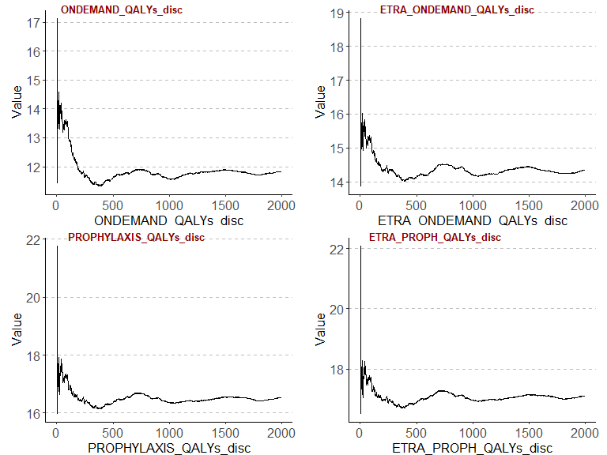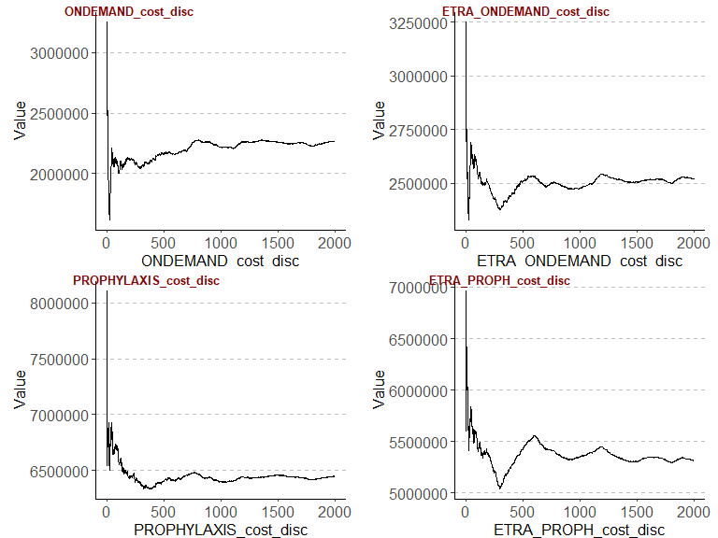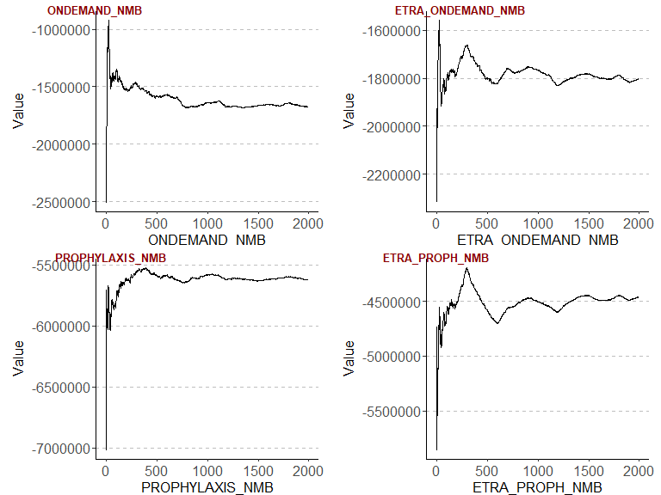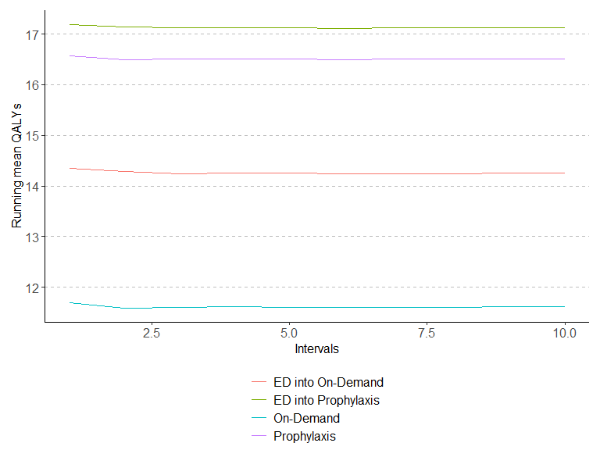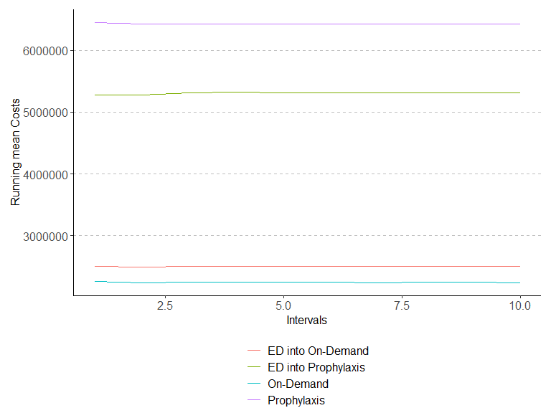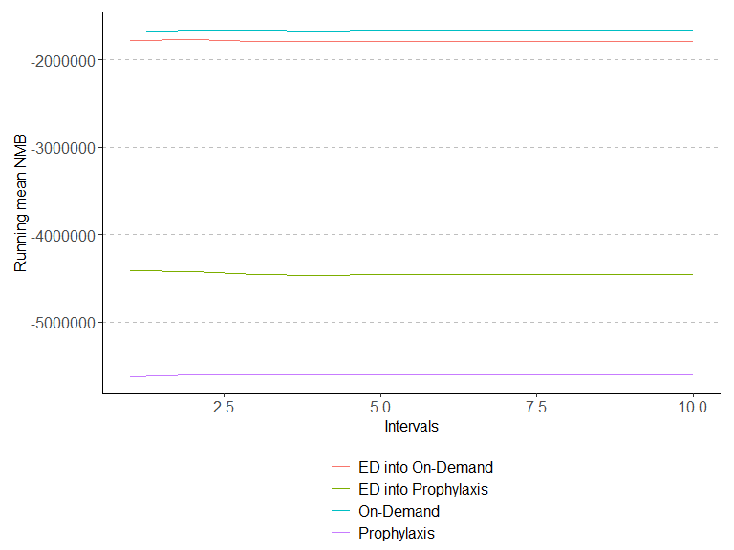
Convergence QALYs
ONDEMAND_QALYs_disc | ETRA_ONDEMAND_QALYs_disc | PROPHYLAXIS_QALYs_disc | ETRA_PROPH_QALYs_disc
0 | 0 | 0 | 0
0 | 0 | 0 | 0
0 | 0 | 0 | 0
0 | 0 | 0 | 0
0 | 0 | 0 | 0
0 | 0 | 0 | 0
0 | 0 | 0 | 0
0 | 0 | 0 | 0
0 | 0 | 0 | 0
0 | 0 | 0 | 0

Convergence Costs
ONDEMAND_cost_disc | ETRA_ONDEMAND_cost_disc | PROPHYLAXIS_cost_disc | ETRA_PROPH_cost_disc
0 | 0 | 0 | 0
1 | 0 | 0 | 0
0 | 0 | 0 | 0
0 | 0 | 0 | 0
0 | 0 | 0 | 0
0 | 0 | 0 | 0
0 | 0 | 0 | 0
0 | 0 | 0 | 0
0 | 0 | 0 | 0
0 | 0 | 0 | 0

Convergence NMB
ONDEMAND_NMB | ETRA_ONDEMAND_NMB | PROPHYLAXIS_NMB | ETRA_PROPH_NMB
0 | 0 | 0 | 0
1 | 0 | 0 | 0
0 | 1 | 0 | 0
0 | 0 | 0 | 0
0 | 0 | 0 | 0
0 | 0 | 0 | 0
0 | 0 | 0 | 0
0 | 0 | 0 | 0
0 | 0 | 0 | 0
0 | 0 | 0 | 0

## CP nsplit rel error xerror xstd
## 1 0.43831508 0 1.0000000 1.0000000 0.002835703
## 2 0.20532081 1 0.5616849 0.5616849 0.002397416
## 3 0.01145018 2 0.3563641 0.3565858 0.002003633
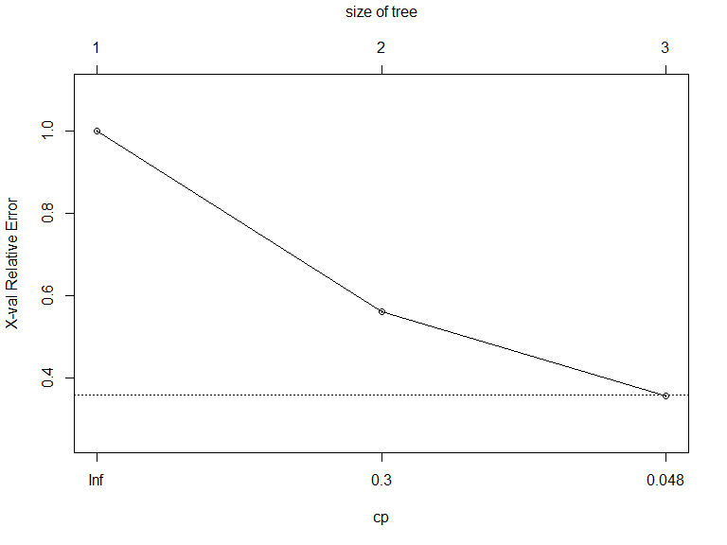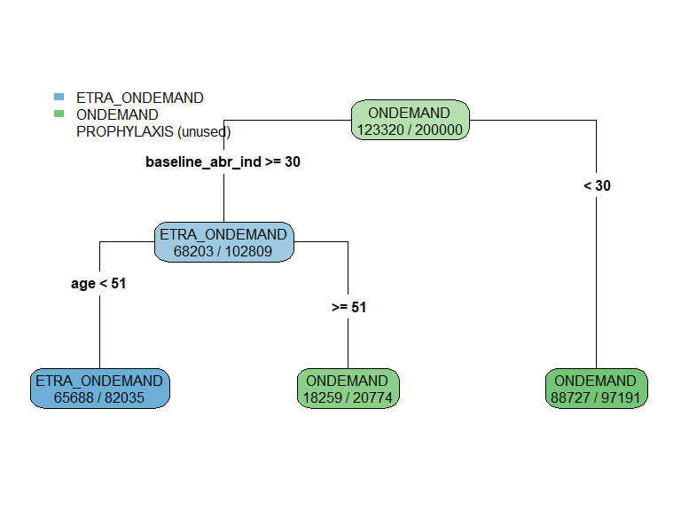

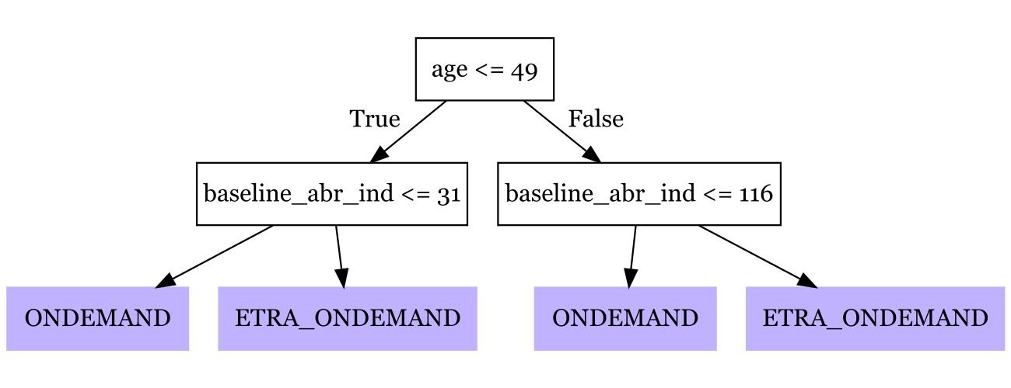

term | estimate | std.error | statistic | p.value
(Intercept) | 2,553,620.99 | 57,256.20 | 44.60 | 0.00
baseline_abr_ind | -151,564.09 | 1,591.08 | -95.26 | 0.00
age | -131,139.06 | 4,914.54 | -26.68 | 0.00
sex | -848,877.16 | 12,395.70 | -68.48 | 0.00
ETRA_ONDEMAND | -1,867,488.93 | 167,177.71 | -11.17 | 0.00
PROPHYLAXIS | -7,471,854.03 | 167,177.71 | -44.69 | 0.00
ETRA_PROPH | -4,180,060.63 | 79,447.36 | -52.61 | 0.00
baseline_abr_ind_INT_age | 847.42 | 2.78 | 304.75 | 0.00
baseline_abr_ind_INT_sex | 1,404.91 | 168.74 | 8.33 | 0.00
age_INT_sex | 16,937.99 | 234.86 | 72.12 | 0.00
ETRA_ONDEMAND_INT_baseline_abr_ind | 62,190.71 | 2,234.34 | 27.83 | 0.00
ETRA_ONDEMAND_INT_age | 34,436.72 | 19,425.65 | 1.77 | 0.08
ETRA_ONDEMAND_INT_sex | 118,121.97 | 8,408.64 | 14.05 | 0.00
PROPHYLAXIS_INT_baseline_abr_ind | 130,971.36 | 2,234.34 | 58.62 | 0.00
PROPHYLAXIS_INT_age | 92,046.29 | 19,425.65 | 4.74 | 0.00
PROPHYLAXIS_INT_sex | -683,117.16 | 8,408.64 | -81.24 | 0.00
ETRA_PROPH_INT_baseline_abr_ind | -111,407.76 | 2,234.34 | -49.86 | 0.00
ETRA_PROPH_INT_age | 37,407.80 | 6,941.11 | 5.39 | 0.00
ETRA_PROPH_INT_sex | -225,074.31 | 8,408.64 | -26.77 | 0.00
baseline_abr_ind_power2 | 1,596.78 | 72.39 | 22.06 | 0.00
ETRA_ONDEMAND_INT_baseline_abr_ind_power2 | -845.40 | 102.37 | -8.26 | 0.00
PROPHYLAXIS_INT_baseline_abr_ind_power2 | -1,856.61 | 102.37 | -18.14 | 0.00
ETRA_PROPH_INT_baseline_abr_ind_power2 | 7,064.26 | 102.37 | 69.01 | 0.00
baseline_abr_ind_power3 | -19.16 | 1.42 | -13.46 | 0.00
ETRA_ONDEMAND_INT_baseline_abr_ind_power3 | 11.63 | 2.01 | 5.78 | 0.00
PROPHYLAXIS_INT_baseline_abr_ind_power3 | 21.14 | 2.01 | 10.50 | 0.00
ETRA_PROPH_INT_baseline_abr_ind_power3 | -126.56 | 2.01 | -62.86 | 0.00
baseline_abr_ind_power4 | 0.13 | 0.01 | 10.35 | 0.00
ETRA_ONDEMAND_INT_baseline_abr_ind_power4 | -0.09 | 0.02 | -5.20 | 0.00
PROPHYLAXIS_INT_baseline_abr_ind_power4 | -0.13 | 0.02 | -7.73 | 0.00
ETRA_PROPH_INT_baseline_abr_ind_power4 | 0.93 | 0.02 | 53.47 | 0.00
baseline_abr_ind_power5 | 0.00 | 0.00 | -8.75 | 0.00
ETRA_ONDEMAND_INT_baseline_abr_ind_power5 | 0.00 | 0.00 | 4.97 | 0.00
PROPHYLAXIS_INT_baseline_abr_ind_power5 | 0.00 | 0.00 | 6.36 | 0.00
ETRA_PROPH_INT_baseline_abr_ind_power5 | 0.00 | 0.00 | -44.94 | 0.00
age_power2 | 3,547.98 | 147.13 | 24.11 | 0.00
ETRA_ONDEMAND_INT_age_power2 | 16.38 | 862.81 | 0.02 | 0.98
PROPHYLAXIS_INT_age_power2 | -4,508.85 | 862.81 | -5.23 | 0.00
ETRA_PROPH_INT_age_power2 | -619.77 | 208.07 | -2.98 | 0.00
age_power3 | -31.56 | 1.56 | -20.22 | 0.00
ETRA_ONDEMAND_INT_age_power3 | -33.32 | 18.29 | -1.82 | 0.07
PROPHYLAXIS_INT_age_power3 | 108.64 | 18.29 | 5.94 | 0.00
ETRA_PROPH_INT_age_power3 | 11.45 | 2.21 | 5.19 | 0.00
ETRA_ONDEMAND_INT_age_power4 | 0.48 | 0.19 | 2.59 | 0.01
PROPHYLAXIS_INT_age_power4 | -0.96 | 0.19 | -5.15 | 0.00
age_power5 | 0.00 | 0.00 | 10.81 | 0.00
ETRA_ONDEMAND_INT_age_power5 | 0.00 | 0.00 | -2.68 | 0.01
PROPHYLAXIS_INT_age_power5 | 0.00 | 0.00 | 3.91 | 0.00
ETRA_PROPH_INT_age_power5 | 0.00 | 0.00 | -8.00 | 0.00

Comparison of treatment assignments and decision rules
 | QALYs | Costs | NMB | Regret | EVIC
ONDEMAND | 11.62 | 2,238,940.48 | -1,657,944.49 | 265,235.39 | 0.00
ETRA_ONDEMAND | 14.26 | 2,499,796.58 | -1,786,915.54 | 394,206.44 | 0.00
PROPHYLAXIS | 16.51 | 6,427,659.72 | -5,601,952.15 | 4,209,243.05 | 0.00
ETRA_PROPH | 17.13 | 5,308,144.04 | -4,451,697.16 | 3,058,988.06 | 0.00
OPTIMAL | 12.84 | 2,034,709.87 | -1,392,709.10 | 0.00 | 265,235.39
LASSO | 12.83 | 2,092,625.56 | -1,450,973.32 | 58,264.22 | 206,971.17
RECURSIVE_PARTITIONING | 12.83 | 2,090,196.74 | -1,448,847.51 | 56,138.41 | 209,096.98
POLICY_TREE | 12.70 | 2,082,204.32 | -1,447,263.85 | 54,554.75 | 210,680.64

## baseline_abr_ind age
## 18 36
## baseline_abr_ind age
## 61 60
## 2.5%
## 21
## 97.5%
## 46
## 2.5%
## 42
## 97.5%
## 56
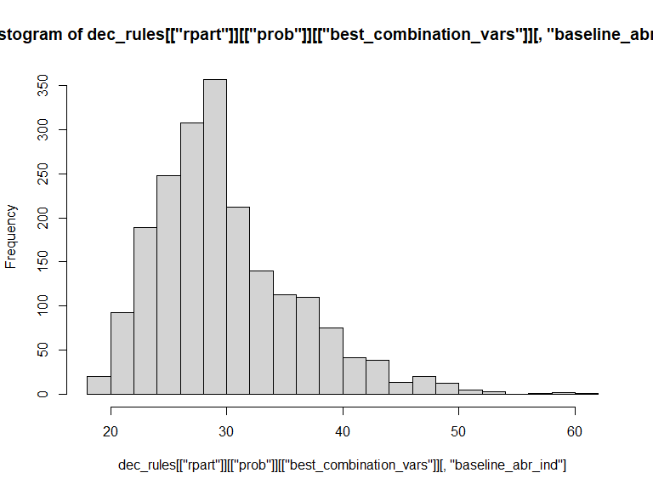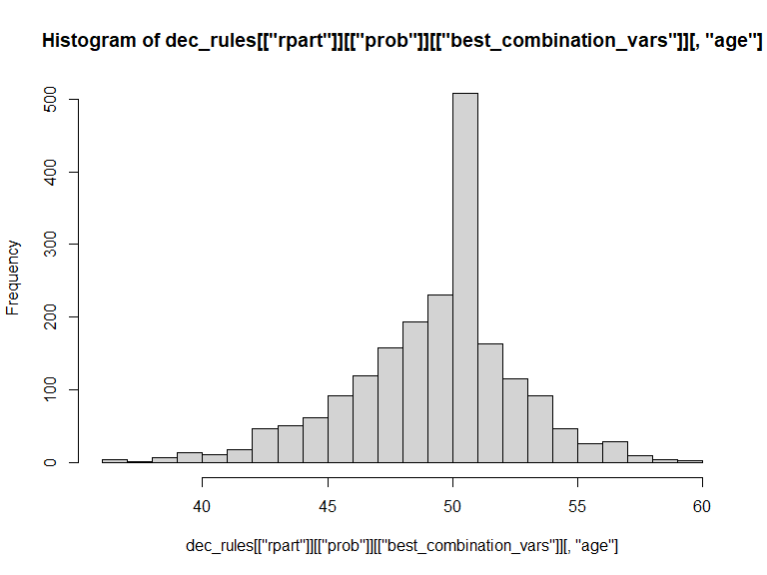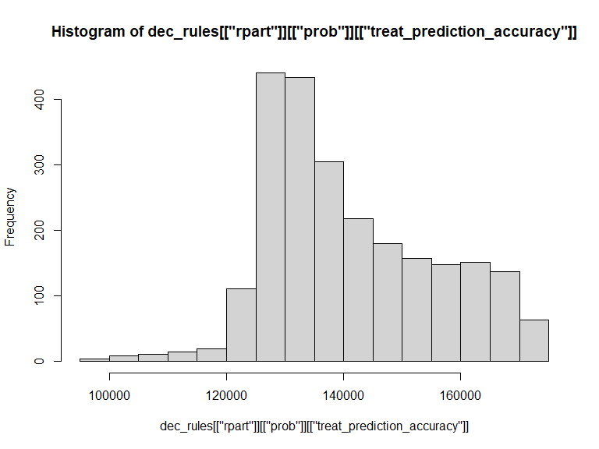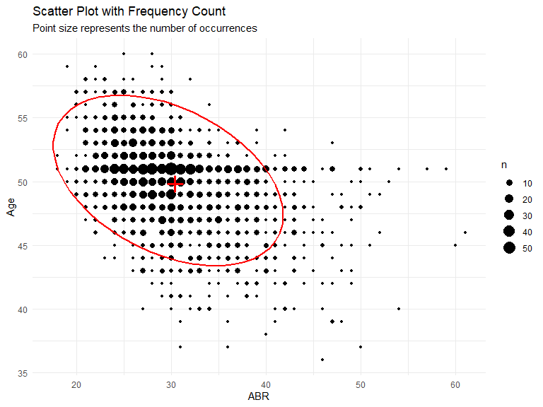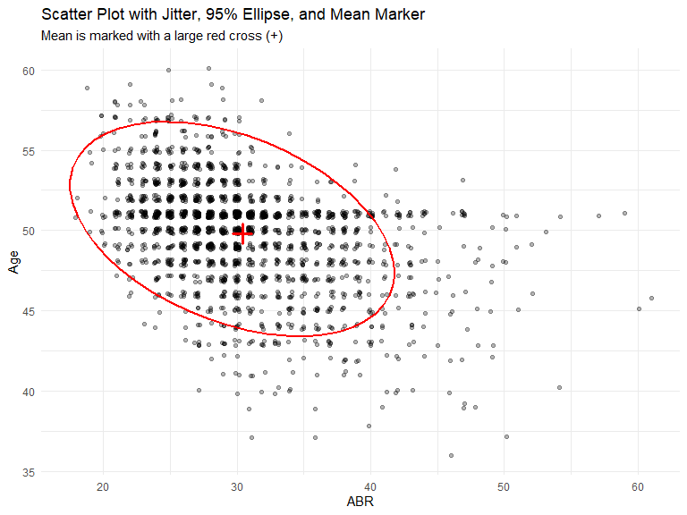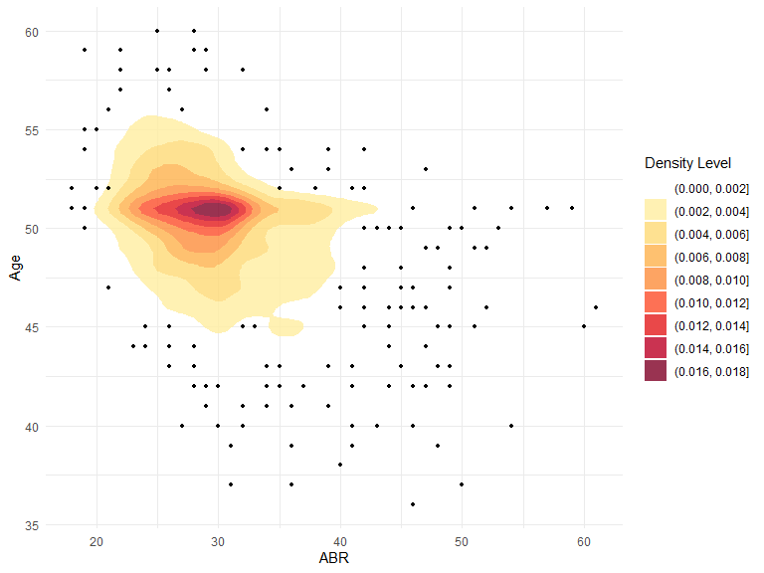

System information
Sys.info()
sysname release version nodename machine login user effective_user
"Windows" "10 x64" "build 26100" "PC2GWPX6" "x86-64" "min1" "min1" "min1"
udomain
"BFH"
sessionInfo(package = NULL)
R version 4.5.0 (2025-04-11 ucrt) Platform: x86_64-w64-mingw32/x64 Running under: Windows 11 x64 (build 26100)
Matrix products: default LAPACK version 3.12.1
locale: [1] LC_COLLATE=German_Switzerland.utf8 LC_CTYPE=German_Switzerland.utf8 LC_MONETARY=German_Switzerland.utf8 [4] LC_NUMERIC=C LC_TIME=German_Switzerland.utf8
time zone: Europe/Zurich tzcode source: internal
attached base packages: [1] stats graphics grDevices utils datasets methods base
other attached packages: [1] knitr_1.50 rsvg_2.6.2 MASS_7.3-65 dplyr_1.1.4 scales_1.4.0 flextable_0.9.9
[7] broom_1.0.8 DiagrammeRsvg_0.1 fastDummies_1.7.5 glmnet_4.1-9 Matrix_1.7-3 rattle_5.5.1
[13] bitops_1.0-9 tibble_3.2.1 rpart.plot_3.1.2 rpart_4.1.24 policytree_1.2.3 grf_2.4.0
[19] mgcv_1.9-1 nlme_3.1-168 kableExtra_1.4.0 rmarkdown_2.29 ggrepel_0.9.6 plyr_1.8.9
[25] ggpubr_0.6.1 truncnorm_1.0-9 lookup_1.1 data.table_1.17.4 pander_0.6.6 RColorBrewer_1.1-3 [31] ggplot2_3.5.2
loaded via a namespace (and not attached): [1] rlang_1.1.6 magrittr_2.0.3 compiler_4.5.0 png_0.1-8
[5] systemfonts_1.2.3 vctrs_0.6.5 stringr_1.5.1 pkgconfig_2.0.3
[9] shape_1.4.6.1 crayon_1.5.3 fastmap_1.2.0 backports_1.5.0
[13] labeling_0.4.3 ragg_1.4.0 purrr_1.0.4 xfun_0.52
[17] jsonlite_2.0.0 uuid_1.2-1 R6_2.6.1 stringi_1.8.7
[21] car_3.1-3 Rcpp_1.0.14 iterators_1.0.14 splines_4.5.0
[25] tidyselect_1.2.1 rstudioapi_0.17.1 abind_1.4-8 yaml_2.3.10
[29] codetools_0.2-20 curl_6.2.3 lattice_0.22-6 withr_3.0.2
[33] askpass_1.2.1 evaluate_1.0.3 survival_3.8-3 isoband_0.2.7
[37] zip_2.3.3 xml2_1.3.8 pillar_1.10.2 carData_3.0-5
[41] DiagrammeR_1.0.11 foreach_1.5.2 generics_0.1.4 equatags_0.2.1
[45] glue_1.8.0 gdtools_0.4.2 tools_4.5.0 ggsignif_0.6.4
[49] visNetwork_2.1.2 cowplot_1.1.3 grid_4.5.0 tidyr_1.3.1
[53] Formula_1.2-5 cli_3.6.5 textshaping_1.0.1 officer_0.6.10
[57] fontBitstreamVera_0.1.1 viridisLite_0.4.2 svglite_2.2.1 V8_6.0.4
[61] katex_1.5.0 gtable_0.3.6 rstatix_0.7.2 digest_0.6.37
[65] fontquiver_0.2.1 xslt_1.5.1 htmlwidgets_1.6.4 farver_2.1.2
[69] htmltools_0.5.8.1 lifecycle_1.0.4 fontLiberation_0.1.0 openssl_2.3.3

