Analysis of HB CE cohort

Niklaus Meier

August 22, 2023

## Warning: Removed 210 rows containing missing values (`geom_line()`).

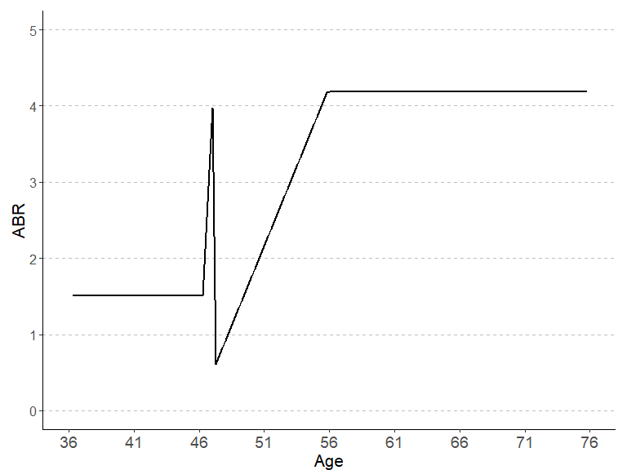

## Warning: Removed 210 rows containing missing values (`geom_line()`).

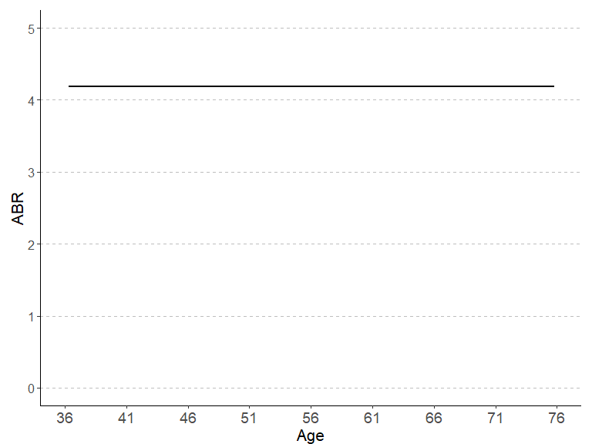

## Warning: Removed 70 rows containing missing values (`geom_line()`).  
## Removed 70 rows containing missing values (`geom_line()`).

## Warning: Removed 207 rows containing missing values (`geom_line()`).

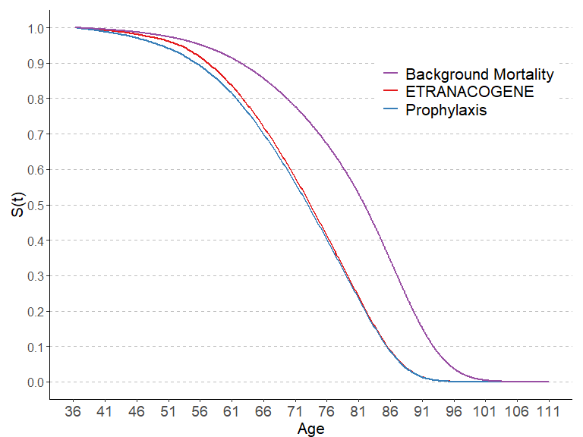

## Warning: Removed 70 rows containing missing values (`geom_line()`).

## Warning: Removed 70 rows containing missing values (`geom_line()`).

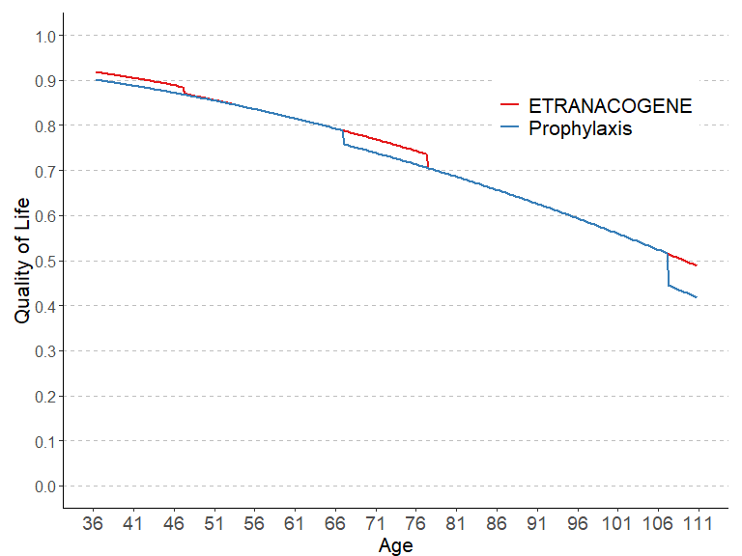

pandoc.table(cycle_length_comp_LYs, "Comparison Life Years", style = 'rmarkdown')

##   
##   
## | &nbsp; | ETRANACOGENE | PROPHYLAXIS |  
## |:-------------:|:------------:|:-----------:|  
## | **12 months** | 21.91 | 21.55 |  
## | **3 months** | 21.57 | 21.23 |  
## | **1 month** | 21.52 | 21.17 |  
## | **1 week** | 21.49 | 21.14 |  
##   
## Table: Comparison Life Years

# We see a relevant reduction in the number of LYs based on shorter cycle lengths,  
# though the difference between one month and one week is very small  
  
pandoc.table(cycle_length_comp_costs, "Comparison Costs", style = 'rmarkdown')

##   
##   
## | &nbsp; | ETRANACOGENE | PROPHYLAXIS |  
## |:-------------:|:------------:|:-----------:|  
## | **12 months** | 5629957 | 7108287 |  
## | **3 months** | 5559866 | 7003264 |  
## | **1 month** | 5586220 | 6986025 |  
## | **1 week** | 5592474 | 6975326 |  
##   
## Table: Comparison Costs

# For ENDOSCAPE: Costs increase considerably with shorter cycle lengths, since  
# retreatment can occur earlier with shorter cycles  
  
# For viral gene therapy and prophylaxis:   
# We see a relevant reduction in the costs based on shorter cycle lengths,  
# though the difference between one month and one week is very small  
  
pandoc.table(cycle_length_INMB, "Comparison Incremental Net Monetary Benefit", style = 'rmarkdown')

##   
##   
## | &nbsp; | ETRANACOGENE vs. PROPHYLAXIS |  
## |:-------------:|:----------------------------:|  
## | **12 months** | 1504734 |  
## | **3 months** | 1468628 |  
## | **1 month** | 1424925 |  
## | **1 week** | 1407957 |  
##   
## Table: Comparison Incremental Net Monetary Benefit

# We see a relevant reduction in the INMB based on shorter cycle lengths,  
# though the difference between one month and one week is very small

# System information

Sys.info()

sysname release version nodename machine login user effective_user   
 "Windows" "10 x64" "build 19045" "M04486" "x86-64" "min1" "min1" "min1"

sessionInfo(package = NULL)

R version 4.3.1 (2023-06-16 ucrt) Platform: x86_64-w64-mingw32/x64 (64-bit) Running under: Windows 10 x64 (build 19045)

Matrix products: default

locale: [1] LC_COLLATE=German_Switzerland.utf8 LC_CTYPE=German_Switzerland.utf8 LC_MONETARY=German_Switzerland.utf8 LC_NUMERIC=C LC_TIME=German_Switzerland.utf8

time zone: Europe/Zurich tzcode source: internal

attached base packages: [1] stats graphics grDevices utils datasets methods base

other attached packages: [1] rmarkdown_2.23 captioner_2.2.3 ggrepel_0.9.3 plyr_1.8.8 ggpubr_0.6.0 truncnorm_1.0-9 lookup_1.0 data.table_1.14.8 pander_0.6.5 RColorBrewer_1.1-3 [11] ggplot2_3.4.2

loaded via a namespace (and not attached): [1] gtable_0.3.3 highr_0.10 dplyr_1.1.2 compiler_4.3.1 ggsignif_0.6.4 tidyselect_1.2.0 Rcpp_1.0.11 tidyr_1.3.0 scales_1.2.1 yaml_2.3.7  
[11] fastmap_1.1.1 R6_2.5.1 generics_0.1.3 knitr_1.43 backports_1.4.1 tibble_3.2.1 car_3.1-2 munsell_0.5.0 pillar_1.9.0 rlang_1.1.1  
[21] utf8_1.2.3 broom_1.0.5 xfun_0.39 cli_3.6.1 withr_2.5.0 magrittr_2.0.3 digest_0.6.33 grid_4.3.1 rstudioapi_0.15.0 lifecycle_1.0.3  
[31] vctrs_0.6.3 rstatix_0.7.2 evaluate_0.21 glue_1.6.2 farver_2.1.1 abind_1.4-5 carData_3.0-5 fansi_1.0.4 colorspace_2.1-0 purrr_1.0.1  
[41] tools_4.3.1 pkgconfig_2.0.3 htmltools_0.5.5